Product Information – Apna Bio-Degradable Sanitary Napkins

Product Overview
Apna sanitary napkins are eco-friendly menstrual products manufactured by Apna Green Products. They are designed using natural, biodegradable materials, free from plastic and harmful chemicals, and are suitable for mass distribution under menstrual hygiene initiatives.

Key Features
• 100% biodegradable – made with natural plant fibers.
• Free from chlorine, artificial fragrance, and plastic film.
• Skin-friendly and rash-free design ideal for school and daily use.
• Conforms to Indian hygiene and safety standards (IS 5405).
• Produced under Make-in-India with sustainability focus.

Price & Packaging
Available Sizes:
• Pack of 6 (Large) – ₹40/-
• Pack of 8 (Large) – ₹45/-
• Pack of 10 (Large) – ₹50/-

Use in the MHM Initiative
These napkins are distributed as part of the Menstrual Hygiene and Dignity Initiative led by NGOs in partnership with education and welfare departments across Telangana. Beneficiaries include girls from government-run institutions like MJPTBCWREIS, KGBV, and TMREIS schools. Each girl receives a starter kit annually.

Product Images
Illustrative product visuals:
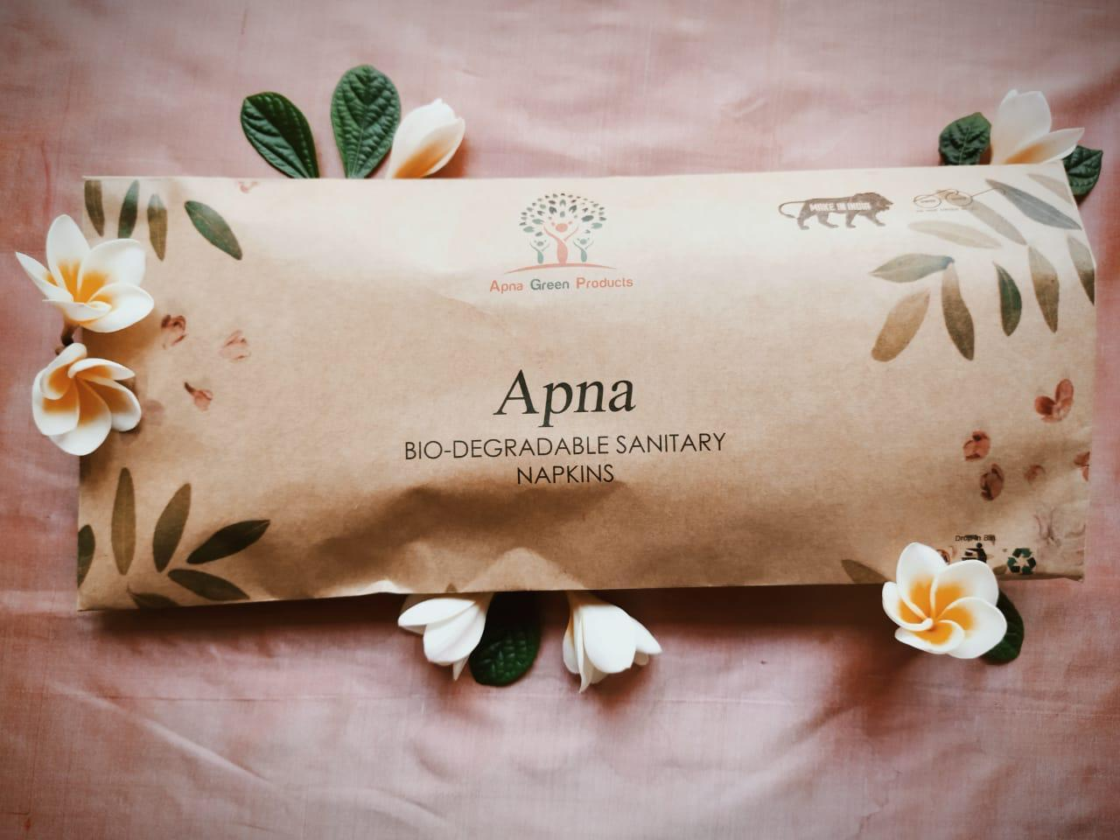
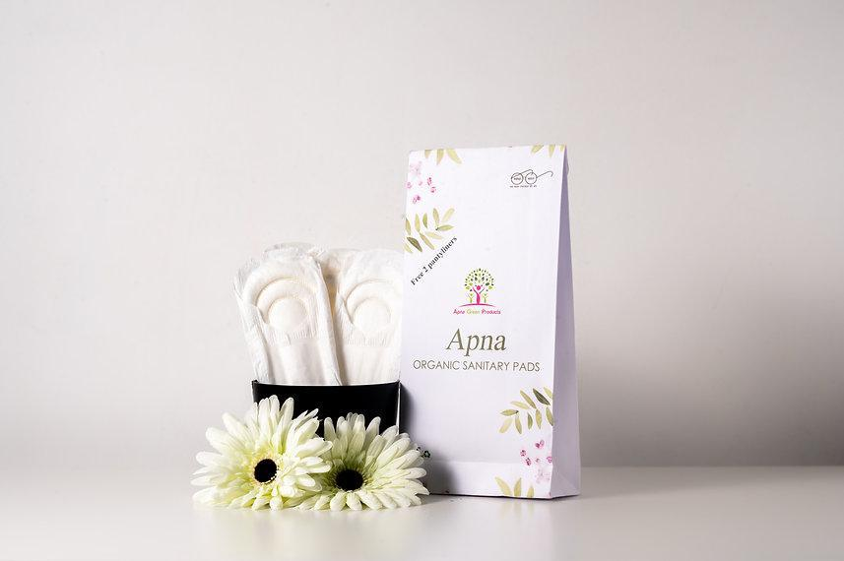
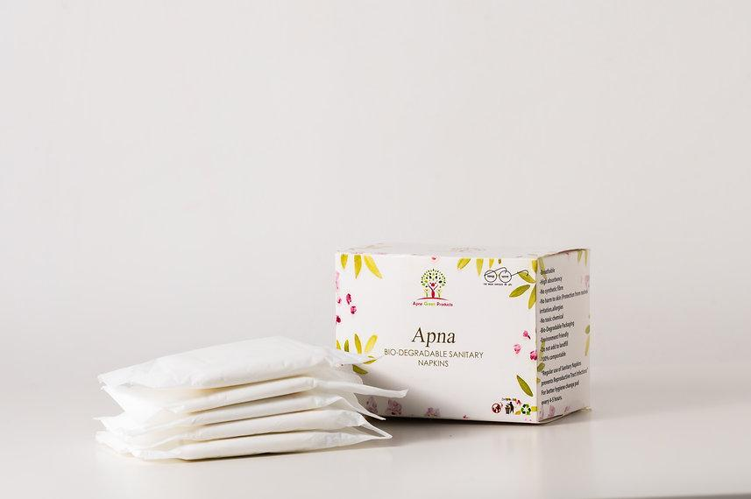
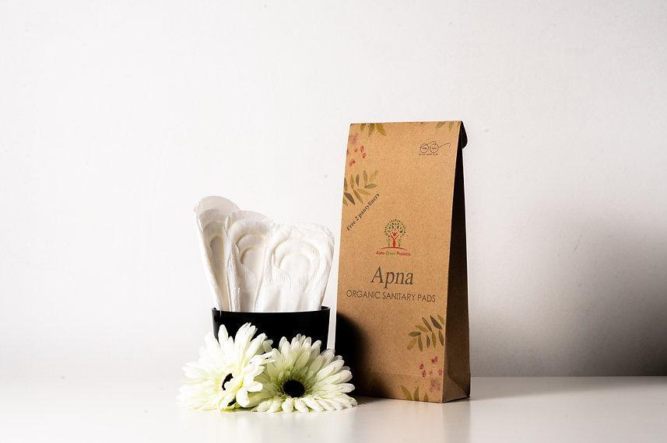

Test Report Summary
The sanitary napkin samples were independently tested to verify quality and safety for public distribution. Key test parameters include absorbency, pH level, microbial load, and chemical residue. Results confirm that Apna sanitary napkins comply with IS 5405 standards and are safe for use.
Test Conducted by: Certified Laboratory (Report Enclosed)
Compliance: Passed quality criteria for hygiene and safety
Year of Testing: 2023
Laboratory Test Report Summary
Issued To:
Apna Green Products
8-7-65/9, Road No.10, RR Nagar, Old Bowenpally,
Secunderabad – 500011, Telangana, INDIA
Test Results
Parameter | Standard Requirement | Result
Pad Size (Extra Large) | Length: 280 ± 20 mmWidth: 60–75 mmThickness: 15 ± 2 mm | 299 mm length70 mm width15.6 mm thick
Absorbency & Leakage Test | Must absorb 30 ml of colored liquid (15 ml/min) without staining bottom/sides | Passed – No stain observed after 30 ml absorption
Disposability | Must disintegrate in 15L water within 5 minutes | Passed – Disintegrated in water in under 5 minutes
pH Value | Should be between 6.0 and 8.5 | 7.6

Method of Testing: As per IS 5405–1980 & IS 1390–1961

