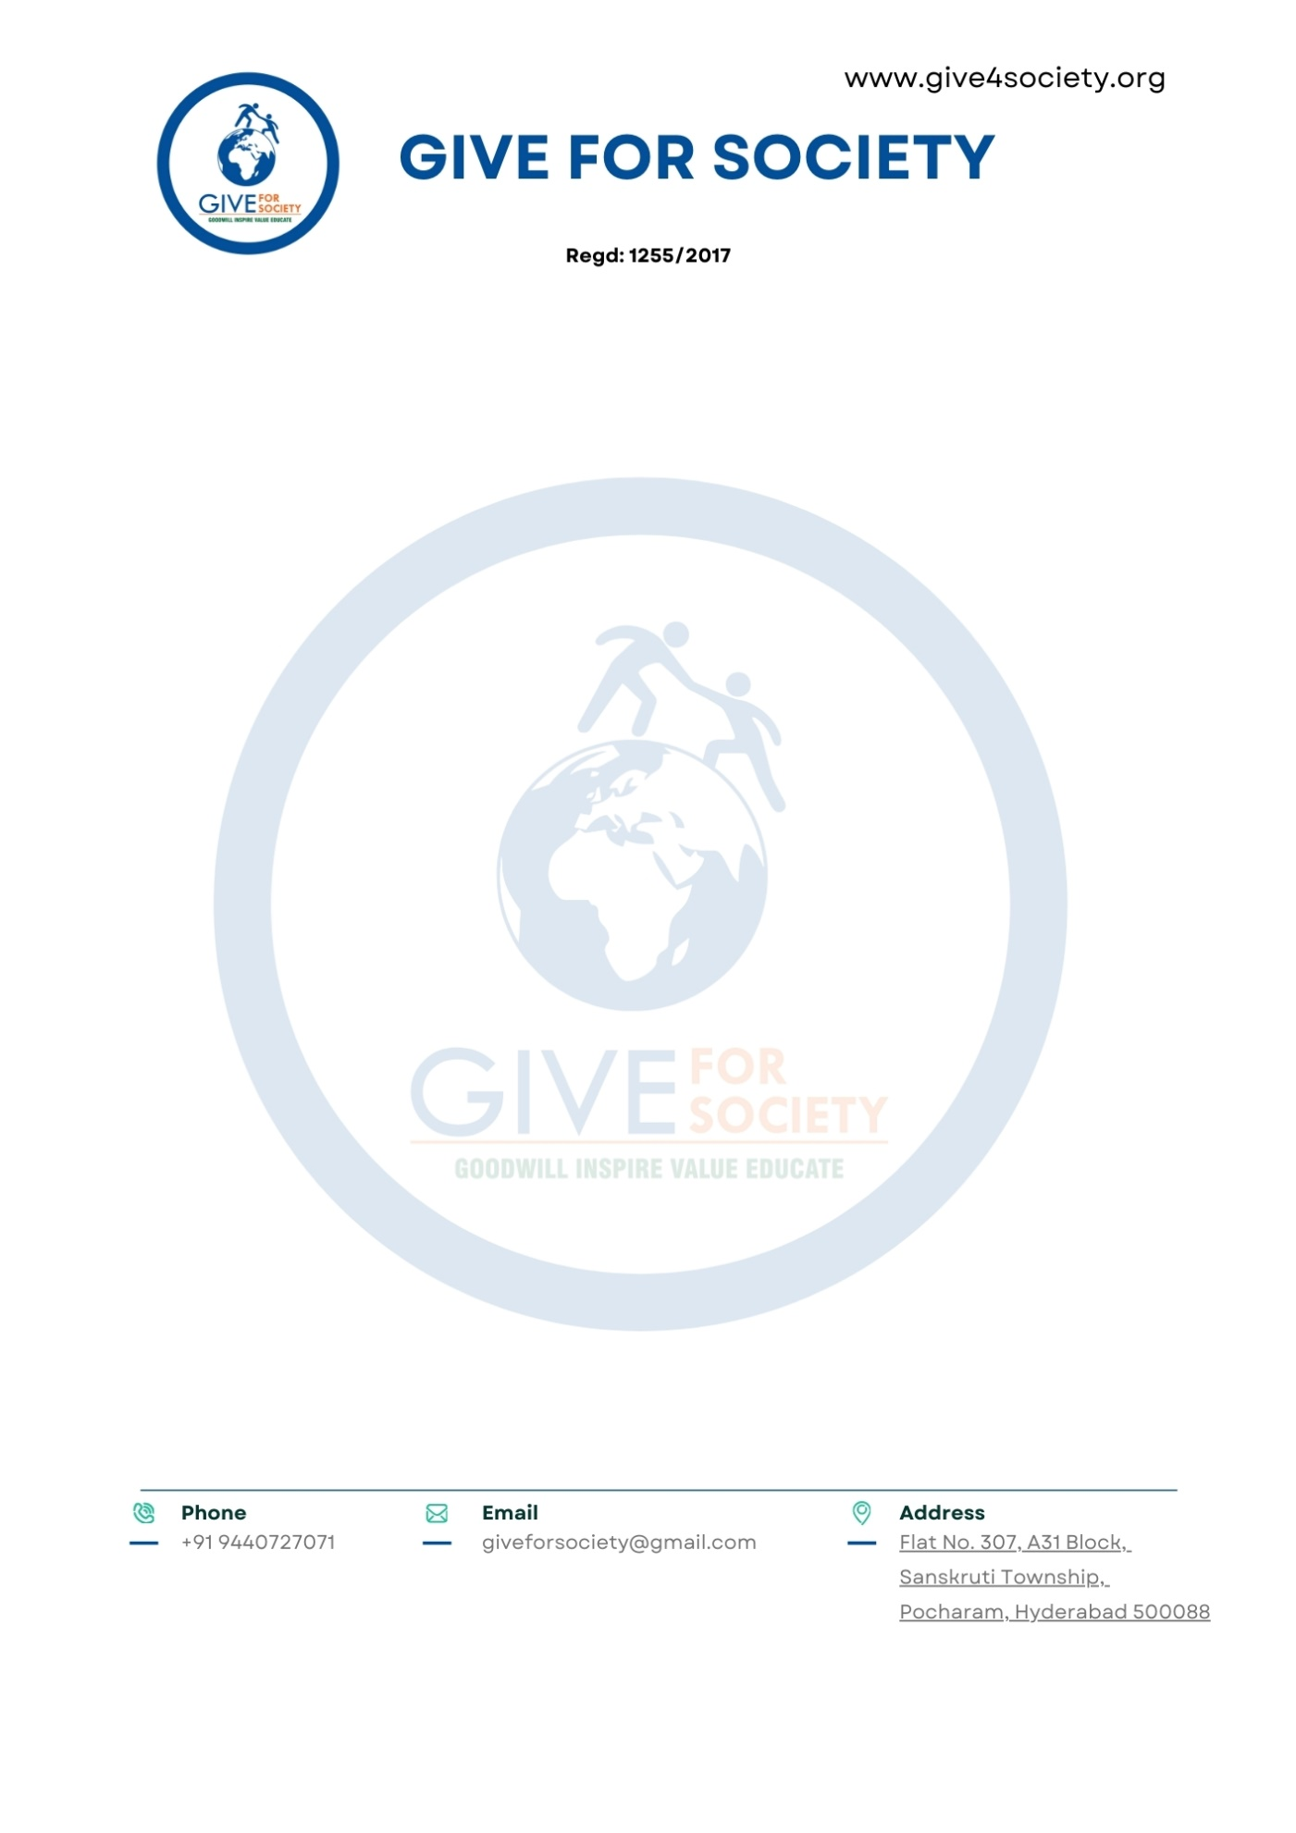

Date: 07 July 2025,
Hyderabad.
To,
The Hon'ble Secretary
Mahatma Jyotiba Phule Telangana Backward Classes Welfare Residential Educational Institutions Society (MJPTBCWREIS)
Government of Telangana
Subject: Submission of Proposal and Memorandum of Collaboration for "Sthree Swabhiman – Menstrual Hygiene and Dignity Initiative"

Respected Sir,

We are Give For Society - honored to present for your kind consideration the project proposal titled "Sthree Swabhiman – Menstrual Hygiene and Dignity Initiative for Girls in MJPTBCWREIS Residential Schools and Junior Colleges, Telangana."

This initiative is envisioned to benefit approximately 1,23,000 adolescent girls across 146 girls-only residential schools and 129 junior colleges under the aegis of MJPTBCWREIS. The program is designed to address menstrual hygiene challenges by delivering:

- Annual awareness and health education sessions
- One-time sanitary napkin starter kits (12 packs per girl)
- Capacity-building for school staff and peer leaders.
- Regional-language Information, Education, and Communication (IEC) material for sustainable reinforcement.
The program will be implemented with full support from Give For Society and funded through mobilized CSR and philanthropic contributions. We have enclosed the detailed proposal along with a draft Memorandum of Collaboration (MoC) for your review.

We kindly request your office to:
- Review and approve the attached proposal and MoC.
- Facilitate necessary coordination with school and college administrators for the smooth rollout of the initiative in the 2025–26 academic year.

