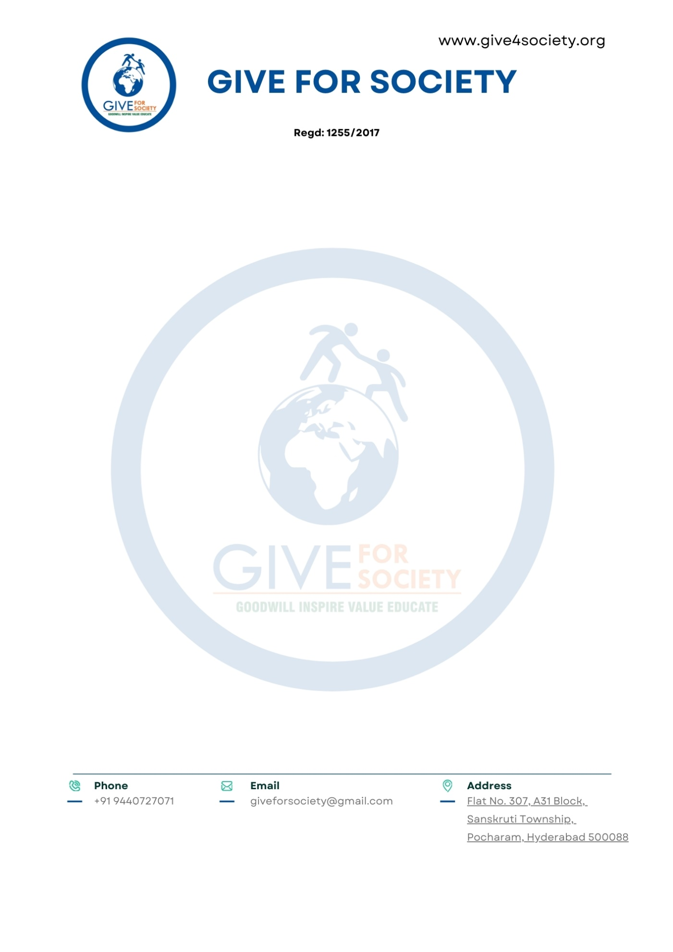

We are confident that this collaboration will create lasting impact on adolescent girls' health, dignity, and school attendance, while aligning with the objectives of NEP 2020 and UN Sustainable Development Goals.

We look forward to your positive support and remain at your disposal for any further discussion or clarification.

Thank you for your time and consideration.

Yours Sincerely,

Give For Society
Enclosures:
- Project Proposal – Sthree Swabhiman - MH Initiative
- Draft Memorandum of Collaboration (MoC)

- Sanitary Napkins – Product information.

