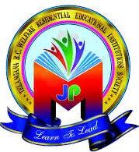 | Memorandum of Collaboration (MoC)  Between  Secretary, Mahatma Jyotiba Phule Telangana Backward Classes Welfare Residential Educational Institutions Society (MJPTBCWREIS)  Government of Telangana  And  Give For Society (NGO) | 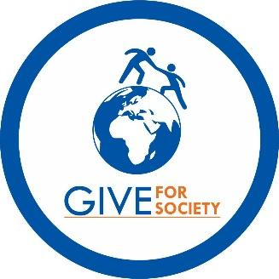

1. Preamble
This Memorandum of Collaboration (MoC) is entered into on this ___ day of __________ 2025, by and between:
Mahatma Jyotiba Phule Telangana Backward Classes Welfare Residential Educational Institutions Society (MJPTBCWREIS), represented by its Hon’ble Secretary (hereinafter referred to as “MJPTBCWREIS”) and
Give For Society (NGO), a registered non-profit organization working for rural education, menstrual hygiene, and dignity-centered school health initiatives.
Collectively referred to as the “Parties”, this MoC outlines a shared commitment to implement the Sthree Swabhiman – Menstrual Hygiene and Dignity Initiative across all MJPTBCWREIS girls' residential schools and junior colleges in Telangana.

2. Purpose and Program Scope
The Sthree Swabhiman initiative aims to institutionalize menstrual hygiene awareness, health education, and starter kit support within the academic framework of MJPTBCWREIS. The program will reach approximately 1,23,000 adolescent girls across 146 residential schools and 129 junior colleges managed by the Society.
This MoC formalizes a collaborative partnership for annual implementation of structured Menstrual Hygiene Management (MHM) sessions, peer-led education, and school-sustained practices.

3. Roles and Responsibilities

3.1. Give For Society (NGO) Shall:
- Design and deliver annual MHM awareness sessions in each MJPTBCWREIS girls' institution.
- Provide starter sanitary napkin kits (12 packs/girl/year) to all newly enrolled girls.
- Conduct Training of Trainers (ToT) sessions for school staff and peer mentors.
- Supply Telugu-language IEC materials for awareness and cultural alignment.
- Track implementation, monitor impact, and submit periodic reports to designated district/state officials.
- Mobilize CSR or philanthropic support to sustain program delivery.

3.2. MJPTBCWREIS Shall:
- Facilitate institutional coordination and schedule approvals.
- Extend school-level and junior college-level administrative support.
- Encourage sustained hygiene practices through health clubs and peer leadership.

4. Monitoring and Feedback
The initiative will be tracked through:
- Feedback from students, staff, and wardens.
- Optional baseline and outcome surveys (absenteeism, hygiene practices).
- Quarterly reports and year-end evaluation briefs to MJPTBCWREIS leadership.

5. Duration and Termination
This MoC is valid for a period of three (3) years from the date of signing and is renewable upon mutual consent.
Either Party may terminate this MoC with 30 days’ written notice.

6. Strategic Alignment
This collaboration aligns with:
- MJPTBCWREIS's mission of inclusive, equitable residential education.
- NEP 2020’s emphasis on health education and well-being.
- SDGs:
  - SDG 3 – Good Health and Well-being
  - SDG 4 – Quality Education
  - SDG 5 – Gender Equality
  - SDG 6 – Sanitation
  - SDG 10 – Reduced Inequalities

7. Signatures
For MJPTBCWREIS
Name: ___________________________
Designation: Secretary, MJPTBCWREIS
Signature: ________________________
Date: ____________________________
For Give For Society (NGO)
Name:
Designation:
Signature: ________________________
Date: ____________________________

