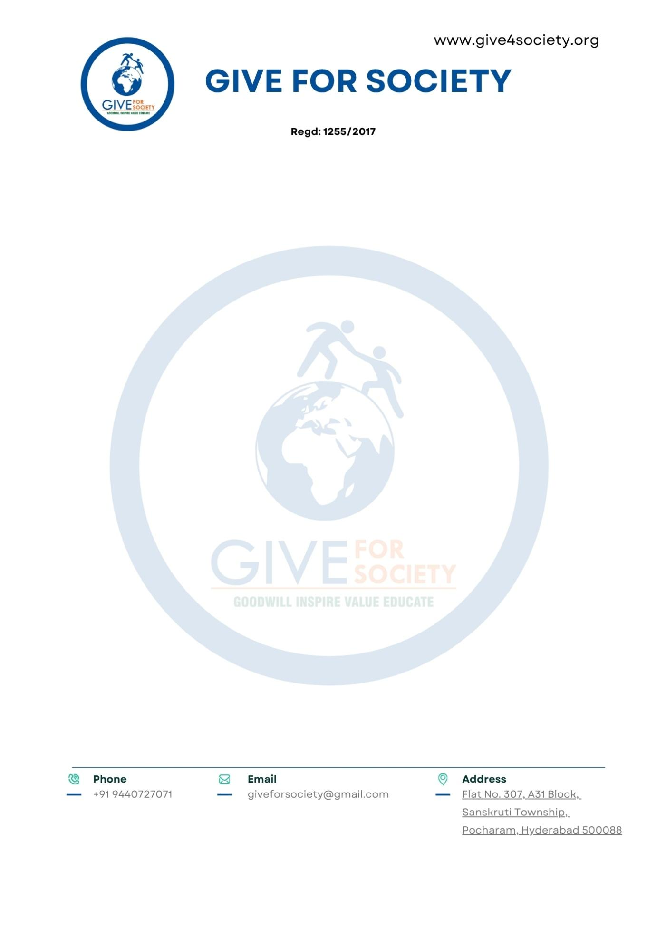

Date:07 July 2025,
Hyderabad.
To
The Secretary,
Telangana Minorities Residential Educational Institutions Society (TMREIS)
Minority Welfare Department
Government of Telangana
Subject: Submission of Proposal and Memorandum of Collaboration for "Sthree Swabiman – Menstrual Hygiene and Dignity Initiative for Girls in TMREIS Institutions"

Respected Sir,

We are pleased to submit for your consideration the project proposal titled "Sthree Swabiman – Menstrual Hygiene and Dignity Initiative for Girls in TMREIS Institutions, Telangana" along with a draft Memorandum of Collaboration (MoC).

This initiative is envisioned to benefit approximately 1,24,000 adolescent girls enrolled in 194 girls-only residential schools and junior colleges under TMREIS, by offering:

- Annual menstrual hygiene awareness and education sessions
- One-time sanitary napkin starter kits (12 packs per girl)
- Training of school/college staff and peer mentors
- Regional-language IEC materials to sustain engagement
- Light-touch monitoring and year-end reporting.
The program is fully supported by Give For Society through mobilized CSR/philanthropic partnerships and is designed for smooth integration into the TMREIS residential education system.

We respectfully request your approval of the proposal and facilitation of necessary coordination with TMREIS institutions to begin phased implementation during the 2025–26 academic year.

We are confident that this partnership will significantly advance adolescent health, dignity, and educational continuity for minority girls across Telangana.

Yours Sincerely,


Give For Society
Enclosures:
- Project Proposal – Sthree Swabhiman - MH Initiative
- Draft Memorandum of Collaboration (MoC)

