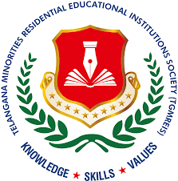 | Memorandum of Collaboration (MoC)  Between  Telangana Minorities Residential Educational Institutions Society (TMREIS)  Government of Telangana  And  Give For Society (NGO) | 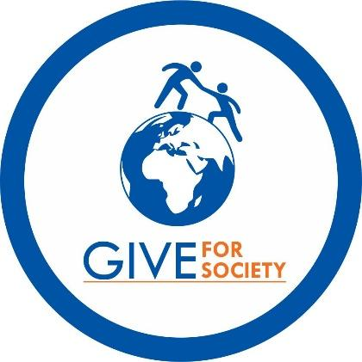

1. Preamble
This Memorandum of Collaboration (MoC) is entered into on this ___ day of __________ 2025, by and between:
Telangana Minorities Residential Educational Institutions Society (TMREIS), represented by its Secretary (Secretary to Government, Minority Welfare Department, Telangana) (hereinafter referred to as "TMREIS")
And
Give For Society (NGO), a registered non-profit organization working for rural education, menstrual hygiene, and dignity-centered adolescent health programs.
Collectively referred to as the "Parties," this MoC outlines a shared commitment to implement the Naaz-e-Haya – Menstrual Hygiene and Dignity Initiative across all TMREIS girls’ residential schools and junior colleges in Telangana.

2. Purpose and Program Scope
The Naaz-e-Haya initiative aims to institutionalize menstrual hygiene education, product access, and behavioral support within the academic framework of TMREIS. The program will reach approximately 1,24,000 adolescent girls across 97 girls-only residential schools and 97 girls-only junior colleges operated by TMREIS.
This MoC formalizes a collaborative partnership for the annual implementation of structured Menstrual Hygiene Management (MHM) awareness sessions, peer-led learning, and institution-sustained hygiene practices.

3. Roles and Responsibilities

3.1. Give For Society (NGO) Shall:
- Design and deliver annual MHM awareness sessions in each TMREIS girls' institution.
- Provide starter sanitary napkin kits (12 packs per girl per year) to all newly enrolled students.
- Conduct Training of Trainers (ToT) sessions for school and college staff, including wardens and peer mentors.
- Supply culturally appropriate, regional-language IEC materials (visual tools, posters, guides).
- Track implementation, monitor outcomes, and submit periodic reports to TMREIS district and state authorities.
- Mobilize CSR and philanthropic partnerships to support sustained program delivery.

3.2. TMREIS Shall:
- Facilitate administrative coordination at the institutional and district levels.
- Approve scheduling of awareness sessions and staff participation in training.
- Support sustained hygiene education through health clubs, assemblies, and student councils.
- Identify institutional focal points to ensure continuity and feedback collection.

4. Monitoring and Feedback
- Feedback will be gathered from students, wardens, and staff post-implementation.
- Optional baseline and follow-up indicators may include absenteeism, pad usage, and knowledge retention.
- Implementation updates and year-end summary reports will be submitted to TMREIS leadership for review and improvement.

5. Duration and Termination
This MoC is valid for a period of three (3) years from the date of signing and may be renewed upon mutual consent.
Either Party may terminate the MoC with 30 days’ written notice, with appropriate closure planning.

6. Strategic Alignment
This collaboration aligns with:
- TMREIS's vision of equitable, inclusive, and value-based residential education for minority girls.
- National Education Policy (NEP) 2020’s emphasis on health education and adolescent well-being.
- United Nations Sustainable Development Goals:
  - SDG 3 – Good Health and Well-being
  - SDG 4 – Quality Education
  - SDG 5 – Gender Equality
  - SDG 6 – Clean Water and Sanitation
  - SDG 10 – Reduced Inequalities

7. Signatures
For TMREIS
Name: ___________________________
Designation: Secretary (Secretary to Government, Minority Welfare), TMREIS
Signature: ________________________
Date: ____________________________
For Give For Society (NGO)
Name: Satya Rapelly
Designation: President & Founder
Signature: ________________________
Date: ____________________________

