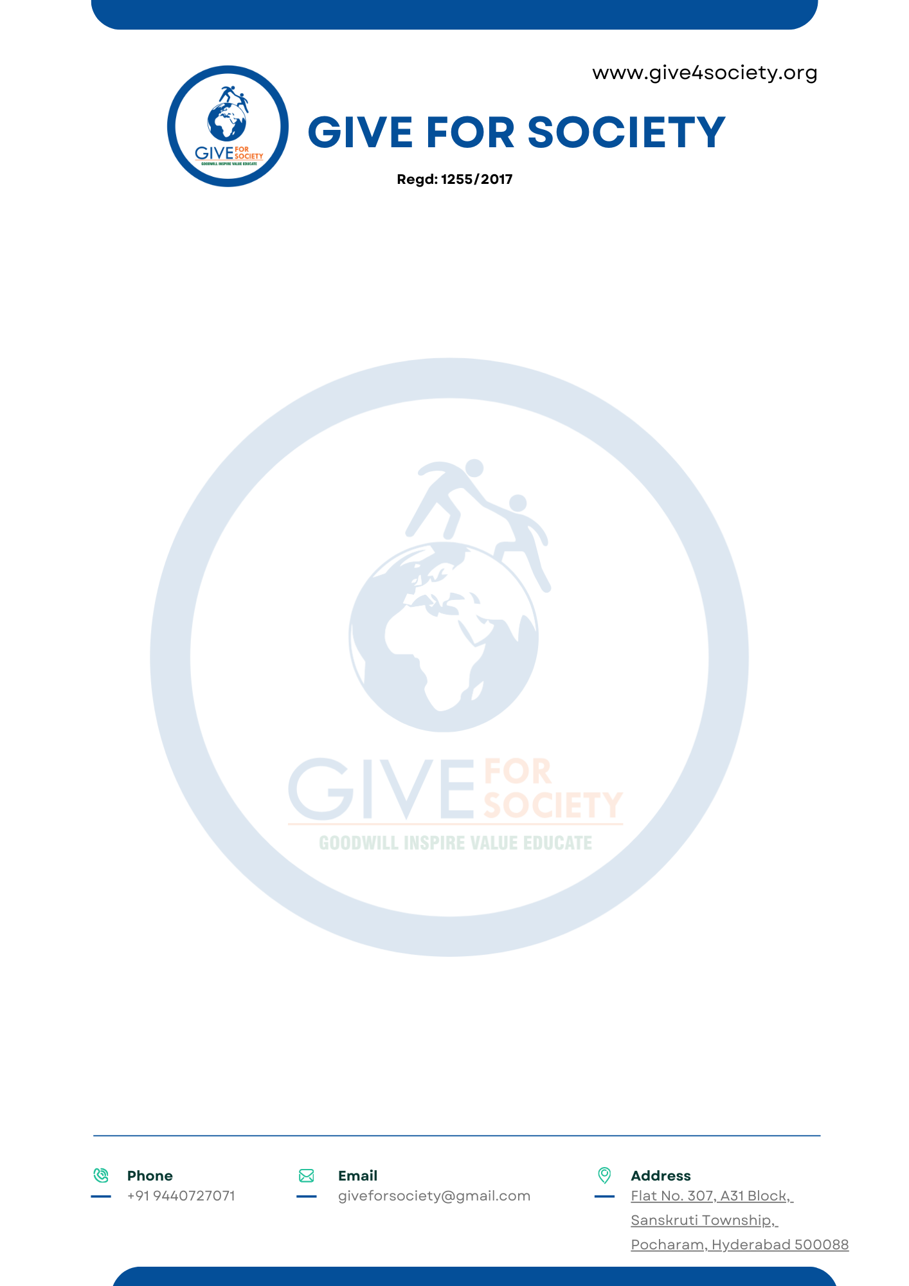
STHREE SWABHIMAN
Community Menstrual Hygiene and Dignity Initiative
Tribal Villages and Rural Communities • Telangana
Detailed Project Report — 3-Year MHM-Enabled Village Programme — CSR Funding Proposal

500  Villages Targeted (3 Years) | 50,000+  Women & Girls Reached | 500  Community Incinerators | 500  MHM-Enabled Villages

Give For Society • Reg. No. 1255/2017 • 12A & 80G Certified • Telangana Governor’s Excellence Award 2025
MoU: District Collector, Mulugu • MoU: District Collector, Jangaon • Pilot: November 2025, Warangal — 1,200+ women and girls

1. Executive Summary
In tribal and rural Telangana, a woman manages her period every month with cloth, ash, or nothing. Nobody has ever explained to her what menstruation is. No safe place exists to dispose of used materials. This is not poverty in the abstract. It is a specific, preventable condition that affects the health, dignity, and daily functioning of millions of women who live outside the reach of institutional programmes.
Sthree Swabhiman — Community Edition is Give For Society’s village-level Menstrual Hygiene Management (MHM) programme for women and girls in tribal and rural communities across Telangana. It is distinct from the institutional Sthree Swabhiman programme (which serves girls in MJPTBCWREIS residential schools) — this programme reaches the women and girls who are not in any institution: those living in tribal habitations, thanda settlements, forest villages, and rural gram panchayats where no structured MHM programme has ever been delivered.
The programme is built on one clear goal: by the end of Year 3, every targeted village should be a certified MHM-Enabled Village — a community where 70% or more of menstruating-age women and girls are practising safe menstrual hygiene, where a community incinerator provides permanent safe disposal, and where trained local women champions sustain the programme without any external support.
The 3-year programme targets 500 villages across Telangana’s tribal and rural districts, reaching approximately 50,000 women and girls as direct beneficiaries with starter kits in Year 1 alone, and installing 500 community incinerators — one per village — as permanent disposal infrastructure. The total CSR investment over three years is ₹7,43,50,000. At approximately ₹1,487 per woman over three years — or under ₹500 per year — this is among the most cost-effective women’s health interventions available at community scale in India.

2. Context and Need
Telangana’s tribal and rural belt — spanning the ITDA districts of Adilabad, Kumuram Bheem Asifabad, Mulugu, Mancherial, Bhadradri Kothagudem, and rural Warangal, Jangaon, Mahabubabad, and Khammam — is home to a large population of women and girls for whom menstrual hygiene is an entirely unaddressed need. The institutional Sthree Swabhiman programme reaches girls in government residential schools. But the majority of menstruating women and girls in these districts are not in residential institutions. They are in villages.
The Gap | What It Looks Like on the Ground
Non-practitioner rate | NFHS-5 data: 60%+ of rural and tribal women in Telangana’s ITDA districts are not using any sanitary product during menstruation — relying on cloth, ash, bark, or nothing.
Knowledge gap | Most women in tribal habitations have never received structured MHM education. Cultural taboos mean menstruation is not discussed at home, in school, or in health settings.
Disposal | No community-level safe disposal infrastructure exists in most tribal villages. Women either burn used materials openly (releasing toxic fumes) or bury them — contaminating soil and water.
Health consequences | Reuse of cloth and unsafe materials causes Reproductive Tract Infections (RTIs) and Urinary Tract Infections (UTIs) that go undetected and untreated in remote communities.
Who is missed | Girls who dropped out before Class VII, married women, agricultural labourers, women in seasonal migration — none of them are reached by any existing institutional MHM programme.

A typical gram panchayat in Telangana’s tribal belt has a total population of 1,500–4,000. Based on 2011 Census data for the target geographies (e.g., Kerameri, Adilabad: population 5,975; Bhatpalle, Asifabad: population 3,902), women aged 14–45 constitute approximately 25–30% of total population. In a 1,500-population village, this is around 375–450 menstruating women and girls. NFHS-5 data indicates 60%+ are non-practitioners in tribal Telangana — meaning approximately 100 women per village are the immediate intervention target.

3. The MHM-Enabled Village Framework
The programme’s defining feature is its outcome certification — every targeted village is assessed at the end of Year 3 against a defined standard. A village is declared MHM-Enabled when it meets all of the following criteria:
# | Criterion | How Verified
1 | 70%+ of menstruating women and girls are practising safe menstrual hygiene | Year 3 intake screening vs Year 1 baseline; beneficiary register comparison
2 | Community incinerator installed and functional | Physical inspection; usage log maintained by Panchayat or SHG
3 | At least 2 trained MHM Women Champions in the village | ToT certification records; confirmed delivery of at least 1 independent session in Year 3
4 | IEC materials (flipbooks, wall charts) visible and in use | Field visit photographic documentation
5 | Zero open burning of menstrual waste reported | Community self-declaration + ASHA/ANM confirmation

Villages that meet all five criteria receive a formal MHM-Enabled Village declaration — a board installed at the Gram Panchayat office, a certificate co-signed by Give For Society and the PHC Medical Officer, and inclusion in a district-level MHM register maintained by the District Health Officer. This creates a permanent, visible, reportable outcome that goes beyond programme delivery into community transformation.

4. Programme Design
The programme has five integrated components, all delivered at village level across a 3-year cycle.
Component A — Village MHM Awareness Sessions
One structured community MHM session per village per year, conducted by the village ASHA worker with GFS female field coordinator support. Sessions are held in Telugu at the Anganwadi centre, Gram Panchayat hall, or community space, coordinated with the Gram Panchayat, VHSNC, and AWC.
- Year 1: Full awareness session covering the menstrual cycle, hygiene practices, product types, myth-busting, safe disposal, and incinerator use. 2-minute verbal intake screening at entry identifies current non-practitioners.
- Year 2: Follow-up session assessing adoption from Year 1. Reinforcement of hygiene practices. Introduction of peer champion model. Identification and training of 2 Women Champions per village.
- Year 3: Community-led session delivered by trained Women Champions with GFS observer support only. GFS certifies and exits.

Component B — Targeted Starter Kit Distribution
Starter kits are distributed exclusively to identified non-practitioners — women and girls who are currently not using any sanitary product. This is not a blanket distribution. The 2-minute intake screening at each session entry creates a beneficiary register that documents who receives a kit, their age, their current practice, and their ASHA worker’s name. This register is the primary CSR compliance document.
- Year 1: 100 women and girls per village (based on census data and 60% non-practitioner rate) × 12 packs × ₹45 = ₹54,000 per village
- Year 2: ~50 new non-practitioners per village (new adolescent girls entering menstrual age + missed Year 1 women) × 12 packs
- Year 3: ~30 new non-practitioners per village (primarily adolescent girls newly reaching menarche)
- All kits framed as a dignity starter — not a recurring subsidy. Women are oriented towards affordable local procurement after receiving the starter kit.

Component C — Community Incinerator Installation
One wall-mounted, electrically-operated eco-friendly sanitary napkin incinerator is installed in every village in Year 1. The incinerator is sited at the Anganwadi centre, health sub-centre, or community space with electrical connection — in consultation with the Gram Panchayat. Responsibility for operation and maintenance is formally handed over to the Panchayat or SHG in Year 1 itself, with a simple maintenance guide in Telugu.
- Combustion at 800–900°C with smoke filtration. Handles all types of sanitary waste.
- One-time capital investment per village — 10-year service life with minimal maintenance.
- Eliminates open burning (which releases dioxins and furans), open-pit burial, and waste contamination.
- Usage log maintained by Panchayat. Quarterly check by GFS field coordinator in Years 1–2; annual check in Year 3.
- Branded with CSR partner and GFS identity for permanent visibility in the community.

Component D — Women Champions: Training of Trainers
In Year 2, two women per village are identified and trained as MHM Women Champions: ideally the village ASHA worker and one active SHG member or anganwadi worker. They receive a one-day structured Training of Trainers (ToT) conducted by GFS, covering session facilitation, beneficiary screening, IEC material use, incinerator operation, and how to track and report MHM practice in their village.
- Training conducted in Telugu. Champions receive a certificate from Give For Society.
- Champions deliver the Year 3 session independently. GFS attends as observer only.
- From Year 4 onwards, Champions are the programme. GFS provides an annual helpline and refresher module — no field presence required.
- Champions are also equipped to conduct annual new-entrant screening and distribute kits for newly menstruating girls using village-level funds or government schemes.

Component E — IEC Materials and Community Visibility
Each village receives a set of reusable IEC materials in Year 1: illustrated Telugu-language flipbooks for session facilitation, wall charts covering the menstrual cycle and hygiene practices (laminated, for permanent display), and a pictorial disposal guide placed next to the incinerator. At MHM-Enabled Village certification, a declaration board is installed at the GP office.

5. Target Beneficiaries
The programme targets women and girls in tribal and rural villages across Telangana who are not reached by any existing institutional MHM programme. This includes: adolescent girls who dropped out before Class VII, married women in reproductive age, agricultural and MNREGA labourers, women in seasonal migration periods, and elderly women who have never received any MHM education.
Group | Year 1 | Year 2 | Year 3
Non-practitioner kit recipients | 100/village × 500 = 50,000 | 50/village × 500 = 25,000 | 30/village × 500 = 15,000
Women attending awareness sessions | 150/village × 500 = 75,000 | 120/village × 500 = 60,000 | 100/village × 500 = 50,000
Women Champions trained | -- | 2/village × 500 = 1,000 | --
Villages with functional incinerator | 500 | 500 (maintained) | 500 (maintained)
Villages certified MHM-Enabled | -- | -- | 500 (target: Year 3)

Target geographies: all erstwhile districts with scheduled tribal areas — Adilabad, Kumuram Bheem Asifabad, Mulugu, Mancherial, Bhadradri Kothagudem, Mahabubabad, Khammam, Warangal (rural), and Jangaon. Village selection prioritised in ITDA mandals, followed by other rural mandals with low institutional MHM coverage.

6. Implementation Plan
Phase | When | Key Activities
Year 1 | Village Reached | Finalise 500 village list with ASHA supervisors and PHC MOs. Site assessment for incinerator placement in each village. Procure 500 incinerators + IEC materials. Conduct 500 MHM awareness sessions (intake screening at entry). Distribute starter kits to 100 non-practitioners per village (50,000 women total). Install 500 community incinerators. Create beneficiary register for each village. Baseline adoption rate recorded.
Year 2 | Adoption Tracked | Follow-up session in all 500 villages. Re-screen to measure adoption from Year 1. Distribute kits to ~50 new non-practitioners per village (25,000 women). Incinerator functionality check and maintenance. Train 1,000 Women Champions (2 per village) through structured ToT. Champions conduct practice facilitation during Year 2 session. Update beneficiary registers. Mid-programme report to CSR partner.
Year 3 | Village Certified | Women Champions independently deliver Year 3 session in all 500 villages. GFS attends as observer. Final intake screening — adoption rate measured against Year 1 baseline. Incinerator final check. Villages meeting all 5 MHM-Enabled criteria receive formal declaration (board + certificate). Kits distributed to ~30 new entrants per village (15,000 women). Year-end impact evaluation report to CSR partner and District Health Officer.
Year 4+ | Self-Sustaining | GFS exits field operations completely. Women Champions sustain programme. Annual refresher module and telephone helpline provided by GFS at no cost. Incinerators functional for 10+ years. MHM-Enabled Village status maintained and tracked by District Health Officer.

7. Budget — 3-Year Programme
7.1 Year 1 Budget
Component | Coverage | Amount (₹)
MHM awareness sessions (500 villages × ₹5,000/session) | 500 sessions | ₹25,00,000
Starter napkin kits — Year 1 non-practitioners | 50,000 women × 12 packs × ₹45 | ₹27,00,000
Community incinerators (1 per village × ₹20,000) | 500 incinerators | ₹1,00,00,000
Incinerator installation (electrical, civil) | 500 villages × ₹3,000 | ₹15,00,000
IEC materials — Telugu flipbooks, wall charts, posters | 500 villages | ₹10,00,000
Beneficiary intake screening forms & registers | 500 villages | ₹1,50,000
GFS field coordinators (10 staff × 12 months) | 10 districts | ₹36,00,000
Monitoring, field audits & documentation | 12 months | ₹6,00,000
Year 1 Total |  | ₹3,20,50,000

7.2 Year 2 Budget
Component | Coverage | Amount (₹)
MHM follow-up sessions (500 villages) | 500 sessions | ₹25,00,000
Starter kits — Year 2 new non-practitioners | 25,000 women × 12 packs × ₹45 | ₹13,50,000
Women Champions ToT (1,000 women, 2/village) | 500 villages × 2 women × ₹2,000 | ₹20,00,000
Incinerator maintenance check | 500 villages | ₹3,00,000
GFS field coordinators (10 staff × 12 months) | 12 months | ₹36,00,000
Monitoring & mid-programme evaluation | 12 months | ₹6,00,000
Year 2 Total |  | ₹1,03,50,000

7.3 Year 3 Budget
Component | Coverage | Amount (₹)
MHM sessions — Champion-led (GFS as observer) | 500 sessions | ₹10,00,000
Starter kits — Year 3 new entrants | 15,000 women × 12 packs × ₹45 | ₹8,10,000
MHM-Enabled Village certification boards (500) | 500 GP boards | ₹10,00,000
MHM-Enabled Village certificates (co-signed) | 500 villages | ₹1,00,000
Final impact evaluation & district-level reporting | All 500 villages | ₹8,00,000
GFS field coordinators (reduced, Year 3) | 6 months support | ₹18,00,000
Champion helpline & refresher content | Post-Year 3 setup | ₹3,40,000
Year 3 Total |  | ₹58,50,000

TOTAL 3-YEAR INVESTMENT (Year 1 + Year 2 + Year 3) ₹4,82,50,000
INR Four Crores, Eighty-Two Lakhs and Fifty Thousand • ₹483 per woman per year • 500 MHM-Enabled Villages at programme close

Incinerators (₹1,00,00,000) are a one-time capital investment in Year 1. From Year 4, the only cost is the annual helpline and refresher content — approximately ₹5,00,000 per year for 500 villages. The community transformation is fully funded in three years and self-sustaining thereafter.

8. SDG Alignment and Schedule VII Compliance
Goal | How This Programme Contributes
SDG 3 — Good Health | Reduces RTIs and UTIs caused by unsafe menstrual practices. Eliminates toxic open burning through community incinerators. Improves reproductive health outcomes for 50,000+ women over 3 years.
SDG 5 — Gender Equality | Directly addresses period stigma at the community level — the most upstream intervention possible. Trains 1,000 women as community health champions with recognised certification.
SDG 6 — Sanitation | 500 incinerators installed across tribal villages prevent menstrual waste from contaminating soil and water. Eliminates open burning and improper disposal.
SDG 10 — Reduced Inequalities | Exclusively targets tribal and rural women not reached by any institutional programme — the most excluded demographic in any national MHM data.
SDG 11 — Sustainable Communities | MHM-Enabled Village certification creates a permanent, self-sustaining community health outcome. Village-level ownership ensures continuity beyond the programme period.

Schedule VII Compliance: Clause (i) — Promoting health care including preventive health care and sanitation. Clause (iii) — Promoting gender equality, empowering women. Clause (x) — Rural development projects. Also aligns with Beti Bachao Beti Padhao, Swachh Bharat Mission, and National Health Mission’s Adolescent Health (RKSK) programme.

9. Monitoring and Reporting
Indicator | Year 1 Target | Year 3 Target
Sessions conducted | 500 | 500 (champion-led)
Non-practitioner kit recipients | 50,000 women | 15,000 (new entrants)
Incinerators installed & functional | 500 | 500 (maintained)
Women Champions trained | -- | 1,000 certified
Adoption rate (% using sanitary products) | Baseline recorded | 70%+ per village
Villages certified MHM-Enabled | -- | 500 (100% target)
Open burning incidents reported | Baseline | Zero

CSR partners receive: annual programme reports with village-wise delivery data; beneficiary registers for every kit recipient (name, age, village, ASHA confirmation); incinerator installation logs and photographs; MHM-Enabled Village certificates at end of Year 3; and Schedule VII compliance documentation including utilisation certificates. Brand visibility: CSR partner named on incinerator plaques in all 500 villages and on MHM-Enabled Village declaration boards at GP offices.
10. Conclusion
The institutional Sthree Swabhiman programme reaches girls inside government residential schools. This programme reaches everyone else. The women working in the fields. The girls who dropped out. The wives in tribal hamlets who have never seen a sanitary pad. The adolescents who just reached menarche with no one to tell them what is happening to their bodies.
Sthree Swabhiman — Community Edition is not a health camp. It is a 3-year community transformation programme with a certified, visible, permanent outcome: 500 MHM-Enabled Villages across tribal Telangana, each with a functional incinerator, trained local champions, and a community where menstruation is no longer managed in silence.
₹4,82,50,000 over three years. 500 villages. 50,000 women and girls in Year 1 alone. And from Year 4 — a self-sustaining community health outcome that costs nothing to maintain.

For partnership discussions, village visit, or detailed financial model:
Give For Society
Reg. No. 1255/2017 | 12A & 80G Certified | Enrolled MP-LADS Implementing Agency
Flat No. 307, A31 Block, Sanskruti Township, Pocharam, Hyderabad – 500088
giveforsociety@gmail.com • +91 9440727071 • www.give4society.org

