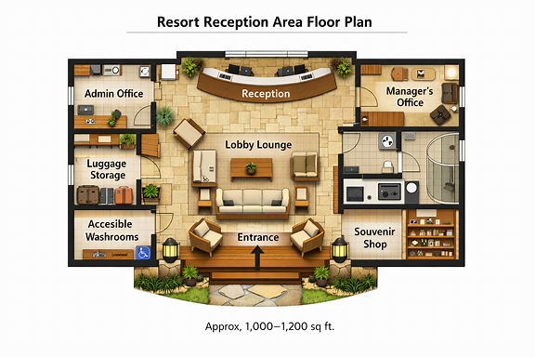

Here’s your 2D floor plan for the resort reception area (approx. 1,000–1,200 sq ft) — a clear, functional layout that ensures smooth guest movement and efficient staff operations.

🏢 Layout Highlights
- Reception counter: Centrally placed curved desk for guest check-in and concierge service.
- Lobby lounge: Spacious seating clusters with greenery and accent lighting.
- Administrative office: Staff workspace with desks and filing cabinets.
- Manager’s office: Private cabin with desk and meeting corner.
- Guest luggage area: Near entrance, equipped with racks and secure storage.
- Accessible washrooms: Male and female units with ADA-compliant fixtures.
- Souvenir shop: Optional retail nook for local crafts and resort merchandise.

🧭 Circulation & Flow
Guests enter through the main entrance into the lobby lounge, greeted by the reception counter directly ahead. Offices and luggage storage sit laterally for privacy, while washrooms and the souvenir shop are positioned toward the rear for convenience.

Exterior
