|  |  |
| --- | --- |
|  | git commands |

Name: Dommeti R V M S SATYA SAI

ROLL NO: 21B21A4689

Team no : 14

Date: 16/02/2025

|  |  |  |
| --- | --- | --- |
| description |  | commands |
| First command you'll use in a new project (Initializes a new, empty Git repository) |  | git init |
| Add the folder into the git |  | git add . |
| Set username for git |  | git config --global user.name "Your Name" |
| Set user mail id for git |  | git config --global user.email "your.email@example.com" |
| To commit the change made (-m allows to message the command directly) |  | git commit -m "Your commit message": |
| Copy or clone the source code from the git hub |  | git clone <repository_url> |
| To fetch the details from the github to the environment |  | git fetch |
| Gives the information about the working directory (changes made, stage & traking) |  | git status |
| Removes a file from Git's tracking |  | git rm <file> |
| Renames the file from github |  | git mv <old_file> <new_file> |
| Resets the file from the github |  | git reset <file> |
| Lists all branches in your repository. |  | git branch |
| Create a new branch |  | git branch <branch_name> |
| Changes the branch to commit changes in the repository |  | git checkout <branch_name> |
| Discard the branch in the working repository |  | git checkout -- <file> |
| Merge the two branches |  | git merge <branch_name> |
| Delete the branches |  | git branch -D <branch_name> |
| Creates a new branches and switches to it. |  | git checkout -b <branch_name> |
| Add the repoisitory link to the git |  | git remote add origin <repository_url> |
| Pushes the commits to the directed branch |  | git push origin <branch_name> |
| Fetch or pull the commits to the directed branch |  | git pull origin <branch_name> |
| Shows the configured Git settings. |  | git config --list |
| Shows who made changes to each line of a file. |  | git blame <file> |
| Shows difference between the working directory and the last commit. |  | git diff |
| Displays the history of commits |  | git log |
| Removes untracked files from the working directory. |  | git clean -f |

Now lets use the step by step process to use these commands

**GIT:** Git is a distributed version control system used to track changes in code and collaborate with multiple developers efficiently. It helps in managing different versions of a project, allowing users to commit, branch, merge, and revert changes as needed.

**Installation of Git:**

Git can be installed from its official site (<https://git-scm.com/>). It works different operating systems like Windows, MAC and Linux. We can download it based on the configuration of our system.

Below mention linkes helps us to download the git directly.

**Windows:** https://github.com/git-for-windows/git/releases/download/v2.48.1.windows.1/Git-2.48.1-64-bit.exe

**MAC OS:** <https://sourceforge.net/projects/git-osx-installer/>

**Debian/Ubuntu:**

# apt-get install git

# add-apt-repository ppa:git-core/ppa  
# apt update; apt install git

**Fedora**

# yum install git (up to Fedora 21)  
# dnf install git (Fedora 22 and later)

**Gentoo**

# emerge --ask --verbose dev-vcs/git

**Arch Linux**

# pacman -S git

**openSUSE**

# zypper install git

**Mageia**

# urpmi git

**Nix/NixOS**

# nix-env -i git

**FreeBSD**

# pkg install git

**Solaris 9/10/11 ([OpenCSW](https://www.opencsw.org/))**

# pkgutil -i git

**Solaris 11 Express, OpenIndiana**

# pkg install developer/versioning/git

**OpenBSD**

# pkg_add git

**Alpine**

$ apk add git

**Set Up:**

**Set up in the VS Code**

1. Open the vs code
2. Create a folder and file (with some extension like “.py”, “.html”, etc)
3. Then insert git into it using “**git init**” command. (Check if git is inserted into folder by having a file **.git** hidden in the folder)



Note : Check if git is inserted into folder by having a file **.git** hidden in the folder



1. Now run a commad “**git add .**” to add the folder to git



1. Now setup user name and user email globally using commands

“**git config --global user.name "Your Name"**”

“**git config --global user.email "your.email@example.com"**”

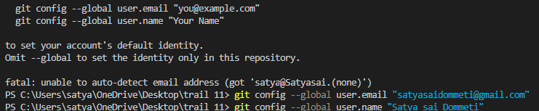

1. Now commit the changes and add message using command

“**git commit -m "Your commit message":**”

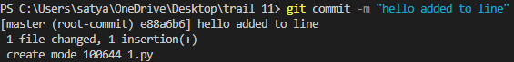

1. Create a branch using command “ **git branch <branch_name>**”



1. Now check the branches created using commad “**git branch**”



1. Now change the directory to the main branch to created branch using the command

“**git checkout <branch_name>**”



1. After all changes are commit then push the folder into the repository using the command

“**git push -u origin new <branch_name>**”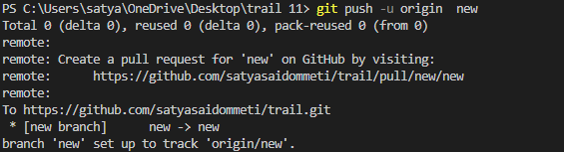

1. Now open the github and check whether the folder/ file is pushed in github.

