SignNet II: A Transformer-Based Two-Way Sign Language Translation Model
In propose paper author introducing SignNet fusion model which consists of two different Transformer Attention CNN Based encoder decoder models where first encoder-decoder model can get trained on Sign Images and Words and second encoder-model will take predicted TEXT output from first model to predict Sign image. So propose model will predict sign text from input video and then convert that text into sign image. In simple terms it’s called as “Sing 2 Text and Text to Sign”.
In propose paper author has used German and American language dataset but you ask us to use word level dataset so we have Word Based Sign dataset which consists of 18 different sign words showing below.
['I', 'apple', 'can', 'get', 'good', 'have', 'help', 'how', 'like', 'love', 'my', 'no', 'sorry', 'thank-you', 'want', 'yes', 'you', 'your']
Above dataset can be downloading from below link
https://universe.roboflow.com/asl-dataset/asl-dataset-p9yw8
To extract features from video frames author has used Open Pose algorithm to detect hand and finger key-points and then utilize word2vec model to convert words into numeric vector. All extracted features will be input to two-way encoder decoder algorithm to train a model and this model can be applied on Live Webcam or video framers to predict sign text to sign image,
Author evaluated propose model by using BLEU score which takes predicted and true words as input and then calculate percentage of number of correct words prediction.
Note: we tried to train above model using JUPYTER notebook but JUPYTER API is unable to load open pose model to extract hand and finger key points so we have implemented this project using TKINTER GUI mode. In below screen showing error giving by JUPYTER
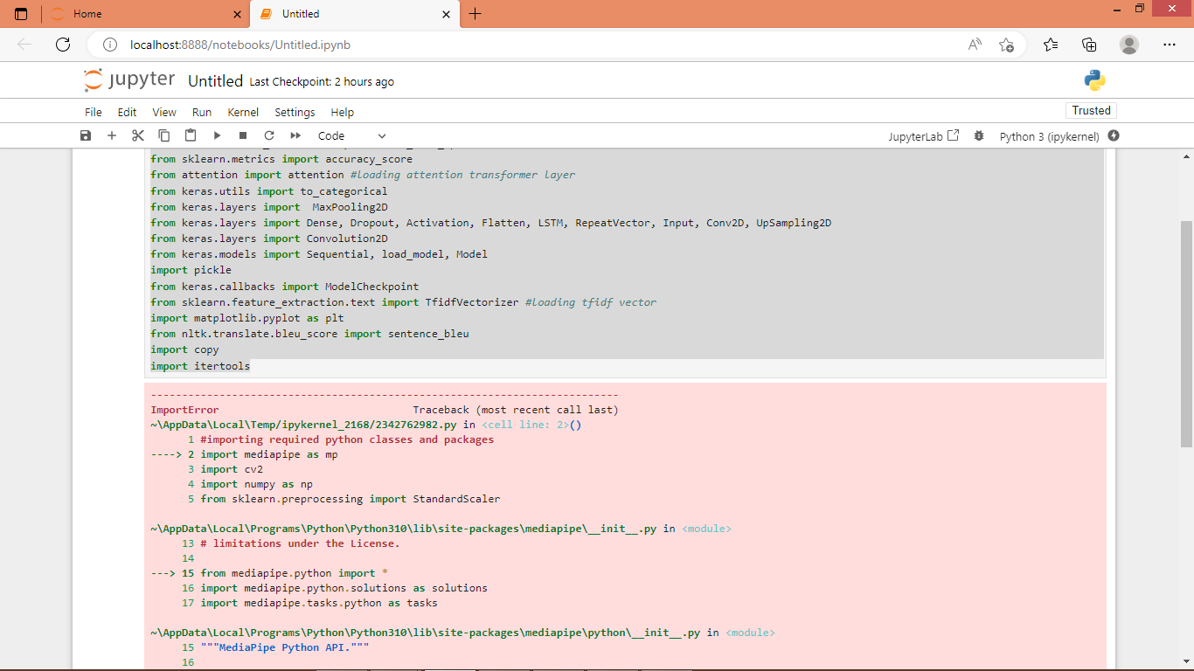
In above screen you can see JUPYTER is unable to load Media-pipe open pose model for hands and finger features extraction.
To implement this project we have designed following modules
- Upload Sign Language Dataset: using this module user can upload dataset and then application will read all images and text and then extract hand and finger key points and convert text to numeric vector
- Pre-process Dataset: all extracted features will be shuffle and normalize
- Train & Test Split: split process data into train and test where application using 80% data for training and 20% for testing
- Train Propose SignNetII Algorithm: 80% training data will be input to SignNet algorithm to train a model and this model will be applied on 20% test data to calculate BLEU score which will be higher than propose model
- Sign to Text to Sign from Video: using this module user can upload TEST video and then SignNet will extract Hand and Finger features and then input to encoder model to predict TEXT and then predicted TEXT will be input to second decoder model to translate text into SIGN image.
- Sign to Text to Sign from Webcam: same sign to text and text to sign can be predicted using LIVE webcam. Here you need to show exact hand sign as per dataset to make correct prediction.
SCREEN SHOTS
To run project double click on ‘run.bat’ file to get below page
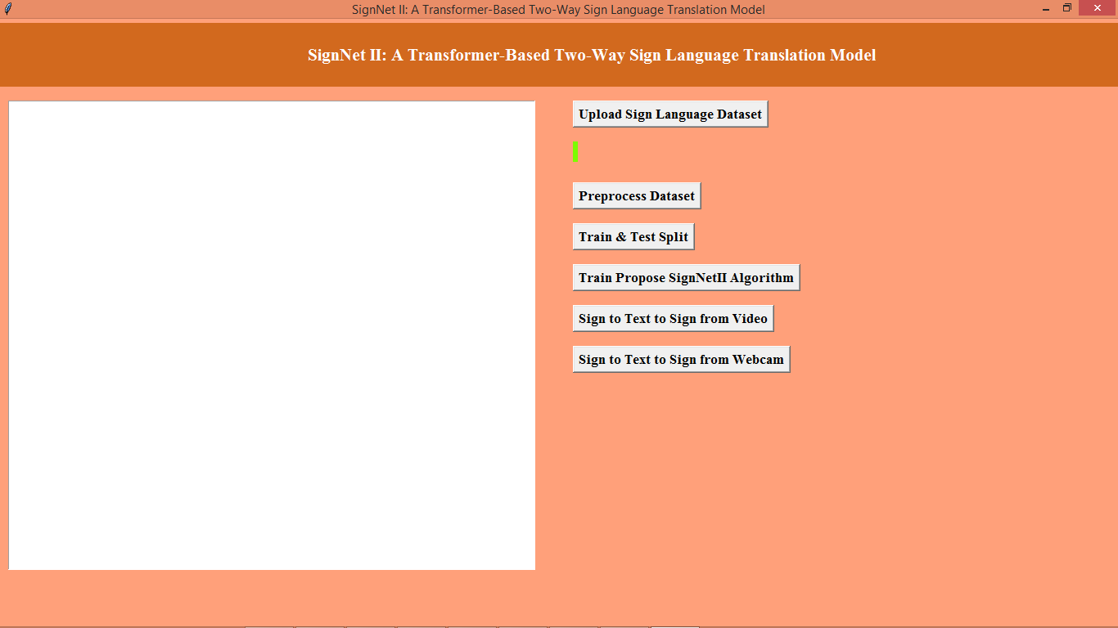
In above screen click on ‘Upload Sign Language Dataset’ button to get below page
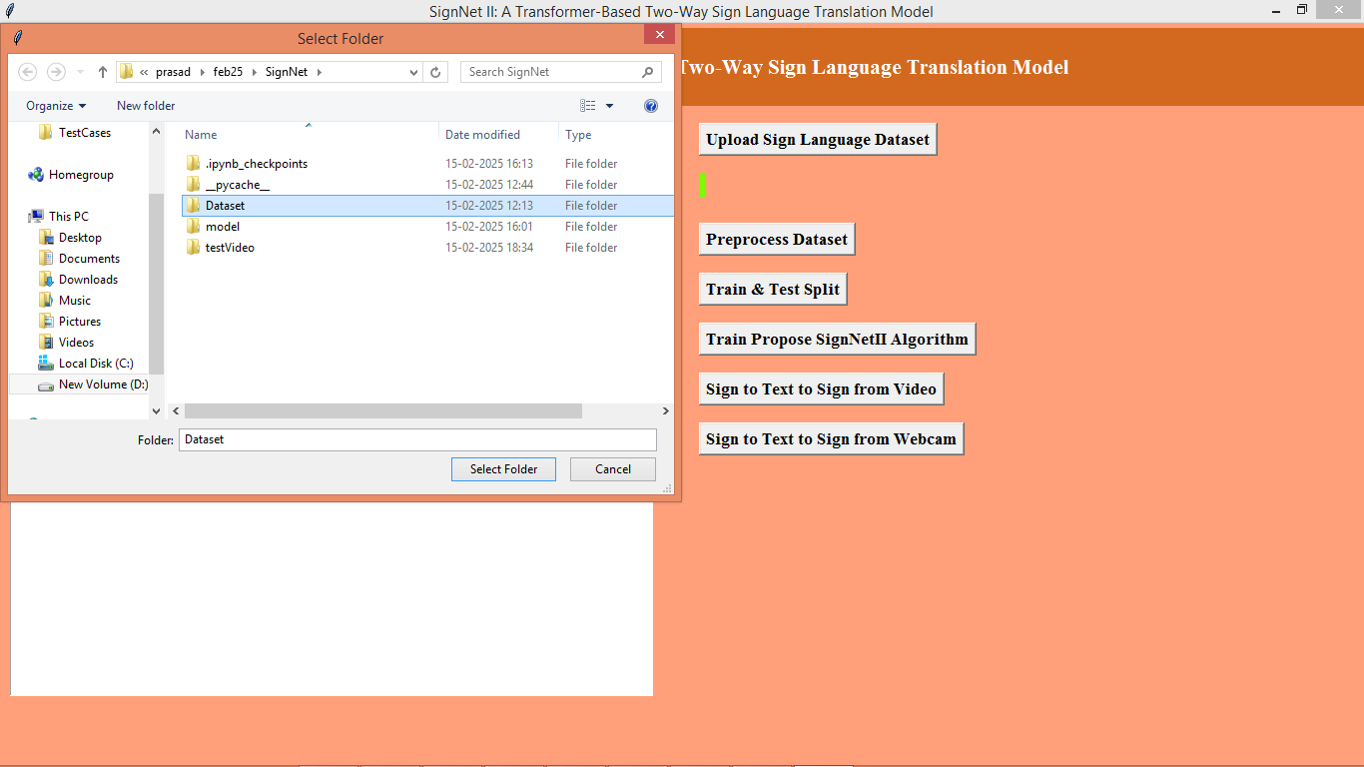
In above screen selecting and uploading entire ‘Dataset’ folder and then click on ‘Select Folder’ button to load dataset and then will get below page
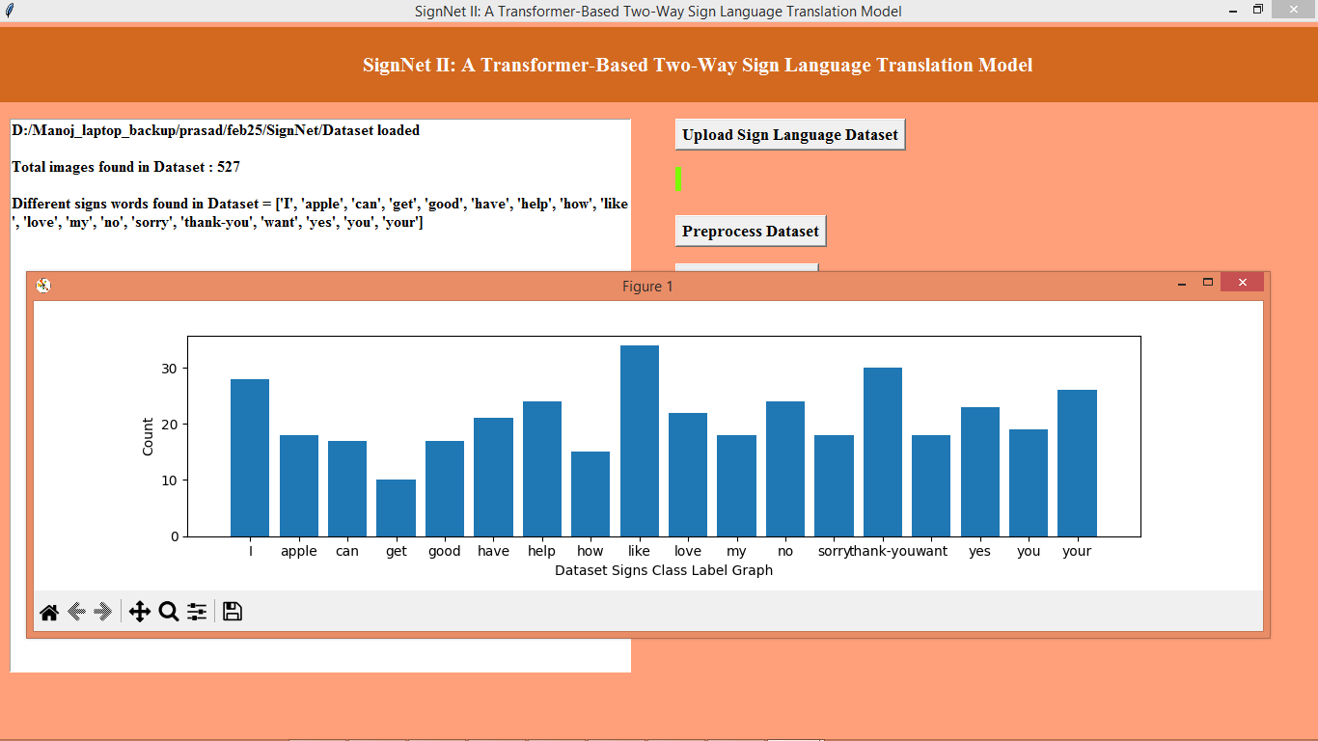
In above screen in text output can see dataset contains 527 images from 18 different class label words and in graph x-axis represents ‘WORD’ name and y-axis represents number of images available for that word. Now click on ‘Pre-process Dataset’ button to clean and normalize dataset values and then will get below page
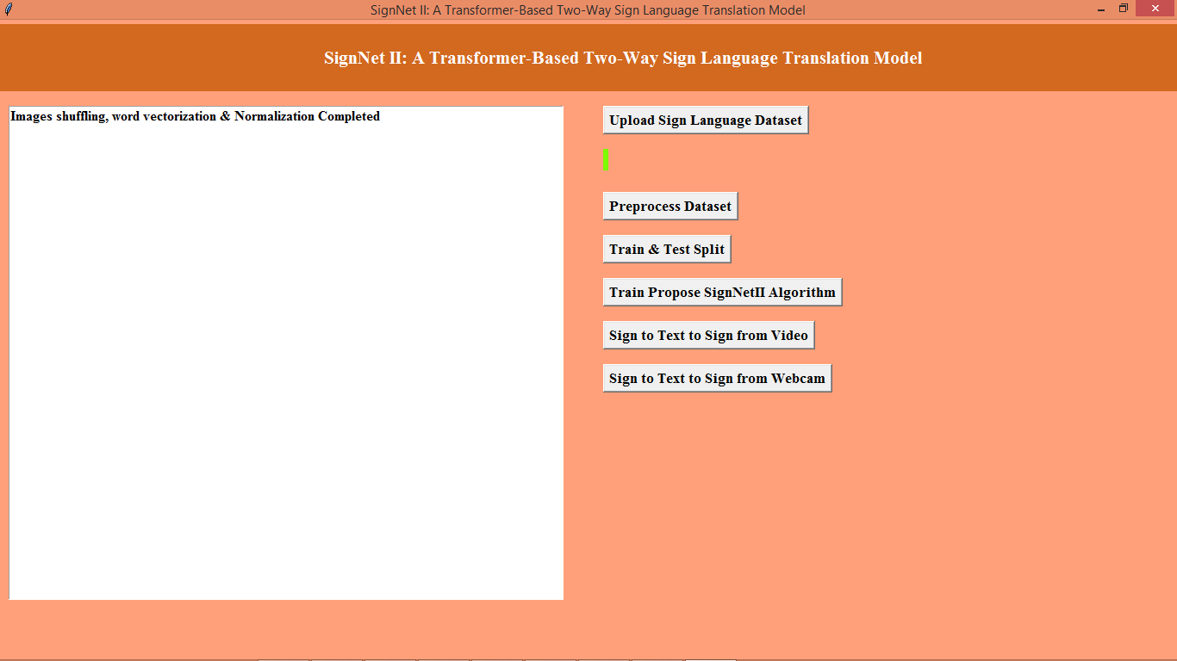
In above screen dataset normalization completed and now click on ‘Train & Test Split’ button to split dataset and then will get below page
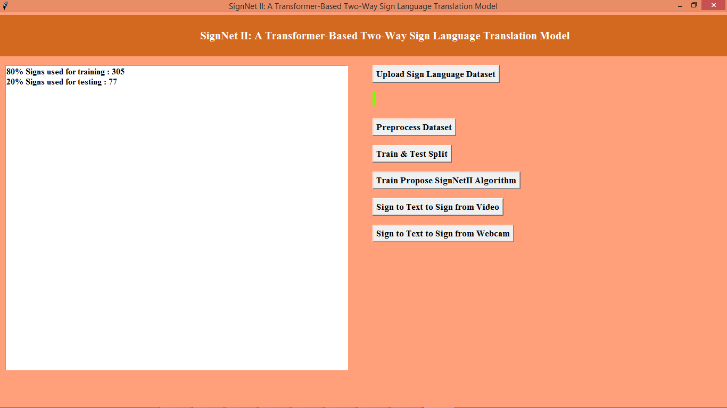
In above screen can see train and test size data and now click on ‘Train Propose SignNetII Algorithm’ button to train a model and then will get below output
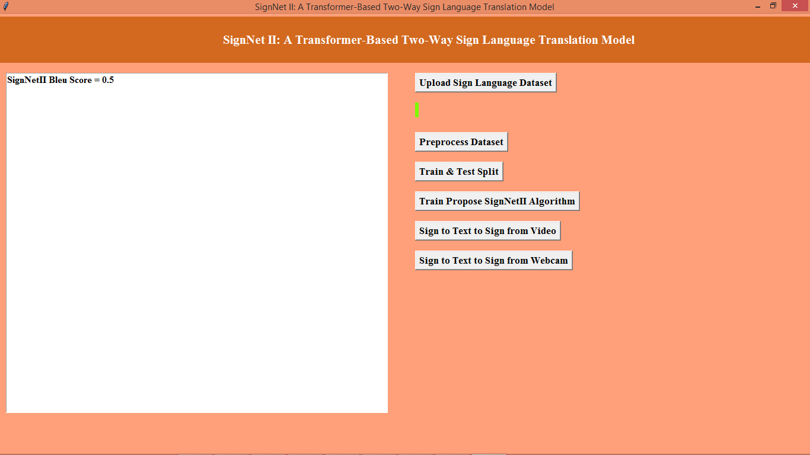
In above screen propose SignNet got 0.5% BLEU score on predicted words from given TEST data and now click on ‘Sign to Text to Sign from Video’ button to upload test video and then will get below output
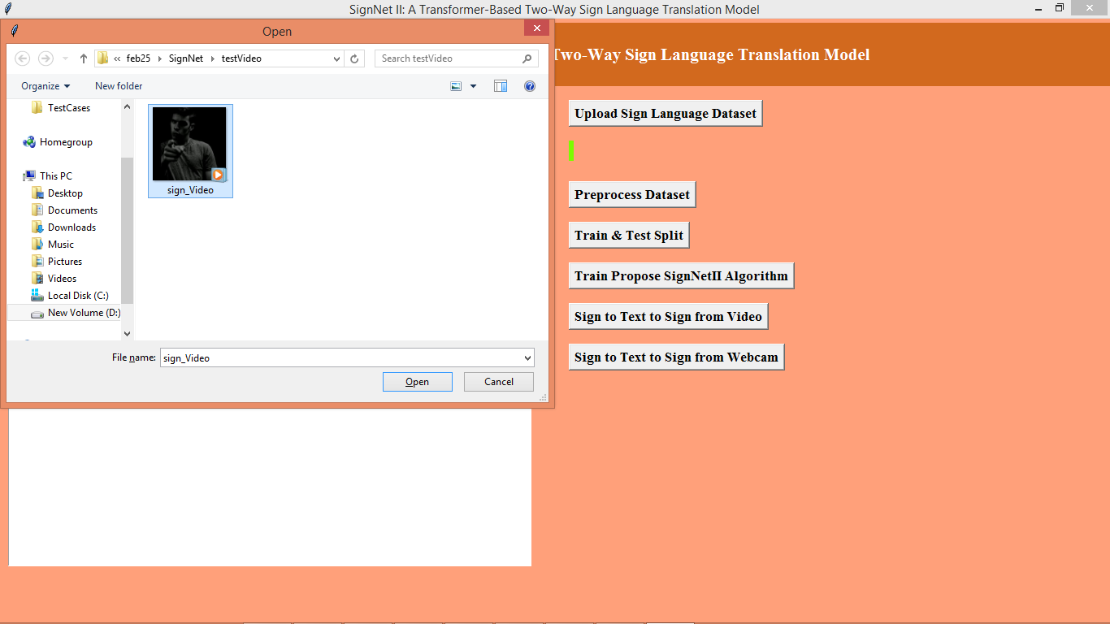
In above screen selecting and uploading test video and then press ‘open’ button to get below output
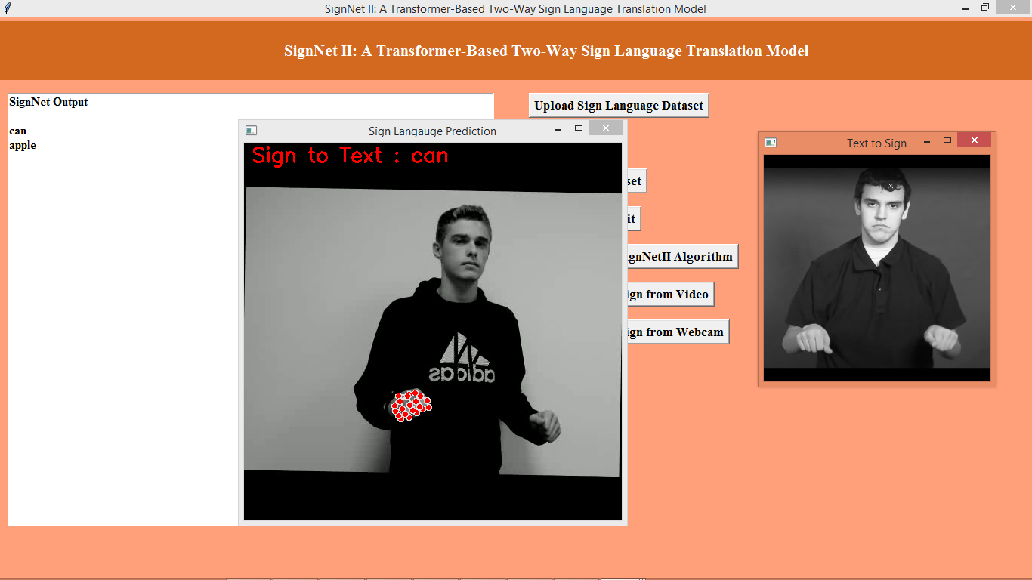
In above screen on hand we can see red dots which are nothing but open pose features extraction and then in red text can see predicted SIGN TEXT as ‘can’ and then second image is the generated or predicted image from predicted TEXT. Below is another frame output
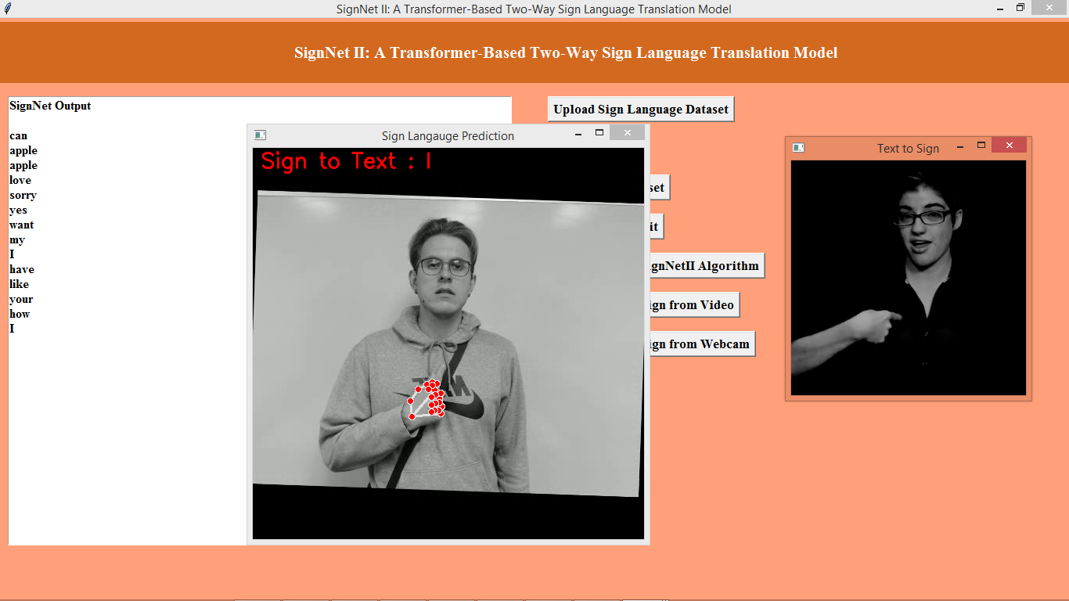
In above screen predicted word is ‘I’ and similar SIGN image also generated which can see in second image. Now click on ‘Sign to Text to Sign from Webcam’ button to start webcam and then show you hand sign to web cam to get below output

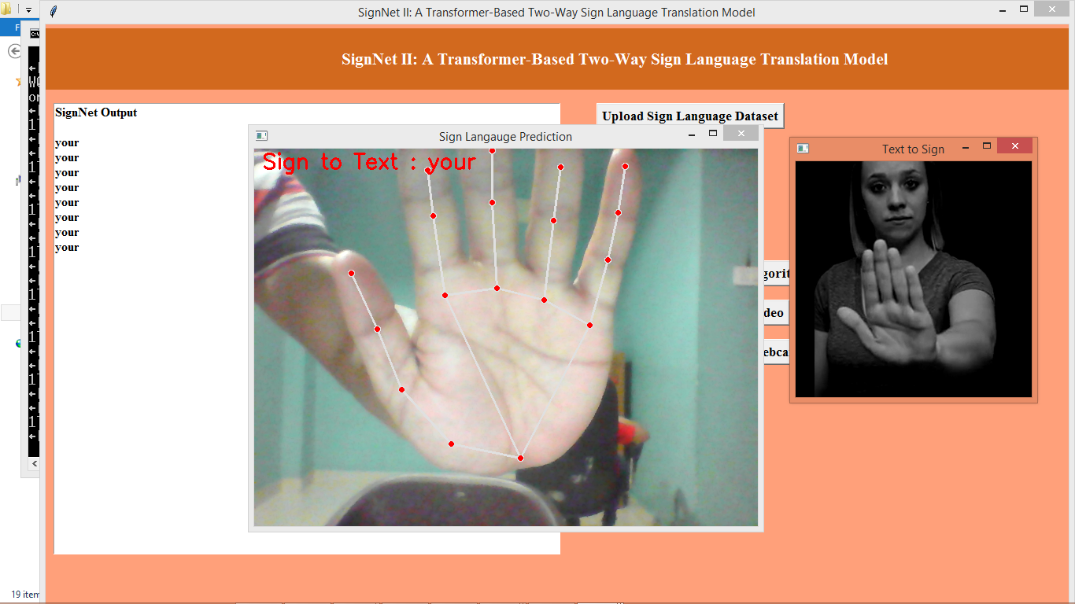
In above screen i am showing some sign from hand and this predicted as ‘your’ and same TEXT is converted to image which can see in second image.
Similarly by following above screens you can run code with both video and webcam.
Note: this project is very heavy in training and prediction as its using multiple models to extract features and for prediction. So we implemented necessary model. While prediction don’t run continuous as there is risk of your hard-disk or SSD crash.
Note: from webcam to get correct output your hand sign must be accurate as per dataset.

