Functional Design Document

CV40

NBTY Supplier Conversion

Document Version | 1.0
Creation Date | Oct-31-2012
Last Update Date
Last Print Date

Contents

Document Control 3
Change Record 3
Peer Reviewers 3
Approvers 3
1. Overview 4
Introduction 4
Objectives 5
Volume Metrics 5
Document References 5
2. Assumptions 6
3. Requirements 7
Data Conversion Requirements 7
Data Selection Criteria 7
Disposition of Non-Converted Data 7
4. Design 8
Approach 8
Process Diagram – Oracle Supplier Conversion 8
5. Conversion Mapping 10
Data Mapping 10
6. Data Validation and Reconciliation 11
Data Validation and Reconciliation Requirements 11
Data Validation Destination (Oracle SDH) 11
7. Error Handling 12
8. Test Conditions 13
9. Open / Closed Issues 15
10. Appendix 16

Document Control

Change Record
Date | Author | Version | Change Reference
Oct 30, 2012 | Rathna | 0.1 | Initial document

Peer Reviewers
Name | Position | Date
Edgard Lamarre | Technical Lead, AS400
Radhakrishna Ramalingam | Tehnical Architect, SDH

Approvers
Name | Position | Signature
Ramya Narasiman | Delivery Manager, SDH
Rob Frey | Solution Manager, SDH
George Zullo | Business Leader, SDH
Carol Sanzata | Business SME, AP

Overview

Introduction

This document will provide the functional specifications required to complete the conversion of supplier (also known as vendor) data from legacy system(Lawson and Pansophic) to Oracle E-Business Suite SDH. Project must provide a multi-step supplier conversion, mapping, and maintenance solution in order to continue to utilize supplier information for processing purchase orders and payments.

The diagram below depicts the high level process for executing supplier cleansing, conversion, and maintenance. This design focuses on the initial conversion of supplier data from the legacy systems(Lawson and Pansophic) to Oracle EBS SDH (Green below).

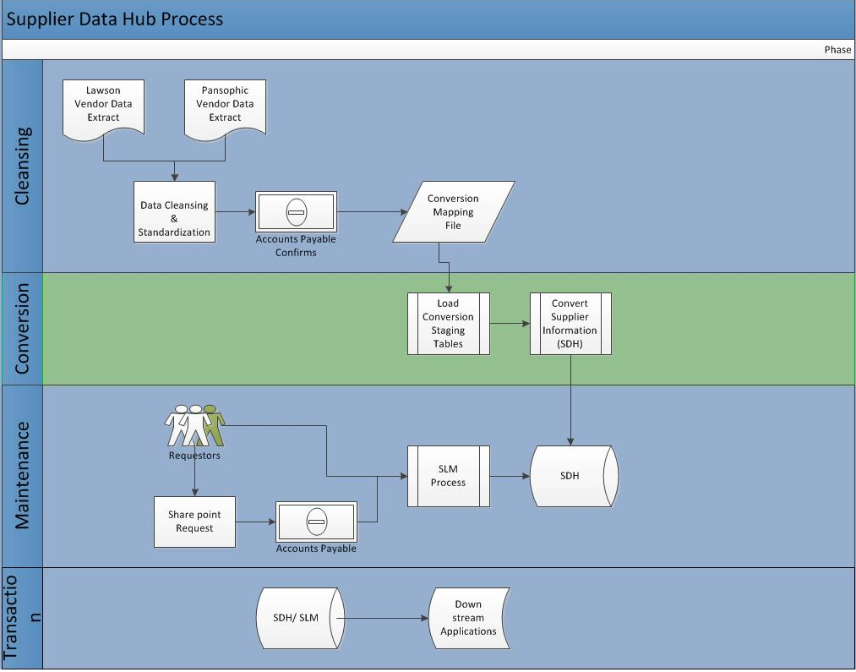

Objectives

Supplier data is currently stored in Lawson and replicated to Pansophic periodically and get enriched. This data needs to be successfully converted to the new Oracle Supplier Data Hub to be leveraged for Purchasing, AP activities and other downstream applications as part of the Supplier Data Hub Implementation. It will be utilized in transactional processing of purchase orders, invoices, etc. Legacy data will need to be flattened/normalized and cleansed during the conversion process in order to enable standard Oracle functionality as well as proper integration with external systems (interfaces and conversion) and custom internal functionalities (extensions and reports).

Volume Metrics
# | Source System | Transaction Volume
1 | Lawson, Pansophic (AS400) | 7000+

Document References
# | Document | Document link / Reference ID
1
2
3

Assumptions
The following are the assumptions for this conversion design:
# | Assumptions
1 | Business provides the active vendors extract data
2 | Most of the data will be cleansed and consolidated before it extracted out. However there will be manual formatting that will be done in excel before review.
3 | Legal Name must be considered as Supplier Name.
4 | A Flag/field in the extract that can indicate the Doing Business As records.
5 | Duplicates records will be merged/inactivated with in the legacy systems before conversion.(except DBAs).
6 | Data – There will be a time gap between the time of conversion and the activation of Oracle SDH (go-live). During this time, all vendor record updates and creation will continue to be done in legacy system. As part of data reconciliation activities, these updated / new records must be identified and entered manually into Oracle post go-live. Currently, there are approximately 90 new records created per month.
7 | Supplier Key Design Decision – Suppliers that are still in the qualification process (suppliers are in the process of being approved, but are not yet approved suppliers) will NOT be converted. Manually entered in SDH after go-live.
8 | All necessary system configuration is must be complete prior to the conversion.
9 | Extract might contain the suppliers from outside US. Ex: China Suppliers for NBTY US business.

Requirements

Data Conversion Requirements
Req-Pro ID | Requirement Description
SDH_CONV_DQ | Supplier Number must be cleansed incase of more than 6 digits  Ex: 999000158 should be converted to 158. Strip off 999000  Supplier Name, Contact Names must be Caps  Phone Numbers must be formatted:xx-xxx-xxx-xxxx  Email IDs must be formatted  Unique Address infromation must be formatted properly and must be in all capital letters.  Unique TaxIDs needs to be populated in the extract(Except DBAs)  - Removal of special characters for Supplier Names and Address fields  Data enrichment for missing data fields like zipcode/city etc.  If Supplier Name is split between name and Address Line1 then combine and create supplier name and make address line2 as Address Line1.  Ex: AMERICAN STOCK TRANSFER &  TRUST COMPANY
SDH_CONV_VAL1 | Unique Suppliers must be loaded
SDH_CONV_VAL2 | Legacy VendorID must be stored for reference
SDH_CONV_VAL3 | Incase of Doing Business As suppliers with same TaxID and multiple legacy vendor numbers, store the main/primary vendor (Pay To) as Supplier and the other vendors as Sites with “Alternate Site Name = DBA/Vendor Name)
SDH_CONV_ASS1 | Supplier Key Design Decision – As part of this conversion, Oracle will keep existing legacy “Vendor IDs” except (DBAs). Post go-live new numbering scheme 200000 will be started for new suppliers.
SDH_CONV_ASS2 | All the suppliers will be assigned to the single OU.
SDH_CONV_ASS3 | Legacy Vendor ID and Site ID must be stored in HZ cross references tables
SDH_CONV_ASS4 | In case of duplicate TaxID records exists with different address/fax/telephone# then create one Oracle Supplier record with most recent vendor# and rest of the records must be created as Sites.
SDH_CONV_RUN1 | Conversion process must be repeatable and partial loads must be manageable. If there are any bad records, should be able to fix and run the program successfully.

Data Selection Criteria
- All the Active Suppliers will be used for the conversion into Oracle EBS SDH.

Disposition of Non-Converted Data
- The un-converted vendor data will be left in the legacy system. This implies that all current historical data inquiries will still be available in the legacy system once the conversion is completed.

Design

Approach

For this conversion, a custom import program will be run to load the data into the staging tables, while a custom interface program must validate the business rules stated in this section and load unique NBTY supplier information.
The main interface tables used for importing Suppliers, and Supplier Sites and Contact Information are as follows –
- AP_SUPPLIERS_INT
- AP_SUPPLIER_SITES_INT
- AP_SUP_SITE_CONTACT_INT

Note: For additional details regarding Oracle’s standard supplier interface tables, please see the Appendix.

Process Diagram – Oracle Supplier Conversion

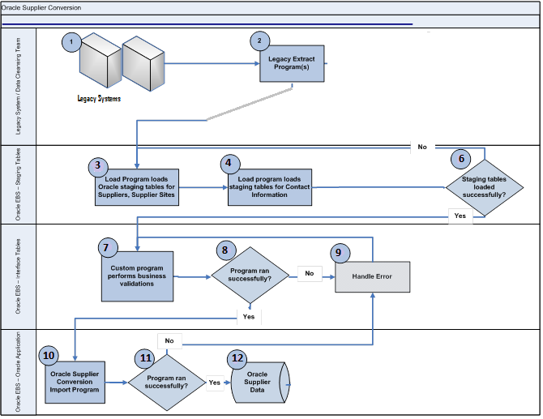

Process Description
Legacy System / Data Cleansing
Step | Explanation
1 | Lawson and Pansophic are current vendor master applications
2 | Business runs the legacy extract programs to provide the active supplier data to be loaded.  Apply manual cleansing rules and enrich the data if any.
3 | Following are the extract files that will be manually generated using client scripts and manual steps:  - Extract1: Vendor Bank Master  - Extract2: Vendor Master + Merge Business Class+ Merge Delivery Email Ids  - Extract3: Vendor Locations Master  - Extract4: Lawson Supplier Comments File

Oracle SDH
Step | Explanation
3,4,5,6 | If the staging tables are loaded successfully, the next steps to perform cleansing and validations to the interface tables begin.  If the staging tables are not loaded successfully, errors are resolved and the load program is restarted appropriately.
7,8 | Oracle custom concurrent program will execute to perform validations on the staging table data and insert into the Oracle Interface Tables (Supplier Open Interface Import Program).
10 | If the import program is run successfully, the supplier data is loaded to the appropriate supplier tables and fields in Oracle EBS.  If an error appears, the Oracle team resolves the issue and restarts the program.
10 | Oracle standard import program is launched to load the Supplier Bank, Supplier, Supplier Site, and Contact Information data into the Oracle base tables.
11,12 | If the standard import program is run successfully the Oracle base tables are loaded.  If not, the error is handled per the error handling strategy and program must be re-started appropriately.
A | Provide the reconciliation report to verify for the success of import.
B | Concurrent programs can be re-submitted in case of any issues. At the beginning of the program cleans the staging tables and starts the conversion again.
C | All concurrent programs will capture the detail logs and error messages if any. Only the errored records must be removed from the conversion program.

Conversion Mapping

Data Mapping
Lawson Field name | Pansophic Field name | Oracle Field Name | Transformations
Legal Name | Lawson | Supplier Name | None
Supplier Name | Lawson | DBA Name Attribute | If it is different from Legal Name
Legal Name (contact tab) | Lawson | Tax Registration: Company Reporting Name
Vendor (main tab) | Lawson | Supplier Number | Sequence Starts from 200000 after conversion
Vendor class (fg/rm, etc)- main tab | Lawson | Supplier Type
Tax-id (main tab) | Lawson | Tax Details: TaxPayer ID
Income code (default tab) | N/A | Tax Details: Income Tax Type | Income Tax Type(MISC1)= 'MISC'+income code and Reportable='Federal'
Options: Income With Holding | N/A | Tax Details: Allow with Holding Tax
Telephone (contact tab) | Lawson | Contact Points. Phone Number | IF Contact Name is blank then  Contact Points. Phone Number and Type='Telephone' and Purpose = 'Business'  Else Contact Directory.Phone Number
Contact name(contact tab) | Purchasing Contact | Contact Directory. First Name and Last Name | Department = 'Purchasing'  IF Purchasing Contact is blank use Vendor Contact.
E-Mail (contact tab) | N/A | Contact Directory. Email Address | IF Contact Name is blank then Contact Points.Email  ELSE  Contact Directory. Email Address and Department = 'Purchasing'
URL | N/A | Contact Points.URL
Fax (Contact tab) | Lawson | Contact Directory. Fax Area Code and Fax Number | IF Contact Name is blank then Contact Points.Fax  ELSE  Contact Directory. Email Address and Department = 'Purchasing'
N/A | Vendor receives POs via f = fax or e = e-mail  (Communication Flag) | Contact Points.Purpose | IF Contact Name is blank then  if ‘0’ then set the fax phone# purpose to ‘PO’ else email Purpose to ‘PO’  ELSE  Notification Method for Primary site =Email/Fax(0)
locations tab/File : Location Code/ Location Name | N/A | Address Book. Address Name | Rule1: if locationcode=blank then Address Name: 'Primary' , Site Use and Address:Purpose = ‘Pay’ and ‘Purchasing’  ELSE address Name = location code and Site Use/ Address:Purpose = ‘Pay’ Only .  Rule2: IF (Vendor Name <> Legal Name)  Then Address Name = SUBSTR( Vendor Name, 1,15) and Populate the full Vendor Name in “DBA Name” attribute.  Rule3: IF((Legal Name <> Location Name) and Location name is not null) then Address Name = SUBSTR( Location Name, 1,11)+Location Code and Populate the full Location Name in “DBA Name” attribute.  Rule4: IF((Legal Name = Location Name)) then Address Name = Location Code.  Rule5: Vendor Number on Location file for each location record must be populated in HZ_PARTY_SITES.ORIG_SYSTEM_REFERENCE  Rule6: Assoiate Contacts to site with Location Code = blank.  Rule7: If it is a duplicate vendor add vendor no in the above logic for address name.
Address 1 (main tab) | Lawson | Address Book. Address Line1
Address 2 (main tab) | Lawson | Address Book. Address Line2
Address 3 (main tab) | Lawson | Address Book. Address Line3
Address 4 (main tab) | Lawson | Address Book. Address Line4
City or Address 5 (main tab) | Lawson | Address Book. City
state or province | Lawson | Address Book: State
country (F2main tab) | Lawson | Address Book: Country
postal code (main tab) | Lawson | Address Book: Postal Code
Remit To Code | N/A | Site Uses: Primay Pay Site Flag | Given Remit to site’s primary pay site flag should be yes
Business Value (attributes tab) | N/A | Business Classification | Need transformation
bank name(vendor bank button) | N/A | Banking Details: Bank Name
Address1(vendor bank button) | N/A | Banking Details: Address Line1
Address2(vendor bank button) | N/A | Banking Details: Address Line2
Address3(vendor bank button) | N/A | Banking Details: Address Line3
City or Address5(vendor bank button) | N/A | Banking Details: City
State or Province(vendor bank button) | N/A | Banking Details: State
Country(vendor bank button) | N/A | Banking Details: Country
Postal Code(vendor bank button) | N/A | Banking Details:Zip Code
branch name (vendor bank button) | N/A | Banking Details: Branch Name | If Branch Name is blank then use State.  If State is blank then use Routing#/ Bank Entity
vendor bank identification (vendor bank button)  Bank Entity ID | N/A | Banking Details: Branch Number | Banking Details: Branch Type = 'ABA' and Branch Number
Vendor Bank Account (vendor bank tab) | N/A | Banking Details: Account Number
Vendor Bank account type (vendor bank button) | N/A | Banking Details: Account Type
N/A | Carrier Name | Purchasing: Ship Via | ‘CALL NBTY TRAFFIC DEPT’ and Transportation arranged= Buying Org when frieght term=ORIGIN else BLANK
N/A | Freight Terms Description | Purchasing: Frieght Terms | ORIGIN or DELIVERED else reject the record.
Invoice (default tab drop down) | N/A | Invoice: Invoice Currency
Payment Terms (default tab drop down) | Lawson | Invoice: Payment Terms
Max Invoice Amount (options tab) | N/A | Invoice: Invoice Amount Limit
Hold Code (options tab) | N/A | Invoice: Payment Hold Reason | Invoice: Payment Hold Reason and Hold All invoices ='Yes'
Handling (default tab drop down) | N/A | On Hold Reason
Match Code / Handling Code | N/A | Receiving: Match Approval Level | If Match Code <> ‘E’ then ‘3-Way’ match else blank
Separate Payment Y/N (options tab) | N/A | Payment Specifications: Pay Each Document Alone
Payment Code / Bank Isntruction Code (default tab) | N/A | Payment: Payment Method Default
  Legacy Pay Method | Oracle Payment Method Code | Oracle Payment Method Name
  CHK | CHECK | Check
  EF1 | EFT | Electronic
  EFT | WIRE | Wire
Payment Priority | N/A | Payment: Payment Priority
Pay Vendor : Main Tab | N/A | Payment Relationship:Remit To Supplier Name, Remit To Supplier Site, From Date | If Pay Vendor <> Legacy Vendor# and Legacy Vendor# is a separate Oracle Supplier then only populate corresponding Supplier and site name.
Delivery Email | N/A | Payment Details: Seperate Remittance Adivce Delivery :Email
Lawson Comments File | N/A | Notes
Category Taxonomy File | N/A | Products and Service Offerings

Data Validation and Reconciliation

Data Validation and Reconciliation Requirements
  - Validate that the correct number of supplier records are converted as per the detailed requirements.
  - Reconcile the Oracle records against legacy records to ensure data mapping accuracy. This will be performed by business users after each mock conversion and go-live conversion.
  - Identify in Lawson all new supplier records and updates made from the time of conversion to go-live (currently, approximately 10 new records are created per day)
  - Necessary SDH data extract will be provided for reconciliation purpose.

Data Validation Destination (Oracle SDH)
- The application development conversion team will check the concurrent log file from the Load program to confirm that the correct number of records was loaded into the staging table.
- The application development conversion team will check the concurrent log file from the Import program to confirm the correct number of records was loaded into the interface table.
- The application development conversion team will query to get a count of the number of master records created to confirm that the correct number of records is in the base table.
- The application development conversion team will provide a complete extract to the business users so that the data can be checked against the source system for completeness and correctness in the Oracle SDH.
- The Criteria for validations are:
Total Supplier records extracted = Supplier Records in SDH+ No of sites with alternate Supplier Name.
Total Supplier Locations records extracted = Supplier Site Records in SDH

Error Handling
# | Potential Errors | Possible Reasons | Solution Strategy
1 | Record fails validation during import (see table below) | Data integrity issue; Missing data | Error message will be captured in the staging table and printed to the concurrent log file. Input data will need to be corrected at the source.
2 | Unexpected Exception during import | Code defect; data integrity issue | Exception handling will capture the standard Oracle error message and store it in the staging table and print it to the concurrent log file. Application development team will need to fix the issue if it is a code problem or the source data will need to be correct at the source if it is a data problem.
3 | Error during import | Missing required data | Error message will be captured in the staging table and printed in the concurrent log file. Input data will need to be corrected at the source. Interface Tables errors will be captured in the concurrent log or in the table itself.

Test Conditions

Conversion Program Test Conditions

# | Test Condition | Expected Result
1 | Supplier Load program is run and completed without errors. | All supplier records are loaded to the staging tables.
2 | Supplier Import program is run and completed without errors | All supplier records are loaded to the Oracle base tables with the test conditions below satisfied.
3 | Verify that the appropriate rejected records | Rejected records must have valid error message in logs.
4 | Verify the On Hold Suppliers records | All On hold supplier records must be set the flags successfully.

Supplier Data Validations

# | Test Condition | Expected Result
1 | Verify the number of records. | The number of supplier headers should match the input sheet (except DBAs)
2 | Verify the number of addresses created | The number should match the input sheet.
3 | Verify the number of sites | The number should match the input sheet(+ DBAs)
4 | Verify that a supplier exists in Oracle | The supplier appears when searching for the supplier in Oracle forms.
5 | Verify that a supplier address values, including Address Line 1, City, State, and Zip exist in Oracle. | The supplier address values appear when searching for the supplier in Oracle SDH.
6 | Verify that the supplier site code exists in Oracle. | The supplier site code appears when searching for the supplier in Oracle SDH.
7 | Verify supplier name format | The Supplier name should be in all capital letters, with no punctuation (example: GENERAL ELECTRIC)
8 | Verify Address Line 1 format | The supplier Address Line 1 should be in all capital letters, with no punctuation (example: PO BOX 1044)
9 | Verify no duplicate Payee Type for a Supplier site. | The Supplier site should not contain duplicate payee types. For example, Site 1 should not have 2 payee codes for purchase, or 2 payee codes for ACH.
10 | Verify that a Payment method for a supplier record is NOT defaulted. | No payment method for the supplier is checked as the default payment method.
11 | Verify that all Payment methods for a supplier record are NOT end dated. | All payment methods for the supplier do not have end dates.
12 | Create a PO for a converted supplier (manual entry in Oracle). | The correct supplier information, including the payee code, address, and contact information should be available for the PO.
13 | Invoice a PO for a converted supplier (manual entry in Oracle). | The correct supplier information, including the payee code, address, and contact information should be available for the invoice.
14 | Pay an invoice for a converted supplier (manual entry in Oracle). | The correct supplier information, including the payee code, address, and contact information should be available for the payment.
15 | Add a site to a converted supplier (manual entry in Oracle). | The correct site should be added to the supplier, with a new payee code generated for the correct purchase or payment types.
16 | Add a contact to a converted supplier (manual entry in Oracle). | The correct contact information should be available for the appropriate supplier site address.
17 | Update a converted supplier (manual entry in Oracle). | The updates to the supplier information, including supplier address, contact information, should be reflected appropriately.
18 | Verify an error is returned when a supplier name format is incorrect (contains lower case letters and / or punctuation) | The following error message appears:  ERROR - Supplier Name <name> is not in all capital letters.  Or  ERROR – Supplier Name <name> contains punctuation (, . ‘ “ {}*, etc)
19 | Verify an error is returned when a supplier address format is incorrect (contains lower case letters and / or punctuation) | ERROR - Supplier Address Line 1 < supplier address line 1> is not in all capital letters. And / or  ERROR - Supplier Address Line 1 < supplier address line 1> contains punctuation (, . ‘ “ {}*, etc)

Open / Closed Issues

ID | Issue | Raised By / Date Needed | Assigned / Responsibility | Resolution | Resolved By / Date Completed | Status

Appendix

