CHAPTER-1
INTRODUCTION & LITERATURE SURVEY

  - Introduction:
With the increase in population and industrialization, the energy demand has increased significantly. However, the conventional energy sources such as coal, oil, and gas are limited in nature. Now, there is a need for renewable energy sources for the future energy demand. The other main advantages of this renewable source are eco-friendliness and unlimited in nature. Due to technical advancements, the cost of the wind power produced is comparable to that of conventional power plants. Therefore, the wind energy is the most preferred out of all renewable energy sources.
In the initial days, wind turbines have been used as fixed speed wind turbines with squirrel cage induction generator and capacitor banks. Most of the wind turbines are fixed speed because of their simplicity and low cost. By observing wind turbine characteristics, one can clearly identify that for extracting maximum power, the machine should run at varying rotor speeds at different wind speeds. Using modern power electronic converters, the machine is able to run at adjustable speeds. Therefore, these variable speed wind turbines are able to improve the wind energy production. Out of all variable speed wind turbines, doubly fed induction generators (DFIGs) are preferred because of their low cost.
The other advantages of this DFIG are the higher energy output, lower converter rating, and better utilization of generators. These DFIGs also provide good damping performance for the weak grid. Independent control of active and reactive power is achieved by the decoupled vector control algorithm presented. This vector control of such system is usually realized in synchronously rotating reference frame oriented in either voltage axis or flux axis. In this work, the control of rotor-side converter (RSC) is implemented in voltage-oriented reference frame.
Grid code requirements for the grid connection and operation of wind farms are discussed in. Response of DFIG-based wind energy conversion system (WECS) to grid disturbance is compared to the fixed speed WECS. As the wind penetration in the grid becomes significant, the use of variable speed WECS for supplementary jobs such as power smoothening and harmonic mitigation are compulsory in addition to its power generation. This power smoothening is achieved by including super magnetic energy storage systems as proposed. The other auxiliary services such as reactive power requirement and transient stability limit are achieved by including static compensator (STATCOM). A distribution STATCOM (DSTATCOM) coupled with fly-wheel energy storage system is used at the wind farm for mitigating harmonics and frequency disturbances. However, the authors have used two more extra converters for this purpose. A super capacitor energy storage system at the dc link of unified power quality conditioner (UPQC) is proposed in for improving power quality and reliability. the authors have used separate converters for compensating the harmonics and also for controlling the reactive power.
However, in later stages, some of the researchers have modified the control algorithms of already existed DFIG converters for mitigating the power quality problems and reactive power compensation. The harmonics compensation and reactive power control are achieved with the help of existing RSC. Therefore, harmonics are injected from the RSC into the rotor windings. This creates losses and noise in the machine. These different harmonics in rotating part may also create mechanical unbalance. Moreover, both reactive power compensation and harmonic compensation are achieved in all these methods using RSC control. These methods increase the RSC rating. harmonic compensation and reactive power control are done using GSC. Therefore, the harmonics are not passing through machine windings in all these cases. Todeschini and Emanuel have compared three different control algorithms and finally concluded that combined modulation of both RSC and GSC are needed for compensating the harmonics and controlling the reactive power. However, the authors have used direct current control of GSC. Therefore, harmonic compensation is not so effective and total harmonic distortion (THD) is not less than 5% as per IEEE-519 standard. The authors have also not verified simulation results experimentally. An indirect current control technique is simple and shows better performance for eliminating harmonics as compared to direct current control.

  - Literature Survey:
R. Pena, J. C. Clare, and G. M. Asher, “Doubly fed induction generator using back-to-back PWM converters and its application to variable-speed wind-energy generation,”
Design of a doubly fed induction generator (DFIG), using back-to-back PWM voltage-source converters in the rotor circuit. A vector-control scheme for the supply-side PWM converter results in independent control of active and reactive power drawn from the supply, while ensuring sinusoidal supply currents. Vector control of the rotor-connected converter provides for wide speed-range operation; the vector scheme is embedded in control loops which enable optimal speed tracking for maximum energy capture from the wind.
A. Gaillard, P. Poure, and S. Saadate, “Active filtering capability of WECS with DFIG for grid power quality improvement,”

A doubly fed induction generator (DFIG) with active filtering capability is presented. We proposed to make use of the DFIG and the associated rotor side converter (RSC) to control stator active and reactive power and simultaneously compensate the most significant and troublesome harmonic currents of the utility grid. We presented a new high selectivity harmonic isolator based on self tuning filter (STF). Simulation results when filtering the harmonic component of the grid current validate the performances of the harmonic isolator principle and the active filtering capability of the DFIG.

B. Singh and J. Solanki, “A comparison of control algorithms for DSTATCOM

A Distribution Static Compensator (DSTATCOM) is proposed for compensation of reactive power and unbalance caused by various loads in distribution system. An evaluation of three different methods is made to derive reference currents for a DSTATCOM. These methods are an instantaneous reactive power theory, a synchronous reference frame theory, and a new Adaline-based algorithm. The Adaline-based algorithm is an adaptive method for extracting reference current signals. These schemes are simulated under MATLAB environment using SIMULINK and PSB toolboxes. Simulation and experimental results demonstrate the performance of these schemes for the control of DSTATCOM.

B. N. Singh, A. Chandra, and K. Al-Haddad, “Performance comparison of two current control techniques applied to an active filter,”

This project compares two types of current control techniques with a view to the problem of switching ripples in the supply current caused by switching of an active power filter (APF). A closed loop control scheme of a three-phase APF is implemented using a TMS320C31 DSP for direct and indirect current control techniques. A current controlled voltage source inverter (CC-VSI) is used as an APF. A three-phase diode bridge rectifier with R-L load is taken as a nonlinear load. Experimental results for both the techniques of current control are compared and the capability of the indirect current control technique towards the elimination of switching ripples is established.

R. Datta and V. T. Ranganathan, “Variable-speed wind power generation using doubly fed wound rotor induction machine—A comparison with alternative schemes,”
In this project, a wind energy conversion system (WECS) using a grid-connected wound rotor induction machine controlled from the rotor side is compared with both fixed speed and variable speed systems using a cage rotor induction machine. The comparison is done on, the basis of: (1) major hardware components required; (2) operating region; and (3) energy output due to a defined wind function using the characteristics of a practical wind turbine. Although a fixed speed system is more simple and reliable, it severely limits the energy output of a wind turbine. In case of variable speed systems, comparison shows that using a wound rotor induction machine of similar rating can significantly enhance energy capture. This comes about due to the ability to operate with rated torque even at super synchronous speeds; power is then generated out of the rotor as well as the stator. Moreover, with rotor side control, the voltage rating of the power devices and DC bus capacitor bank is reduced. The size of the line side inductor also decreased. Results are presented to show the substantial advantages of the doubly fed system.

A. Gaillard, P. Poure, and S. Saadate, “Active filtering capability of WECS with DFIG for grid power quality improvement,”

A doubly fed induction generator (DFIG) with active filtering capability is presented. We proposed to make use of the DFIG and the associated rotor side converter (RSC) to control stator active and reactive power and simultaneously compensate the most significant and troublesome harmonic currents of the utility grid. We presented a new high selectivity harmonic isolator based on self tuning filter (STF). Simulation results when filtering the harmonic component of the grid current validate the performances of the harmonic isolator principle and the active filtering capability of the DFIG.
1.3 Objective of the work:

In this work, a new control algorithm for GSC is proposed for compensating harmonics produced by nonlinear loads using an indirect current control. RSC is used for controlling the reactive power of DFIG. The other main advantage of proposed DFIG is that it works as an active filter even when the wind turbine is in shutdown condition. Therefore, it compensates load reactive power and harmonics at wind turbine stalling case. Both simulation and experimental performances of the proposed integrated active filter-based DFIG are presented in this work. The dynamic performance of the proposed DFIG is also demonstrated for varying wind speeds and changes in unbalanced nonlinear loads at point of common coupling (PCC).

CHAPTER-2
WIND ENERGY

2.1. INTRODUCTION:
The conventional energy sources are limited and pollute the environment. So more attention and interest have been paid to the utilization of renewable energy source such as Wind Energy, Fuel Cell, Solar Energy etc., Wind Energy is the fastest growing and most promising renewable energy source among them as it is economically viable.
2.2. WIND ENERGY IN INDIA:
In 2008, India was the country that brought online the third largest amount of wind energy, after the US and China, and it now ranks fifth in total installed capacity with 9,645 MW of wind power installed at the end of 2008. A strong domestic manufacturing base has underpinned the growth of the Indian wind energy market.
The Indian wind turbine manufacturer Suzlon is now a recognized player on the global market and many international companies are established in India. India has a great untapped potential for wind energy a strong domestic manufacturing base has underpinned the growth of the Indian wind energy market.
India has a great untapped potential for wind energy. According to official estimates, the Country's total wind energy resource amounts to 48 GW of installed capacity, but some experts think that this figure is on the conservative side, and that technological improvements could significantly increase this potential. The positive development of wind energy in India has mainly been driven by progressive state level legislation, including policy measures such as renewable portfolio standards and feed-inariffs. At the moment, there is no coherent national renewable energy policy to drive the development of wind energy. This is urgently needed to realize the country's full potential and reap the benefits for both the environment and the economy. The Government of India is currently considering the introduction of a national renewable energy policy, so this report comes as a timely reminder of how important a role wind energy could play in securing India’s energy security, curbing its CO2 emissions, providing new employment and boosting economic development.
This also realizes how important a role wind energy could play in securing India's energy security, curbing its CO2 emissions, providing new employment and boosting economic development. As can be seen by the Indian Wind Energy Outlook, the wind industry, both domestic and international, stands ready to do its part in achieving an energy revolution in India.
2.3 WIND POTENTIAL:
The total potential for wind power in India was first estimated by the Centre for Wind Energy Technology (C-WET) at around 45 GW, and was recently increased to 48.5 GW. This figure was also adopted by the government as the official estimate.
The C-WET study was based on a comprehensive wind mapping exercise initiated by MNRE, which established a country-wide network of 105O wind monitoring and wind mapping stations in 25 Indian States. This effort made it possible to assess the national wind potential and identify suitable areas for harnessing wind power for commercial use, and 216 suitable sites have been identified.
However, the wind measurements were carried out at lower hub heights and did not take into account technological innovation and improvements and repowering of old turbines to replace them with bigger ones At heights of 55-65 meters, to replace them with Bigger ones. At heights of 55-65 meters, the Indian Wind Turbine Manufacturers Isolation (IWTMA) estimates that the potential for wind development in India is around 65-70 GW. The World Institute for Sustainable Energy, India (WISE) considers that with larger turbines, greater land availability and expanded resource exploration, the potential could be as big as 100 GW. Wind power in India has been concentrated in a few regions, especially the Southern state of Tamil Nadu, which maintains its position as the state with the most wind power, with 4.1 GW installed at the end of 2008, representing 44% of India‟s total wind capacity.
2.4 WIND FARMS IN INDIA:
1. Muppandal–Perungudi (Tamil Nadu) :
With an aggregate wind power capacity of 450 MW, the Muppandal –Perungudi region near Kanyakumari in Tamil Nadu has the distinction of having one of the largest clusters of wind turbines. About Rs 2500 crores has been invested in wind power in this region.

2. KavdyaDonger, Supa (Maharashtra) :
A wind farm project has been developed at KavdyaDonger at Supa, off the Pune–Ahmednagar highway, about 100 km from Pune. This wind farm has 57 machines of 1-MW capacity each. Annual utilization capacity of up to 22% has been reported from this site. The farm is connected through V-SAT to project developers as well as promoters for online performance monitoring.
3. Satara district (Maharashtra) :
Encouraging policy for private investment in wind power projects has resulted in significant wind power development in Maharashtra, particularly in the Satara district. Wind power capacity of about 340 MW has been established at Vankusawade, Thosegarh, and Chalkewadi in Satara district, with an investment of about Rs.1500 crores.
2.5 POWER IN WIND:
Wind energy is not a constant source of energy. It varies continuously and gives energy in sudden bursts. About 50% of the entire energy is given out in just 15% of the operating time. Wind strengths vary and thus cannot guarantee continuous power. It is best used in the context of a system that has significant reserve capacity such as hydro, or reserve load, such as a desalination plant, to mitigate the economic effects of resource variability.
The total capacity of wind power on this earth that can be harnessed is about 72 TW. There are now many thousands of wind turbines operating in various parts of the world, with utility companies having a total capacity of 59,322 MW. The power generation by wind energy was about 94.1GW in 2007 which makes up nearly 1% of the total power generated in the world. Globally, the long-term technical potential of wind energy is believed to be 5 times current global energy consumption or 40 times current electricity demand. This would require covering 12.7% of all land area with wind turbines. This land would have to be covered with 6 large wind turbines per square kilometer
The power extracted from the wind can be calculated by the given formula:
Pw = 0.5ρπ $R^{2}V^{3}$Cp(λ,β)1.1
Pw = extracted power from the wind,
ρ = air density, (approximately 1.225 kg/m3 at 20₀ C at sea level)
R= blade radius (in m), (it varies between 40-60 m)
Vw = wind velocity (m/s) (velocity can be controlled between 3 to 30 m/s)
Cp = the power coefficient which is a function of both tip speed ratio (λ), and blade pitch angle, (β) (Degrees)
Power coefficient (Cp) is defined as the ratio of the output power produced to the power available in the wind.

BETZ LIMIT:
No wind turbine could convert more than 59.3% of the kinetic energy of the wind into Mechanical energy turning a rotor. This is known as the Betz Limit, and is the theoretical Maximum coefficient of power for any wind turbine. The maximum value of Cp according to Betz limit is 59.3%. For good turbines it is in the range of 35-45%.

2.6. TYPES OF WIND ENERGY CONVERTION:
A wind turbine is a rotating machine which converts the kinetic energy in wind into mechanical energy. If the mechanical energy is then converted to electricity,
The machine is called a wind generator, wind turbine, wind power unit (WPU), wind energy converter (WEC), or aero generator.
Wind turbines can be separated into two types based by the axis in which the turbine rotates. Turbines that rotate around a horizontal axis are more common. Vertical-axis turbines are less frequently used.

Figure 2.1 – Different wind turbines.
2.7. HORIZONTAL AXIS WIND TURBINE:
Horizontal-axis wind turbines (HAWT) have the main rotor shaft and electrical generator at the top of a tower, and must be pointed into the wind. Most have a gearbox, which turns the slow rotation of the blades into a quicker rotation that is more suitable to drive an electrical generator. Since a tower produces turbulence behind it, the turbine is usually pointed upwind of the tower. Turbine blades are made stiff to prevent the blades from being pushed into the tower by high winds. Additionally, the blades are placed a considerable distance in front of the tower and are sometimes tilted up a small amount.
2.7.1. Aerofoil:
The wind stream at the top of the aerofoil has to traverse a longer path than that at the bottom, leading to a difference in velocities. This gives rise to a difference in pressure (Bernoulli’s principle), and a lift force is produced. There is also a drag force that tries to push the aerofoil back in the direction of the wind. The aggregate force is determined by the resultant of these forces .
2.7.2. High-speed Propeller-type Wind Machines:
The horizontal-axis wind turbines that are used today for electricity generation don’t operate on thrust force, but on the aerodynamic forces that develop when wind flows around a blade of aerofoil design. Actually, the windmills that work on thrust forces are less efficient.
Figure:2.2 Various parts in a Horizontal Axis Wind Turbine- propeller type.

2.7.3. Advantages of HAWT:
• Variable blade pitch, which gives the turbine blades the optimum angle of attack. Allowing the angle of attack to be remotely adjusted gives greater control, so the turbine collects the maximum amount of wind energy for the time of day and season.
• The tall tower base allows access to stronger wind in sites with wind shear. In some wind shear sites, every ten meters up, the wind speed can increase by 20% and the power output by 34%.
• High efficiency, since blades always move perpendicularly to the wind, receiving power through the whole rotation. In contrast, all vertical axis wind turbines, and most proposed airborne wind turbine designs, involve various types of reciprocating actions, requiring aerofoil surfaces to backtrack against the wind for part of the cycle. Backtracking against the wind leads to inherently lower efficiency.

2.7.4. Disadvantages of HAWT:
• The tall towers and blades up to 90 meters long are difficult to transport. Transportation can now cost 20% of equipment costs.
• Tall HAWTs are difficult to install, needing very tall and expensive cranes and skilled operators.
• Massive tower construction is required to support the heavy blades, gearbox, and generator.
• Reflections from tall HAWTs may affect side lobes of radar installations creating signal clutter, although filtering can suppress it.
• Downwind variants suffer from fatigue and structural failure caused by turbulence when a blade passes through the tower's wind shadow (for this reason, the majority of HAWTs use an upwind design, with the rotor facing the wind in front of the tower).
• HAWTs require an additional yaw control mechanism to turn the blades toward the wind. 20
2.8. VERTICAL AXIS WIND TURBINE:
Vertical-axis wind turbines (or VAWTs) have the main rotor shaft arranged vertically. Key advantages of this arrangement are that the turbine does not need to be pointed into the wind to be effective. This is an advantage on sites where the wind direction is highly variable. VAWTs can utilize winds from varying directions. With a vertical axis, the generator and gearbox can be placed near the ground, so the tower doesn't need to support it, and it is more accessible for maintenance. Drawbacks are that some designs produce pulsating torque. Drag may be created when the blade rotates into the wind.
2.8.1. Savonius rotor:
The savonius rotor is an extremely simple vertical- axis device that entirely because of the thrust force of the wind. The basic equipment is a drum cut into two halves vertically. The two parts are attached to the two opposite sides of a vertical shaft. The wind blowing into the assembly meets two different surfaces- convex and concave- and different forces are exerted on them, giving torque to the rotor.
Providing a certain overlap between drums increases the torque because wind blowing on the concave side turns around and pushes the inner surface of the other drum, which partly cancels the wind thrust on the convex side. An overlap of one- third of the drum diameter gives best results.

Figure 2.3.Savonius Rotor

2.8.2. Darrieus Rotor:

Figure 2.4 – Darrieus Wind Turbine

At each position the lift force has a positive component in the direction of rotation, giving rise to net positive torque. The torque is different in different directions. It varies from zero to maximum in about a quarter of a revolution. The torque makes two complete excursions from zero to maximum and back in each revolution-both in positive sense. The pulsations in the shaft torque can be minimized by using a three blade system. However, the two blade design has lower erection cost. The torque here is function of speed of rotation and the wind speed. The torque increases with rotational speed, and is zero at zero rotational speed. Torque increases with wind speed up to a certain value and then falls off at very high wind speeds. Therefore, this has inbuilt protection from stormy weather- the rotor tends to stall at high winds.
As the darrieus rotor operates on the lift force, its efficiency approaches that of modern horizontal- axis propeller-type windmills. The theoretical limit of power extraction can be shown to be 0.554 times the power in the wind; the corresponding betz limit for a horizontal-axis machine is 0.593.
The Darrieus rotor, with its efficiency and high speed, is perfectly suited for electrical power generation. The cost of construction is low because the generator and the gear assembly can be located at the ground level, drastically reducing the cost of the tower. However, it is unable to take advantage of the winds speeds available at the higher altitudes. An electrical machine provides the starting torque running as motor, but changing to generating mode as the rotor starts generating power.
2.8.3. Advantages of VAWT :
• A massive tower structure is less frequently used, as VAWTs are more frequently mounted with the lower bearing mounted near the ground.
• Designs without yaw mechanisms are possible with fixed pitch rotor designs.
• A VAWT can be located nearer the ground, making it easier to maintain the moving parts.
• VAWTs have lower wind start-up speeds than HAWTs. Typically, they start creating electricity at 6 M.P.H. (10 km/h).
• VAWTs may have a lower noise signature.

2.8.4. Disadvantages of VAWT:
• Most VAWTs produce energy at only 50% of the efficiency of HAWTs in large part because of the additional drag that they have as their blades rotate into the wind.
• While VAWTs' parts are located on the ground, they are also located under the weight of the structure above it, which can make changing out parts nearly impossible without dismantling the structure if not designed properly.
• Having rotors located close to the ground where wind speeds are lower due to wind shear, VAWTs may not produce as much energy at a given site as a HAWT with the same footprint or height.
• Because VAWTs are not commonly deployed due mainly to the serious disadvantages mentioned above, they appear novel to those not familiar with the wind industry. This has often made them the subject of wild claims and investment scams over the last 50 years.

CHAPTER-3
INDUCTION GENERATOR
An induction generator or asynchronous generator is a type of AC electrical generator that uses the principles of induction motors to produce power. Induction generators operate by mechanically turning their rotor in generator mode, giving negative slip. In most cases, a regular AC asynchronous motor is used as a generator, without any internal modifications.
3.1 PRINCIPLE OF OPERATION:
Induction generators and motors produce electrical power when their rotor is rotated faster than the synchronous frequency. For a typical four-pole motor (two pairs of poles on stator) operating on a 60 Hz electrical grid, synchronous speed is 1800 rotations per minute. Similar four-pole motor operating on a 50 Hz grid will have synchronous speed equal to 1500 rpm. In normal motor operation, stator flux rotation is faster than the rotor rotation. This is initiating stator flux to induce rotor currents, which create rotor flux with magnetic polarity opposite to stator. In this way, rotor is dragged along behind stator flux, by value equal to slip. In generator operation, a prime mover (turbine, engine) drives the rotor above the synchronous speed. Stator flux still induces currents in the rotor, but since the opposing rotor flux is now cutting the stator coils, active current is produced in stator coils, and motor is now operating as a generator, and sending power back to the electrical grid.
3.2 GRID AND STAND ALONE CONNECTIONS:
In induction generators the magnetizing flux is established by a capacitor bank connected to the machine in case of stand-alone system and in case of grid connection it draws magnetizing current from the grid.
For a grid connected system, frequency and voltage of the machine will be dictated by the electric grid, since it is very small compared to the whole system.
For stand-alone systems, frequency and voltage are complex function of machine parameters, capacitance used for excitation, and load value and type.

3.2.1 GRID CONNECTED INDUCTION GENERATOR:
Grid connected induction generators develop their excitation from the Utility grid. The generated power is fed to the supply system when the IG is run above synchronous speed. Machines with cage type rotor feed only through the stator and generally operate at low negative slip. But wound rotor machines can feed power through the stator as well as rotor to the bus over a wide range known as Doubly Fed Induction Machines.
3.3 ELECTRICAL SYSTEM:
Currently used Generator Systems: As stated before two types of wind turbines can be distinguished namely variable speed and fixed speed turbines. For constant speed turbines one applies induction generators that are directly connected to the grid. For variable speed turbines a variety of conversions systems is available. The three most commonly used generator systems applied in wind turbines are depicted in discussed below.

Figure 3.1. The three commonly used generator systems.
3.3.1. Fixed speed wind turbine with squirrel cage induction generator:
Between the rotor and the generator, there is a gearbox so that a standard (mostly 1500 rpm) squirrel cage induction generator can be used. The generator is directly connected to the 50 Hz or 60 Hz utility grid. Mostly, the power is limited using the classic stall principle: if the wind speed increases above the rated wind speed, the power coefficient inherently reduces, so that the power produced by the turbine stays near the rated power. Sometimes active stall is used: negative pitch angles are used to limit the power. There are a few variants:
1 pole changing generators with two stator windings with different numbers of pole pairs so that the turbine can operate at two constant speeds in order to increase energy yield and reduce audible noise, and
2 generators with electronically variable rotor resistance in order to reduce mechanical loads by making larger speed variations possible: the semi variable speed wind turbine.
3.3.2. Variable speed wind turbine with doubly-fed (wound rotor) induction generator (VTDI):
Between the rotor and the generator, there is a gearbox so that a standard (mostly 1500 rpm) doubly-fed induction generator can be used. The stator is directly connected to the utility grid. The rotor is connected to a converter. A speed range from roughly 60% to 110 % of the rated speed is sufficient for a good energy yield, that is achieved by using the variable speed capability to keep the tip speed ratio l at the value resulting in optimal energy capture. If the gearbox ratio is chosen such that the synchronous speed of the generator just falls in the middle of the speed range (in this case at 85% of rated speed), then the lowest converter power rating is obtained. A converter rating of roughly 35 % of the rated turbine power is sufficient, particularly when star-delta switching at the rotor winding is applied. At wind speeds above the rated wind speed, the power is reduced by pitching the blades.
3.3.3Variable speed wind turbines with direct-drive synchronous generator (VTDD):
In this system, no gearbox is necessary, because the generator rotates at very low speed, typically 10 to 25 rpm for turbines in the MW range. Standard generators can therefore not be used and generators have to be developed specifically for this application. The total turbine power goes through a converter that converts the varying generator frequency to the constant grid frequency. At wind speeds above the rated wind speed, the power is again reduced by pitching the blades.
3.4. Comparison of the three systems:
3.4.1. Cost, size and weight
Squirrel cage induction generators are roughly 25% cheaper than doubly-fed (wound-rotor) induction generators. The converter for a doubly-fed induction machine is smaller and cheaper than for a direct-drive generator. Direct-drive generators are much more expensive because they are large and heavy and have to be specially developed. However, direct drive turbines do not need a heavy gearbox.

3.4.2. Suitability for 50 and 60 Hz grid frequency:
Turbines wit h generators that are directly coupled to the grid (CT and VTDI) need different gearboxes for different grid frequencies. This is not the case when a converter decouples the two frequencies.
3.4.3. Audible noise from blades:
In a well-designed wind turbine, the blades are the main sources of audible noise. In variable speed wind turbines, the rotor speed is low at low wind speeds, and so is the audible noise. This is not the case in constant speed wind turbines. At higher wind speed the noise from the blade tips drowns in the wind noise caused by obstacles more close to the observer. However, in a wind turbine that is not properly designed, mechanical resonance can also cause other audible noise.
3.4.4. Energy yield:
In order to capture the maximum energy from the wind, the rotor speed has to be proportional to the wind speed in region 2 of figure 3. Therefore, the energy yield of variable speed wind turbines is larger than of constant speed wind turbines.
Especially in part load, gearboxes and power electronic converters have limited efficiencies. Direct-drive generators have lower efficiencies than standard induction machines.
3.4.5. Reliability and maintenance:
Brushed synchronous generators and doubly-fed induction generators have brushes, which need regular inspection and replacement. Permanent magnet (PM) and squirrel cage induction generators don’t have this problem. Gearboxes are widely used, well-known components with many of applications. However, in wind turbines, gearboxes show a reliability record that is rather negative .
In constant speed wind turbines, wind gusts immediately lead to torque variations, while in variable speed wind turbines, wind gusts lead to variations in the speed without large torque variations. Therefore, constant speed wind turbines suffer from heavier mechanical loads, which may result a decrease in reliability and an increase in maintenance. Generally, more complex systems suffer from more failures than simple systems.
3.4.6 Power quality:
Measurements of wind speed sequences and the resulting rotor speeds, pitch angles and output powers for the three most used generator systems at wind speeds around the rated wind speed. It appears that the power output of variable speed wind turbines is much smoother (less ‘flicker’) than constant speed wind turbines because rapid changes in the power drawn from the wind are buffered in rotor inertia.
The fast power fluctuations in constant speed wind turbines are caused by variations in wind speed, but also by the tower shadow. If the converter rating is large enough, variable speed wind turbines also can be used for voltage and frequency (V&f) control in the grid (within the limits posed by the actual wind speed) , which is not possible with constant speed wind turbines. Power electronic converters produce harmonics that may need to be filtered away.
3.4.7. Grid faults:
The three concepts behave differently in case of a grid fault causing a voltage dip. In case of a fault; constant speed wind turbines can deliver the large fault currents, necessary for activating the protection system. However, when the voltage comes back, they consume a lot of reactive power and thus impede the voltage restoration after the dip. In addition both the fault and the reconnection results in large torque excursions that may damage the gear box.

CHAPTER-4

Double fed induction GENERATOR (dfig)

DFIG is an abbreviation for Double Fed Induction Generator, a generating principle widely used in wind turbines. It is based on an induction generator with a multiphase wound rotor and a multiphase slip ring assembly with brushes for access to the rotor windings. It is possible to avoid the multiphase slip ring assembly (see brushless doubly-fed electric machines), but there are problems with efficiency, cost and size. A better alternative is a brushless wound-rotor doubly-fed electric machine.

4.1 Principle of a Double Fed Induction Generator
The principle of the DFIG is that rotor windings are connected to the grid via slip rings and back-to-back voltage source converter that controls both the rotor and the grid currents. Thus rotor frequency can freely differ from the grid frequency (50 or 60 Hz). By using the converter to control the rotor currents, it is possible to adjust the active and reactive power fed to the grid from the stator independently of the generator's turning speed. The control principle used is either the two-axis current vector control or direct torque control (DTC). DTC has turned out to have better stability than current vector control especially when high reactive currents are required from the generator.

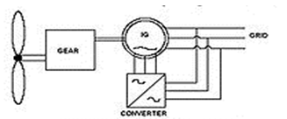
Fig. 4.2: Principle of a DFIG connected to a wind turbine

The doubly-fed generator rotors are typically wound with 2 to 3 times the number of turns of the stator. This means that the rotor voltages will be higher and currents respectively lower. Thus in the typical ± 30 % operational speed range around the synchronous speed, the rated current of the converter is accordingly lower which leads to a lower cost of the converter. The drawback is that controlled operation outside the operational speed range is impossible because of the higher than rated rotor voltage. Further, the voltage transients due to the grid disturbances (three- and two-phase voltage dips, especially) will also be magnified. In order to prevent high rotor voltages - and high currents resulting from these voltages - from destroying the IGBTs and diodes of the converter, a protection circuit (called crowbar) is used.
The crowbar will short-circuit the rotor windings through a small resistance when excessive currents or voltages are detected. In order to be able to continue the operation as quickly as possible an active crowbar has to be used. The active crowbar can remove the rotor short in a controlled way and thus the rotor side converter can be started only after 20-60 ms from the start of the grid disturbance. Thus it is possible to generate reactive current to the grid during the rest of the voltage dip and in this way help the grid to recover from the fault.
A doubly fed induction machine is a wound-rotor doubly-fed electric machine and has several advantages over a conventional induction machine in wind power applications. First, as the rotor circuit is controlled by a power electronics converter, the induction generator is able to both import and export reactive power. This has important consequences for power system stability and allows the machine to support the grid during severe voltage disturbances (low voltage ride through, LVRT).
Second, the control of the rotor voltages and currents enables the induction machine to remain synchronized with the grid while the wind turbine speed varies. A variable speed wind turbine utilizes the available wind resource more efficiently than a fixed speed wind turbine, especially during light wind conditions. Third, the cost of the converter is low when compared with other variable speed solutions because only a fraction of the mechanical power, typically 25-30 %, is fed to the grid through the converter, the rest being fed to grid directly from the stator. The efficiency of the DFIG is very good for the same reason

4.2 System Model:
The electrical model for the system is developed using dynamic phasors or complex space vectors in the anachronously rotating – reference frame. An illustration of the axes conventions The default convention assumed here aligns the -axis with the positive real axis and the -axis with the negative imaginary axis, and the complex vector. In certain instances it is convenient to locate the real and imaginary axes aligned with a particular complex vector, for instance , in which case the axes are designated and respectively, and the real and (negative) imaginary components with respect to the reference are designated and , a respectively.
The following simplifying assumptions are made in the development of the model.
1) The iron losses, mechanical and power converter losses are negligible.
2) The magnetic circuit of the machine can be represented bya linear model.
3) The entire mechanical system can be modeled using a lumped inertia parameter referred to the electrical angle and speed of the induction generator.
4) The power converters can be modeled using state-space averaged representation to represent their low frequency dynamics.
5) The wind farm collection network to PCC is electrically stiff. The conventional DFIG T circuit is transformed into an equivalent circuit

The system equivalent circuits model under these assumptions The complete set of nonlinear state equations are
dλ_{s}/dt=− λ_{s} (R_{s}/L_{s}+jω_{e}) +i_{R} R_{s} + ν_{f} + ν_{i}
di_{R}/dt=1/L_{L}[−i_{R}(R_{R}+Rs+jω_{sl}L_{L}) +λs(Rs/Ls+jωr)+ν_{R}−(ν_{f}+ν_{i})]
di_{re}/dt=u(ν_{f}−ν_{re})(ν_{re}−ν_{f}L_{re}−jω_{e}i_{re})
dν_{dc}/dt=-3/2ν_{dc}C_{dc}[νi.(λ_{s}/L_{s}−i_{R})−ν_{re}.i_{re}+ν_{R}.i_{r}

dω_{r}/dt=p/2J_{m}[3pλ_{s}.i_{R}/4+T_{m}−2ω_{r}/pG_{m}]
Where u(.) is the unit step function.
The complex vector dynamic state equations are used form the evaluation of steady state properties and the development of control laws. The dynamic states of the system include the stator flux, , rotor current , rectifier current , dc link voltage, , and rotor speed, . Controllable inputs to the system include the complex voltage vectors for the MSC and SGSC, and respectively.
Since the PGSR is a passive network, its conduction state is determined by the state of the diode which conducts when the voltage is greater than. The mechanical power generated at the wind turbine shaft is proportional to the coefficient of performance and the cube of the wind speed. The mechanical torque production due to wind energy capture can be throttled via the blade pitch actuators.

4.3 DFIG CONTROL:
When the DFIG is connected to a network, connection must be done in three steps which are presented below the first step is the regulation of the statoric voltages with the network voltages as reference the second step is the stator connection to this network. As the voltages of the two devices are synchronized, this connection can be done without problem. Once this connection is achieved, the third step, which constitutes the topic of this project, is the power regulation between the stator and the network.

Fig.4 .3 First step

Fig. 4.4: Third step
4.4 TYPES OF DOUBLE FED INDUCTION GENERATOR:
Brushless doubly-fed induction generator:
Brushless doubly-fed induction electric generator (i.e., electric motors or electric generators) are constructed by adjacently placing two multiphase winding sets with unlike pole-pairs on the stator body. With unlike pole-pairs between the two winding sets, low frequency magnetic induction is assured over the speed range. One of the stator winding sets (power winding) is connected to the grid and the other winding set (control winding) is supplied from a frequency converter. The shaft speed is adjusted by varying the frequency of the control winding. As a doubly-fed electric machine, the rating of the frequency converter need only be fraction of the machine rating.
The brushless doubly-fed induction generator does not utilize core real-estate efficiently and the dual winding set stator assembly is physically larger than other electric machines of comparable power rating. In addition, a specially designed rotor assembly tries to focus most of the mutual magnetic field to follow an indirect path across the air-gap and through the rotor assembly for inductive coupling (i.e., brushless) between the two adjacent winding sets. As a result, the adjacent winding sets are excited independently and actively participate in the electro-mechanical energy conversion process, which is a criterion of doubly-fed electric machines.
The type of rotor assembly determines if the machine is a reluctance or induction doubly-fed electric machine. The constant torque speed range is always less than 1800 rpm @ 60 Hz because the effective pole count is the average of the unlike pole-pairs of the two active winding sets. Brushless doubly-fed electric machines incorporate a poor electromagnetic design that compromises physical size, cost, and electrical efficiency, to chiefly avoid a multiphase slip ring assembly. Although brushless doubly-fed electric machines have not seen commercial success since their conception in the early 1970s, the promise of a low cost, highly efficient electronic controller keeps the concept under perpetual study, research, and development.

Brushless wound-rotor doubly-fed generator:
The brushless wound-rotor doubly-fed electric generator (i.e., electric motor or electric generator) incorporates the electromagnetic structure of the wound-rotor doubly-fed electric machine, but replaces the traditional multiphase slip ring assembly with a brushless means to independently power the rotor winding set (i.e., doubly-fed) with multiphase AC power. The torque of the wound-rotor doubly-fed electric machine is dependent on both slip and position, which is a classic condition for instability.
For stable operation, the frequency and phase of the multiphase AC power must be synchronized and fixed instantaneously to the speed and position of the shaft, which is not trivial at any speed and particularly difficult about synchronous speed where induction no longer exists.
If these conditions are met, all the attractive attributes of the wound-rotor doubly-fed electric machine, such as high power density, low cost, ultra-high efficiency, and ultra-high torque potential, are realized without the traditional slip-ring assembly and instability problems. One company has patented and is selling a brushless, fully stable, synchronous wound-rotor doubly-fed electric machine with symmetric quality of motoring or generating. Another brushless wound-rotor construction invented by Lars Gertmar has been described in the patent application.

Wound-rotor doubly-fed generator:
Two multiphase winding sets with similar pole-pairs are placed on the rotor and stator bodies, respectively. The wound-rotor doubly-fed electric machine is the only electric machine with two independent active winding sets, the rotor and stator winding sets, occupying the same core volume as other electric machines. Since the rotor winding set actively participates in the energy conversion process with the stator winding set, utilization of the magnetic core real estate is optimized.
The doubly fed generator operation at unity stator power factor requires higher flux in the air-gap of the machine than when the machine is used as wound rotor induction machine. It is quite common that wound rotor machines not designed to doubly fed operation saturate heavily if doubly fed operation at rated stator voltage is attempted. Thus a special design for doubly fed operation is necessary.
A multiphase slip ring assembly (i.e., sliding electrical contacts) is traditionally used to transfer power to the rotating (moving) winding set and to allow independent control of the rotor winding set. The slip ring assembly requires maintenance and compromises system reliability, cost and efficiency. Attempts to avoid the slip ring assembly are constantly being researched with limited success (see Brushless doubly-fed induction electric machines).

4.5 advantages of DFIM :

Electronic control

The electronic controller, a frequency converter, conditions bi-directional (i.e., four quadrant), speed synchronized, and multiphase electrical power to at least one of the winding sets (generally, the rotor winding set). Using four quadrant control, which must be continuously stable throughout the speed range, a wound-rotor doubly-fed electric machine with two poles (i.e., one pole-pair) has a constant torque speed range of 7200 rpm when operating at 60 Hz. However, in high power applications two or three pole-pair machines with respectively lower maximum speeds are common.
The electronic controller is smaller, less expensive, more efficient, and more compact than electronic controllers of singly-fed electric machine because in the simplest configuration, only the power of the rotating (or moving) active winding set is controlled, which is less than half the total power output of the electric machine. Due to the lack of damper windings used in synchronous machines, the doubly fed electric machines are susceptible to instability without stabilizing control. Like any synchronous machine, losing synchronism will result in alternating torque pulsation and other related consequences.
Doubly-fed electric machines require electronic control for practical operation and should be considered an electric machine system or more appropriately, an adjustable-speed drive.

Efficiency:

Neglecting the slip ring assembly, the theoretical electrical loss of the wound-rotor doubly-fed machine in super synchronous operation is comparable to the most efficient electric machine systems available (i.e., the synchronous electric machine with permanent magnet assembly) with similar operating metrics because the total current is split between the rotor and stator winding sets while the electrical loss of the winding set is proportional to the square product of the current flowing through the winding set.

Further considering the electronic controller conditions less than 50% of the power of the machine, the wound-rotor doubly-fed electric motor or generator (without brushes and with stable control at any speed) theoretically shows nearly half the electrical loss (i.e., winding set loss) of other electric motor or generator systems of similar rating.

Power density:
Neglecting the slip ring assembly and considering similar air-gap flux density, the physical size of the magnetic core of the wound-rotor doubly-fed electric machine is smaller than other electric machines because the two active winding sets are individually placed on the rotor and stator bodies, respectively, with virtually no real-estate penalty. In all other electric machines, the rotor assembly is passive real estate that does not actively contribute to power production. The potential of higher speed for a given frequency of excitation, alone, is an indication of higher power density potential. The constant-torque speed range is up to 7200 rpm @ 60 Hz with 2 poles compared to 3600 rpm @ 60 Hz with 2 poles for other electric machines. In theory, the core volume is nearly half the physical size (i.e., winding set loss) of other electric motor or generator systems of similar rating.

Cost:
Neglecting the slip ring assembly, the theoretical system cost is nearly 50% less than other machines of similar rating because the power rating of the electronic controller, which is the significant cost of any electric machine system, is 50% (or less) than other electric motor or generator systems of similar rating.

4.6 CONTROL TECHNIQUES:
4.6.1 Control of RSC:
The main purpose of RSC is to extract maximum power with independent control of active and reactive powers. Here, the RSC is controlled in voltage-oriented reference frame. Therefore, the active and reactive powers are controlled by controlling direct and quadrature axis rotor currents (idr and iqr),respectively. Direct axis reference rotor current is selected such that maximum power is extracted for a particular wind speed. This can be achieved by running the DFIG at a rotor speed for a particular wind speed.

4.6.2 Control of GSC:
The novelty of this work lies in the control of this GSC for mitigating the harmonics produced by the nonlinear loads. The control block diagram of GSC is shown in Fig. 4. Here, an indirect current control is applied on the grid currents for making them sinusoidal and balanced. Therefore, this GSC supplies the harmonics for making grid currents sinusoidal and balanced. These grid currents are calculated by subtracting the load currents from the summation of stator currents and GSC currents. Active power component of GSC current is obtained by processing the dc-link voltage error (vdce) between reference and estimated dc-link voltage (V ∗ dc and Vdc) through PI controller

ADVANTAGES
* Total harmonic can be reduced.
* Reactive power can be compensated by local loads.
* Efficiency of the system is improved.

TYPES OF WIND TURBINE:

The following wind turbine systems are normally used in Wind Energy Conversion System (WECS).

• Fixed speed wind turbine with an induction generator.
• Variable speed wind turbine equipped with a cage bar induction generator or synchronous generator or multiple pole synchronous generator or multiple pole permanent magnet synchronous generator.
• Variable speed wind turbine equipped with a doubly fed induction generator (DFIG).

Fixed Speed Wind Turbine:
For the fixed speed wind turbine the induction generator (IG) is directly connected to the electrical grid according to Fig. 4.1. The rotor speed of the fixed speed wind turbine is in principle determined by a gearbox and the pole pair of the generator. The fixed speed wind turbine system has often two fixed speeds. This is accomplished by using two generators with different ratings and pole pairs, or it can be a generator with two windings having different ratings and pole pairs. This leads to increased aerodynamic capture as well as reduced magnetizing losses at low wind speeds.

Variable Speed Wind Turbine

The system presented in Fig.4.2 consists of wind turbine equipped with a converter connected to the stator of the generator. The generator could either be a cage bar induction generator or a synchronous generator. The gearbox is designed so that maximum rotor speed corresponds to rated speed of the generator. Synchronous generators or permanent magnet synchronous generators can be designed with multiple poles which implies that there is no need for a gearbox, see Fig.4.3. Since this full power converter/generator system is commonly used for other applications, one advantage with this system is its well developed and robust control.

Variable Speed Wind Turbine with DFIG

This system, see Fig. 4.4, consists of a wind turbine with DFIG. This means that the stator is directly connected to the grid while the rotor winding is connected via slip rings to a converter. This system has recently become very popular as generators for variable speed wind turbines. This is mainly due to the fact that the power electronic converter only has to handle a fraction (20–30%) of the total power. Therefore, the losses in the power electronic converter can be reduced. In addition, the cost of the converter becomes lower. There exists a variant of the DFIG method that uses controllable external rotor resistances. The main drawback of this method is unnecessarily energy dissipated in the external rotor resistances.
ENERGY EFFICIENCY OF DFIG:

Investigation of energy efficiency of DFIG is discussed in the following section. The energy efficiency is mainly focusing on:
- Reducing the magnetizing losses of the DFIG system.
- Influence of the converter’s size on the energy production.
- Comparison of the DFIG system to other electrical systems.
- In this discussion, aerodynamic losses, gearbox losses, induction generator losses and converter losses are also taken into account

CHAPTER-5
Pulse width Modulation (pwm)

Pulse Width Modulation (PWM) is the most effective means to achieve constant voltage battery charging by switching the solar system controller’s power devices. When in PWM regulation, the current from the solar array tapers according to the battery’s condition and recharging needs Consider a waveform such as this: it is a voltage switching between 0v and 12v. It is fairly obvious that, since the voltage is at 12v for exactly as long as it is at 0v, then a 'suitable device' connected to its output will see the average voltage and think it is being fed 6v - exactly half of 12v. So by varying the width of the positive pulse - we can vary the 'average' voltage.
Fig 5.1 : Average Voltage varying the width of positive pulse
Similarly, if the switches keep the voltage at 12 for 3 times as long as at 0v, the average will be 3/4 of 12v - or 9v, as shown below and if the output pulse of 12v lasts only 25% of the overall time, then the average is
Fig 5.2 Average voltage when pulse varies from 0-12v

Fig 5.3 Average voltage when pulse lasts for 25% of overall time
By varying - or 'modulating' - the time that the output is at 12v (i.e. the width of the positive pulse) we can alter the average voltage. So we are doing 'pulse width modulation'. I said earlier that the output had to feed 'a suitable device'. A radio would not work from this: the radio would see 12v then 0v, and would probably not work properly. However a device such as a motor will respond to the average, so PWM is a natural for motor control.
5.1 Pulse Width modulator:
So, how do we generate a PWM waveform? It's actually very easy, there are circuits available in the TEC site. First you generate a triangle waveform as shown in the diagram below. You compare this with a d.c voltage, which you adjust to control the ratio of on to off time that you require. When the triangle is above the 'demand' voltage, the output goes high. When the triangle is below the demand voltage, the
Fig 5.4 : Modulating and Modulated Waveforms
When the demand speed it in the middle (A) you get a 50:50 output, as in black. Half the time the output is high and half the time it is low. Fortunately, there is an IC (Integrated circuit) called a comparator: these come usually 4 sections in a single package. One can be used as the oscillator to produce the triangular waveform and another to do the comparing, so a complete oscillator and modulator can be done with half an IC and maybe 7 other bits.
The triangle waveform, which has approximately equal rise and fall slopes, is one of the commonest used, but you can use a saw tooth (where the voltage falls quickly and rinses slowly). You could use other waveforms and the exact linearity (how good the rise and fall are) is not too important.
Traditional solenoid driver electronics rely on linear control, which is the application of a constant voltage across a resistance to produce an output current that is directly proportional to the voltage. Feedback can be used to achieve an output that matches exactly the control signal. However, this scheme dissipates a lot of power as heat, and it is therefore very inefficient.
A more efficient technique employs pulse width modulation (PWM) to produce the constant current through the coil. A PWM signal is not constant. Rather, the signal is on for part of its period, and off for the rest. The duty cycle, D, refers to the percentage of the period for which the signal is on. The duty cycle can be any wherefrom 0, the signal is always off, to 1, where the signal is constantly on. A 50% D results in a perfect square wave.

Fig 5.5 : Modulated Wave forms with Duty cycles
A solenoid is a length of wire wound in a coil. Because of this configuration, the solenoid has, in addition to its resistance, R, a certain inductance, L. When a voltage, V, is applied across an inductive element, the current, I, produced in that element does not jump up to its constant value, but gradually rises to its maximum over a period of time called the rise time. Conversely, I does not disappear instantaneously, even if V is removed abruptly, but decreases back to zero in the same amount of time as the rise time.
Therefore, when a low frequency PWM voltage is applied across a solenoid, the current through it will be increasing and decreasing as V turns on and off. If D is shorter than the rise time, I will never achieve its maximum value, and will be discontinuous since it will go back to zero during V’s off period .* In contrast, if D is larger than the rise time, I will never fall back to zero, so it will be continuous, and have a DC average value. The current will not be constant, however, but will have a ripple.
Fig 5.6: Low Frequency PWM
Fig 5.7: Continuous Current Ripple
At high frequencies, V turns on and off very quickly, regardless of D, such that the current does not have time to decrease very far before the voltage is turned back on. The resulting current through the solenoid is therefore considered to be constant. By adjusting the D, the amount of output current can be controlled. With a small D, the current will not have much time to rise before the high frequency PWM voltage takes effect and the current stays constant. With a large D, the current will be able to rise higher before it becomes constant.
Fig 5.8: Resultant Current based on Duty Cycle
Why the PWM frequency is important:
The PWM is a large amplitude digital signal that swings from one voltage extreme to the other. And, this wide voltage swing takes a lot of filtering to smooth out. When the PWM frequency is close to the frequency of the waveform that you are generating, then any PWM filter will also smooth out your generated waveform and drastically reduce its amplitude. So, a good rule of thumb is to keep the PWM frequency much higher than the frequency of any waveform you generate.
Finally, filtering pulses is not just about the pulse frequency but about the duty cycle and how much energy is in the pulse. The same filter will do better on a low or high duty cycle pulse compared to a 50% duty cycle pulse. Because the wider pulse has more time to integrate to a stable filter voltage and the smaller pulse has less time to disturb it the inspiration was a request to control the speed of a large positive displacement fuel pump. The pump was sized to allow full power of a boosted engine in excess of 600 Hp.
Idle or highway cruise, this same engine needs far less fuel yet the pump still normally supplies the same amount of fuel. As a result the fuel gets recycled back to the fuel tank, unnecessarily heating the fuel. This PWM controller circuit is intended to run the pump at a low speed setting during low power and allow full pump speed when needed at high engine power levels.
5.2 Motor Speed Control (Power Control):
Typically when most of us think about controlling the speed of a DC motor we think of varying the voltage to the motor. This is normally done with a variable resistor and provides a limited useful range of operation. The operational range is limited for most applications primarily because torque drops off faster than the voltage drops.
Most DC motors cannot effectively operate with a very low voltage. This method also causes overheating of the coils and eventual failure of the motor if operated too slowly. Of course, DC motors have had speed controllers based on varying voltage for years, but the range of low speed operation had to stay above the failure zone described above.
Additionally, the controlling resistors are large and dissipate a large percentage of energy in the form of heat. With the advent of solid state electronics in the 1950’s and 1960’s and this technology becoming very affordable in the 1970’s & 80’s the use of pulse width modulation (PWM) became much more practical. The basic concept is to keep the voltage at the full value and simply vary the amount of time the voltage is applied to the motor windings. Most PWM circuits use large transistors to simply allow power On & Off, like a very fast switch.
This sends a steady frequency of pulses into the motor windings. When full power is needed one pulse ends just as the next pulse begins, 100% modulation. At lower power settings the pulses are of shorter duration. When the pulse is On as long as it is Off, the motor is operating at 50% modulation. Several advantages of PWM are efficiency, wider operational range and longer lived motors. All of these advantages result from keeping the voltage at full scale resulting in current being limited to a safe limit for the windings.
PWM allows a very linear response in motor torque even down to low PWM% without causing damage to the motor. Most motor manufacturers recommend PWM control rather than the older voltage control method. PWM controllers can be operated at a wide range of frequencies. In theory very high frequencies (greater than 20 kHz) will be less efficient than lower frequencies (as low as 100 Hz) because of switching losses.
The large transistors used for this On/Off activity have resistance when flowing current, a loss that exists at any frequency. These transistors also have a loss every time they “turn on” and every time they “turn off”. So at very high frequencies, the “turn on/off” losses become much more significant. For our purposes the circuit as designed is running at 526 Hz. Somewhat of an arbitrary frequency, it works fine.
Depending on the motor used, there can be a hum from the motor at lower PWM%. If objectionable the frequency can be changed to a much higher frequency above our normal hearing level (>20,000Hz).
5.3 PWM Controller Features:
This controller offers a basic “Hi Speed” and “Low Speed” setting and has the option to use a “Progressive” increase between Low and Hi speed. Low Speed is set with a trim pot inside the controller box. Normally when installing the controller, this speed will be set depending on the minimum speed/load needed for the motor. Normally the controller keeps the motor at this Lo Speed except when Progressive is used and when Hi Speed is commanded (see below). Low Speed can vary anywhere from 0% PWM to 100%.
Progressive control is commanded by a 0-5 volt input signal. This starts to increase PWM% from the low speed setting as the 0-5 volt signal climbs. This signal can be generated from a throttle position sensor, a Mass Air Flow sensor, a Manifold Absolute Pressure sensor or any other way the user wants to create a 0-5 volt signal. This function could be set to increase fuel pump power as turbo boost starts to climb (MAP sensor). Or, if controlling a water injection pump, Low Speed could be set at zero PWM% and as the TPS signal climbs it could increase PWM%, effectively increasing water flow to the engine as engine load increases.
This controller could even be used as a secondary injector driver (several injectors could be driven in a batch mode, hi impedance only), with Progressive control (0-100%) you could control their output for fuel or water with the 0-5 volt signal.
Progressive control adds enormous flexibility to the use of this controller. Hi Speed is that same as hard wiring the motor to a steady 12 volt DC source. The controller is providing 100% PWM, steady 12 volt DC power. Hi Speed is selected three different ways on this controller: 1) Hi Speed is automatically selected for about one second when power goes on. This gives the motor full torque at the start. If needed this time can be increased (The value of C1 would need to be increased). 2) High Speed can also be selected by applying 12 volts to the High Speed signal wire. This gives Hi Speed regardless of the Progressive signal.
When the Progressive signal gets to approximately 4.5 volts, the circuit achieves 100% PWM – Hi Speed.
aDVANTAGES:
The benefits noted above are technology driven. The more important question is how the PWM technology jumping from a 1970’s technology into the new millennium offers:
• Longer battery life:
– reducing the costs of the solar system
– reducing battery disposal problems
• More battery reserve capacity:
– increasing the reliability of the solar system
– reducing load disconnects
– Opportunity to reduce battery size to lower the system cost
• Greater user satisfaction:
– get more power when you need it for less money

5.4 SINUSOIDAL PULSE WIDTH MODULATION:
The switches in the voltage source inverter can be turned on and off as required. In the simplest approach, the top switch is turned on if turned on and off only once in each cycle, a square wave waveform results. However, if turned on several times in a cycle an improved harmonic profile may be achieved.
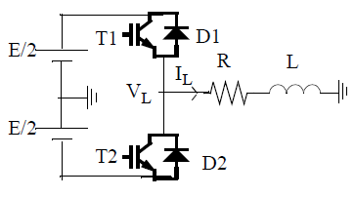
Fig 5.9: Simple Voltage Sourced Inverter
In the most straightforward implementation, generation of the desired output voltage is achieved by comparing the desired reference waveform (modulating signal) with a high-frequency triangular ‘carrier’ wave as depicted schematically. Depending on whether the signal voltage is larger or smaller than the carrier waveform, either the positive or negative dc bus voltage is applied at the output. Note that over the period of one triangle wave, the average voltage applied to the load is proportional to the amplitude of the signal (assumed constant) during this period. The resulting chopped square waveform contains a replica of the desired waveform in its low frequency components, with the higher frequency components being at frequencies of an close to the carrier frequency. Notice that the root mean square value of the ac voltage waveform is still equal to the dc bus voltage, and hence the total harmonic distortion is not affected by the PWM process. The harmonic components are merely shifted into the higher frequency range and are automatically filtered due to inductances in the ac system.
When the modulating signal is a sinusoid of amplitude Am, and the amplitude of the triangular carrier is Ac, the ratio m=Am/Ac is known as the modulation index. Note that controlling the modulation index therefore controls the amplitude of the applied output voltage.
With a sufficiently high carrier frequency (drawn for fc/fm = 21 and t = L/R = T/3; T = period of fundamental), the high frequency components do not propagate significantly in the ac network (or load) due the presence of the inductive elements. However, a higher carrier frequency does result in a larger number of switchings per cycle and hence in an increased power loss. Typically switching frequencies in the 2-15 kHz range are considered adequate for power systems applications. Also in three-phase systems it is advisable to use fc/fm=3 k,(k ∈ N) so that all three waveforms are symmetric.
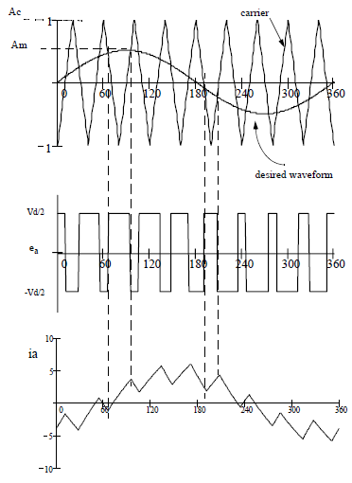
Fig 5.10: Principal of Pulse Width Modulation
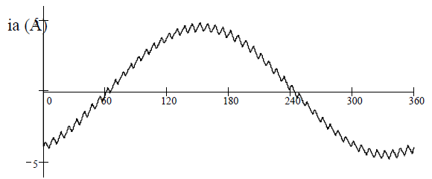
Fig. 5.11: SPWM with fc/fm = 48, L/R = T/3
Note that the process works well for m $≤$ 1. For m >1, there are periods of the triangle wave in which there is no intersection of the carrier and the signal as in Fig. 4. However, a certain amount of this “over modulation” is often allowed in the interest of obtaining a larger ac voltage magnitude even though the spectral content of the voltage is rendered somewhat poorer.
Note that with an odd ratio for fc/fm, the waveform is anti-symmetric over a 360 degree cycle. With an even number, there are harmonics of even order, but in particular also a small dc component. Hence an even number is not recommended for single phase inverters, particularly for small ratios of fc/fm.

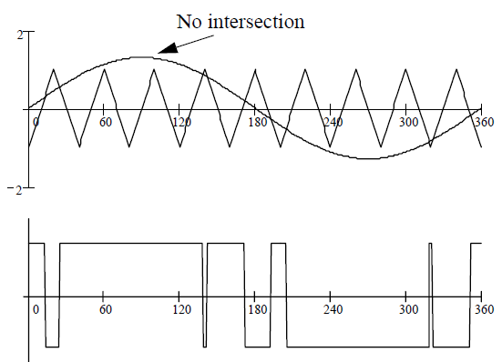
Fig. 5.12: Over modulation: m= 1.3
SPWM Spectra:
Although the SPWM waveform has harmonics of several orders in the phase voltage waveform, the dominant ones other than the fundamental are of order n and n±2 where n = fc/fm. This is evident for the spectrum for n=15 and m = 0.8 shown in Note that if the other two phases are identically generated but 120o apart in phase, the line-line voltage will not have any triplen harmonics. Hence it is advisable to choose fc/fm=3k,(k∈N) , as then the dominant harmonic will be eliminated. It is evident from that the dominant 15th harmonic in is effectively eliminated in the line voltage. Choosing a multiple of 3 is also convenient as then the same triangular waveform can be used as the carrier in all three phases, leading to some simplification in hardware.
It is readily seen that as the (pwm(θ))²=E² where E is the dc bus voltage, that the rms value of the output voltage signal is unaffected by the PWM process. This is strictly true for the phase voltage as triplen harmonic orders are cancelled in the line voltage. However, the problematic harmonics are shifted to higher orders, thereby making filtering much easier. Often, the filtering is carried out via the natural high-impedance characteristic of the load.
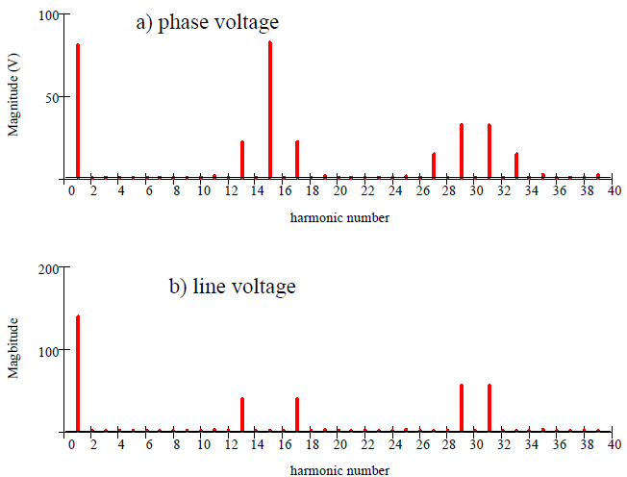
Fig.5.13: SPWM Harmonic Spectra: n = 15, m =0.8

CHAPTER-6
BRIEF OF THE INSTANTANEOUS POWER THEORY
As the name implied, the instantaneous power theory is based on a definition of instantaneous real and reactive powers in time domain. It is very useful not only in the steady-state but also in the transient state analysis for both three-phase systems with or without a neutral conductor. To illustrate the theory, let consider a set of instantaneous three phase quantity, for example a v ,b v and c v . It starts with transforming a set of three-phase variables in the abc into αβ 0 coordinates. This transformation is so-called as the Clark transformation as described follows.
……………. (1)
………………… (2)
In three-phase, three-wire systems, there is no zero sequence components. If 0 v and 0 i are both neglected, instantaneous voltage, v, and current phasors, i, can be defined from their corresponding instantaneous α and β components as follows
v=v_{α} + jv_{b}……….. (3)
i=i_{α} + ji_{β}………. (4)
From (3) and (4), instantaneous complex powers, s, can be defined as the product of the instantaneous voltage phasor and the complex conjugate of the instantaneous current phasor given in (5).
s=vi∗=(v_{α} + jv_{β})(i_{α} – ji_{β})=p+jq …………… (5)
Where,
P=v_{α}i_{α}+ v_{β} i_{β}p is the instantaneous active power
q=v_{β}i_{α} − v_{α}i_{β} is the instantaneous reactive power
The instantaneous complex power is useful. It can be applied for transient or steady-state analysis. The following equation is a compact form for the instantaneous real and reactive power definition and its inversion.
…………… (6)
…………… (7)
………………. (8)
……………….. (9)
Fig. 6.1. Concept of shunt current compensation

Fig. 6.2. Control block of shunt current compensation based on the instantaneous power theory
These two powers can be separated into average components (and) and oscillating components (and) as shown in (8) and (9). The average values of both p and q agree with conventional real and reactive powers in AC circuits. The oscillating terms that naturally produce a zero mean give additional oscillating power flow without contribution of the energy transfer neither from the source to the load nor from the load to the source. One important application of the instantaneous power theory is the shunt current compensation as shown in Fig.6.2. To achieve the compensation, the oscillating components of p and q must be eliminated. The powers to be compensated can be simply determined by eliminating the oscillating real and reactive power components. Assume that the instantaneous powers of load and line current are calculated. The instantaneous current references to minimize the oscillating terms can be established with some efficient concepts. A general idea of shunt current compensation based on the instantaneous power theory described in this section.

CHAPTER-7
PROPORTIONAL INTEGRAL CONTROLLER
7.1 PI Controller
Proportional-integral controller (PI Controller) is a feedback controller which drives the system to be controlled with a weighted sum of the error signal (difference between the output and desired set point) and the integral of that value.
Figure 2.2 shows the block diagram of Controller system. The controller system is partially part of distribution system.

In this case, PI controller will process the error signal to zero. The load r.m.s voltage is brought back to the reference voltage by comparing the reference voltage with the r.m.s voltages that had been measured at the load point.
It also is used to control the flow of reactive power from the DC capacitor storage circuit. PWM generator is the device that generates the Sinusoidal PWM waveform or signal. To operate PWM generator, the angle is summed with the phase angle of the balance supply voltages equally at 120 degrees. Therefore, it can produce the desired synchronizing signal that required. PWM generator also received the error signal angle from PI controller. The modulated signal is compared against a triangle signal in order to generate the switching signals for VSC valves.
The general block diagram of the PI speed controller is shown in Figure
...
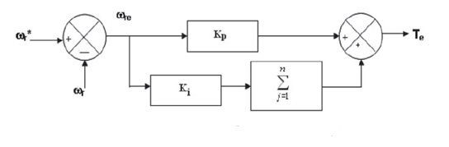
Fig 7.2 Block diagram of PI speed controller

The output
Of the speed controller (torque command) at n-th instant is expressed as follows:
Te (n)=Te(n−1)+Kp_ωre(n)+Kiωre(n)
Where Te (n) is the torque output of the controller at the n-th instant, and Kp and Ki the proportional and integral gain constants, respectively.
A limit of the torque command is imposed as
$$T_{e\left(n+1)\right)}=\left\{\begin{aligned}{ T}_{emax} for T_{e\left(n+1\right)}≥T_{emax} \\ -T_{emax} for T_{e\left(n+1\right)}≤-T_{emax}\end{aligned}\right.$$
The gains of PI controller can be selected by many methods such as trial and error method, Ziegler–Nichols method and evolutionary techniques-based searching. The numerical values of these controller gains depend on the ratings of the motor.

Advantages and disadvantages
- The integral term in a PI controller causes the steady-state error to reduce to zero, which is not the case for proportional-only control in general.
- The lack of derivative action may make the system more steady in the steady state in the case of noisy data. This is because derivative action is more sensitive to higher-frequency terms in the inputs.
- Without derivative action, a PI-controlled system is less responsive to real (non-noise) and relatively fast alterations in state and so the system will be slower to reach set point and slower to respond to perturbations than a well-tuned PID system may be.
7.3 Methods for Tuning PI-Controllers
PI-controllers have been applied to control almost any process one could think of, from aerospace to motion control, from slow to fast systems. With changes in system dynamics and variation in operating points PI-controllers should be retuned on a regular basis. Adaptive PI-controllers avoid time-consuming manual tuning by providing optimal PI-controllers settings automatically as the system dynamics or operating points change. There are various conventional methods used for tuning of PI-controller such as:
1. Trial and error
2. Continuous cycling method (Ziegler Nichols method)
3. Process Reaction Curve Methods (Ziegler-Nichols and Cohen-Coon methods)
4. Ziegler-Nichols method (both types of responses)
5. Cohen-Coon method (self regulating response only.
Trial and Error
PI-Controller equation is:
$$P\left(t\right)=K_{c}\left[e\left(t\right)+\frac{1}{τ}\int_{0}^{t}{e\left(t\right)dt}\right]$$
It is quite time consuming if a large number of trial are required or if the process dynamics are slow. Testing can be expensive because of lost productivity or poor product quality
Continuous cycling may be objectionable because the process is pushed to the stability limit. Consequently, if external disturbances or a change in the process occurs during controller tuning an unstable operation or a hazardous situation could result. The tuning process is not applicable to processes that are open loop because such processes typically are unstable at high and low values of K_{c} but are stable at intermediate range values.
This information is an analogy of knowledge of how the other agents around them have performed. Namely, each agent tries to modify its position.

CHAPTER-8
SIMULINK MODEL RESULTS

The simulated performance of DFIG –Based WECS with Integrated Active Filter Capabilities

8.1 SIMULINK BLOCK DIAGRAM:
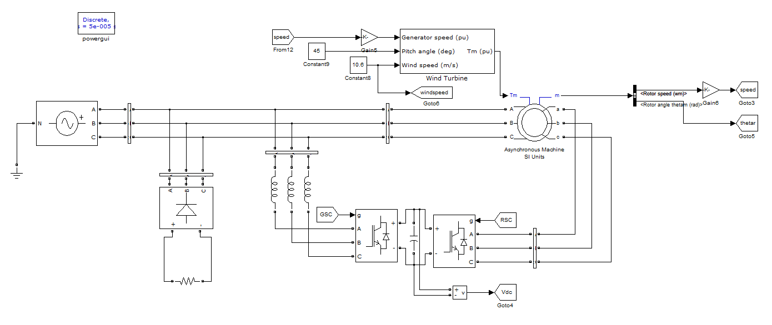

FIG 8.1 Block diagram of proposed DFIG-based WECS at fixed wind speed of 10.6 m/s (rotor speed of 1750 rpm).
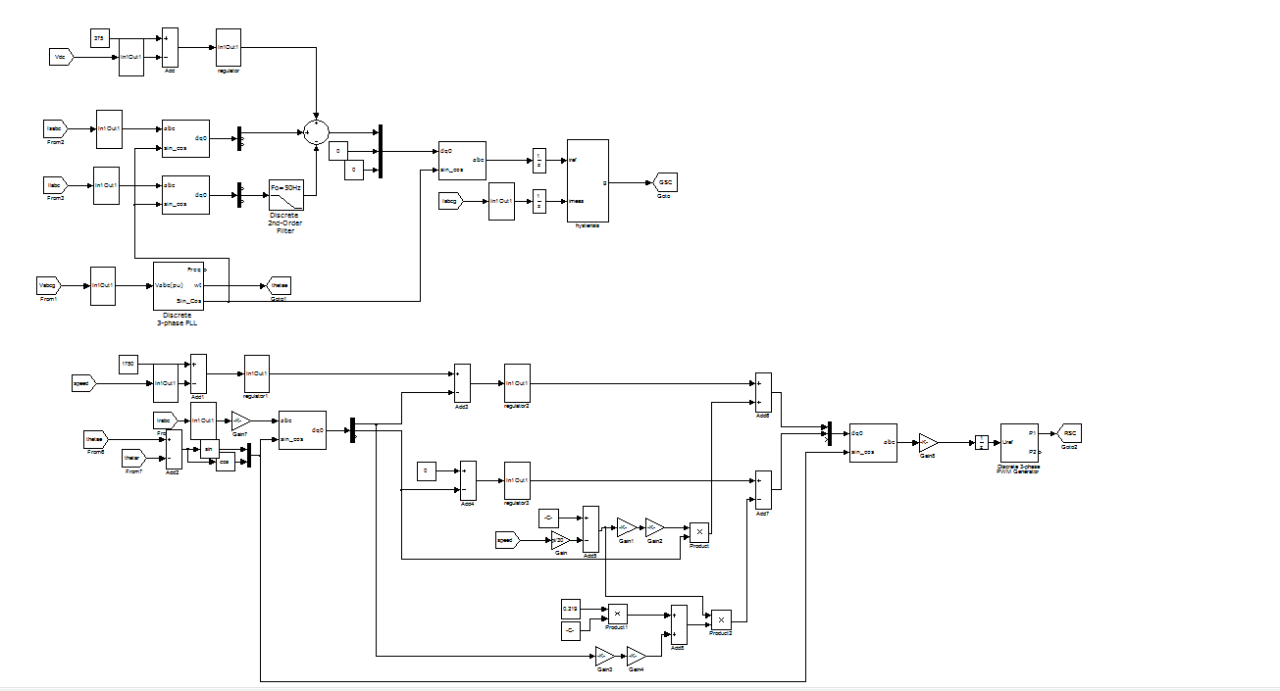

FIG 8.2 CONTROL BLOCK DIAGRAM

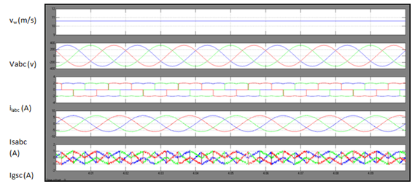
Time(s)

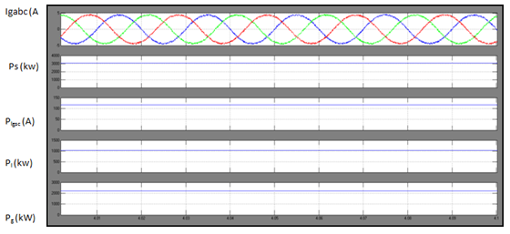
Time(s)
Fig. 8.3. Simulated performance of the proposed DFIG-based WECS at fixed wind speed of 10.6 m/s (rotor speed of 1750 rpm).
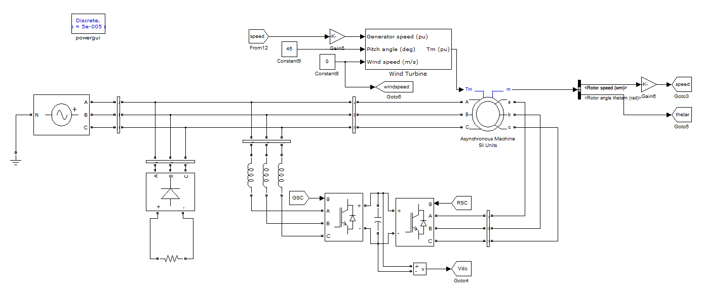
Fig 8.4 MAIN BLOCK DIAGRAM OF proposed DFIG-based WECS working as a STATCOM at zero wind speed.
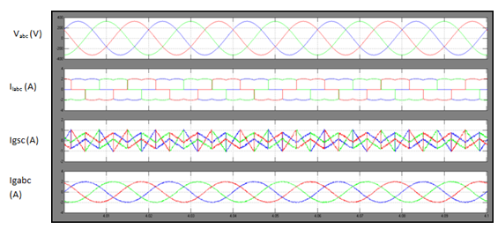
Time(s)
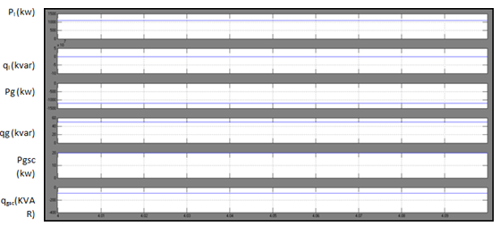
Time(S)
Fig.8.5 Simulated performance of the proposed DFIG-based WECS working as a STATCOM at zero wind speed.

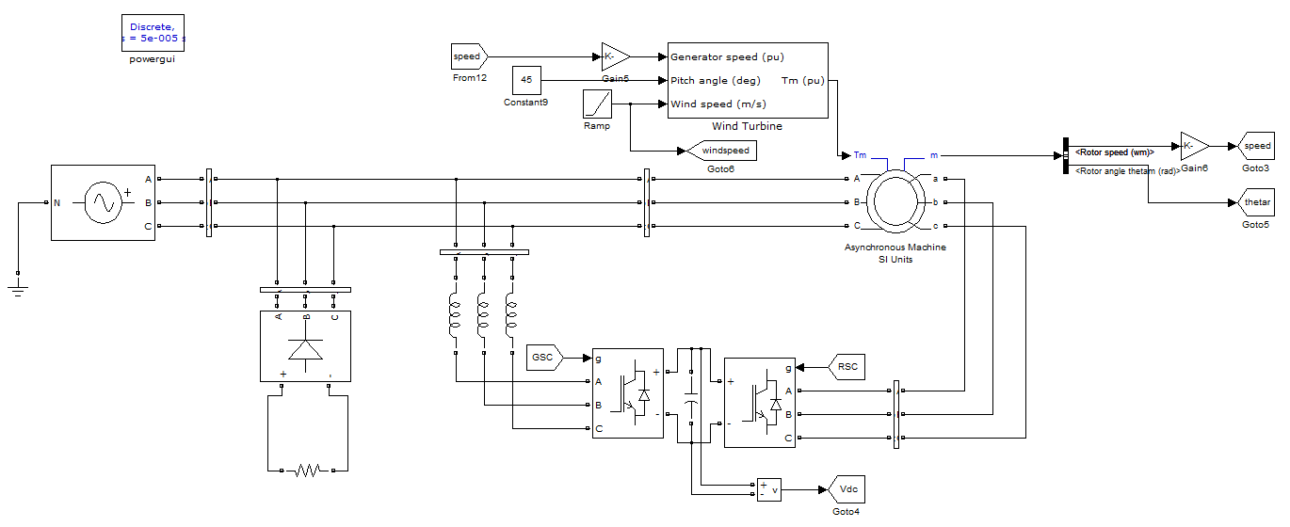 FIG 8.6 Block diagram of proposed DFIG for fall in wind speed

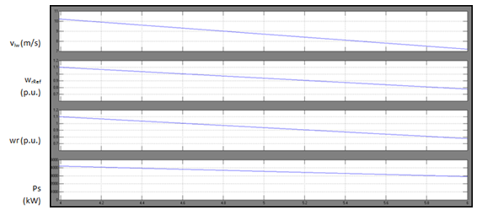

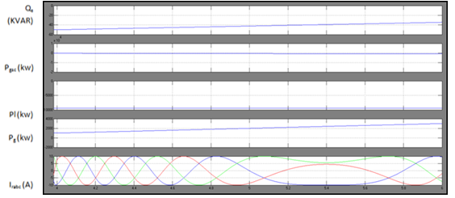 Fig 8.7 Simulated performance of proposed DFIG for fall in wind speed
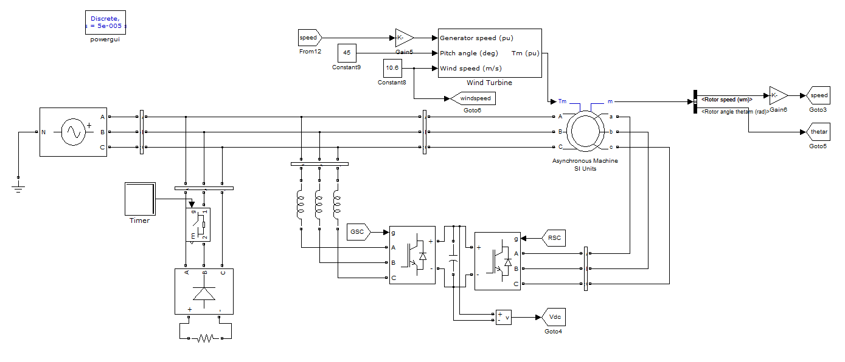
Fig. 8.8 Dynamic performance of DFIG-based WECS for the sudden removal and application of local loads.

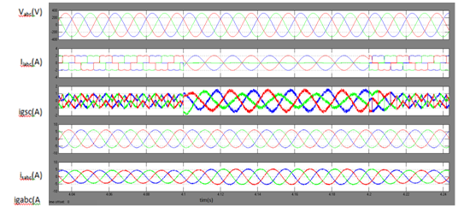
Time(s)
Fig. 8.9 Dynamic performance of DFIG-based WECS for the sudden removal and application of local loads

CONCLUSION
The GSC control algorithm of the proposed DFIG has been modified for supplying the harmonics and reactive power of the local loads. In this proposed DFIG, the reactive power for the induction machine has been supplied from the RSC and the load reactive power has been supplied from the GSC. The decoupled control of both active and reactive powers has been achieved by RSC control. The proposed DFIG has also been verified at wind turbine stalling condition for compensating harmonics and reactive power of local loads. This proposed DFIG-based WECS with an integrated active filter has been simulated using MATLAB/Simulink environment, and the simulated results are verified with test results of the developed prototype of this WECS. PI controller is used for the harmonic reduction of GSC and RSC controller. Steady-state performance of the proposed DFIG has been demonstrated for a wind speed. Dynamic performance of this proposed GSC control algorithm has also been verified for the variation in the wind speeds and for local nonlinear load.

REFERENCES

[1] D. M. Tagare, Electric Power Generation the Changing Dimensions. Piscataway, NJ, USA: IEEE Press, 2011.

[2] G. M. Joselin Herbert, S. Iniyan, and D. Amutha, “A review of technical issues on the development of wind farms,” Renew. Sustain. Energy Rev., vol. 32, pp. 619–641, 2014.

[3] I.Munteanu, A. I. Bratcu, N.-A. Cutululis, and E. Ceang, Optimal Control of Wind Energy Systems Towards a Global Approach. Berlin, Germany: Springer-Verlag, 2008.

[4] A. A. B. Mohd Zin, H. A. Mahmoud Pesaran, A. B. Khairuddin, L. Jahanshaloo, and O. Shariati, “An overview on doubly fed induction generators controls and contributions to wind based electricity generation,” Renew. Sustain. Energy Rev., vol. 27, pp. 692–708, Nov. 2013.

[5] S. S. Murthy, B. Singh, P. K. Goel, and S. K. Tiwari, “A comparative study of fixed speed and variable speed wind energy conversion systems feeding the grid,” in Proc. IEEE Conf. Power Electron. Drive Syst. (PEDS’07), Nov. 27–30, 2007, pp. 736–743.

[6] D. S. Zinger and E. Muljadi, “Annualized wind energy improvement using variable speeds,” IEEE Trans. Ind. Appl., vol. 33, no. 6, pp. 1444– 1447, Nov./Dec. 1997.

[7] H. Polinder, F. F. A. van der Pijl, G. J. de Vilder, and P. J. Tavner, “Comparison of direct-drive and geared generator concepts for windturbines,” IEEE Trans. Energy Convers., vol. 21, no. 3, pp. 725–733, Sep. 2006.

[8] R. Datta and V. T. Ranganathan, “Variable-speed wind power generation using doubly fed wound rotor induction machine—A comparison with alternative schemes,” IEEE Trans. Energy Convers., vol. 17, no. 3, pp. 414–421, Sep. 2002.
[9] E. Muljadi, C. P. Butterfield, B. Parsons, and A Ellis, “Effect of variable speed wind turbine generator on stability of a weak grid,” IEEE Trans. Energy Convers., vol. 22, no. 1, pp. 29–36, Mar. 2007.

[10] R. Pena, J. C. Clare, and G. M. Asher, “Doubly fed induction generator using back-to-back PWM converters and its application to variable-speed wind-energy generation,” IEE Proc. Elect. Power Appl., vol. 143, no. 3, pp. 231–241, May 1996.

[11] S. Muller, M. Deicke, and R. W. De Doncker, “Doubly fed induction generator systems for wind turbines,” IEEE Ind. Appl. Mag., vol. 8, no. 3, pp. 26–33, May/Jun. 2002.

[12] W. Qiao and R. G. Harley, “Grid connection requirements and solutions for DFIG wind turbines,” in Proc. IEEE Energy 2030 Conf. (ENERGY’08), Nov. 17–18, 2008, pp. 1–8.

[13] A. Petersson, T. Thiringer, L. Harnefors, and T. Petru, “Modeling and experimental verification of grid interaction of a DFIG wind turbine,” IEEE Trans. Energy Convers., vol. 20, no. 4, pp. 878–886, Dec. 2005.

[14] H. M. Hasanien, “A set-membership affine projection algorithm-based adaptive-controlled SMES units for wind farms output power smoothing,” IEEE Trans. Sustain. Energy, vol. 5, no. 4, pp. 1226–1233, Oct. 2014.

[15] Z. Saad-Saoud, M. L. Lisboa, J. B. Ekanayake, N. Jenkins, and G. Strbac, “Application of STATCOMs to wind farms,” IEE Proc. Gener. Transmiss. Distrib., vol. 145, no. 5, pp. 511–516, Sep. 1998.

[16] G. O. Suvire and P. E. Mercado, “Combined control of a distribution static synchronous compensator/flywheel energy storage system for wind energy applications,” IET Gener. Transmiss. Distrib., vol. 6, no. 6, pp. 483–492, Jun. 2012.

APPENDIX
1) DFIG: 3.7 kW, Rs= 1.32 ohm, Lls = 6.832 mH, R2 =
1.708 ohm, Llr = 6.832 mH, Rc = 419.646 ohm, Lm =
0.219 H, J = 0.1878 kg · m2, stator to rotor turns ratio
Nr/Ns = 1/2, stator rated rms current = 12 A, rotorrated
rms current = 18 A.
2) DC machine: Ra = 1.3 ohms, Rf = 220 ohms, La =
7.2 mH, Lf = 7.5 mH, KΦ = 1.3314.
3) IEEE-519 limits [35]: Current distortion limits for distribution system (120 to 69 000 V) in Table I.
4) Voltage sensors: LEM made LV25P.
5) Current sensors: LEM made LA25P.
6) GSC: IGBT three-leg Semikron inverter module SKM-
100GB128DN, Lf = 4 mH, 5 kVA star-delta transformer.
7) RSC: IGBT three-leg Semikron inverter module
SKM100GB128DN.
8) Controller gains.
a) Speed controller: kpd = 0.1, kid = 0.12.
b) Current controller; kpdv, kpqv = 100, kidv, kiqv =130.
c) DC-link voltage controller: kpdc = 0.08, kidc = 0.02.

