1. Creating and Renaming Files/Directories:
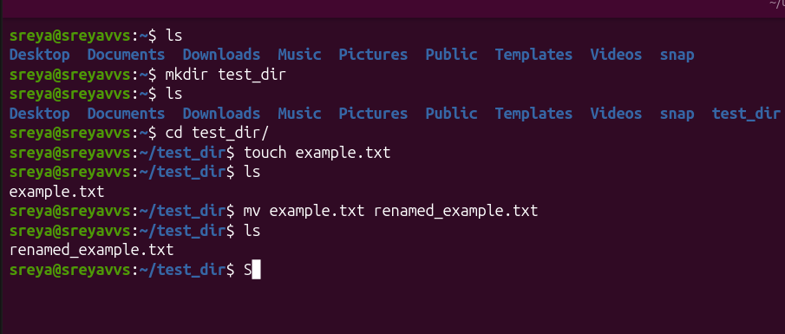

1. mkdir - makes new directory
2. touch- creates new file (any file py, cpp, txt etc)
3. mv - moves or renames the files or dicts, syntax: [mv source_file destination_file]

2. Viewing File Contents
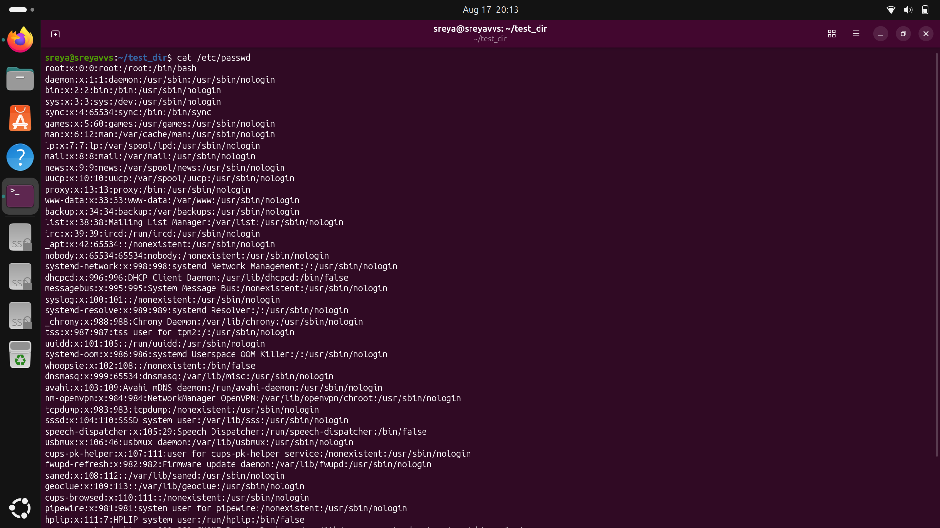
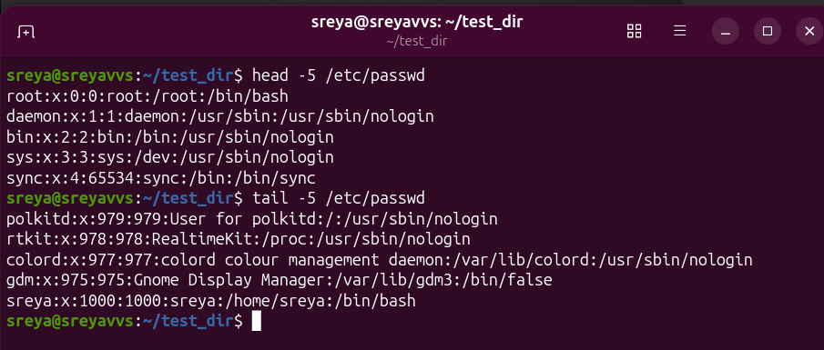
4. cat: displays the contents of the file and creates files and combines the text files.
5. head: head - n displays first n lines of the file
6. tail: tail - n displays last n lines of the file

3. Searching for Patterns
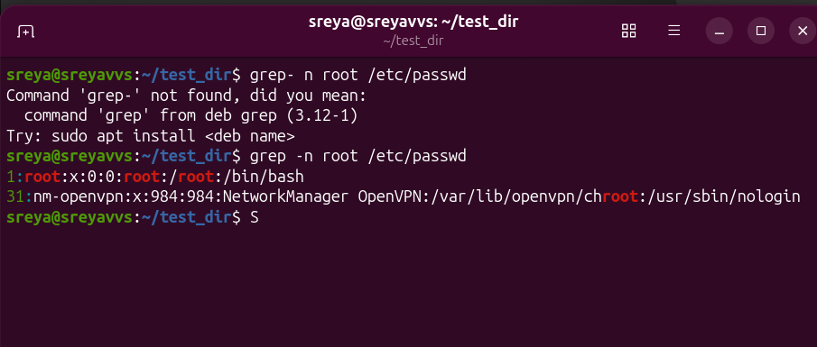
7. grep: grep is used for searching the words in files. -n will give line number

4. Zipping and Unzipping
8. zip: to zip a directory, -r (recurssive) is used. zip -r dest_folder.zip source_folder
9. unzip: to unzip a directory, -d (destination) is used. unzip source_folder.zip -d source_folder
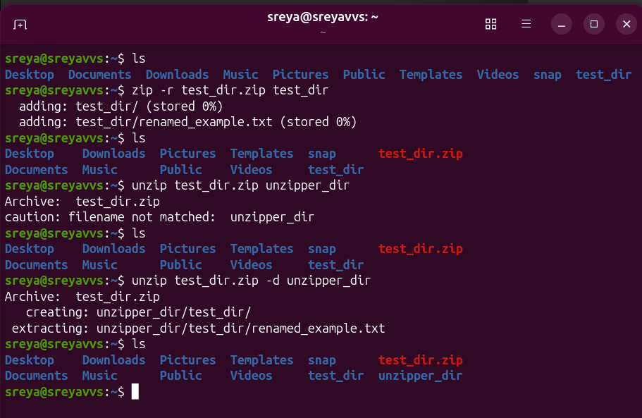
5. Downloading Files
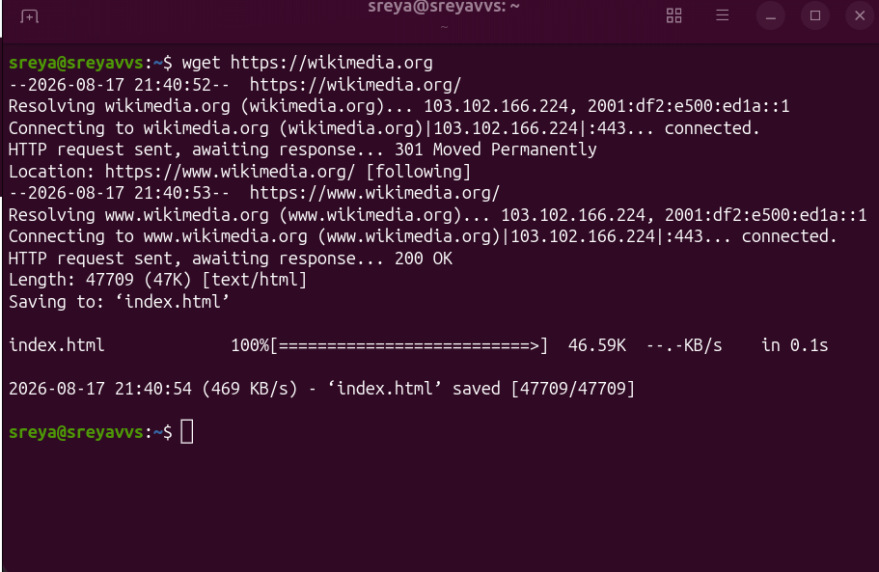
10. wget: download any urls
6. Changing Permissions
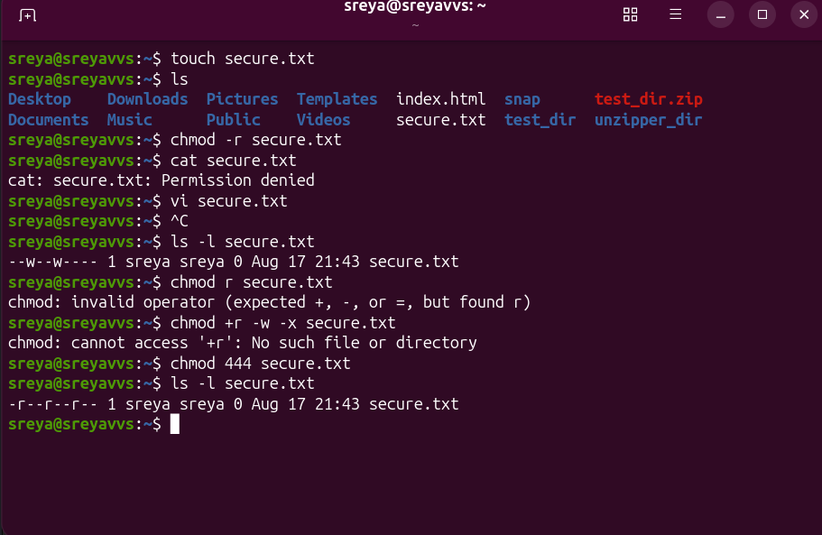
11. chmod: changes the mode of file to get read only 444 is used or chmod +r,-w,-x secure.txt can also be used
7. Working with Environment Variables
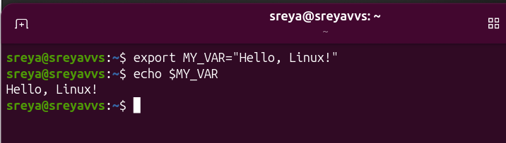
12. export:an environment variable, making it available to all child processes and commands run in that terminal session
echo: is print statement with $.

