DAY 1:
Who invented Python….?
- Creator: Guido van Rossum
- Started: 1989
- First Release: 1991
- Reason: Started as a hobby project during Christmas holidays

Why is it called Python…? Named after the BBC comedy series “Monty Python’s Flying Circus”

Why Python…………………………………….?
- Fewer lines of code
- Easy to learn and read
- High-level language
- Large community and lots of learning resources
High-level and low-level languages: -
High-level (human-friendly): Easy for humans to read and understand. Readable syntax, easier to write and debug, more portable
Low-level (machine-friendly): Machine language, difficult to write and debug, difficult for humans to understand.
Encryption and decryption are used to protect data and keep it secure.
- Encryption: Converting readable data (plaintext) into an unreadable format (ciphertext) using an algorithm/key.
- Decryption: Converting the encrypted data (ciphertext) back into readable data (plaintext) using a key.
DAY 2 – 22-09-26
Interpreter vs. Compiler
Interpreter: Translates and executes code line by line; slower execution
Compiler: Translates the entire program before execution
Open Terminal check the version of Python
Python - - version to check the version
Installing python
python –version
python
help
modules, topics, keywords, …
print () displays the output; allows us to display text
Basic programs in interpreter: -
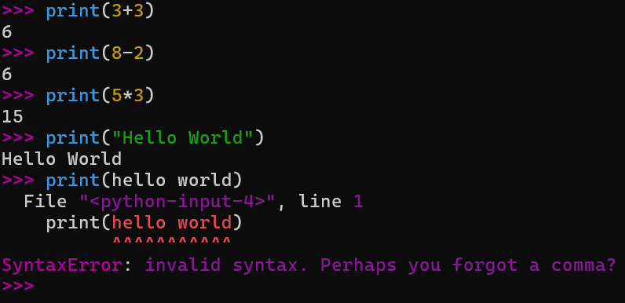
Write code in Notepad:
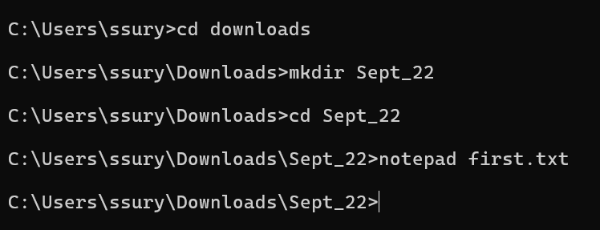
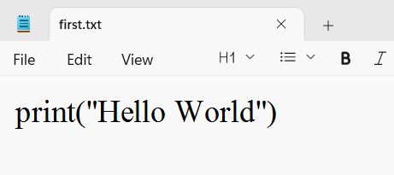
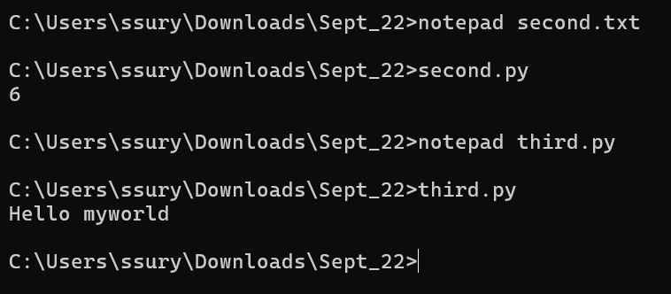
Code in interpreter:
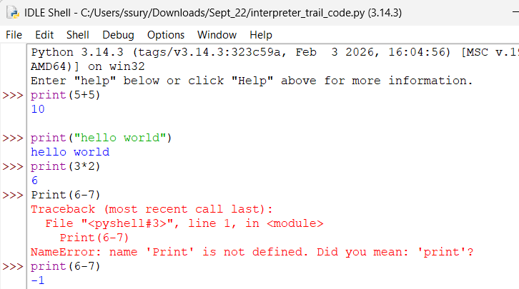
Running code in compiler:
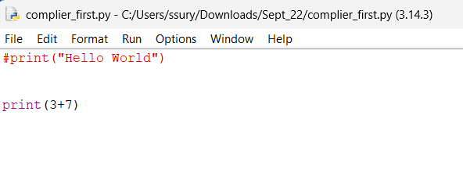
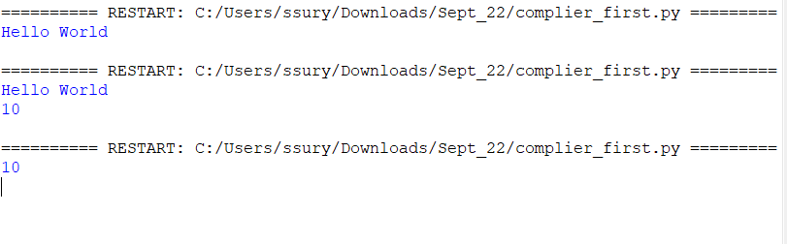
DAY 3 – Variables, string concatenation
Variables: Store data in a program; act as containers.
Variable naming rules:
- Names can contain alphanumeric characters and underscores.
- Can't start with digits.
- Case-sensitive
- Can't use reserved words, i.e. keywords
- Avoid spaces and special characters
Data types & type conversion:
Datatype – type of value stored in variables
Types of data types:
Integers Eg: 9,4,5,6, int
Float 9.0, 8.9,5.6 float
Complex 3 + 9j ( 3 is real number and 9j is imaginary part) complex
String “name”, “section”, “satya” str
Boolean True, False bool
[codes in folder]
Day 4 – Github and Linkedin
How to use GitHub and LinkedIn
Day 5 – Operators
7 types of operators:
1) Arithmetic- + , -, *, //, /, **,%
2) Assignment- +=, -=, *=, //=, /=, **=,%=
3) Comparison- >, <, >=,<=,!=,==
4) Identity- is, is not
5) Logical- and, or, not
6) Membership operators- in, not in
7) Bitwise operators- &, |, ~
Number | 8 | 4 | 2 bit | 1 bit
0 | 0 | 0 | 0 | 0
1 | 0 | 0 | 0 | 1
2 | 0 | 0 | 1 | 0
3 | 0 | 0 | 1 | 1
4 | 0 | 1 | 0 | 0
5 | 0 | 1 | 0 | 1
6 | 0 | 1 | 1 | 0
7 | 0 | 1 | 1 | 1
8 | 1 | 0 | 0 | 0
9 | 1 | 0 | 0 | 1
10 | 1 | 0 | 1 | 0

Day 6- Strings
Indexing is used to access elements in a string
Two types of indexing.
- Positive indexing starts from 0 left to right
- Negative indexing starts from -1 right to left
Slicing: used to access elements by giving an index from start index to stop index
Two types of indexing.
- Positive indexing starts from 0 left to right
- Negative indexing starts from -1 right to left
Striding: to access a specific part of a given string
[start:stop:step]
- Useful for text manipulation
- Step:
  - Positive left to right
  - Negative right to left
  - Trick s[-8:-1:-2]; when using step, first simply start – step = result , result -step……..continue
Day 7- String methods:
len() gives the number of characters in a given string
variable_name.count() number of repeated words or characters in a given string
variable_name.find() finds the given character or word (first occurrence and gives the position of the character or word
Escape sequences:
- \n new line
- \t tab space (1 tab space = 4- 8 spaces)
variable_name.replace() it replaces one word or character with another word or character
variable_name.upper() converts all characters in upper case/capital letters
variable_name.lower() converts all characters in lower case/small letters
conditions – string methods
variable_name.isupper() is uppercase or not
variable_name.islower() is lowercase or not
variable_name.isalnum() given string is alphanumeric or not(no special characters are allowed
variable_name.isdigit() given string is digits
variable_name.strip() remove spaces from the left and right sides (no middle spaces)
variable_name.lstrip() remove spaces from the left side only
variable_name.rstrip() remove spaces from the right side only
Concatenation of strings: a + b + operator to concatenate or join two strings
split() splits all values in one variable
variable_name.join() joins the two strings
Formatting:
- print(“The sum is: ”, a+b)
- print(“hello {} {}”.format(a,b))
- print(f“hello{a}{b}”)
DAY -8 – Lists & Tuples
List:
Definition: collection of different types of data
Properties:
- Mutable,
- Should be in [] square brackets
- Any data type (int, float, string, complex, and bool)
List methods:
- Variable_name.append() - #append --> add one item to an existing list; adding more than one item is also possible, but it automatically creates another list in the existing list
- Variable_name.extend --> add one or more items to the existing list
- Variable_name.insert --> add item at particular position
- Variable_name.index --> gives position of any item
- Variable_name.copy() --> copies the list and returns copied list
- Variable_name.sort --> ascending order(if your list has both upper case and lower case then first it wll consider uppercase, then lower case)
- Variable_name.reverse() --> it prints from end to start of the list
- len() difference in usage of len() in string and list (in strings, it calculates the characters; in lists, it calculates the words)
Tuples:
Definition: collection of different types of data
Properties:
- Immutable,
- Should be in () round brackets
- Any data type (int, float, string, complex, and bool)
Tuple methods only count(), index() and len() as they are immutable
Sets:
- Unordered collections
- Removes duplicates
- Semi-mutable
- Should be in {} brackets
- Any data type (int, float, string, complex, and bool)
Set methods:
- Variable_name.add() adds element in existing set
- Variable_name.issubset() check the list b/ a is part of list a/b
- Variable_name.issuperset()
- Variable_name.union() merges two sets
- Variable_name.intersection () --> it returns common elements from the set
- Variable_name.update() it updates the sets
Day 9 Dictionaries
key-value pairs
Properties:
- Mutable,
- It doesn’t allow duplicates
- Should be in {} brackets
- Any data type (int, float, string, complex, and bool)
Difference between sets and dictionaries:
set only values
dict key-value pairs

dict_methods
- Variable_name.keys() – returns only keys from dict
- Variable_name.values() – returns only values from dict
- Variable_name.items() – returns both keys and values from the dict
- Variable_name.pop() – if you want to remove a particular key-value
- Variable_name.popitem() – it removes the last item from the dict
- Variable_name.update() it adds item in existing dict
- Variable_name.setdefault() - it will set default/ add
- Variable_name.copy() – it copies the dictionary
#difference between update and default- # In update we should put it in dict format whereas default no dict format is required- #in update using{} we can add any number of items whereas in default only one item can be added
list(a) a is converted to a list
tuple()
swapping two variables 4 methods
Day 10 – runtime input()
Day 11 – conditions/Decision making
3 conditions if, else, elif
Usage if, if-else, if- elif-else, multiple elif, multiple if, nested if
We use 4 types of operators: logical, comparison, membership, identity
1 indentation = 1 tab space
= and == difference

= assignment operator | == comparison operator
Assigns a value to a variable | It compares two values.
Stores data in a variable | Checks whether two values are equal or not
Does not return True or False by itself | Returns True or False

Difference between nested if and multiple_if…?
Nested if | Multiple if
If statement written inside another if statement. | Two or more separate if statements
The Inner condition is checked only if the outer condition is true. | Each condition is checked independently.
Used when one condition depends on another. | Used when multiple conditions need separate checks.

Day 12 – Loops
Loops used to execute a block of code repeatedly until a condition is met or all items in a sequence are processed.
6 loops in Python for, while, break, continue, pass, range
- For
sequence iterations; iterations happen in order
While
Break
Range the range function returns a sequence of numbers, by default starting from zero and increments by 1 by 1 and stops before a specified number.

Why for loop in range….?
1 number is the stop
Continue
pass
Difference between break, continue and pass
#break – it is used to terminate the entire loop
#Continue – it is used to skip the current iteration, and the rest of the code will continue
#pass – it is a null statement; it does nothing, but syntactically we need it
DAY 13- HackerRank
Constraints conditions: see properly
Number patterns
Letters patterns
Star patterns
Day 14 – List Comprehensions
#list comprehensions - every list comprehension can be rewritten as a for loop, and every for loop cannot be rewritten as a list comprehensions
#for loop lo list comprehension anedi possible avvadhu .............................................. list comprehension lo for loop anedi use cheyyachu
No elif usage in list comprehensions; we use only if and else
Built in functions: max() , min(), sum()
Max() returns highest number
Min() lowest number
Sum() sum of given input
Day 15 - Functions
- A function is a block of organized, reusable code, and it is used to perform a single or multiple tasks.
- Python has built-in functions like print; you can make your own function also, and these are called user-defined functions.
- Function blocks begin with the keyword “def” followed by the function name and parentheses ()
- # Difference between normal code and functions
- def function_name (a,b):
  - def defining a function; it’s a keyword
  - function_name user-defined (user can give a function)
  - (a, b ) arguments
Difference between print vs return:
print just shows the human user output in the console. Return is used to terminate the function and gives back the value from the function.
Print is a built-in function, and return is a keyword
Print(“Choose options add , sub, mul”)

For storing any data if you want store then prefer list why not tuples, sets, and dictionary: because lists are mutable, allows duplicates; tuples are immutable, sets doesn’t allow duplicates and dictionaries are key value pairs.

#global and local variables Scope of the variables
# a variable is inside and outside the function is called global and a local variable
A variable is defined above the function and is accessible to the entire global space is called a global variable.
A variable is defined inside a function is called local variable.
Four cases:
- Using global variable

- Using both local and global variable
- #definition of global keyword - when user wants to create a variable inside the function directly and carry forward the updated value, we need to use global keyword
#Generators -- no tuple comprehension in the above cases; if we remove those braces and keep parentheses, then the outcome is generators

are nameless functions and we use a keyword called as lambda to create anonymous functions

Lists vs array
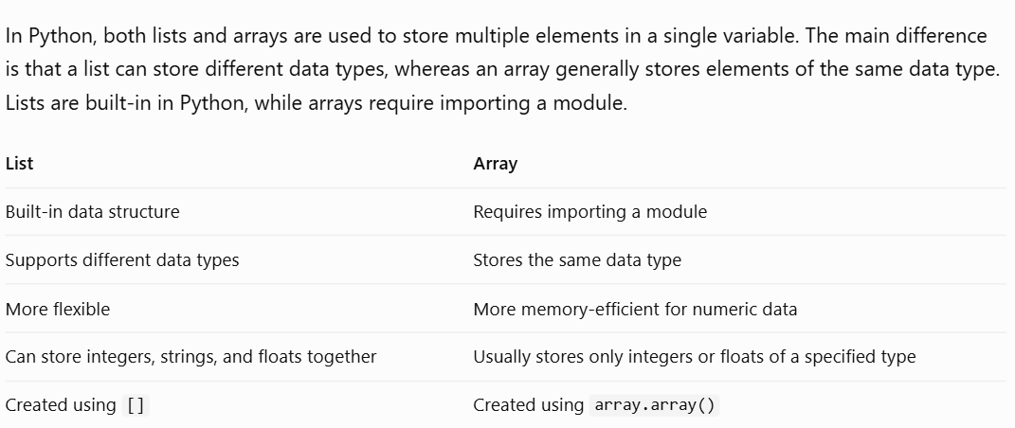

NumPy –
NumPy, short for Numerical Python, is the fundamental package required for high-performance scientific computing and data analysis.
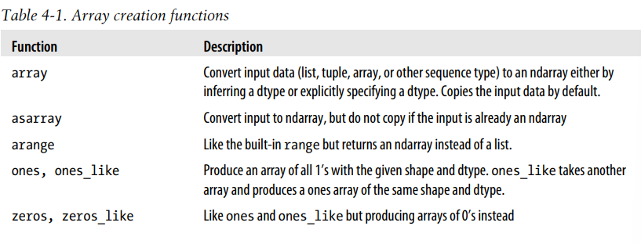
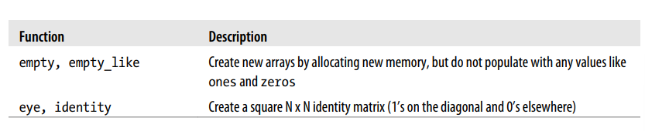

OOPS – Object-Oriented Programming System
- A class contains attributes, variables, methods, and functions that can manipulate the data.
- A class is the blueprint of the object.
- An object is an initiation of a class.
- Methods are functions that are defined inside the body of the class.
4 Pillars of OOP:
- Polymorphism:
In this, we have 4 types:
- Operator overloading
- Operator overriding
- Method overloading
- Method overriding
- Inheritance –
In this, we have 5 types:
- Single Inheritance
- Multiple Inheritance
- Multi-level inheritance
- Hybrid Inheritance
- Hierarchical
- super( )
- Encapsulation –
In this, we have 3 types:
- Public
- _protect
- __private
- Abstraction –
In this, we have 2 types
- Abstract class
- Abstract method

