09-Apr-26:
Web Development Course:
Web Development:
Web development is the process of designing and developing websites using technologies like HTML, CSS, and JavaScript to make them functional and interactive.
Web Site Front End Development+ Backend Development +Database
A website is built using three main parts: Front End Development + Back End Development + Database.
Together, these components make the website visible, functional, and capable of storing data.
Front End Development Technologies:
- HTML
- CSS
- JavaScript
Backend Development:
- Node.js
- Java
- Python
- PHP
Database:
- MySQL
- MongoDB
Key Technologies:
- HTML: The standard markup language for creating web pages.
HTML creates the structure of a webpage.
Ex: Heading, Paragraph, Image, Button, Form
- CSS: A language used to describe the presentation of a web page, including layout, colors, and fonts.
CSS is used to design and style the webpage.
Ex: colors, fonts, spacing, layout, alignment
- JavaScript: A programming language used for client-side(Browser) scripting, enabling dynamic and interactive web pages.
JavaScript makes webpages interactive and dynamic.
Ex: button click actions, form validation, popups, sliders, menus

Client-side(user machine) vs Server-side scripting:
Client-side scripting improves user interaction, while server-side scripting handles business logic and database operations.
Client-side:
Runs inside browser
Example: JavaScript
Server-side:
Runs inside server
Example: Node.js / Java

Example: Login page
Step-by-step:
- User enters username
- Frontend sends request
- Backend verifies data
- Database checks records
- Response sent back to user
Career Opportunities:
- Frontend Developer
- Backend Developer
- Full Stack Developer
- UI Developer
- React Developer
HTML:
- HTML structure deeply
- Basic tags usage
- Page layout creation
- Forms introduction

  - <!DOCTYPE html>
<html>
<head>
<title>Page Title</title>
</head>

<body>

Content

</body>
</html>
<tagname> Content goes here... </tagname>
HtmlRoot Element
HeadMeta information
TittleBrowser Tab name
BodyVisible Content
2.HTML Headings & Paragraphs:
<h1>Main Heading</h1>
<h2>Sub Heading</h2>
<h3>Sub Heading</h3>
<h4>Sub Heading</h4>
<h5>Sub Heading</h5>
<h6>Sub Heading</h6>
<p>This is paragraph text</p>
<div>Seperates the divison</div>
Example:
<!DOCTYPE html>
<html>
<head>
<link rel="stylesheet" href="style.css">
</head>
<body>
<h1 style="color:blue">Hello Skillhub</h1>
<button onclick="showmessage()">Click Me</button>
</body>
<script src="script.js"></script>
(Or)
<script>

function showmessage(){
alert("Welcome Everyone")
}
</script>

</html>
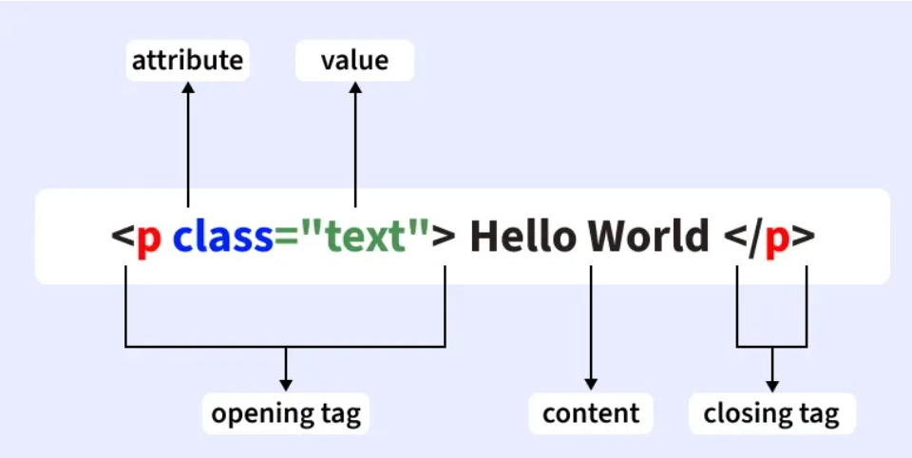
- The <!DOCTYPE html> declaration defines that this document is an HTML5 document
- The <html> element is the root element of an HTML page
- The <head> element contains meta information about the HTML page

- The <title> element specifies a title for the HTML page (which is shown in the browser's title bar or in the page's tab)
- The <body> element defines the document's body, and is a container for all the visible contents, such as headings, paragraphs, images, hyperlinks, tables, lists, etc.
- The <h1> element defines a large heading
- The <p> element defines a paragraph
- <> angle brackets
However, never rely on this! Unexpected results and errors may occur if you forget the end tag!
If you used click as a function name and it’s not working, the most common reason is that click is already a built-in browser event/function name in JavaScript. So it can cause conflicts or unexpected behavior. ⚠️
<button onclick="click()">Click Me</button>

<script>
function click(){
alert("Hello");
}
</script>
click() conflicts with the browser’s default click event method, so it may not run properly.

- Points Need to consider as web developer:
- Web application need to be responsive
- Web app should have good visibility & performance along with user friendly experience
10-Apr-26:
- The HTML <p> element defines a paragraph.
<p>content</p>
- HTML headings are defined with the <h1> to <h6> tags.
- <h1> defines the most important heading. <h6> defines the least important heading.
<h1>Heading 1</h1>
<h2>Heading 2</h2>
<h3>Heading 3</h3>
<h4>Heading 4</h4>
<h5>Heading 5</h5>
<h6>Heading 6</h6>

<input> element: The <input> element is used to create form fields where users can enter data
- We use <input> to collect user information such as:
- Name
- Email
- Phone number
- Password
- Date
- Gender selection
- Upload files
- Submit form
- <input> void element and does not have a closing tag

Ex:
Used to enter short text <input type="text">
Used to enter hidden characters/Password <input type=”password”>
Used to enter email address <input type="email">
Used to enter numbers<input type="number">
Used to select date<input type="date">
Used to select one option <input type="radio">
Used to select multiple options <input type="checkbox">
Used to submit form data <input type="submit">
Placeholder attribute:
Displays hint text inside input box <input placeholder="Enter Name">
Sets default value <input value="Satya">
<label for="name">Name</label>
<input id="name" placeholder="Enter Name">
- for="name" connects label
- id="name" connects input
Ex:
<form>
<label for="username">Username</label>
<input id="username" placeholder="Enter Username">
<br><br>
<label for="password">Password</label>
<input type="password" placeholder="Enter Password">
<br><br>
<input type="submit">
</form>

Key points to remember :
- <input> is used inside forms
- It is a void element
- It does not need closing tag
- type attribute defines input behavior
- label improves accessibility
- placeholder shows hint text
Forms: forms used to collect group of data & it used for validation and send data server
- Note: check without form required
- <form>
- <label for=”text”>Name: </label>
- <input type="text" id=”text”>
- <br><br>

- <label for=”pass”>Password:</label>
- <input type="pass" >
- <br><br>
- <input type="submit">
- </form>
- for attribute improves user experience

4. Lists:
Ordered List: upper-roman,lower-roman,upper-alpha,lower-alpha,decimal
<ol style=”list-style-type:decimal”>
<li>HTML</li>
<li>CSS</li>
<li>JavaScript</li>
</ol>
Unordered List: disc,circle,square,none
<ul>
<li>Apple</li>
<li>Mango</li>
<li>Orange</li>
</ul>
5.Images in HTML:
<img src="image.jpg" width="200">
Attribute | Purpose
src | image location
width | image size
height | image size
alt | accessibility text

6.Links (Anchor Tag):Navigation between pages and to open external pages
<a href="https://google.com">
Visit Google
</a>
7.Tables:
<table border="1">
<tr>
<th>Name</th>
<th>Course</th>
</tr>

<tr>
<td>Satya</td>
<td>Web Development</td>
</tr>

</table>
- tr → row
- th → heading cell
- td → data cell
Ex:
<button style="background-color:#ffffff;color:blue;border-radius:10px">click Me</button>
<span>:It is used to create inline content for block level elements
<p style="color:red">Hello <span style="color:blue">Satya</span> </p>
8. The HTML <pre> element defines preformatted text.
The text inside a <pre> element is displayed in a fixed-width font (usually Courier), and it preserves both spaces and line breaks:
Ex: <pre>
My Bonnie lies over the ocean.
My Bonnie lies over the sea.
My Bonnie lies over the ocean.
Oh, bring back my Bonnie to me.
</pre>
9.HTML Comment Tag: HTML comments are not displayed in the browser, but they can help document your HTML source code
<!-- Write your comments here -->
10. Hyperlinks: The HTML <a> tag defines a hyperlink.
<a href="url">link text</a>
The target attribute specifies where to open the linked document.
- _self - Default. Opens the document in the same window/tab as it was clicked
- _blank - Opens the document in a new window or tab
- _parent - Opens the document in the parent frame
- _top - Opens the document in the full body of the window
<a href="https://www.w3schools.com/" target="_blank">Visit W3Schools!</a>

Absolute URLs vs. Relative URLs
- Both examples above are using an absolute URL (a full web address) in the href attribute.
- A local link (a link to a page within the same website) is specified with a relative URL (without the "https://www" part)
a:hover when mousing over a link
10. The Title Element: Every web page should have a page title to describe the meaning of the page.
<!DOCTYPE html>
<html>
<head>
<title>HTML Tutorial</title>
</head>
<body>
The content of the document......
</body>
</html>
The page title is very important for search engine optimization (SEO).
11. HTML Block and Inline Elements:
Block-level Elements: A block-level element always starts on a new line, and the browsers automatically add some space (a margin) before and after the element.
Ex: <p> and <div>.
Inline Elements: An inline element does not start on a new line.
An inline element only takes up as much width as necessary.
Ex:<span></span>
12. The HTML <button> element defines a clickable button.
<button>Click Me</button>
13. An HTML iframe is used to display a web page within a web page.
<iframe src="url" title="description"></iframe>
14. Semantic Elements
A semantic element clearly describes its meaning to both the browser and the developer.
Examples of non-semantic elements: <div> and <span> - Tells nothing about its content.
Examples of semantic elements: <img>, <table>, and <article> - Clearly defines its content.
15.Grids:
The Grid Layout Module offers a grid-based layout system, with rows and columns.
display: grid;
grid-template-columns: auto auto auto;
Term | Meaning
Grid container | parent element
Grid item | children
Grid line | divider lines
Grid row | horizontal space
Grid column | vertical space
Grid cell | single box
Grid area | group of cells
.container{
display:grid;
grid-template-columns:100px 100px 100px;
} Creates 3 columns.
.container{
display:grid;
grid-template-columns:100px 200px 150px;
}
Creates 3 columns with fixed widths.
grid-template-columns:1fr 1fr 1fr; fr = fraction of available space
grid-template-columns:1fr 2fr 1fr; | 1 part | 2 parts | 1 part |
grid-template-rows
grid-template-rows:100px 200px; Creates 2 rows.
gap:10px; row-gap:10px;
column-gap:20px;
justify-content:center; Moves grid horizontally
align-content:center; Moves grid vertically

Task:
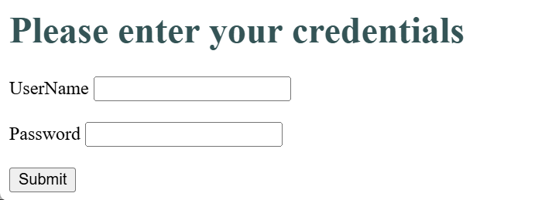

Username:
Phone Num:
Email:
Confirm:
password:
Confirm-Email:
Username:
Username:
Username:
Sumbit

