CONFIDENTIAL

Project name: Employee Management System

Class Design Specification

DOCUMENT VERSION HISTORY

Document Version | Date Issued | Comments
1.0 | 12-07-2019 | First version of the Web Portal

Table of Contents

Table of Contents 2
Class Design
1 Introduction 3
2 Conventions followed 3
3 Class Diagrams 4

Introduction

The class diagram is the main building block of object oriented modelling. It is used both for general conceptual modelling of the systematics of the application, and for detailed modelling translating the models into programming code. Class diagrams can also be used for data modeling. The classes in a class diagram represent both the main objects and or interactions in the application and the objects to be programmed. In the class diagram these classes are represented with boxes which contain three parts:
A class with three sections:
- The upper part holds the name of the class
- The middle part contains the attributes of the class
- The bottom part gives the methods or operations the class can take or undertake

Conventions followed

Hungarian Convention

Class Diagrams

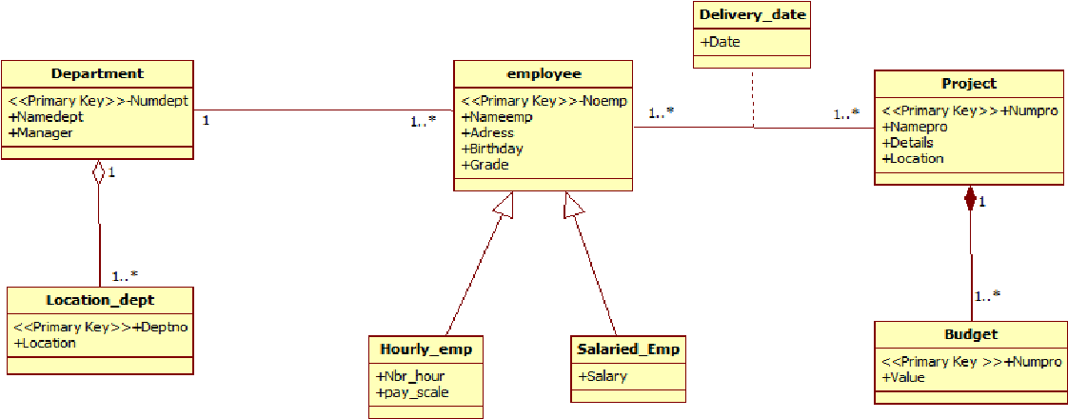

Classes

Admin

Class Description :
The Administrator class holds those attributes and functions which may be used for the functioning of the system. The administrator manages employee, new employee and any user. The administrator uploads the fresh data to the management so that when requires it can be used.

Methods
 | Function | OutPut Parameters | Description
1 | deleteUser(String, String, String) | int | This function deletes the existing user from the database
2 | login(String, String) | int | checks for the authentic username and password and provides the login
3 | updateData(String, String, String, String, String) | int | the administrator make changes in the user details, qualifications, etc
4 | receivePayments(String, String, String, String, String) | int | enables to receive payments from the user
5 | uploadMaterials(String, String, String) | int | the administrator uploads materials which can be accessed online or downloaded and can be used by user for learning
6 | update(String) | int | the administrator keeps the website updated by updating the home page details
7 | moderatecomments(String, String, String, String) | int | the administrator views the comments and moderates them.
8 | updatesJobBoard(String, String, String, String, String) | int | the administrator updates the latest jobs available and is very useful for the tutors who want good money and students
9 | updatesLatestTutors(String, String, String, String) | int | the administrator updates the latest tutors i.e. give the new tutors the chance to establish themselves and get good monetary value
10 | updateNews(String, String) | int | the administrator keeps its user updated with the world by giving them regular updates about the new technologies and subjects

HR’s:

Methods
 | Function | OutPut Parameters
1 | register(String, String, String, String, String, String, String, String, String, String, String) | Int
2 | login(String, String,String) | Int

