Use Case Specification

DMT/RM01/TMP

|  |  |
| --- | --- |
| Project Code | PRJ_AssetManagementSystem _001 |
| Project Name | Asset Management System |

|  |  |  |
| --- | --- | --- |
| Prepared/Modified by | Role | Date of Preparation |
| Himanshu/Indraneel | Associate Consultant | 4th October, 2017 |
| Reviewed by | Role | Date of Review |
| Dayanand Patil | Assistant Manager | 4th October, 2017 |
| Approved by | Role | Date of Approval |
| Shilpa Bhosle | Deputy Manager | 4th October, 2017 |
| Circulation List |  | Version Number of the template:1.1 |
| Version Number | 1.1 |  |

<<Customer>> REVIEW HISTORY

<<Customer comments on the Use case along with the signed off is tracked here>>

|  |  |  |  |  |  |  |
| --- | --- | --- | --- | --- | --- | --- |
| Version | 1.0 |  |  |  |  |  |
| Date | <<Date of Review>> |  |  |  |  |  |
| Reviewed by | << Reviewer Name>> |  |  |  |  |  |
| Reviewed UI Specification doc | << Whether UI Specification doc is reviewed >> |  |  |  |  |  |
| All Open Queries/issues closed | << Whether all the open queries and issues resolved>> |  |  |  |  |  |
| Agreement on Assumptions | <<Whether all the assumptions have been agreed upon by the customer>> |  |  |  |  |  |
| Sign Off | <<Signature>> |  |  |  |  |  |

Disclaimer:

The scope of the project ‘**Asset Management System** is restricted to the contents of this signed off use case.

TABLE OF CONTENTS

1. Use Case Name: Login to the University Admission System 5

2. Actor(s) 5

3. Preconditions 5

4. Flow of Events 5

4.1 Basic Flow 5

4.2 Alternative Flows 5

4.2.1 Alternate Flow 1: successful login to BEP on second attempt 5

4.2.2 Alternate Flow 2 6

Exception Flow 1: Web Server Down 6

Exception Flow 2: Database Connectivity Error 6

Exception Flow 3: Network Connectivity Error 6

5. Post Conditions 6

6. Special Requirements 7

Performance 7

Availability 7

User Interface 7

Security 7

7. Extension Points 7

Extension in Alternate Flow 1: 7

Extension in Alternate Flow x: 8

8. Business Rules 8

9. Diagrams 9

Use Case Diagram for 9

10. Scenarios 9

Success Scenarios 9

Failure Scenarios 9

11. Issues 10

12. UI Specifications 10

13. Inter System Dependencies 10

14. Integration with an already existing System of the <<Customer>> 10

15. Assumptions 10

1. Use Case Name: Adding Asset In the Asset Management System

**Use Case ID:**  BEP.ADMIN.ADDEXAM_001

**Brief Description:** This Use Case describes the process by which administrator can add a new exam to the existing set of exams.

1. Actor(s)
2. Administrator
3. Preconditions
4. Administrator is an employee of a Banking Exam Portal company.
5. Administrator has an access to the Banking Exam Portal Website.
6. Administrator has a valid user id and a password.
7. Administrator has already logged in to the banking exam portal
8. Flow of Events

4.1 Basic Flow

Name: Successful adding a new exam to the existing set of exams

1. Administrator clicks on the **Add Exam Details** link available on the Admin Home Page
2. The system navigates the administrator to the Add an Exam Web page
3. Administrator enters name of the exam in **Exam Name**
4. Administrator enters name of the bank in **Bank Name**
5. Administrator selects date of commencement of online registration
6. Administrator selects date of clousure of online application
7. Administrator select date of the exam in **Exam Date**
8. Administrator enters description about the exam.
9. Administrator enters **Examination Fees**
10. Administrator clicks on the **Submit** button to complete the process of adding a new exam
11. The system validates all the fields as per the rules
    1. Alternative Flows

4.2.1 Alternate Flow 1: successful login to BEP on second attempt due to incorrect exam date

1. Administrator clicks on the **Add Exam Details** link available on the Admin Home Page
2. The system navigates the administrator to the Add an Exam Web page
3. Administrator enters name of the exam in **Exam Name**
4. Administrator enters name of the bank in **Bank Name**
5. Administrator selects date of commencement of online registration
6. Administrator selects date of clousure of online application
7. Administrator select date of the exam in **Exam Date**
8. Administrator enters description about the exam.
9. Administrator enters **Examination Fees**
10. Administrator clicks on the **Submit** button to complete the process of adding a new exam
11. The system validates all the fields as per the rules
12. The system propmts the administrator to re-enter the **Exam Date**
13. Administrator clicks on the **Submit** button to complete the process of adding a new exam
14. The system validates all the fields as per the rules

* + 1. Alternate Flow 2:successful login to BEP on second attempt due to Exam fees not mentioned

1. Administrator clicks on the **Add Exam Details** link available on the Admin Home Page
2. The system navigates the administrator to the Add an Exam Web page
3. Administrator enters name of the exam in **Exam Name**
4. Administrator enters name of the bank in **Bank Name**
5. Administrator selects date of commencement of online registration
6. Administrator selects date of clousure of online application
7. Administrator select date of the exam in **Exam Date**
8. Administrator enters description about the exam.
9. Administrator clicks on the **Submit** button to complete the process of adding a new exam
10. The system validates all the fields as per the rules
11. The system propmts the administrator to enter the **Examination Fees**
12. Administrator clicks on the **Submit** button to complete the process of adding a new exam
13. The system validates all the fields as per the rules

Exception Flow 1: Web Server Down

1. Administrator clicks on the **Add Exam Details** link available on the Admin Home Page
2. The system displays an error message regarding web server unavailability problem

Exception Flow 2: Database Connectivity Error

1. Administrator clicks on the **Add Exam Details** link available on the Admin Home Page
2. The system navigates the administrator to the Add an Exam Web page
3. Administrator enters name of the exam in **Exam Name**
4. Administrator enters name of the bank in **Bank Name**
5. Administrator selects date of commencement of online registration
6. Administrator selects date of clousure of online application
7. Administrator select date of the exam in **Exam Date**
8. Administrator enters description about the exam.
9. Administrator clicks on the **Submit** button to complete the process of adding a new exam
10. The system validates all the fields as per the rules
11. The system displays an error message regarding database connectivity problem.

Exception Flow 3: Network Connectivity Error

1. Administrator clicks on the **Add Exam Details** link available on the Admin Home Page
2. The system navigates the administrator to the Add an Exam Web page
3. Administrator enters name of the exam in **Exam Name**
4. Administrator enters name of the bank in **Bank Name**
5. Administrator selects date of commencement of online registration
6. Administrator selects date of clousure of online application
7. Administrator select date of the exam in **Exam Date**
8. Administrator enters description about the exam.
9. Administrator clicks on the **Submit** button to complete the process of adding a new exam
10. The system validates all the fields as per the rules
11. The system displays an error message regarding network connectivity problem.
12. Post Conditions

| Flow Name | Post Condition |
| --- | --- |
| Successful adding a new exam in the Banking Exam Portal | Administrator will successfully add a new exam to the existing set of exams |
| Login to the Banking Exam Portal with reattempt due to incorrect exam date | Administrator will successfully add a new exam to the existing set of exams |
| Login to the Banking Exam Portal with reattempt due to Exam fees not mentioned | Administrator will successfully add a new exam to the existing set of exams |
| Web Server Down | The system should display an error message to the admin regarding web server unavailability problem |
| Database Connectivity Error | The system should display an error message to the admin regarding the database connectivity problem |
| Network Connectivity Error | The system should display an error message to the admin regarding the network connectivity problem |

1. Special Requirements

Performance

1. The Exam Code should be displayed within 2 seconds of entering exam name.

Availability

* 1. The admin can add a new exam details on any days 24x .

User Interface

* 1. The letters on Menus shall be bold
  2. The logout and back button should be available on every page of the application
  3. The reset buttom should reset the form
  4. The cancel button should cancel the form entry and bring admin to the admin home page

Security

1. The BEP will allow admin to Cancel the form at any point.
2. Extension Points

Extension in Alternate Flow 1:

In step 7, if the admin has entered wrong date :

1. The system prompts the admin to re-enter the exam date

2. Admin enters the correct date

3. Administrator clicks on the **Submit** button to complete the process of adding a new exam

4. The system validates all the fields as per the rules

Extension in Alternate Flow x:

In step y, if the customer has not entered any detail :

1. The system displays error message saying mandatory fields necessary
2. User either backs out of this use case, or tries again after rectifying the cause.
3. Business Rules

| Business Rule Name | Business Rule Description | System action (if BR fails) |
| --- | --- | --- |
| BR01 | All fields on the Add Exam page are mandatory | Displays error message “All fields are mandatory” |
| BR02 | The exam name should be unique | Displays error message “duplicate exam name” |
| BR03 | Exam code to be auto-generated once the exam name is enterd | Successful generation of exam code |
| BR04 | The commencement of online registration date should be a future date | Displays error message “Enter a future date” |
| BR05 | Closure date of online application should be 30 days from commencement date | Displays error message “Entered date must be 30 days from commencement date” |
| BR06 | Exam date should be atleast 60 days ahead of the commencement date | Displays error message ”Entered date should be atleast 60 days ahead of the commencement date” |

1. Diagrams

Use Case Diagram for

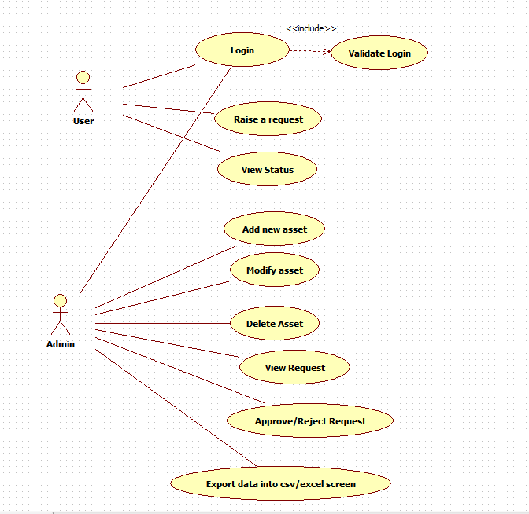

1. Scenarios

Success Scenarios

* Successful addition of a new exam details to the exixting set of exams
* Successful addition of a new exam details reattempt

Failure Scenarios

* Web Server Down
* Database Connectivity Error
* Network Connectivity Error

1. Issues

* What is the maximum size of username and password that a user can have ?
* What if the user is blocked after invalid login attempts for three times ?

1. UI Specifications

<< Provide a link to the UI specification document of the Use case. Please don’t embed the document here>>

1. Inter System Dependencies

**Module: ‘**Apply Online for Course’ gets impacted due to :

Use case name: Alternate Flow 1

**Impact**: If the user tries to apply for a course without login, he should be denied so.

1. Integration with an already existing System of the <<Customer>>

<< This is especially applicable if the project at hand is an enhancement to an existing system.>>

1. Assumptions

<< List down all the assumptions considered by this use case>>

REVISION HISTORY OF THE WORK PRODUCT

<to be maintained by projects>

|  |  |  |  |  |  |
| --- | --- | --- | --- | --- | --- |
| # | Date | Version # | Section Changed | Details of changes made | Approved By |
| 1 |  |  |  |  |  |
| 2 |  |  |  |  |  |