Use Case Specification

DMT/RM01/TMP

|  |  |
| --- | --- |
| Project Code | PRJ_AssetManagementSystem _001 |
| Project Name | Asset Management System |

|  |  |  |
| --- | --- | --- |
| Prepared/Modified by | Role | Date of Preparation |
| Himanshu/Indraneel | Associate Consultant | 4th October, 2017 |
| Reviewed by | Role | Date of Review |
| Dayanand Patil | Assistant Manager | 4th October, 2017 |
| Approved by | Role | Date of Approval |
| Shilpa Bhosle | Deputy Manager | 4th October, 2017 |
| Circulation List |  | Version Number of the template:1.1 |
| Version Number | 1.1 |  |

<<Customer>> REVIEW HISTORY

<<Customer comments on the Use case along with the signed off is tracked here>>

|  |  |  |  |  |  |  |
| --- | --- | --- | --- | --- | --- | --- |
| Version | 1.0 |  |  |  |  |  |
| Date | <<Date of Review>> |  |  |  |  |  |
| Reviewed by | << Reviewer Name>> |  |  |  |  |  |
| Reviewed UI Specification doc | << Whether UI Specification doc is reviewed >> |  |  |  |  |  |
| All Open Queries/issues closed | << Whether all the open queries and issues resolved>> |  |  |  |  |  |
| Agreement on Assumptions | <<Whether all the assumptions have been agreed upon by the customer>> |  |  |  |  |  |
| Sign Off | <<Signature>> |  |  |  |  |  |

Disclaimer:

The scope of the project ‘**Asset Management System’** is restricted to the contents of this signed off use case.

TABLE OF CONTENTS

1. Use Case Name: Login to the Asset Management System 5

2. Actor(s) 5

3. Preconditions 5

4. Flow of Events 5

4.1 Basic Flow 5

4.2 Alternative Flows 5

4.2.1 Alternate Flow 1: successful login to AMS on second attempt 5

4.2.2 Alternate Flow 2 6

Exception Flow 1: Web Server Down 6

Exception Flow 2: Database Connectivity Error 6

Exception Flow 3: Network Connectivity Error 6

5. Post Conditions 6

6. Special Requirements 7

Performance 7

Availability 7

User Interface 7

Security 7

7. Extension Points 7

Extension in Alternate Flow 1: 7

Extension in Alternate Flow x: 8

8. Business Rules 8

9. Diagrams 9

Use Case Diagram for 9

10. Scenarios 9

Success Scenarios 9

Failure Scenarios 9

11. Issues 10

12. UI Specifications 10

13. Inter System Dependencies 10

14. Integration with an already existing System of the <<Customer>> 10

15. Assumptions 10

1. Use Case Name: Modify Asset In the Asset Management System

**Use Case ID:**  AMS.ADMIN.MODIFYASSET_001

**Brief Description:** This Use Case describes the process by which administrator can modify an existing asset.

1. Actor(s)
2. Administrator
3. Preconditions
4. Administrator is an employee of a Asset Management System company.
5. Administrator has an access to the Asset Management System Website.
6. Administrator has a valid Name and a password.
7. Administrator has already logged in to the Asset Management System portal
8. Flow of Events

4.1 Basic Flow

Name: Successful modification of an existing asset

1. Administrator clicks on the **Add/Modify Asset** link available on the Admin Main Page.
2. The system navigates the administrator to the Add/Modify Web page.
3. Administrator clicks on **Modify Asset** link available on the Add/Modify Web page.
4. The system navigates the administrator to the Modify Web page.
5. Administrator selects an asset.
6. Administrator clicks on Modify Button.
7. The system navigates the administrator to the Modify Asset Web page
8. Administrator enters description about the Asset in **Asset Description**.
9. Administrator enters quantity of asset in **Asset Quantity**
10. The system displays Asset ID in **Asset ID** field
11. Administrator clicks on the **Update** button to complete the process of updating an Asset
12. The system validates all the fields as per the rules
    1. Alternative Flows

4.2.1 Alternate Flow 1: successful Asset Addition to AMS on second attempt due to Asset Quantity Not Mentioned

1. Administrator clicks on the **Add/Modify Asset** link available on the Admin Main Page.
2. The system navigates the administrator to the Add/Modify Web page.
3. Administrator clicks on **Modify Asset** link available on the Add/Modify Web page.
4. The system navigates the administrator to the Modify Web page.
5. Administrator selects an asset.
6. Administrator clicks on Modify Button.
7. The system navigates the administrator to the Modify Asset Web page
8. Administrator enters description about the Asset in **Asset Description**.
9. The system displays Asset ID in **Asset ID** field
10. Administrator clicks on the **Update** button to complete the process of updating an Asset
11. The system validates all the fields as per the rules
12. The system propmts the administrator to enter the **Asset Quantity**
13. Administrator clicks on the **Update**  button to complete the process of updating the Asset
14. The system validates all the fields as per the rules

Exception Flow 1: Web Server Down

1. Administrator clicks on the **Add/Modify Asset** link available on the Admin Home Page
2. The system displays an error message regarding web server unavailability problem

Exception Flow 2: Database Connectivity Error

1. Administrator clicks on the **Add/Modify Asset** link available on the Admin Main Page.
2. The system navigates the administrator to the Add/Modify Web page.
3. Administrator clicks on **Modify Asset** link available on the Add/Modify Web page.
4. The system navigates the administrator to the Modify Web page.
5. Administrator selects an asset.
6. Administrator clicks on Modify Button.
7. The system navigates the administrator to the Modify Asset Web page
8. Administrator enters description about the Asset in **Asset Description**.
9. Administrator enters quantity of asset in **Asset Quantity**
10. The system displays Asset ID in **Asset ID** field
11. Administrator clicks on the **Update** button to complete the process of updating an Asset
12. The system validates all the fields as per the rules
13. The system displays an error message regarding database connectivity problem.

Exception Flow 3: Network Connectivity Error

1. Administrator clicks on the **Add/Modify Asset** link available on the Admin Main Page.
2. The system navigates the administrator to the Add/Modify Web page.
3. Administrator clicks on **Modify Asset** link available on the Add/Modify Web page.
4. The system navigates the administrator to the Modify Web page.
5. Administrator selects an asset.
6. Administrator clicks on Modify Button.
7. The system navigates the administrator to the Modify Asset Web page
8. Administrator enters description about the Asset in **Asset Description**.
9. Administrator enters quantity of asset in **Asset Quantity**
10. The system displays Asset ID in **Asset ID** field
11. Administrator clicks on the **Update** button to complete the process of updating an Asset
12. The system validates all the fields as per the rules
13. The system displays an error message regarding network connectivity problem.
14. Post Conditions

| Flow Name | Post Condition |
| --- | --- |
| Successful updatig Asset in the Asset Management System Portal | Administrator will successfully update Asset to the existing set of Assets |
| Asset Updation to the Asset Management System with reattempt due asset quantity not mentioned | Administrator will successfully update Asset to the existing set of Assets |
| Web Server Down | The system should display an error message to the admin regarding web server unavailability problem |
| Database Connectivity Error | The system should display an error message to the admin regarding the database connectivity problem |
| Network Connectivity Error | The system should display an error message to the admin regarding the network connectivity problem |
|  |  |

1. Special Requirements

Performance

1. The Add/Modify Page should be displayed within 2 seconds of clicking Add/Modify Asset link on Admin home page.
2. The Add Asset Page should be displayed within 2 seconds of clicking Add Asset link on Add/Modify page.

Availability

* 1. The admin can update an Asset details on any days 24x7 .

User Interface

* 1. The Home , About Us and logout link should be available on every page of the application
  2. The active links shoul be displayed in red color
  3. The visited links should be displayed in purpule color

Security

1. The AMS will allow admin to Close the form at any point.
2. Extension Points

Extension in Alternate Flow 1:

If the admin has not entered Asset Quantity :

1. The system prompts the admin to enter the Asset Quantity

2. Admin enters the Asset Quantity

3. Administrator clicks on the **Update** button to complete the process of adding a new Asset

4. The system validates all the fields as per the rules

1. Business Rules

| Business Rule Name | Business Rule Description | System action (if BR fails) |
| --- | --- | --- |
| BR01 | All Fields on the Modify Asset page are mandatory | Displays error message “ All fields are mandatory” |
| BR02 | The Asset name should be of maximum 25 characters | Displays error message “Name should be less than 25 characters” |
| BR03 | The Asset description should be of maximum 25 characters | Displays error message “Description should be less than 25 characters” |
| BR04 | Asset Quantity Field should accept only numbers | Displays error message “Enter only numbers” |
| BR05 | Asset ID show be Unique |  |

1. Diagrams

Use Case Diagram for

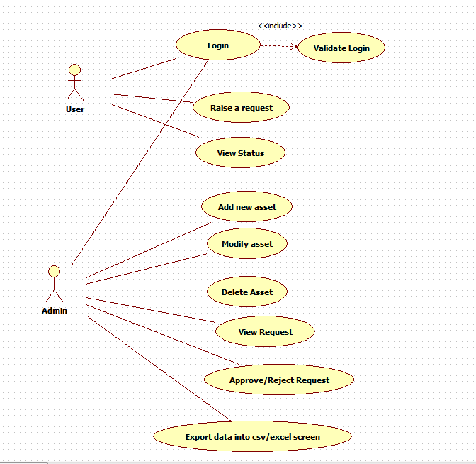

1. Scenarios

Success Scenarios

* Successful updation of Asset details to the exixting set of Assets
* Successful addition of a new Asset details on reattempt

Failure Scenarios

* Web Server Down
* Database Connectivity Error
* Network Connectivity Error

1. Issues

* What is the maximum number of quantity admin can enter?
* What if we want to change the Asset Name?
* Shouldn’t Asset ID field be non editable?

1. UI Specifications

<< Provide a link to the UI specification document of the Use case. Please don’t embed the document here>>

1. Inter System Dependencies

**Module: ‘**Apply Online for Course’ gets impacted due to :

Use case name: Alternate Flow 1

**Impact**: If the user tries to apply for a course without login, he should be denied so.

1. Integration with an already existing System of the <<Customer>>

<< This is especially applicable if the project at hand is an enhancement to an existing system.>>

1. Assumptions

<< List down all the assumptions considered by this use case>>

REVISION HISTORY OF THE WORK PRODUCT

<to be maintained by projects>

|  |  |  |  |  |  |
| --- | --- | --- | --- | --- | --- |
| # | Date | Version # | Section Changed | Details of changes made | Approved By |
| 1 |  |  |  |  |  |
| 2 |  |  |  |  |  |