Use Case Specification

DMT/RM01/TMP

|  |  |
| --- | --- |
| Project Code | PRJ_BankingExamPortal _001 |
| Project Name | Asset Management System |

|  |  |  |
| --- | --- | --- |
| Prepared/Modified by | Role | Date of Preparation |
| Neelima Padmawar | Assistant Manager | 7th August, 2016 |
| Reviewed by | Role | Date of Review |
| Dayanand Patil | Assistant Manager | 8th August, 2016 |
| Approved by | Role | Date of Approval |
| Shilpa Bhosle | Deputy Manager | 9th August, 2016 |
| Circulation List |  | Version Number of the template:1.1 |
| Version Number | 1.1 |  |

<<Customer>> REVIEW HISTORY

<<Customer comments on the Use case along with the signed off is tracked here>>

|  |  |  |  |  |  |  |
| --- | --- | --- | --- | --- | --- | --- |
| Version | 1.0 |  |  |  |  |  |
| Date | <<Date of Review>> |  |  |  |  |  |
| Reviewed by | << Reviewer Name>> |  |  |  |  |  |
| Reviewed UI Specification doc | << Whether UI Specification doc is reviewed >> |  |  |  |  |  |
| All Open Queries/issues closed | << Whether all the open queries and issues resolved>> |  |  |  |  |  |
| Agreement on Assumptions | <<Whether all the assumptions have been agreed upon by the customer>> |  |  |  |  |  |
| Sign Off | <<Signature>> |  |  |  |  |  |

Disclaimer:

The scope of the project ‘**Asset Management System’** is restricted to the contents of this signed off use case.

TABLE OF CONTENTS

Use Case Name: Login to the Asset Management System 4

1. Actor(s) 4

2. Preconditions 4

3. Flow of Events 4

4.1 Basic Flow 4

4.2 Alternative Flows 5

4.2.1 Alternate Flow 1: successful login to AMS on second attempt 5

4.2.2 Alternate Flow 2 5

Exception Flow 1: Web Server Down 5

Exception Flow 2: Database Connectivity Error 5

Exception Flow 3: Network Connectivity Error 5

4. Post Conditions 6

5. Special Requirements 6

Performance 6

Availability 6

User Interface 6

Security 7

6. Extension Points 7

Extension in Alternate Flow 1: 7

Extension in Alternate Flow x: 7

7. Business Rules 7

8. Diagrams 8

Use Case Diagram for 8

9. Scenarios 9

Success Scenarios 9

Failure Scenarios 9

10. Issues 9

11. UI Specifications 9

12. Inter System Dependencies 9

13. Integration with an already existing System of the <<Customer>> 9

14. Assumptions 10

Use Case Name: Login to the Asset Management System

**Use Case ID:**  AMS.USER.LOGIN_001

**Brief Description:** This Use Case describes the process by which user can log into the Asset Management system.

1. Actor(s)
2. User
3. Preconditions
4. User is a registered employee in Asset Management system.
5. User has an access to the Asset Management System Website.
6. User has a valid user id and a password.
7. Flow of Events

4.1 Basic Flow

Name: Successful login to the Asset Management System

1. User visits the Asset Management System URL http://blrwfl11473:8086/AssetManagementSystem using any standard browser.
2. The system displays Home Page Screen for online AMS.
3. User clicks on the link ‘Click here to Login’.
4. The system displays **Login** page.
5. User enters his/her **name** in Login Section
6. User enters his/her **password** in Login Section
7. User clicks on the **Submit** button in the section of a home page given for User login.
8. The system validates the **userid and password** combination with the database.
9. The system navigates User to the **AMS Screen**
   1. Alternative Flows

4.2.1 Alternate Flow 1: successful login to AMS on second attempt

1. User visits the Asset Management System URL [http://blrwfl11473:8086/AssetManagementSystem](http://www.bankersjob.com/exam) using any standard browser
2. The system displays Home Page Screen for online AMS.
3. User clicks on the link ‘Click here to Login’.
4. The system displays **Login** page.
5. User enters his/her **name** in Login Section
6. User enters his/her **password** in Login Section
7. User clicks on the **Submit** button in the section of a home page given for User login.
8. The system validates Username & Password
9. The system validation fails due to invalid User credentials
10. The system propmts the User to re-enter the username and password
11. The step 4 of Basic flow is followed.

4.2.2 Alternate Flow 2

Exception Flow 1: Web Server Down

1. User visits the Asset Management System URL [http://blrwfl11473:8086/AssetManagementSystem](http://www.bankersjob.com/exam) using any standard browser
2. The system displays an error message regarding web server unavailability problem

Exception Flow 2: Database Connectivity Error

1. User visits the Asset Management System URL [http://blrwfl11473:8086/AssetManagementSystem](http://www.bankersjob.com/exam) using any standard browser
2. The system displays **Login** page.
3. User enters his/her **name** in Admin Login Section
4. User enters his/her **password** in Admin Login Section
5. User clicks on the **Login** button in the section of a home page given for User login.
6. The system displays an error message regarding database connectivity problem.

Exception Flow 3: Network Connectivity Error

1. User visits the Asset Management System URL [http://blrwfl11473:8086/AssetManagementSystem](http://www.bankersjob.com/exam) using any standard browser
2. The system displays Home Page Screen for online AMS.
3. User clicks on the link ‘Click here to Login’.
4. The system displays **Login** page.
5. User enters his/her **name** in Admin Login Section
6. User enters his/her **password** in Admin Login Section
7. User clicks on the **Login** button in the section of a home page given for User login.
8. The system displays an error message regarding network connectivity problem.
9. Post Conditions

| Flow Name | Post Condition |
| --- | --- |
| Successful admin login to the Asset Management System | User will be logged in to the AMS successfully and system should navigate admin to the AdminHome Page |
| Login to the Asset Management System with reattempt | User will be logged in to the AMS successfully and system should navigate user to the Asset Management System |
| Web Server Down | The system should display an error message to the admin regarding web server unavailability problem |
| Database Connectivity Error | The system should display an error message to the admin regarding the database connectivity problem |
| Network Connectivity Error | The system should display an error message to the admin regarding the network connectivity problem |

1. Special Requirements

Performance

1. The click on ‘Click here to Login’ shall navigate the user to login page within 10 seconds of user request

Availability

1. The user can login only on any day 24x7.

User Interface

* 1. The active links shoul be displayed in red color
  2. The visited links should be displayed in purpule color
  3. The logout and back button should be available on every page of the application

Security

1. The system shall display the letters of password in a masked format when they are entered by the customer.
2. Extension Points

Extension in Alternate Flow 1:

In step 5 or 6, if the customer has entered wrong user credentials :

1. The system prompts the user to re-enter the credentials

2. User enters the name and password

3. The system takes user to the **Step 4** of **Basic Flow**

Extension in Alternate Flow x:

In step y, if the customer has entered wrong course name in the search option :

1. The system displays error message saying no courses are available, and provides the reason & also how to rectify if possible.
2. User either backs out of this use case, or tries again after rectifying the cause.
3. Business Rules

| Business Rule Name | Business Rule Description | System action (if BR fails) |
| --- | --- | --- |
| BR01 | User must be valid | User is prompted to re-enterr the login credentials |
| BR02 | All fields on the Login web page are mandatory | Displays error message “All fields are mandatory” |
| BR03 | User Name field can accept only characters | Displays error message “Invalid User name-Accepts only characters” |
| BR04 | User Name fiels should accept maximum 15 characters | Displays error message “Maximum 15 characters only” |
| BR05 | Password must have at least six characters | Displays error message “Enter minimum six characters” |
| BR06 | Passwords must use at least three of the four character types:lowercase,uppercase letters,numbers, and symbols | Displays error message ”Invalid Password Format: Passwords must use at least three of the four character types:lowercase,uppercase letters,numbers, and symbols” |

1. Diagrams

Use Case Diagram for

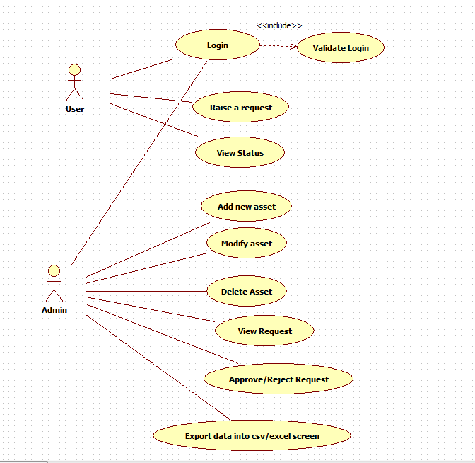

1. Scenarios

Success Scenarios

* Successful User login to the Asset Management System
* Login to the Asset Management System with reattempt

Failure Scenarios

* Web Server Down
* Database Connectivity Error
* Network Connectivity Error

1. Issues

* What is the maximum size of username and password that a user can have ?
* What if the user is blocked after invalid login attempts for three times ?

1. UI Specifications

<< Provide a link to the UI specification document of the Use case. Please don’t embed the document here>>

1. Inter System Dependencies

**Module: ‘**Apply Online for Course’ gets impacted due to :

Use case name: Alternate Flow 1

**Impact**: If the user tries to apply for a course without login, he should be denied so.

1. Integration with an already existing System of the <<Customer>>

<< This is especially applicable if the project at hand is an enhancement to an existing system.>>

1. Assumptions

<< List down all the assumptions considered by this use case>>

REVISION HISTORY OF THE WORK PRODUCT

<to be maintained by projects>

|  |  |  |  |  |  |
| --- | --- | --- | --- | --- | --- |
| # | Date | Version # | Section Changed | Details of changes made | Approved By |
| 1 |  |  |  |  |  |
| 2 |  |  |  |  |  |