Use Case Specification

DMT/RM01/TMP

|  |  |
| --- | --- |
| Project Code | PRJ_AssetManagementSystem _001 |
| Project Name | Asset Management System |

|  |  |  |
| --- | --- | --- |
| Prepared/Modified by | Role | Date of Preparation |
| Himanshu/Indraneel | Associate Consultant | 4th October, 2017 |
| Reviewed by | Role | Date of Review |
| Dayanand Patil | Assistant Manager | 4th October, 2017 |
| Approved by | Role | Date of Approval |
| Shilpa Bhosle | Deputy Manager | 4th October, 2017 |
| Circulation List |  | Version Number of the template:1.1 |
| Version Number | 1.1 |  |

<<Customer>> REVIEW HISTORY

<<Customer comments on the Use case along with the signed off is tracked here>>

|  |  |  |  |  |  |  |
| --- | --- | --- | --- | --- | --- | --- |
| Version | 1.0 |  |  |  |  |  |
| Date | <<Date of Review>> |  |  |  |  |  |
| Reviewed by | << Reviewer Name>> |  |  |  |  |  |
| Reviewed UI Specification doc | << Whether UI Specification doc is reviewed >> |  |  |  |  |  |
| All Open Queries/issues closed | << Whether all the open queries and issues resolved>> |  |  |  |  |  |
| Agreement on Assumptions | <<Whether all the assumptions have been agreed upon by the customer>> |  |  |  |  |  |
| Sign Off | <<Signature>> |  |  |  |  |  |

Disclaimer:

The scope of the project ‘**Asset Management System’** is restricted to the contents of this signed off use case.

TABLE OF CONTENTS

1. Use Case Name: Login to the University Admission System 5

2. Actor(s) 5

3. Preconditions 5

4. Flow of Events 5

4.1 Basic Flow 5

4.2 Alternative Flows 5

4.2.1 Alternate Flow 1: successful login to AMS on second attempt 5

4.2.2 Alternate Flow 2 6

Exception Flow 1: Web Server Down 6

Exception Flow 2: Database Connectivity Error 6

Exception Flow 3: Network Connectivity Error 6

5. Post Conditions 6

6. Special Requirements 7

Performance 7

Availability 7

User Interface 7

Security 7

7. Extension Points 7

Extension in Alternate Flow 1: 7

Extension in Alternate Flow x: 8

8. Business Rules 8

9. Diagrams 8

Use Case Diagram for 8

10. Scenarios 9

Success Scenarios 9

Failure Scenarios 9

11. Issues 10

12. UI Specifications 10

13. Inter System Dependencies 10

14. Integration with an already existing System of the <<Customer>> 10

15. Assumptions 10

1. Use Case Name: Raise Request In the Asset Management System

**Use Case ID:**  AMS.USER.RAISEREQUEST_001

**Brief Description:** This Use Case describes the process by which user can raise a request into the Asset Management system.

1. Actor(s)
2. User
3. Preconditions
4. User is a registered employee in Asset Management system.
5. User has an access to the Asset Management System Website.
6. User has a valid user id and a password.
7. User has successfully logged into Asset Management System.
8. Flow of Events

4.1 Basic Flow

Name: Successful raising a request in Asset Management System.

1. User clicks **Raise Request** link available on the Asset Management System home page.
2. The system navigates to raise a request screen.
3. User selects **EMP NO**.
4. User selects **Asset Name.**
5. User enters **Description.**
6. User enters **Quantity.**
7. User clicks on the **Submit** button.
8. The system validates the details with available rules..
9. The system navigates User to the **AMS Screen.**
   1. Alternative Flows

4.2.1 Alternate Flow 1: successful Raising a request in AMS on second attempt due to entered Quantity is ‘0’

1. User clicks **Raise Request** link available on the Asset Management System home page.
2. The system navigates to raise a request screen.
3. User selects **EMP NO**.
4. User selects **Asset Name.**
5. User enters **Description.**
6. User enters **Quantity** as 0**.**
7. User clicks on the **Submit** button.
8. The system validates the details with available rules.
9. The system prompts the User to re-enter the Quantity.
10. The step 3 of Basic flow is followed.

4.2.2 Alternate Flow 2

Exception Flow 1: Web Server Down

1. User clicks **Raise Request** link available on the Asset Management System home page.
2. The system displays an error message regarding web server unavailability problem

Exception Flow 2: Database Connectivity Error

1. User clicks **Raise Request** link available on the Asset Management System home page.
2. The system navigates to raise a request screen.
3. User selects **EMP NO**.
4. User selects **Asset Name.**
5. User enters **Description.**
6. User enters **Quantity.**
7. User clicks on the **Submit** button.
8. The system displays an error message regarding database connectivity problem.

Exception Flow 3: Network Connectivity Error

1. User clicks **Raise Request** link available on the Asset Management System home page.
2. The system navigates to raise a request screen.
3. User selects **EMP NO**.
4. User selects **Asset Name.**
5. User enters **Description.**
6. User enters **Quantity.**
7. User clicks on the **Submit** button.
8. The system displays an error message regarding network connectivity problem.
9. Post Conditions

| Flow Name | Post Condition |
| --- | --- |
| Successful raising a request in Asset Management System. | System will register a request and should navigates user to the AMS Home Page. |
| Successful raising a request in Asset Management System with reattempt. | System will register a request and should navigates user to the AMS Home Page. |
| Web Server Down | The system should display an error message to the user regarding web server unavailability problem |
| Database Connectivity Error | The system should display an error message to the user regarding the database connectivity problem |
| Network Connectivity Error | The system should display an error message to the user regarding the network connectivity problem |

1. Special Requirements

Performance

1. The click on ‘Raise Request’ shall navigate the user to login page within 10 seconds of user request

Availability

1. The user can login only on any day 24x7.

User Interface

* 1. The active links should be displayed in red color
  2. The visited links should be displayed in purpule color
  3. Employee number field should have a drop down to select.
  4. Asset Number field should have a drop down to select.

Security

1. The system shall display only valid employee numbers.
2. Extension Points

Extension in Alternate Flow 1:

In step 6, if the customer has entered quantity as zero :

1. The system prompts the user to re-enter the qunatity

2. User enters quantity greater than zero.

3. The system takes user to the Step 7 of Basic Flow

1. Business Rules

| Business Rule Name | Business Rule Description | System action (if BR fails) |
| --- | --- | --- |
| BR01 | A valid emp no should be selected. | User is prompted to re-select the emp no. |
| BR02 | All fields on the Raise a Request web page are mandatory | Displays error message “All fields are mandatory” |
| BR03 | Description field can accept only alphabets and numbers. | Displays error message “Invalid.Description-Accepts only alphanumeric” |
| BR04 | Description should accept maximum of 25 characters. | Displays error message “Maximum 25 characters only” |
| BR05 | Quantity field should accept only positive numbers. | Displays error message “Enter only positive numeric values” |

1. Diagrams

Use Case Diagram for

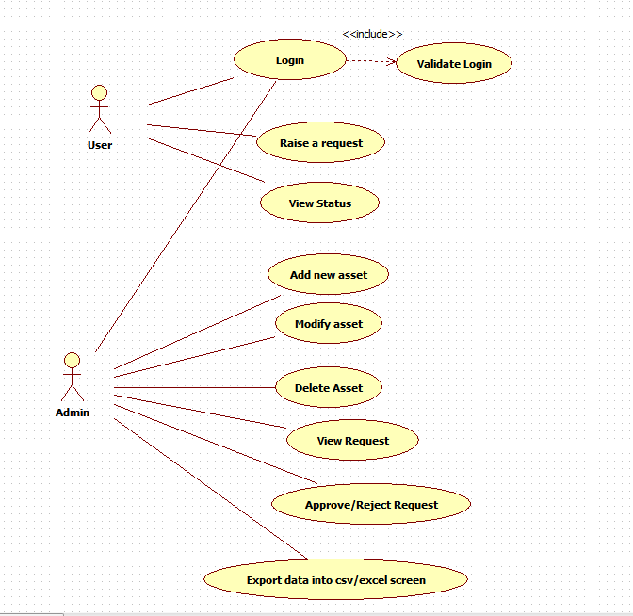

1. Scenarios

Success Scenarios

* Successful Raise a Request in Asset Management System
* Succefully rasing a request in Asset Management System with reattempt

Failure Scenarios

* Web Server Down
* Database Connectivity Error
* Network Connectivity Error

1. Issues

* What is the maximum number that can be entered I quantity ?

1. UI Specifications

<< Provide a link to the UI specification document of the Use case. Please don’t embed the document here>>

1. Inter System Dependencies

**Module: ‘**Apply Online for Course’ gets impacted due to :

Use case name: Alternate Flow 1

**Impact**: If the user tries to apply for a course without login, he should be denied so.

1. Integration with an already existing System of the <<Customer>>

<< This is especially applicable if the project at hand is an enhancement to an existing system.>>

1. Assumptions

<< List down all the assumptions considered by this use case>>

REVISION HISTORY OF THE WORK PRODUCT

<to be maintained by projects>

|  |  |  |  |  |  |
| --- | --- | --- | --- | --- | --- |
| # | Date | Version # | Section Changed | Details of changes made | Approved By |
| 1 |  |  |  |  |  |
| 2 |  |  |  |  |  |