Use case diagram

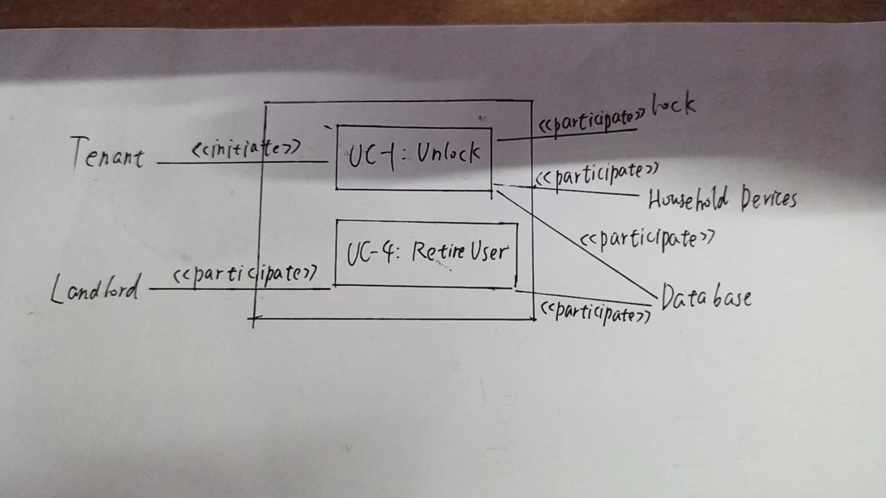

Use case schema

|  |  |
| --- | --- |
| Use Case UC-1 | Unlock |
| Related Requirements | REQ-1、2、3、4、5、6 |
| Initiating Actor | Tenant |
| Actor’s Goal | Unlock and enter home |
| Participating Actors | Lock, Household Devices,  DataBase |
| Preconditions | 1. 用户信息存储在非空数据库 2. 门键盘在能见度情况下背光 |
| Postconditions | 记录匹配失败次数 |
| Flow of Events for  Main Success Scenario | -> 1.Tenant利用手机开锁  <- 2.系统向Tenant发送锁的状态，同时发送信号开锁  -> 3.锁打开，Tenant进入房间 |

|  |  |
| --- | --- |
| Use Case UC-4 | RetireUser |
| Related Requirements | REQ-1、2、3、4、5、6 |
| Initiating Actor | Landlord |
| Actor’s Goal | Retire an existing user account and disable access |
| Participating Actors | DataBase |
| Preconditions | 用户信息存储在非空数据库 |
| Postconditions |  |
| Flow of Events for  Main Success Scenario | -> 1.Landlord打开管理系统  <- 2.系统展示用户信息界面  -> 3.Landlord删除指定账户信息  <- 4.退出管理系统 |

Acceptance Tests

|  |  |
| --- | --- |
| Test-case Identifier | TC-1 |
| Use Case Tested | UC-1 |
| Pass/fail Criteria | 用户号码位于数据库中，且尝试次数少于失败次数限制，测试通过 |
| Input data | 手机号 |
| Test Procedure: | Expected Result |
| 1.提供错误的电话号码 | 系统记录失败尝试，并要求用户重试 |
| 2.提供正确的电话号码 | 系统记录成功尝试，开锁 |

|  |  |
| --- | --- |
| Test-case Identifier | TC-2 |
| Use Case Tested | UC-4 |
| Pass/fail Criteria | 用户退出账户，系统删除账户信息，测试通过 |
| Input data | 用户信息 |
| Test Procedure: | Expected Result |
| 1.使用即将移除用户的账户开门 | 系统记录成功尝试，开锁 |
| 2.删除退出用户账户 | 数据库删除该用户信息 |
| 3.再次使用该账户开门 | 开锁失败 |