*Tongji-KNU Global Capstone Design Project 2016*

**Project B: Intelligent Driving Behavior Analysis**

**Requirements and Plan**

## 1. Protocols, techniques and tools

* OBD adapter (ELM327) with OBD-II protocol
* Parameter IDs ([PIDs](https://en.wikipedia.org/wiki/OBD-II_PIDs)) defined by SAE J1979 Standards[1]
* Bluetooth connection between the client and the OBD adapter
* RESTful Web services for communication between server and clients
* Programming with C# and the .NET framework
* Visual Studio Community 2015 for software development
* GitHub for version control

## 2. System architecture and modules

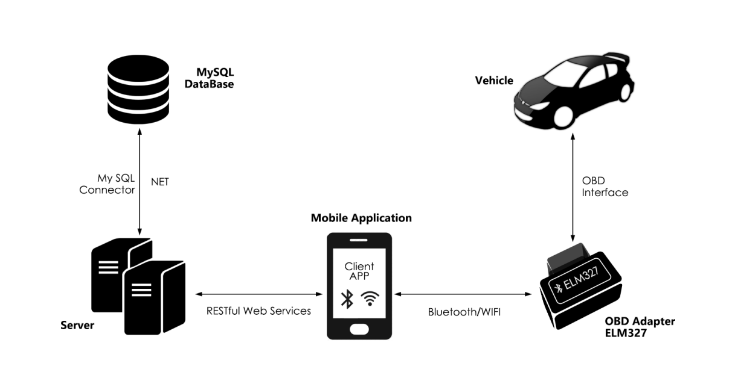

## 3. System functionalities and division of work

**Tongji Students:**

Design and implement the client app, with the following functionalities:

1. Client registration (sign up and sign in);
2. Retrieve data from the OBD adapter;
3. Display real-time information (such as speed, engine temperature, engine RPM, diagnostic trouble) which is directly retrieved from the OBD adapter;
4. Upload data to the server for storage and analysis;
5. Retrieve and display generated reports on driving behavior analysis from the server.

**KNU Students:**

Design and implement the server, with the following functionalities:

1. Store the data uploaded by the clients;
2. Perform driving behavior analysis and generate reports accordingly;
3. Provide services that are accessed by the clients (such as client registration, report retrieval);
4. Provide services that are accessed by other parties (such as insurance recommendation)

## 4. General plan

|  |  |
| --- | --- |
| **Duration** | **Task** |
| 1 March - 20 April | Requirement analysis |
| 21 April - 5 May | System design (such as Web service interfaces, module interfaces, database tables, user interfaces) |
| 6 May - 30 June | Software implementation (including programming and unit testing) |
| 1 July - 10 July | Integrated testing and deployment |
| 11 July - 15 July | Preparation for demonstration and presentation |

1. All light duty vehicles (i.e. less than 8,500 pounds) sold in North America since 1996, as well as medium duty vehicles (i.e. 8,500-14,000 pounds) beginning in 2005, and heavy duty vehicles (i.e. greater than 14,000 pounds) beginning in 2010 are required to support OBD-II diagnostics and a subset of the SAE J1979 defined PIDs.