1354202 王雨晴 homework3

7.22
analysis：
1 customer can receive or send n packages
1 package can be reveived and sent by n customers
1 package -- 1 id , 1 sent and received time，1 presentlocation ，n historylocations
customer has two roles -- sender and receiver

package -- full participation
customer-- full participation
location -- paticial participationn

customer(customer_id,name,address)
custome_package(send_id,receive_id,package_id,sendtime,receivetime,foreign key send_id references customer, foreign key receive_id references customer, foreign key package_id references package)
package(pa_id,pa_content,pa_weight)
package_location(pa_id,loc_id,time,foreign key package_id references package, foreign key loc_id references location)
location(loc_id,country,city,street)

entity set : customer, package , location
relation set: customer_package , package_location

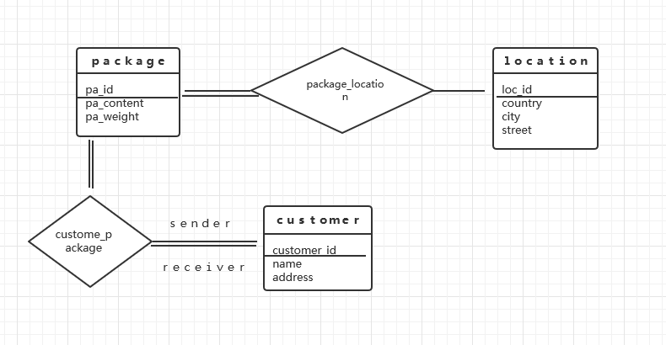
8.19
closure set of F:
A → BC
CD → E
B → D
E → A

BC → DC
BC →E
BC →A
BC →ABCDE

A →ABCDE

E →ABCDE

CD →ABCDE

so,the candidate key: A E BC CD
B is not one of them . So B → D is nontrivial and the left hand side is not a superkey
so decompose the (ABCDE) to r1(B,D) and r2(A,B,C,E)

8.27
let result be the B+
result = {B}.
FDs in F, we ﬁnd that the only B → B and B → D satisfying b ⊆ result.
So, result = {B, D}. No more dependencies in Fcan change the result set .

