1354202 王雨晴 homework4

11.1
1 need more storage to store the extra indices
2 when do deletions or insertions, every inndex costs more time
3 when do updates, the content of index might have to change
4 the improvement of the query time is so little that we need not keep indices on other attributes.

11.3
a
19

 | 5 |  | 11
29

 | 2 |  | 3
 | 5 |  | 7
 | 11 |  | 17
 | 19 |  | 23
 | 29 |  | 31

b

 | 7 |  | 19

 | 2 |  | 3 |  | 5

 | 19 |  | 23 |  | 29 |  | 31
 | 7 |  | 11 |  | 17

c
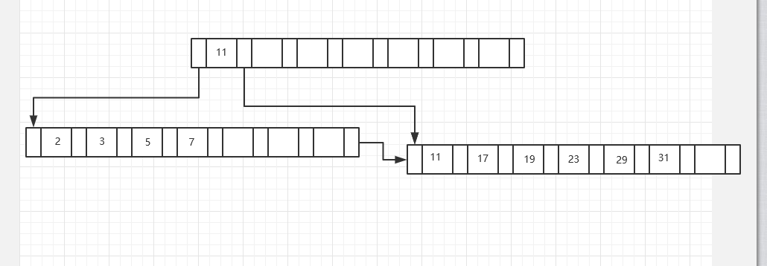

11.4
for a:
insert 9:

19

 | 5 |  | 9 |  | 11
29

 | 2 |  | 3
 | 5 |  | 7
 | 11 |  | 17
 | 19 |  | 23
 | 29 |  | 31

insert 10:

19

 | 5 |  | 9 |  | 11
29

 | 2 |  | 3
 | 5 |  | 7
 | 11 |  | 17
 | 19 |  | 23
 | 29 |  | 31
 | 9 |  | 10

insert 8:

19

 | 5 |  | 9 |  | 11
29

 | 2 |  | 3
 | 5 |  | 7 |  | 8
 | 11 |  | 17
 | 19 |  | 23
 | 29 |  | 31
 | 9 |  | 10

delete 23:

11

 | 5 |  | 9
19

 | 2 |  | 3
 | 5 |  | 7 |  | 8
 | 11 |  | 17
 | 19 |  | 29 |  | 31

 | 9 |  | 10

delete 19:

11

 | 5 |  | 9
29

 | 2 |  | 3
 | 5 |  | 7 |  | 8
 | 11 |  | 17
 | 29 |  | 31

 | 9 |  | 10

for b:
insert 9:
 | 7 |  | 19

 | 2 |  | 3 |  | 5

 | 19 |  | 23 |  | 29 |  | 31
 | 7 |  | 9 |  | 11 |  | 17

insert 10:

 | 7 |  | 19

 | 2 |  | 3 |  | 5

 | 19 |  | 23 |  | 29 |  | 31
 | 7 |  | 9 |  | 10 |  | 11 |  | 17

insert 8:

 | 7 |  | 10 |  | 19

 | 2 |  | 3 |  | 5

 | 19 |  | 23 |  | 29 |  | 31
 | 10 |  | 11 |  | 17

 | 7 |  | 8 |  | 9

delete 23:

 | 7 |  | 10 |  | 19

 | 2 |  | 3 |  | 5

 | 19 |  | 29 |  | 31
 | 10 |  | 11 |  | 17

 | 7 |  | 8 |  | 9

delete 19:

 | 7 |  | 10

 | 2 |  | 3 |  | 5

 | 10 |  | 11 |  | 17 |  | 29 |  | 31

 | 7 |  | 8 |  | 9

for c:
insert 9:

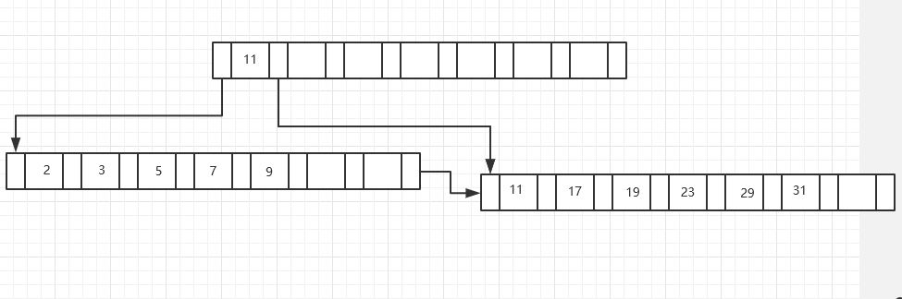
insert 10:
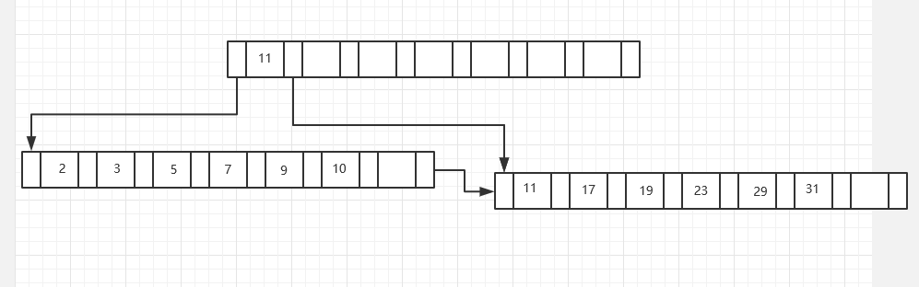

insert 8:
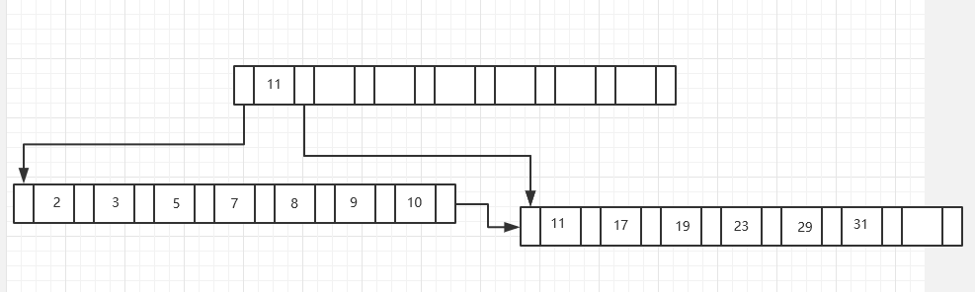

delete 23:
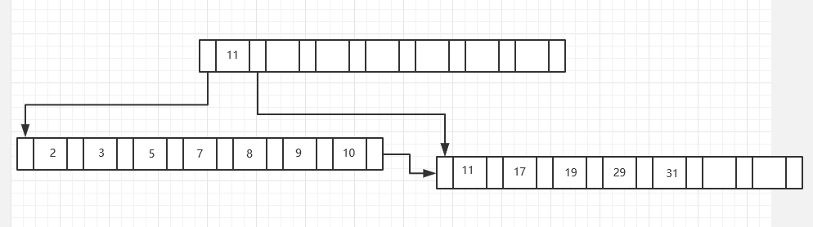

delete 19:
