matlab优化
1 无约束优化： fminunc：Large scale and Medium scale usually using Ms
and fminsearch
求二次极小值初始点x=0
对于非光滑问题，fminunc可能得不到正确结果。fminsearch却可以。
2约束优化：
fmincon：activeset interiorpoint trustregionreflective
trustregionreflective 中Linear inequalities Derivatives NCf 都不能用--说明这种算法只能求解含线性等式约束的约束优化问题

选择不同算法
Large-Scale vs. Medium-Scale AlgorithmsAn optimization algorithm is large scale when
大规模和中等规模算法的比较
it uses linear algebra that does not need to store, nor operate on,
使用不需要存储或不用在满矩阵上运行的线性代数是大规模
full matrices. This may be done internally by storing sparse matrices,
可能通过在内部存储稀疏矩阵并通过使用系数线性代数来计算。
and by using sparse linear algebra for computations whenever possible.
Furthermore, the internal algorithms either preserve sparsity, such
内部算法要么保存稀疏性比如一个系数乔姆斯基分解
as a sparse Cholesky decomposition, or do not generate matrices, such
要么不产生矩阵比如共轭梯度方法
as a conjugate gradient method.In contrast, medium-scale methods internally
相比较而言，中等规模内部创造力满阵并使用稠密线代
create full matrices and use dense linear algebra. If a problem is
如果一个问题足够大，满阵占用很大内存
sufficiently large, full matrices take up a significant amount of
memory, and the dense linear algebra may require a long time to execute.Don't let the name
并且稠密线代通常需要很长运行时间
"large scale" mislead you;
you can use a large-scale algorithm on a small problem. Furthermore,
可以看到大规模算法适合小型问题。你不需要指明某一稀疏矩阵来使用大规模算法
you do not need to specify any sparse matrices to use a large-scale
algorithm. Choose a medium-scale algorithm to access extra functionality,
选择中等规模算法来获得其他功能比如附加的约束类型或者更好的性能
such as additional constraint types, or possibly for better performance.Potential Inaccuracy with
内点法算法的潜在不正确性在fmincon quadprog linprog中有许多好的特性
Interior-Point AlgorithmsInterior-point algorithms in fmincon, quadprog,
and linprog have many good characteristics, such
as low memory usage and the ability to solve large problems quickly.
比如很少的内存和快速度
However, their solutions can be slightly less accurate than those
但是这种方案可能减少了精度
from other algorithms. The reason for this potential inaccuracy is
that the (internally calculated) barrier function keeps iterates away
不断迭代而远离不等式的约束边界。
from inequality constraint boundaries.For most practical purposes, this inaccuracy is usually quite
为了现实目的，这些不正确性非常小。减少试着重新选择small TolX TolFun 并且TolCon容忍度 但是保持在合理范围
small.To reduce the inaccuracy, try to:Rerun the solver with smaller TolX, TolFun,
and possibly TolCon tolerances (but keep the tolerances
sensible.) See Tolerances and Stopping Criteria).Run a different algorithm, starting from the interior-point用不同的算法采用interior-point
solution. This can fail, because some algorithms can use excessive
这可能失败因为一些算法产生过多内存和时间 一些算法并不接受内点法
memory or time, and some linprog and quadprog algorithms
do not accept an initial point.For example, try to minimize the function x when
试着减小函数范围到0
bounded below by 0. Using the fmincon interior-point algorithm:
：

3 非线性最小二乘优化
lsqnonlin
4线性规划
5智能
6无约束一维极值问题
进退法求极值区间
黄金分割：不断缩小区间
斐波那契 subs(f,findsym(f),l)
牛顿
全局牛顿
割线
抛物
三次插值

我希望保持自己独立的性格和想法。我知道自己能够静下来抚平一切，接受现实然后付出。
我没那么一无是处。所以我需要有支撑。然而我并非天才，所以仰赖一切幸运，我需要敬畏。
安心然后做想做的事。其他人的命运和我相关的部分大多我都会想太多而忽视自己。所以我需要内省和珍视自己的存在。哪怕微不足道。但未必。
至少我还知道。

Armijo-Goldstein准则的核心思想有两个：①目标函数值应该有足够的下降；②一维搜索的步长α不应该太小。

7 opt=optimset(‘Display’,iter);
[x,fval,exitflag,output]=fminbnd(‘x^4-x^2+x-1’,-2,1,opt)
fminbnd同样可以频率很高的振荡函数求min 可以含绝对值
但是单变量连续性不好的话可以用golden section
振荡只能求出一个min 而且不一定是最小可以编代码求出区间所有的极小值但是存在误差
如果极值点在端点，则收敛很慢
fzero(@f,[a b]);
含有参变量则无法求出
8含参变量无约束一维极值问题：maple
9无约束多维极值
8 fminsearch用于多变量min

comet(y) displays a comet
graph of the vector y. A comet graph is an animated
graph in which a circle (the comet head) traces
the data points on the screen. The comet body is
a trailing segment that follows the head. The tail is
a solid line that traces the entire function.comet(x,y) displays a comet
graph of vector y versus vector x. comet(x,y,p) specifies a
comet body of length p*length(y). p defaults
to 0.1.comet(axes_handle,...) plots
into the axes with the handle axes_handle instead
of into the current axes (gca).

Cluster Analysis, also called data segmentation, has a variety of goals that relate to grouping or segmenting a collection of objects (i.e., observations, individuals, cases, or data rows) into subsets or clusters, such that those within each cluster are more closely related to one another than objects assigned to different clusters. Central to all of the goals of cluster analysis is the notion of degree of similarity (or dissimilarity) between the individual objects being clustered. There are two major methods of clustering: hierarchical clustering and k-means clustering. For information on k-means clustering, refer to the k-Means Clustering section.
聚类分析又称数据分离，许多需要聚类。相似程度是聚类分析的关注点。两大方法：层次聚类和kmeans聚类。
In hierarchical clustering, the data is not partitioned into a particular cluster in a single step. Instead, a series of partitions takes place, which may run from a single cluster containing all objects to n clusters that each contain a single object. Hierarchical Clustering is subdivided into agglomerative methods, which proceed by a series of fusions of the n objects into groups, and divisive methods, which separate n objects successively into finer groupings. Agglomerative techniques are more commonly used, and this is the method implemented in XLMiner. Hierarchical clustering may be represented by a two-dimensional diagram known as a dendrogram, which illustrates the fusions or divisions made at each successive stage of analysis. Following is an example of a dendrogram.
层次聚类中，数据不在一个步骤中分成特定类别。可以通过二维的图来展示，即系统树图。
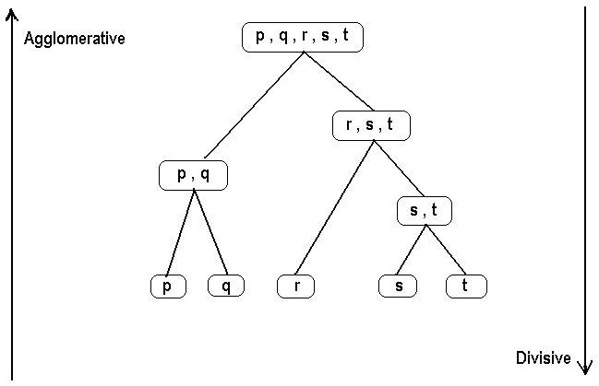
Agglomerative methods
An agglomerative hierarchical clustering procedure produces a series of partitions of the data, Pn, Pn-1, ....... , P1. The first Pn consists of n single object clusters, the last P1, consists of single group containing all n cases.
At each particular stage, the method joins together the two clusters that are closest together (most similar). (At the first stage, this amounts to joining together the two objects that are closest together, since at the initial stage each cluster has only one object.)
Differences between methods arise due to different ways of defining distance (or similarity) between clusters. The following sections describe several agglomerative techniques in detail.
因对距离的定义不同，产生不同的agglomerative clustering

Single linkage clustering
最简单的凝聚聚类。也称最邻近技术。
One of the simplest agglomerative hierarchical clustering methods is single linkage, also known as the nearest neighbor technique. The defining feature of the method is that distance between groups is defined as the distance between the closest pair of objects, where only pairs consisting of one object from each group are considered.
In the single linkage method, D(r,s) is computed as
D(r,s) = Min { d(i,j) : Where object i is in cluster r and object j is cluster s }

The distance between every possible object pair (i,j) is computed, where object i is in cluster r and object j is in cluster s. The minimum value of these distances is said to be the distance between clusters r and s. In other words, the distance between two clusters is given by the value of the shortest link between the clusters.
At each stage of hierarchical clustering, the clusters r and s , for which D(r,s) is minimum, are merged. In this case, those two clusters are merged such that the newly formed cluster, on average, will have minimum pairwise distances between the points.
This measure of inter-group distance is illustrated in the following figure.
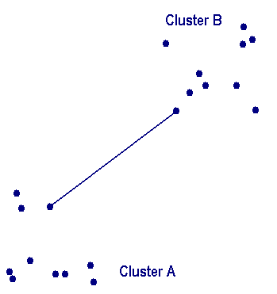
Complete linkage clustering
完全邻近聚类
In the complete linkage, also called farthest neighbor, the clustering method is the opposite of single linkage. Distance between groups is now defined as the distance between the most distant pair of objects, one from each group.
In the complete linkage method, D(r,s) is computed as
D(r,s) = Max { d(i,j) : Where object i is in cluster r and object j is cluster s }
The distance between every possible object pair (i,j) is computed, where object i is in cluster r and object j is in cluster s and the maximum value of these distances is said to be the distance between clusters r and s. In other words, the distance between two clusters is given by the value of the longest link between the clusters.
At each stage of hierarchical clustering, the clusters r and s , for which D(r,s) is minimum, are merged.对每个d最小则归并。
Complete linkage clustering is illustrated in the following figure.

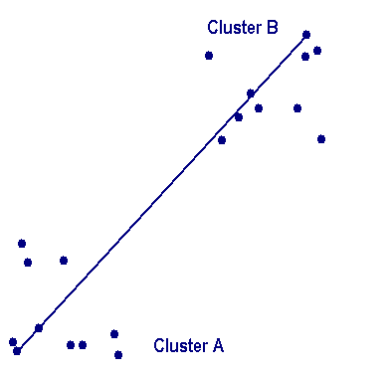
Average linkage clustering
In Average linkage clustering, the distance between two clusters is defined as the average of distances between all pairs of objects, where each pair is made up of one object from each group.
In the average linkage method, D(r,s) is computed as
D(r,s) = Trs / ( Nr * Ns)
Where Trs is the sum of all pairwise distances between cluster r and cluster s. Nrand Ns are the sizes of the clusters r and s, respectively.
At each stage of hierarchical clustering, the clusters r and s , for which D(r,s) is the minimum, are merged.
Average linkage clustering is illustrated in the following figure.

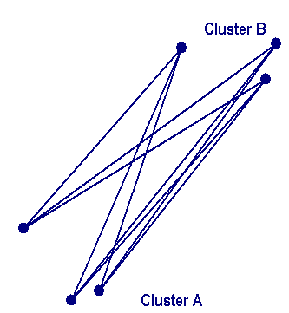
Average group linkage
With this method, groups once formed are represented by their mean values for each variable (i.e., their mean vector and inter-group distance is defined in terms of distance between two such mean vectors).
In the average group linkage method, the two clusters r and s are merged such that the average pairwise distance within the newly formed cluster is minimum. Suppose we label the new cluster formed by merging clusters r and s as t. Then the distance between clusters r and s, D(r,s), is computed as
D(r,s) = Average { d(i,j) : Where observations i and j are in cluster t, the cluster formed by merging clusters r and s }

At each stage of hierarchical clustering, the clusters r and s , for which D(r,s) is minimum, are merged. In this case, those two clusters are merged such that the newly formed cluster, on average, will have minimum pairwise distances between the points.

Ward's hierarchical clustering method
Ward (1963) proposed a clustering procedure seeking to form the partitions Pn, P n-1,........, P1 in a manner that minimizes the loss associated with each grouping, and to quantify that loss in a form that is readily interpretable. At each step in the analysis, the union of every possible cluster pair is considered and the two clusters whose fusion results in minimum increase in information loss are combined. Information loss is defined by Ward in terms of an error sum-of-squares criterion (ESS).
The rationale behind Ward's proposal can be illustrated most simply by considering univariate data. Suppose for example, 10 objects have scores (2, 6, 5, 6, 2, 2, 2, 2, 0, 0, 0) on some particular variable. The loss of information that would result from treating the ten scores as one group with a mean of 2.5 is represented by ESS,
ESS One group = (2 -2.5)2 + (6 -2.5)2 + ....... + (0 -2.5)2 = 50.5
On the other hand, if the 10 objects are classified according to their scores into four sets,
{0,0,0}, {2,2,2,2}, {5}, {6,6}
The ESS can be evaluated as the sum of squares of four separate error sums of squares
ESS One group = ESS group1 + ESSgroup2 + ESSgroup3 + ESSgroup4 = 0.0
Thus, clustering the 10 scores into four clusters results in no loss of information.

On the XLMiner ribbon, from the Applying Your Model tab, select Help - Examples, then Forecasting/Data Mining Examples, and open the example file Wine.xlsx. As shown in the figure below, each row in this example data set represents a sample of wine taken from one of three wineries (A, B, or C). In this example, the Type variable representing the winery is ignored, and the clustering is performed simply on the basis of the properties of the wine samples (the remaining variables). 每行代表葡萄酒的数据 种类，酒精，果酸，灰度，碱度……
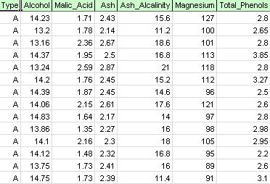
Select a cell within the data set, and then on the XLMiner ribbon, from the Data Analysis tab, select XLMiner - Cluster - k-Means Clustering to open the k-Means Clustering Step 1 of 3 dialog.

From the Variables list, select all variables except Type, then click the > button to move the selected variables to the Selected Variables list.

Click Next to advance to the Step 2 of 3 dialog.

At # Clusters, enter 8. This is the parameter k in the k-means clustering algorithm. The number of clusters should be at least 1 and at most the number of observations -1 in the data range. Set k to several different values and evaluate the output from each.
Leave #Iterations at the default setting of 10. The value for this option determines how many times the program will start with an initial partition and complete the clustering algorithm. The configuration of clusters (and data separation) may differ from one starting partition to another. The program will go through the specified number of iterations, and select the cluster configuration that minimizes the distance measure.
Set Random starts to 5. When this option is selected, the algorithm starts building the model from any random point. XLMiner generates five cluster sets and generates the output based on the best cluster.
Set seed is selected by default. This option initializes the random number generator that is used to calculate the initial cluster centroids. Setting the random number seed to a non-zero value (by default, 12345) ensures that the same sequence of random numbers is used each time the initial cluster centroids are calculated. When the seed is zero, the random number generator is initialized from the system clock, so the sequence of random numbers are different each time the centroids are initialized. Set the seed to view successive runs of the clustering method as comparable.
Select the Normalize input data option to normalize the data. In this example, the data will not be normalized. Select Next to open the Step 3 of 3 dialog.
Select Show data summary (default) and Show distances from each cluster center (default), then click Finish.

The k-Means Clustering method starts with k initial clusters as specified. At each iteration, the records are assigned to the cluster with the closest centroid, or center. After each iteration, the distance from each record to the center of the cluster is calculated. These two steps are repeated (the record assignment and distance calculation) until the redistribution of a record results in an increased distance value.
When a random start is specified, the algorithm generates the k cluster centers randomly, and fits the data points in those clusters. This process is repeated for all specified random starts. The output is based on the clusters that exhibit the best fit.
The worksheet KM_Output1 is inserted immediately to the right of the Data worksheet. In the top section of the output worksheet, the selected options are listed.

In the middle section of the output worksheet, XLMiner has calculated the sum of the squared distances and determined the start with the lowest Sum of Square Distance as the Best Start (#5). After the Best Start is determined, XLMiner generates the remaining output using the Best Start as the starting point.

In the bottom portion of the output worksheet, XLMiner has listed the Cluster Centers (shown below). The upper box shows the variable values at the Cluster Centers. Cluster 8 has the highest average Alcohol, Total_Phenols, Flavanoids, Proanthocyanins, Color_Intensity, Hue, and Proline content. Compare this cluster to Cluster 2, which has the highest average Ash_Alcalinity and Nonflavanoid_Phenols.
The lower box shows the distance between the Cluster Centers. From the values in this table, it is determined that cluster 3 is very different from cluster 8 due to the high distance value of 1,176.59, and cluster 7 is close to cluster 3 with a low distance value of 89.73.

The Data Summary (below) displays the number of records (observations) included in each cluster and the average distance from cluster members to the center of each cluster. Cluster 6 has the highest average distance of 42.79, and includes 24 records. Compare this cluster to cluster 2, which has the smallest average distance of 29.66, and includes 26 members.

Click the KM_Clusters1 worksheet. This worksheet displays the cluster to which each record is assigned and the distance to each of the clusters. For the first record, the distance to cluster 6 is the minimum distance of 23.205, so this first record is assigned to cluster 6.

