文件系统模拟作业
学号：010081， 姓名：陈寒光
班级：1.5+2.5
程序演示：
下面是对输入的命令与相应的结果， 其中命令用红色显示标出
最初， 画面如下图
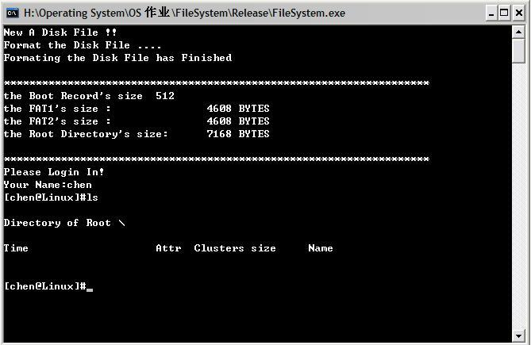
Please Login In!
Your Name:chen
[chen@Linux]#s
wrong command
[chen@Linux]#ls

Directory of Root \

Time Attr Clusters size Name
2004-6-30 7:20:26 <DIR> [2,] 0 chen
2004-6-30 7:20:26 <DIR> [3,] 0 os
2004-6-30 7:20:26 <DIR> [4,] 0 java
2004-6-30 7:20:26 <DIR> [5,] 0 c++

[chen@Linux]#cd chen
[chen@Linux]#ls

Directory of chen\

Time Attr Clusters size Name

[chen@Linux]#mkdir 1 2 3 4 5 6 7 8 9 0 11 12 13 14 15
1 has been create !
2 has been create !
3 has been create !
4 has been create !
5 has been create !
6 has been create !
7 has been create !
8 has been create !
9 has been create !
0 has been create !
11 has been create !
12 has been create !
13 has been create !
14 has been create !
15 has been create !
16 has been create !
[chen@Linux]#cd.
wrong command
[chen@Linux]#cd ..
[chen@Linux]#ls

Directory of Root \

Time Attr Clusters size Name
2004-6-30 7:20:26 <DIR> [2,] 0 chen
2004-6-30 7:20:26 <DIR> [3,] 0 os
2004-6-30 7:20:26 <DIR> [4,] 0 java
2004-6-30 7:20:26 <DIR> [5,] 0 c++

[chen@Linux]#cd chen
[chen@Linux]#ls

Directory of chen\

Time Attr Clusters size Name
2004-6-30 7:26:34 <DIR> [18,] 0 1
2004-6-30 7:26:34 <DIR> [19,] 0 2
2004-6-30 7:26:34 <DIR> [20,] 0 3
2004-6-30 7:26:34 <DIR> [21,] 0 4
2004-6-30 7:26:34 <DIR> [22,] 0 5
2004-6-30 7:26:34 <DIR> [23,] 0 6
2004-6-30 7:26:34 <DIR> [24,] 0 7
2004-6-30 7:26:34 <DIR> [25,] 0 8
2004-6-30 7:26:34 <DIR> [26,] 0 9
2004-6-30 7:26:34 <DIR> [27,] 0 0
2004-6-30 7:26:34 <DIR> [28,] 0 11
2004-6-30 7:26:34 <DIR> [29,] 0 12
2004-6-30 7:26:34 <DIR> [30,] 0 13
2004-6-30 7:26:34 <DIR> [31,] 0 14
2004-6-30 7:26:34 <DIR> [32,] 0 15
2004-6-30 7:26:34 <DIR> [33,] 0 16

[chen@Linux]#touch 17
the input fileName: 17 does not apply to the 8.3 rule
[chen@Linux]#mkdir 17
17 has been create !
[chen@Linux]#ls

Directory of chen\

Time Attr Clusters size Name
2004-6-30 7:26:34 <DIR> [18,] 0 1
2004-6-30 7:26:34 <DIR> [19,] 0 2
2004-6-30 7:26:34 <DIR> [20,] 0 3
2004-6-30 7:26:34 <DIR> [21,] 0 4
2004-6-30 7:26:34 <DIR> [22,] 0 5
2004-6-30 7:26:34 <DIR> [23,] 0 6
2004-6-30 7:26:34 <DIR> [24,] 0 7
2004-6-30 7:26:34 <DIR> [25,] 0 8
2004-6-30 7:26:34 <DIR> [26,] 0 9
2004-6-30 7:26:34 <DIR> [27,] 0 0
2004-6-30 7:26:34 <DIR> [28,] 0 11
2004-6-30 7:26:34 <DIR> [29,] 0 12
2004-6-30 7:26:34 <DIR> [30,] 0 13
2004-6-30 7:26:34 <DIR> [31,] 0 14
2004-6-30 7:26:34 <DIR> [32,] 0 15
2004-6-30 7:26:34 <DIR> [33,] 0 16
2004-6-30 7:27:41 <DIR> [35,] 0 17

[chen@Linux]#cd ..
[chen@Linux]#ls

Directory of Root \

Time Attr Clusters size Name
2004-6-30 7:20:26 <DIR> [2,34,] 0 chen
2004-6-30 7:20:26 <DIR> [3,] 0 os
2004-6-30 7:20:26 <DIR> [4,] 0 java
2004-6-30 7:20:26 <DIR> [5,] 0 c++

[chen@Linux]#pwd
/
[chen@Linux]#usage
The Disk's such cluster has been used:
2,3,4,5,6,7,8,9,10,11,12,13,14,15,16,17,18,19,20,21,22,23,24,25,26,27,28,29,30,3
1,32,33,34,35,
[chen@Linux]#

