# Intelligent Driving Behavior analysis

1352923 马致远 350046243@qq.com

1354202 王雨晴 863623756@qq.com

## 1) Functionalities

1. Search and connected to the obd adapter.
2. Getting real time data from obd adapter every 5 seconds.

The specific data include:

|  |  |
| --- | --- |
| Data name | units |
| Speed | Km/h |
| Engine coolant temperature | ℃ |
| Calculated Engine Load Value | % |
| Fuel Pressure | Kpa |
| Throttle position | % |
| Ambient Air Temperature | ℃ |
| Distance since MIL On | Km |
| Engine Rpm | rpm |
| Fuel-Air Ratio | / |
| Fuel Type | / |
| Intake Manifold Pressure | Kpa |
| MAF Air-Flow Rate | grams/secRuntime Since Engine Start |
| Runtime Since Engine Start | seconds |
| Time since MIL ON | minutes |

1. upload the data to REST server.
2. Get and show the car’s Diagnostic Trouble Code.

## USER MANUAL

At first ,user should go to the setting of the phone or PC,open the Bluetooth and pair the obd device.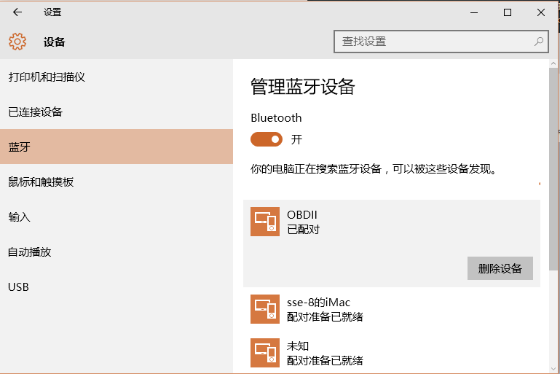

Then user should go to “settings” interface of this program to connect to the obd device ,

# 

If no device has been connected,and user go to other interface an Tip box like this would show:

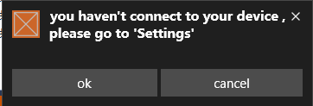

After the user successfully choose and connected to the obd device . The real time Data and Diagnostic Trouble code will show.

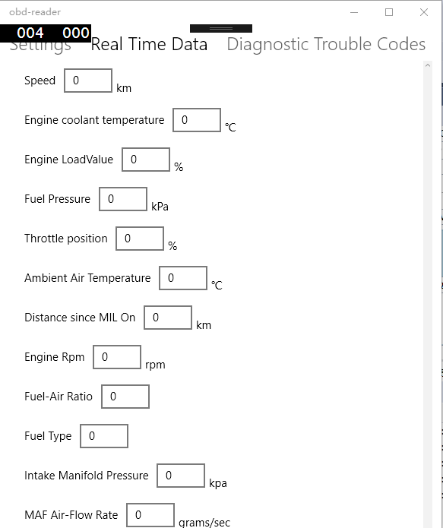

(Default value is “0”)

## Architectural and component design

GetValue function will write “pids” (the instruction to get data from obd)to the Obd interface through the socket and read the raw data returned by the obd interface.

Different get data function will all call the GetValue function with different “pid” ,and process the raw data differently, and then return the formatted readable data.

......

GetEngineTemp

GetFuelPressure

GetSpeedKm

GetValue

Socket

## 

## Key techniques involved in system design and implementation

1. Bluetooth Socket communication
2. [Asynchronous Programming](https://msdn.microsoft.com/en-us/library/hh191443.aspx)
3. EventHandler
4. Binary data process and parse
5. HTTP communication