**Project: Optimizing a CNN Accelerator for Image Super Resolution**

**LABORDE-TASTET Antonin & Satyam**

**Issued:** June 8 (Thursday), 2023 **Due: June 22nd (Thursday), 2023**

**What to turn in**: **Copy the text from your MODIFIED codes and paste it into a document**. If a question asks you to plot or display something on the screen, also include the plot and screen output your code generates. Submit either a *.doc or *.pdf file.

**\*\*\*\*\*\*\*\*\*\*\*\*\*\*\*\*\*\*\*\*\*\*\*\*\*\*\*\*\*\*\*\*\*\*\*\*\*\*\*\*\*\*\*\*\*\*\*\*\*\*\*\*\*\*\*\*\*\*\*\*\*\*\*\*\*\*\*\*\*\*\*\*\*\*\*\*\*\*\*\*\*\*\*\*\*\*\*\*\*\*\*\*\*\*\*\*\*\***

**Problem 1 (100p): CNN Accelerator for SR**

1. **Baseline code (10p)**

What you have to do:

1. Do a simulation with time = 4ms and capture the waveform.

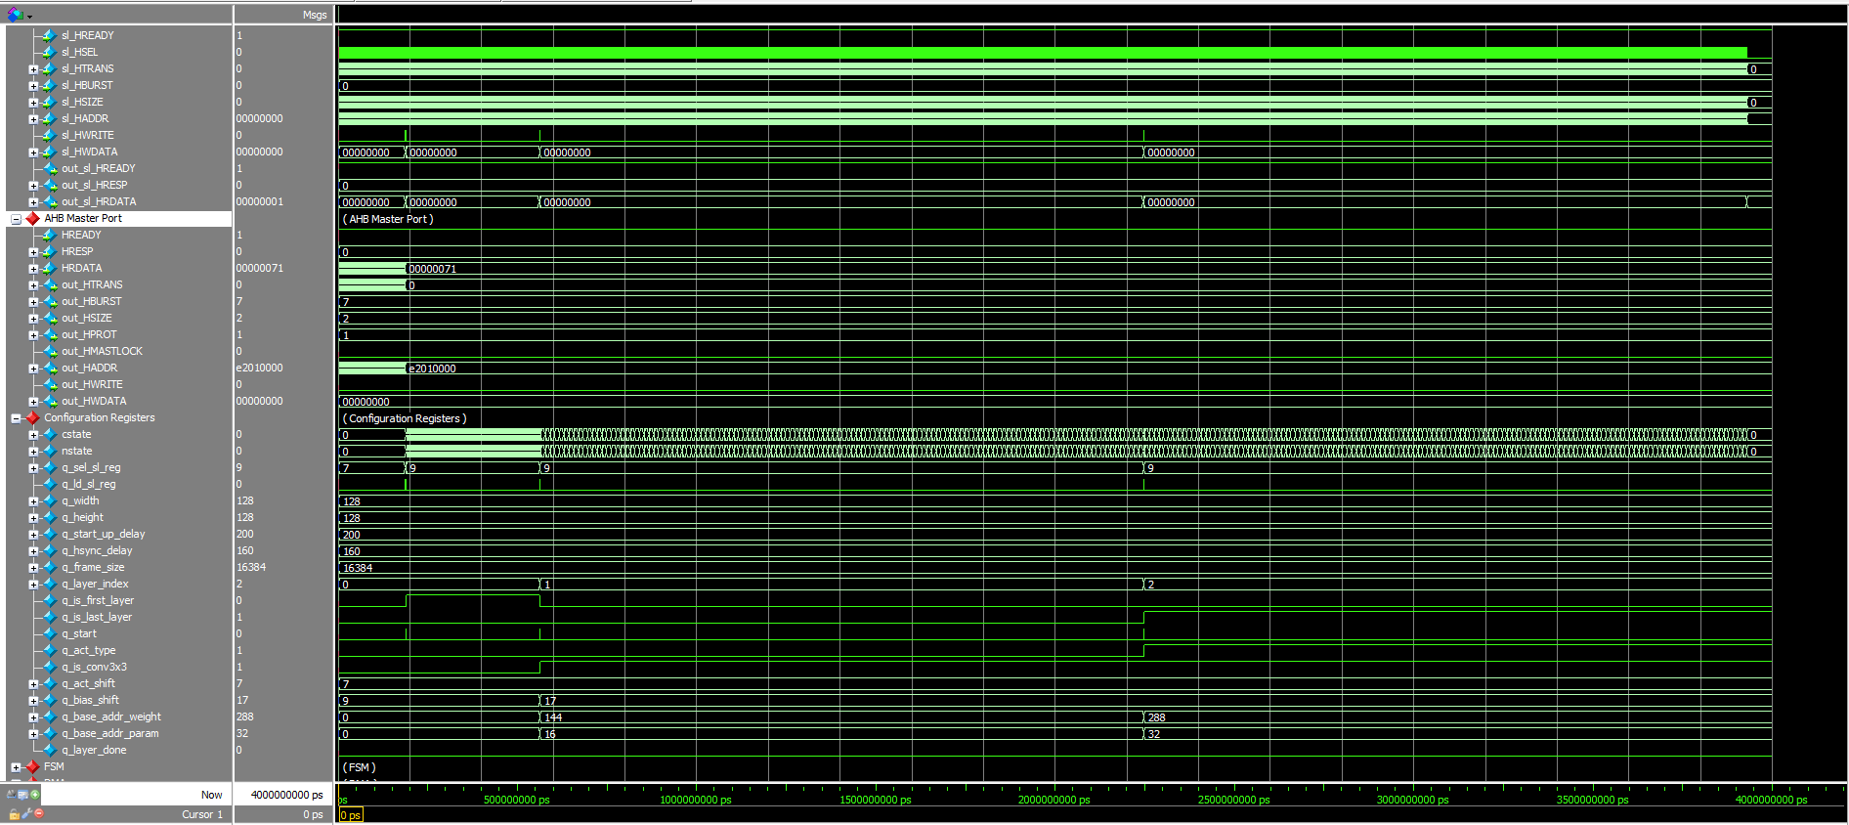

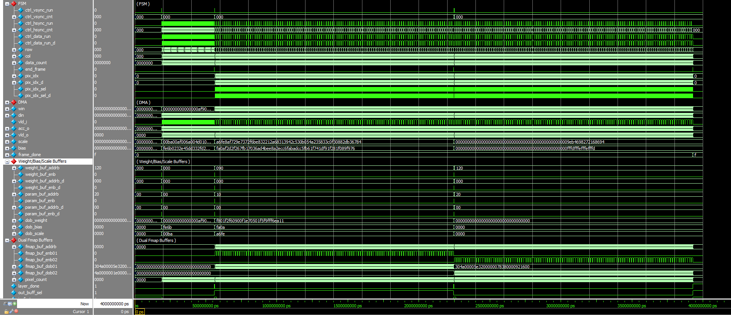

Figure 1-1: A captured waveform of cnn_accel.

1. Use check_hardware_results.m to verify the output images generated by the H/W simulation.

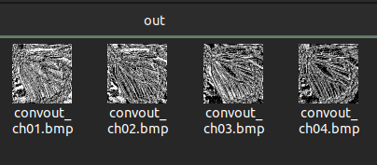

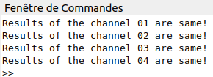

1. **Reference S/W (40p)**

Modify the codes to run a deeper network for SR named SSAI2021 which has 8 convolutional layers in Table I.

Table I: SSAI2021 Network Architecture for Image Super-Resolution

| Layer | Filter size | Input channels | Output channels | Input | Output |
| --- | --- | --- | --- | --- | --- |
| 1 | 3×3 | 1 | 16 | 128×128×1 | 128×128×16 |
| 2 | 1×1 | 16 | 16 | 128×128×16 | 128×128×16 |
| 3 | 3×3 | 16 | 16 | 128×128×16 | 128×128×16 |
| 4 | 3×3 | 16 | 16 | 128×128×16 | 128×128×16 |
| 5 | 3×3 | 16 | 16 | 128×128×16 | 128×128×16 |
| 6 | 3×3 | 16 | 16 | 128×128×16 | 128×128×16 |
| 7 | 1×1 | 16 | 16 | 128×128×16 | 128×128×16 |
| 8 | 3×3 | 16 | 4 | 128×128×16 | 128×128×4 |

What you have to do:

1. **Configuration (20p)**

The configuration parameters of all eight layers are defined in Table II. Run the reference S/W code (hw_uniform_architecture_ssai2021.m) and complete Table II.

Table II: SSAI2021’s configuration parameters

|  | Layer | | | | | | | |
| --- | --- | --- | --- | --- | --- | --- | --- | --- |
| #1 | #2 | #3 | #4 | #5 | #6 | #7 | #8 |
| q_is_first_layer | 1 | 0 | 0 | 0 | 0 | 0 | 0 | 0 |
| q_is_last_layer | 0 | 0 | 0 | 0 | 0 | 0 | 0 | 1 |
| q_is_conv3x3 | 0 | 0 | 1 | 1 | 1 | 1 | 0 | 1 |
| bias_shift | 16 | 22 | 23 | 23 | 23 | 23 | 23 | 24 |
| act_shift | 1 | 1 | 1 | 1 | 1 | 1 | 0 | 0 |

1. **Data preparation (20p)**

* Run write_cnn_model_to_hex_file.m to generate all hexadecimal files, including input, weights, scales, biases, and outputs at the folder /output_hex_file/ssai2021. Note that weights, biases, scales, and outputs of a layer can be stored separately for verification.

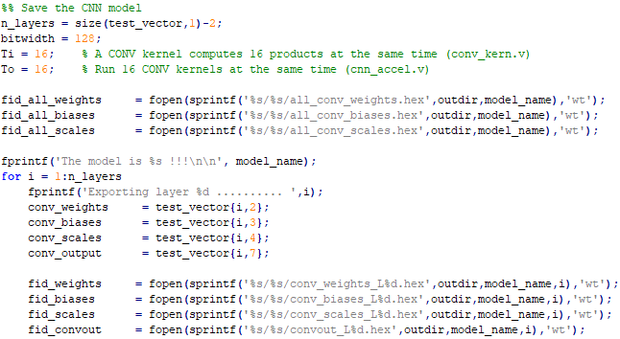

Figure 1-2: Matlab code used to define the file identifiers for writing.

* Based on the hexadecimal files, determine the buffer sizes required for weights, biases, and scales and the buffer sizes by completing Table III.

Table III: The buffer requirements

|  | No. of bit  per line | Number of lines | | | | | | | | | Buffer Size in total | |
| --- | --- | --- | --- | --- | --- | --- | --- | --- | --- | --- | --- | --- |
| #1 | #2 | #3 | #4 | #5 | #6 | #7 | #8 | Word  (bit) | | No. of  words |
| Weight | 128 | 16 | 16 | 144 | 144 | 144 | 144 | 16 | 144 | 128 | | 768 |
| Scale | 16 | 16 | 16 | 16 | 16 | 16 | 16 | 16 | 16 | 16 | | 128 |
| Bias | 16 | 16 | 16 | 16 | 16 | 16 | 16 | 16 | 16 | 16 | | 128 |

* (5p) Are those values in Table III optimal? Explain your answer.

These values are **not optimal**.

As we can see with the weight configuration in the hex file for the last layer (Layer 8):



With this configuration, each 12 of the 16 conv_kern will produce useless outputs -> 0 because for this layer we only need to produce 4 output feature maps. Thus, these 12 conv_kern could be used to compute other pixels. Hence, in the **conv_weights_L8.hex** file, we could fill these ‘000… 00’ gap with other pixels’ weight and **reduce its size from 144 to 36**.

For conv_weights_L1.hex, similarly, the configuration is 16 words of 9 weight which is not optimal, a solution could be to set the weight file as follows: to 9 words of 16 weight. => Fully utilized.

1. **(20p) Sub-pixel layer (See Lecture 14 for the detailed description)**

* Implement the code in accel_cnn.v to handle **the sub-pixel layer**. Basically, four pixels are generated at the sub-pixel layer. Each of the four pixels must be added with the corresponding input.

reg [7:0] rec1;

reg [7:0] rec2;

reg [7:0] rec3;

reg [7:0] rec4;

reg [8:0] px;

reg [8:0] pr1;

reg [8:0] pr2;

reg [8:0] pr3;

reg [8:0] pr4;

always@(*) begin

if(q_is_last_layer && !layer_done) begin

px = {1'b0,in_img[pixel_count]};

pr1 = {1'b0,acc_o[7:0]};

pr2 = {1'b0,acc_o[15:8]};

pr3 = {1'b0,acc_o[15:8]};

pr4 = {1'b0,acc_o[15:8]};

if((px+pr1) & 9'b100000000)

rec1 = 8'd255;

else

rec1 = px+pr1;

if((px+pr2) & 9'b100000000)

rec2 = 8'd255;

else

rec2 = px+pr2;

if((px+pr3) & 9'b100000000)

rec3 = 8'd255;

else

rec3 = px+pr3;

if((px+pr4) & 9'b100000000)

rec4 = 8'd255;

else

rec4 = px+pr4;

end

end

assign out_pixel = {rec4,rec3,rec2,rec1};

* Make a new BMP writer that captures a 32-bit input and writes the high-resolution image.

out_img[2*row * (2*WIDTH) + (2*col )] <= din[7:0]; /*Your code*/

out_img[2*row * (2*WIDTH) + (2*col+1)] <= din[15:8]; /*Your code*/

out_img[(2*row+1) * (2*WIDTH) + (2*col )] <= din[23:16]; /*Your code*/

out_img[(2*row+1) * (2*WIDTH) + (2*col+1)] <= din[31:24]; /*Your code*/

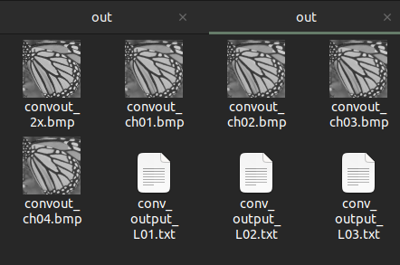

1. **(30p) H/W simulation and verification for SSAI2021**

What you have to do:

1. Copy the weight/scale/bias hex files of SSAI2021 from Part 2b to input_data/
2. Update the **buffer** parameters for SSAI2021 in the top file (cnn_accel.v) and the test bench (top_system_tb.v).

Hint: Only changing the number of layers may work.

1. Modify the test bench (top_system_tb.v) to execute SSAI2021 on the CNN accelerator

Hint: Use the parameters in Part 2a.

1. Do a simulation with time = 10ms and capture the waveform.

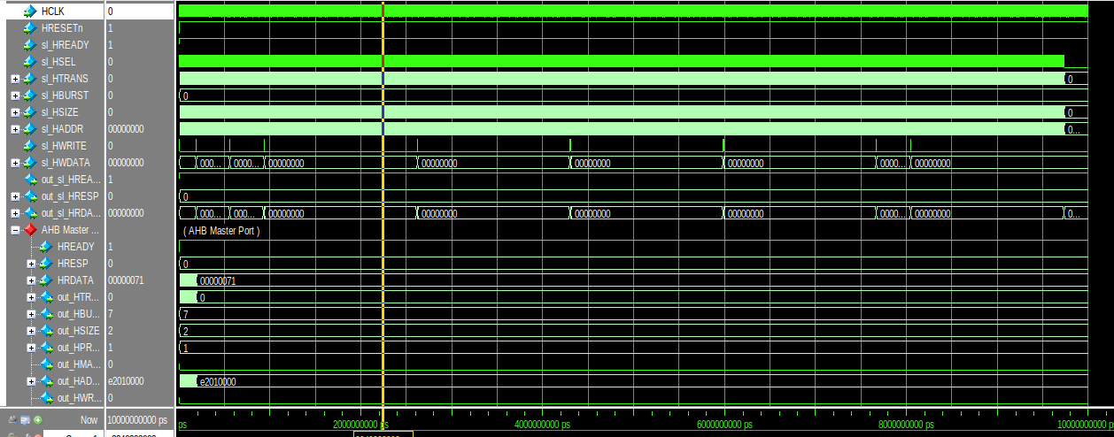

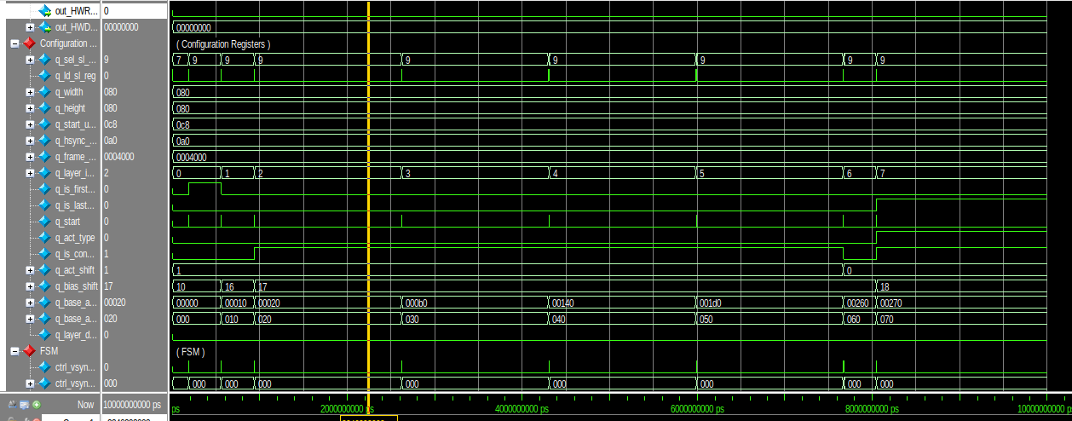

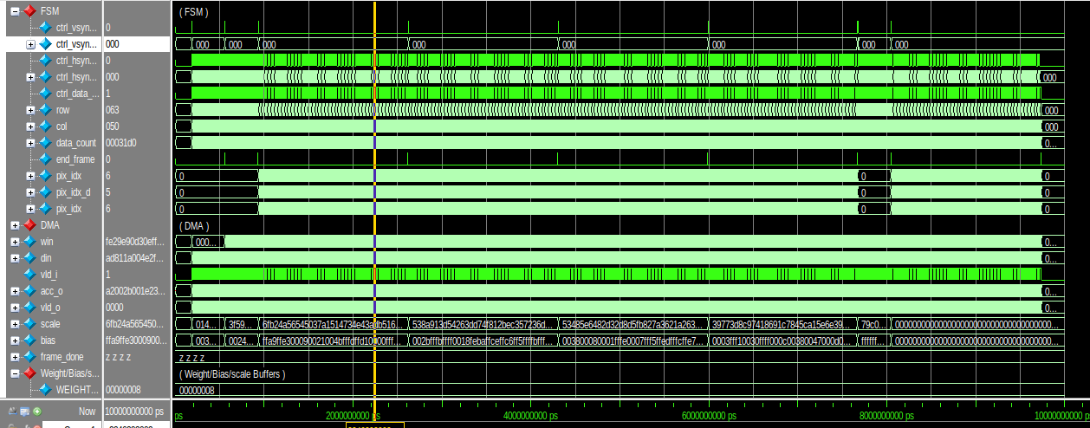

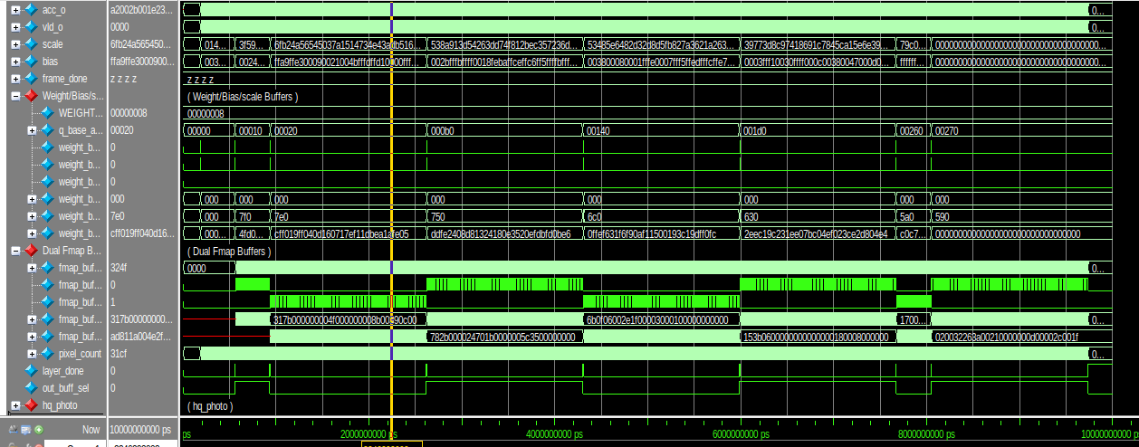

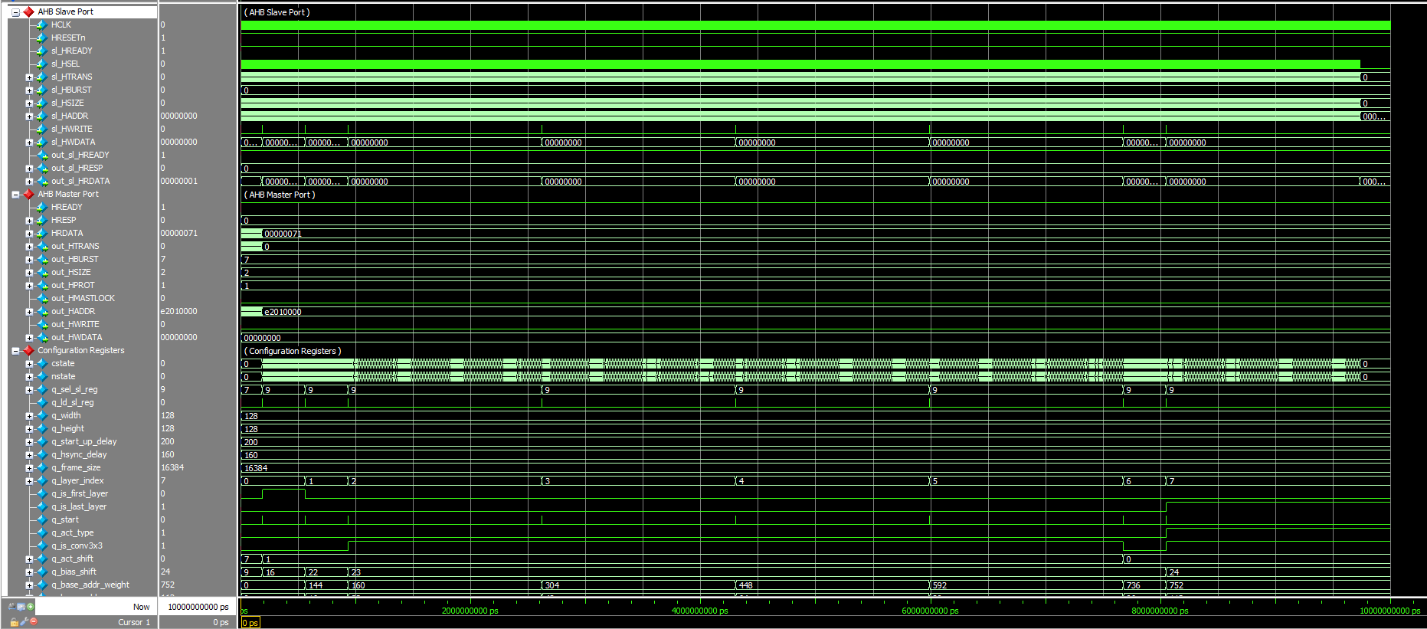

(a)

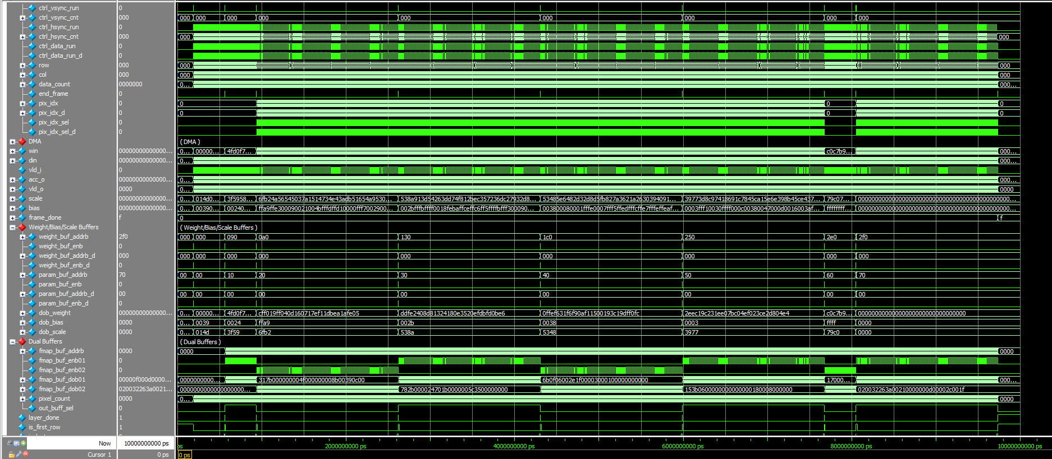

(b)

Figure 1-3: Figure 1-1: A captured waveform of cnn_accel.

Hints:

* **You should check the configuration registers carefully**.
* To speed up the simulation time, the following code in the top module (cnn_accel.v) is **commented out,** as shown in Fig. 1-4. During debugging, you may **uncomment** them to verify the outputs of some first CONV layers early.

1. Use check_hardware_results.m to verify the output images generated by the H/W simulation.

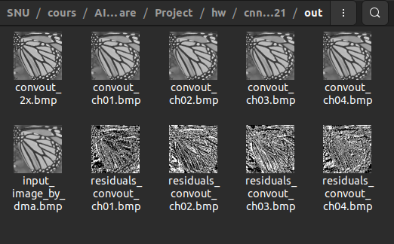

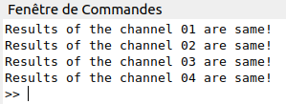

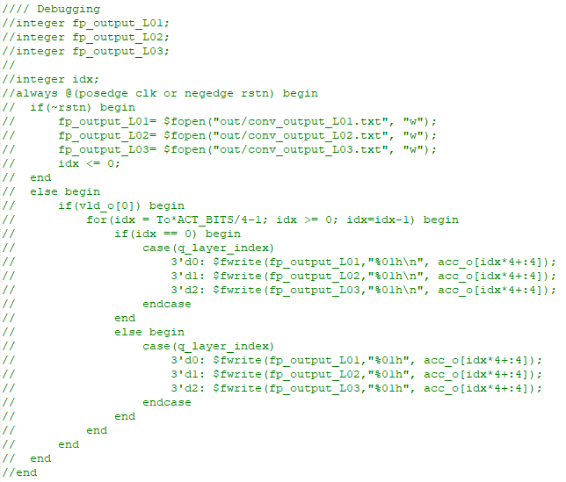

Figure 1-4: Disable the file logging to speed up the simulation time.

**Problem 2 (100p): Optimization**

1. **Optimization (90p)**

Improve the CNN accelerator design for time and buffer reduction. Check Lecture 14b for details.

1. **Problem and scopes**

The goal is to improve the CNN accelerator by reducing or minimizing the number of cycles and the buffer size.

Scopes and constraints:

* The baseline code is cnn_accel_opt/, which executes **the three-layer CNN** as in the class.
* Ti and To are fixed to 16. Do NOT increase the number of convolution kernels or the number of multipliers in a kernel.
* Weights, scales, and biases are quantized to 8-bit, 16-bit, and 16-bit numbers, respectively.
* The clock frequency is fixed to 100MHz. Do NOT increase the clock frequency to speed up the system.
* WIDTH, HEIGHT, and FRAME_SIZE are fixed.
* The running time and the buffer size of the baseline are **t0=3,930** us and **s0=4,280** Kbits.

What you can modify:

* Hex files: You can reorganize the input file (img/ butterfly_32bit.hex) or the weight/bias/scale files.
* The CNN accelerator top module (cnn_accel.v, cnn_fsm.v).
* The test bench (top_system_tb.v).
* The image writer (bmp_image_writer.v) may be modified if you define a new output order.

1. **Optimization methods**

As described in the class, we can reduce execution and buffer size by:

* Reordering the input data and the number of transactions on DMA.
* Pipelining the DMA and the convolution computation to reduce the input buffer.

**DMA Optimization:**

if(data_vld_o_ld) begin

if(in_pixel_count == q_frame_size-1)

in_pixel_count <= 0;

else

in_pixel_count <= in_pixel_count + 4; // modif

end

if(data_vld_o_ld) begin

in_img[in_pixel_count] <= data_o_ld[7:0];

in_img[in_pixel_count+1] <= data_o_ld[15:8];// modif

in_img[in_pixel_count+2] <= data_o_ld[23:16];// modif

in_img[in_pixel_count+3] <= data_o_ld[31:24];// modif

end

With the re-ordered file, we can load the pixel 4 by 4 instead of 1 by 1.

if(data_last_o_ld) begin // End of loading a line

if(start_line_ld == q_height-4) begin // Last line //

start_line_ld <= 0;

start_addr_ld <= q_input_image_base_addr;

load_image_done <= 1'b1;

end

else begin // Normal line

start_line_ld <= start_line_ld + 4; // modif

start_addr_ld <= start_addr_ld + {q_width,2'b00};

end

end

*cnn_accel.v*

while(!image_load_done) begin

#(32*p) @(posedge HCLK) u_top_system.u_riscv_dummy.task_AHBread(`CNN_ACCEL_INPUT_IMAGE_LOAD,image_load_done); // modif

end

*top_system_tb.v*

* Fully utilizing the convolution kernels when executing Layer 3.
* Applying layer fusion

You should describe your modified code in the report.

1. **Evaluation**

* Use check_hardware_results.m to verify the output images generated by H/W simulation. Please make sure that your optimized code functions correctly as the baseline.
* Report the execution time (t) and the buffer size (s) of your design. The overall improvement is measured by the following metric:

Overall improvement in time was not significant but **DMA’s time reduced four fold. (From 188us to 47us)** and total running time from 3,930 to 3,790 us

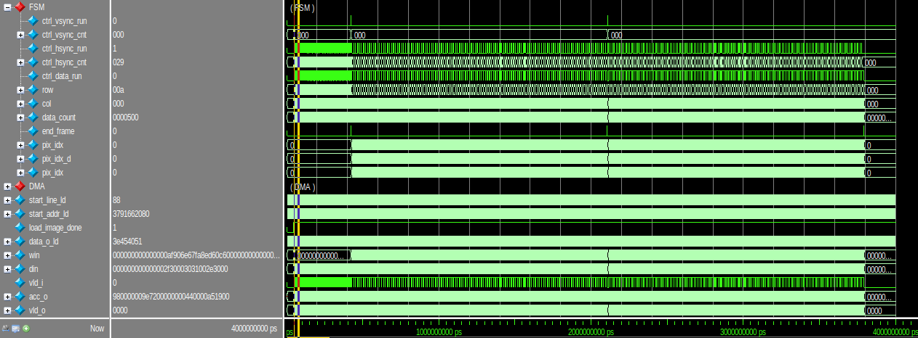

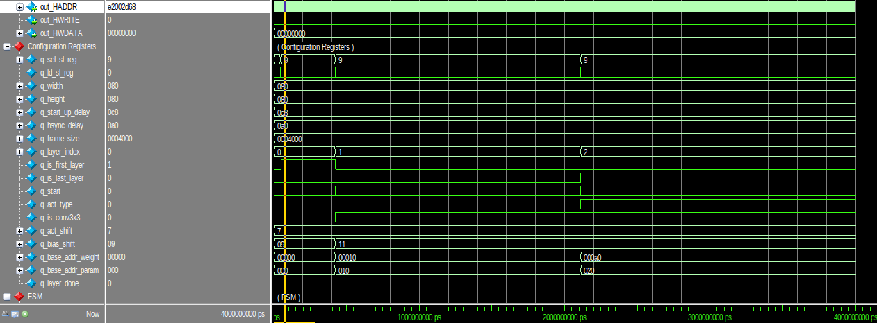

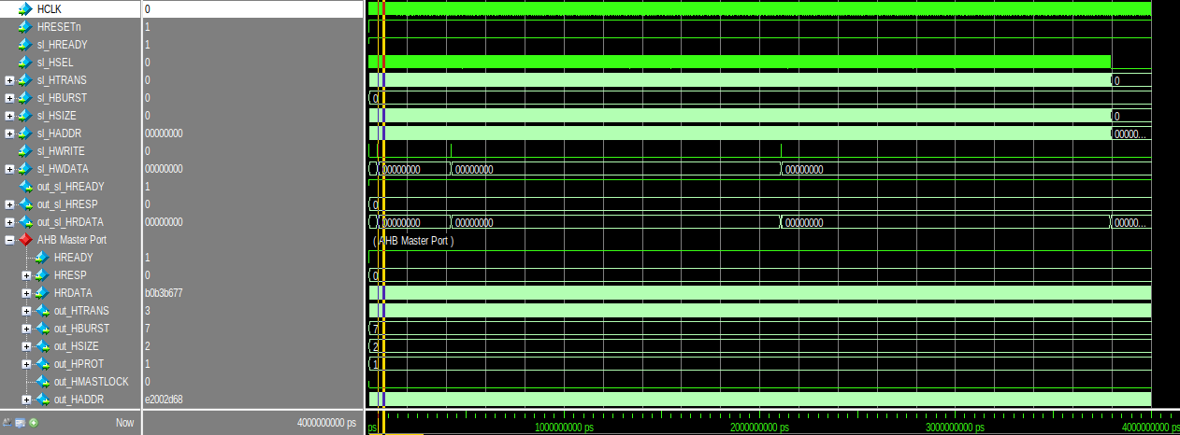

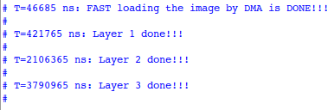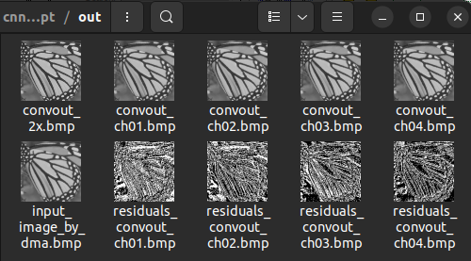

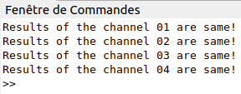

Where t0 and s0 are the execution time and the buffer size of the baseline version, respectively.

1. **Optimality analysis (10p)**

Explain why you choose parameters for your approach. For example, to reduce the input buffer size, you only preload a few image lines, i.e., *n*, from Memory and then pipeline the DMA and the convolution computation. Then, you should explain the choice of *n*.