**HW#03: Program Counter, Branch Instructions**

**Issued:** March 28 (Tue.), 2023 **Due:** April 3 (Mon.), 2023

**What to turn in**: **Copy the text from your MODIFIED codes and paste it into a document**. If a question asks you to plot or display something on the screen, also include the plot and screen output your code generates. Submit either a *.doc or *.pdf file.

**\*\*\*\*\*\*\*\*\*\*\*\*\*\*\*\*\*\*\*\*\*\*\*\*\*\*\*\*\*\*\*\*\*\*\*\*\*\*\*\*\*\*\*\*\*\*\*\*\*\*\*\*\*\*\*\*\*\*\*\*\*\*\*\*\*\*\*\*\*\*\*\*\*\*\*\*\*\*\*\*\*\*\*\*\*\*\*\*\*\*\*\*\*\*\*\*\*\***

**Problem 1 (15p): Program Counter**

Design a program counter in Verilog. Please see the description in the lecture note for details.

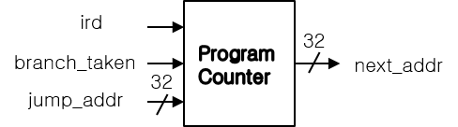

What you have to do:

1. Program Counter (10p)

* Complete a program counter and its test bench based on the baseline codes.
* Do simulation and capture its result, i.e., waveform and transcript window.

1. The extended program counter (5p): Compared to riscv_pc_tb1, riscv_pc_tb2 connects iaddr_i to the output of the Program Counter.

* Complete the test bench (riscv_pc_tb2.v).
* Do simulation and capture its result, i.e., waveform and transcript window.

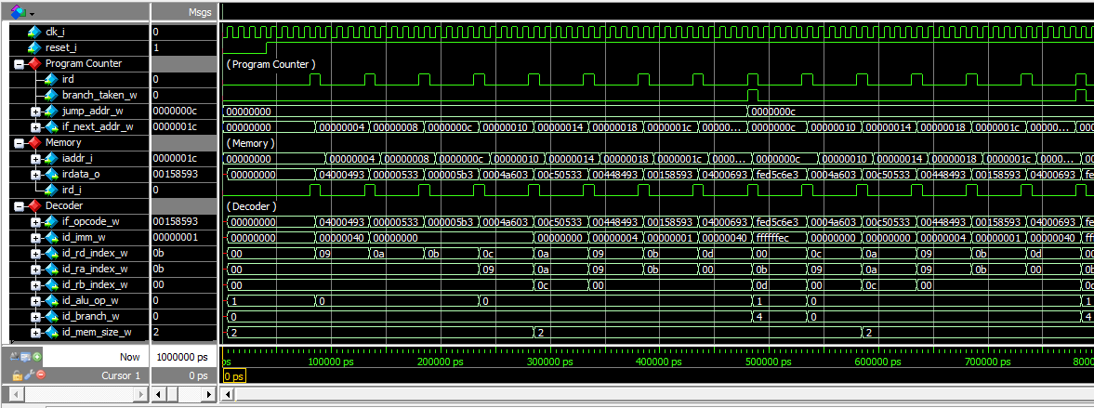

**Problem 2 (20): Program**

Design a simplified RISC-V core in Verilog. Please see the description in the lecture note.

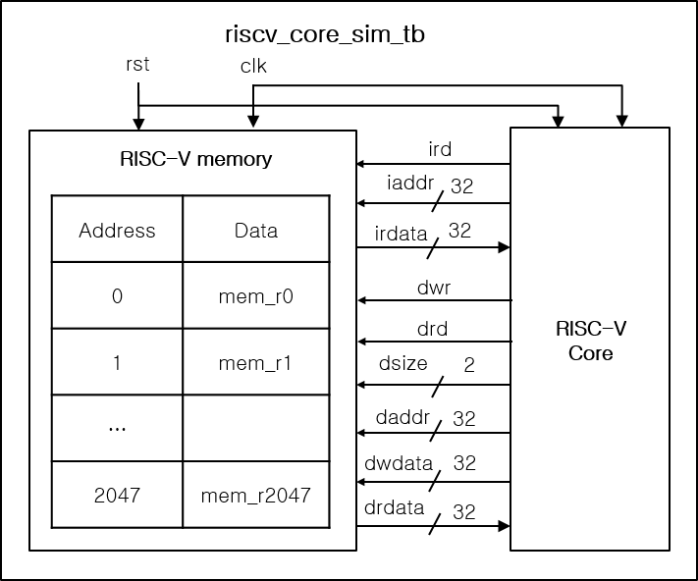

What you have to do:

1. Baseline core(10p)

* Use Program Counter in Problem 1, complete all connections for ALU, Decoder, and Register File modules.
* Do a simulation and capture the waveform.

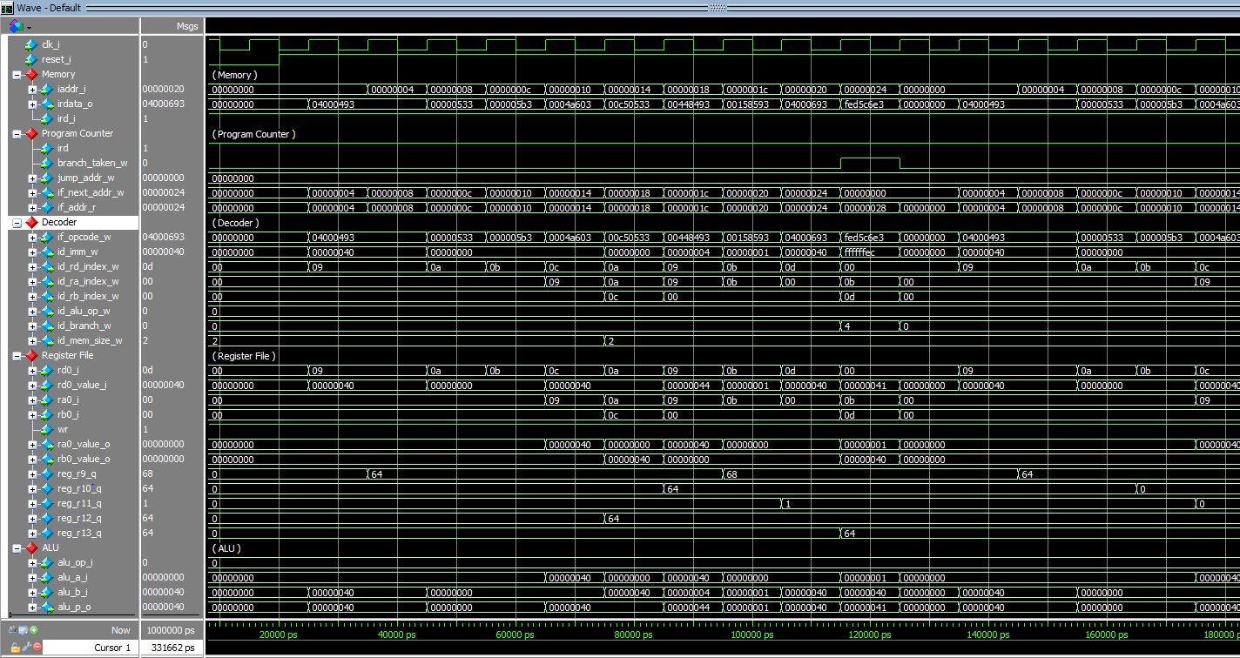

| **C code** | **Assembly Code** | |
| --- | --- | --- |
| int A[64];  int sum = 0;  for (int i=0; i<64; i++)  sum += A[i]; | addi x9, x0, 64  add x10, x0, x0  add x11, x0, x0  Loop:    lw x12, 0(x9)    add x10, x10, x12    addi x9, x9, 4    addi x11, x11, 1    addi x13, x0, 64    blt x11, x13, Loop | # x9=&A[0]  # sum=0  # i=0  # x12=A[i]  # sum+= A[i]  # &A[i++]  # i++  # x13=64 |

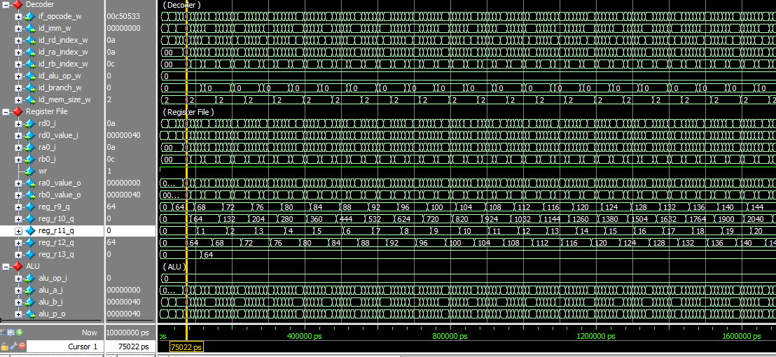

Fig. 2-1: Simulation result.

1. Default target address and branch enable signal for Brach-Less-Than BLT (2p)

In the baseline mode for (BLT), the target address for Branch-Less-Than (BLT) is set to 0, while the branch “enable” signal is **always set to 1**. Explain why r11 in Register File only has two values, 0 and 1.

(c) Branch instruction Brach-Less-Than (BLT) (8p)

1. Target Address for BLT (4p)

* Make code to calculate a target address for BLT.
* Do a simulation and capture its result, i.e., waveform.

1. Target enable for BLT (4p)

* Make code to generate a branch enable signal for BLT
* Do a simulation and capture the waveform.

**Problem 3 (2p) Branch-Not-Equal(BNE) (Optional): Bonus**

The following table shows C codes and their assembly codes for a program that calculates an array’s sum of all elements. Two code versions use LESS-THAN and NOT-EQUAL operations for a conditional branch in a loop. In this problem, you have to do the following:

1. Generate a memory file for the modified assembly code using a NOT-EQUAL operation, called mem_bne.hex.
2. Modify a test bench to use a new memory file (riscv_core_sim_bne_tb.v).
3. Make code to compute a target address and a branch enable signal for Branch-Not-Equal (BEQ).
4. Do a simulation and capture its waveform.

| **C code** | **Assembly Code** | |
| --- | --- | --- |
| int A[64];  int sum = 0;  for (int i=0; i< 64; i++)  sum += A[i]; | addi x9, x0, 64  add x10, x0, x0  add x11, x0, x0  Loop:  lw x12, 0(x9)  add x10, x10, x12  addi x9, x9, 4  addi x11, x11, 1  addi x13, x0, 64  blt x11, x13, Loop | # x9=&A[0]  # sum=0  # i=0  # x12=A[i]  # sum+= A[i]  # &A[i++]  # i++  # x13=64 |
| int A[64];  int sum = 0;  for (int i=0; i≠64; i++)     sum += A[i]; | addi x9, x0, 64  add x10, x0, x0  add x11, x0, x0  Loop:    lw x12, 0(x9)    add x10, x10, x12    addi x9, x9, 4    addi x11, x11, 1    addi x13, x0, 64    bne x11, x13, Loop | # x9=&A[0]  # sum=0  # i=0  # x12=A[i]  # sum+= A[i]  # &A[i++]  # i++  # x13=64 |