**Homework 6: IO, LCD Drive, and Image processing applications**

**Issued:** April 18 (Tuesday), 2023 **Due:** April 24 (Monday), 2023

**What to turn in**: **Copy the text from your MODIFIED codes and paste it into a document**. If a question asks you to plot or display something to the screen, also include the plot and screen output your code generates. Submit either a *.doc or *.pdf file.

**\*\*\*\*\*\*\*\*\*\*\*\*\*\*\*\*\*\*\*\*\*\*\*\*\*\*\*\*\*\*\*\*\*\*\*\*\*\*\*\*\*\*\*\*\*\*\*\*\*\*\*\*\*\*\*\*\*\*\*\*\*\*\*\*\*\*\*\*\*\*\*\*\*\*\*\*\*\*\*\*\*\*\*\*\*\*\*\*\*\*\*\*\*\*\*\*\*\***

**Problem 1 (10p): LCD Drive**

Implement an LCD drive system. Please see the description in the lecture note for details.

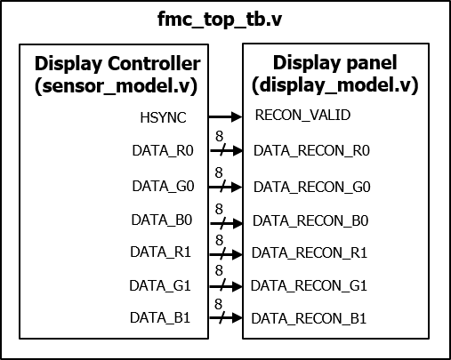

Fig. 1-1: Top test-bench module.

What you have to do:

* Design an LCD drive system by completing the missing codes in the display controller (sensor_model.v) and the display model (display_model.v).
* Submit your RTL files.
* Capture the results, including the waveform and the output image.

**Problem 2 (10p): Brightness Adjustment**

Implement an LCD drive system with a brightness adjustment module. Please see the description in the lecture note for details.



Fig. 2-1: Top test-bench module.

What you have to do:

* Design an LCD drive system with a brightness adjustment module by:
  1. Reusing a sensor (sensor_model.v) and a display (display_model.v) in Problem 2.
  2. Completing the missing codes in brightness_adjustment.v.
  3. Modifying the test bench to obtain images in different modes.
* Submit your RTL files.
* Capture the results, including the waveform and the output images.



Fig. 2-2: Simulation results.

**Problem 3 (10p): Reversible color transform (RCT)**

Implement forward and inverse RCT modules and integrate them into an LCD drive system. Please see the description in the lecture note for details.

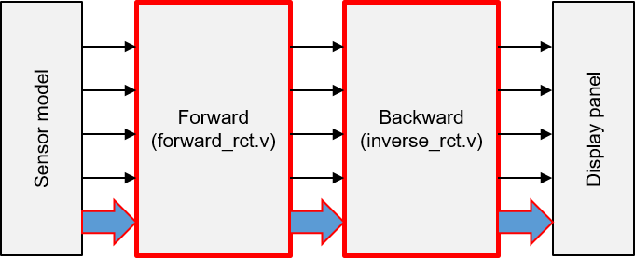

Fig. 3-1: Simulation results.

What you have to do:

* Design an LCD drive system with RCT modules by:
  1. Reusing a sensor (sensor_model.v) and a display (display_model.v) in Problem 2.
  2. Completing the missing codes in forward_rct.v and inverse_rct.v.
* Submit your RTL files.
* Capture the results including the waveform and the output images.

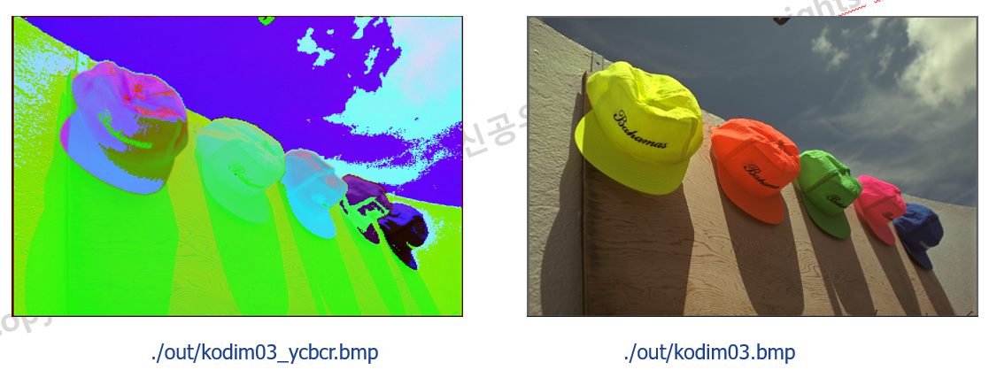

Fig. 3-2: Simulation results.

**Problem 4 (2p) (Optional): Bonus**

* Explain why the output images of Problems 1 and 3 are similar but not identical.
* Guess the motivation to use the RCT forward and inverse modules in Problem 3.