**Invention Disclosure Details**

**Name and Address of APPLICANT:**

|  |  |
| --- | --- |
| **Name** | **Department/Address** |
| **MANIPAL UNIVERSITY JAIPUR** | Jaipur-Ajmer Express Highway, Dehmi Kalan, Near GVK Toll Plaza, Jaipur, Rajasthan 303007 |
|  |  |

**Name and Address of Inventor:**

|  |  |
| --- | --- |
| **Name** | **Department/Address** |
| **Satyam Nautiyal** | Department of IoT & IS, Manipal University Jaipur |
| **Dr. G.L. Saini** | Department of IoT & IS, Manipal University Jaipur |

**DETAILS OF THE PUBLICATION/COMMUNICATION/EXHIBITION IN WHICH THE INVENTION WAS DISCLOSED PRIOR TO PATENT FILING IN PUBLIC DOMAIN.**

**Response**: NO

**TITLE:** MediWay - Blood Report Analysis and Consultation Chatbot Platform

## ABSTRACT:

The primary objective of this invention is to develop an AI tool that automatically interprets medical blood diagnostic reports, to make them more understandable to laypersons.

Traditionally, medical report interpretation have been done medical experts, thus creating a hurdle for normal people to interpret their health data without the intervention of a medical expert. The lack of timely interpretation can lead to delayed medical treatment and increased patient stress levels. The project presented here targets to address this problem through the application of Natural Language Processing (NLP) and Optical Character Recognition (OCR) technologies to extract, analyze, and generate readable, custom-made summaries of diagnostic reports.  
  
The platform allows patients to effectively comprehend the meaning of their test results, thereby allowing them to make well-informed decisions regarding their health. Moreover, it also reduces patients' absolute dependence on healthcare professionals to provide basic clarifications and thereby bridging the gap. Additionally, the platform provides, evidence-based information for patient symptoms, as well as a chatbot support system to personalize user engagement though chat based consultation. This innovation finds special relevance within telemedicine and online healthcare channels, where distance-based access to healthcare information has to be viable.  
  
Unlike existing solutions, this new technology is a blend of real-time, AI-based explanations and is, hence, a one of a kind product in the digital health space.

## WHAT PROBLEM WAS SOLVED BY THE INVENTION?

Medical diagnostic reports include technical jargon and quantitative information that needs some degree of professional expertise for proper interpretation. Patients usually find it difficult to comprehend their test results, and this causes unnecessary stress, delay in seeking health care, and an undue reliance on health professionals for simple explanations. Health professionals are not within reach in rural or underserved areas, further limiting the ability of people to comprehend their health information. People in these areas also need to be consulted in their Native languages making it yet more difficult for them and especially the elderly to shift to the Technology based solutions.  
  
Also, current AI-based healthcare solutions either are centered on clinical decision support for physicians or provide static explanations without personalized insights derived from an individual's own health profile and medical history. There is no such widespread system yet that actively involves users, takes their health history into account, and provides them with real-time personalized health information.

The invention met these challenges by:  
  
1. Medical information recovery from photographs and PDFs using Optical Character Recognition (OCR).  
  
2. The use of Natural Language Processing (NLP) to create comprehensible explanations tries to explain confusing medical terminology.  
  
3. Providing user-context based dynamic responses while taking factors such as age, weight, height, illness history, and symptoms into consideration.  
  
4. Enabling interactive follow up consultations with a chatbot to resolve their queries and receive contextually appropriate answers.

5. Allowing Conversation in Native languages like Hindi, making it useful to a wider segment of the population.

6. Allowing a Family view where members of a family can view the reports of each other, making health tracking easier.  
  
By providing personalized, AI-based medical information to patients, this technology removes the dependency of doctors on premature reports and enables users to make well-informed health choices.

**Literature Review:**

Artificial intelligence (AI) has revolutionized the healthcare industry through innovation in patient empowerment, medical information management, and self-service medical data. Artificial intelligence-based systems, such as chatbots and data scrapers, are revolutionizing access and the form of health delivery.

*CN104254863A (Inventors: Liu Hong, Fang Xiaoyun)* accounts for an AI-powered healthcare system for mobile that assists diagnostics based on patient inputs and contextual information. Once again, the focus here is more on symptom-based diagnosis and less on interpreting formal diagnostic information such as the findings of blood tests. MediWay, however, is designed to interpret such formal reports and translate them into layman-friendly, personalized narratives.

*US10834026B2 (Inventors: Jeremy Jordan, Giorgi Kvernadze, et al.)* Introduces a smart health system that offers suggestions that change dynamically with user input and therefore offers quality personalized insights. But it is intended primarily for general management of health and not for report-specific, in-depth diagnostic analysis provided by MediWay. Also, it does not upload diagnostic reports and process them with OCR and NLP workflows.

*US20220231985A1 (Inventors: Zachary Abzug et al.)* talks about a chatbot platform that utilizes real user data for real-time interaction and response customization. While it is real-time analysis-focused, it is far from the full extent of structured report analysis and interpretation offered by MediWay. Further, it does not offer integration with PDF-formatted lab reports or scans.

*US20250046448A1 (Inventors: Aravind Krishnan, Ayush Tyagi)* suggests a system that utilizes OCR and NLP to convert medical records, including diagnostic reports. This is quite in keeping with MediWay's approach; however, the patent is more on raw extraction and visualization. MediWay, by contrastm superimposes personalized explanations and interpretations of such records, so that users can understand their health information in context meaningful to their profile (age, gender, medical history, etc.).

**MediWay introduces the following key advancements to overcome the shortcomings of existing systems:**

**Patient-Specific Explanation of Diagnostic Reports**  
Unlike prior art which provides general healthcare responses or static diagnostic interpretations, MediWay uses a personalized approach to convert blood test values and scan results into intuitive narratives. The narratives generated are unique and personalized to every user by using the user context and health background information.

**OCR-Driven PDF Report Ingestion**  
MediWay lets users upload diagnostic report PDFs and uses Optical Character Recognition (OCR) to extract structured medical information, even from scanned or image-based files. This end-to-end integration from file to analysis is more comprehensive than the systems described in existing patents.

**Natural Language-Based Interpretations**  
Through the integration of large language models (LLMs), MediWay not only retrieves data from diagnostic reports but also generates explanations in conversational and comprehensible formats. This enables patients to engage meaningfully with their health data without needing a medical professional to interpret the results.

**Interactive Health Assistant with Learning Feedback Loop**  
MediWay also has a chatbot-based interface and provides interactive question-and-answer functionality, and it can fine-tune its responses based on user feedback and therefore become more intelligent and context-sensitive over time. This feature of ongoing learning is absent in the systems described above.

## ADVANTAGES OF THE INVENTION

**1. Patient Empowerment**

**The site offers Instant Health Insights with easy explanations, thereby eliminating anxiety and confusion regarding test data meaning.**

**2. Dynamic AI Responses**

**User context, such as age, weight, height, past medical condition, and symptoms, creates personalized context bases information.**

**Follow-Up Interactions allow users to resolve user queries about test results and receive credible AI-generated consultation based on their health profile.**

**3. Improved Healthcare Efficiency**

**The software lightens the workload of medical personnel by answering repetitive queries and doubts, enabling them to focus on cases requiring their utmost need.**

**Effective information access enables off-site patients to easily obtain information prior to a doctor visit, allowing them to be well prepared with their doubts.**

**4. Savings**

**Reducing Number of Doctor Visits – Patients are able to obtain basic information about reports without a need to visit doctor.**

**The platform eliminates the total dependency on experts, proving beneficial to regions experiencing physician shortages, it acts a first filter of reports.**

**6. Better Health Outcomes**

**Preventive care and early diagnosis helps users to detect risks early and get proactive medical treatment to mitigate the complexities.**

**Promotes Health Involvement – Patients become more engaged with their health by uncovering the information in their reports firsthand.**

**7. Multilingual Access and Inclusivity Offers language support for indigenous languages, allowing native speakers.**

## SALIENT FEATURES OF THE INVENTION

Unique Characteristics of the Project

Our innovation is an Artificial Intelligence-based Integrated Medication Adherence and Management Platform aimed at reading medical reports, generating customized health insights, and enabling dynamic medical consultations for patients. As opposed to conventional consumers of medical reports, the platform contextualizes content based on user demographics, symptoms, and medical history, thus offering highly personalized and accurate health interpretations.  
  
**1. AI-based interpretation of medical reports**  
Incorporation of OCR & NLP – Extracts text from clinical reports (images/PDFs) and transforms them into structured insights.  
  
Layman-Friendly Explanations converts complex medical terms into layman-friendly language, allowing reports to be understood by non-medical users.  
  
**2. Context-Aware Dynamic Consultation**  
User-Specific Analysis – tailors interpretations as per patient details (age, weight, height, symptoms, history).  
  
The subsequent interaction feature allows users to ask questions about their reports and receive answers created by artificial intelligence.  
  
Progressive Learning enhances explanations over time, taking into account new medical advances and user feedback.  
  
**3. Smart Health Recommendations**

Early Risk Detection identifies unusual reporting patterns and warns individuals of potential health threats.

Preventive health advice advises lifestyle change depending on the findings of medical check-ups.

**4. Streamlined Healthcare Access**

Empowers Patients – Allows patients to take charge of their health without direct physician intervention.  
  
Reduces Physician Workload – Eliminates redundant questions, allowing physicians to focus on complex cases.  
  
Augments Telemedicine – Gives prior analysis prior to virtual consultation, boosting efficiency of health.

**Family View System** – Users can securely view and manage medical reports of family members, improving coordinated care.  
  
**6. Multilingual and User-Centric Design**

An Inclusive, Multilingual Interface Supports Multiple Languages Facilitates the provision of health information to multilingual populations.  
  
User Interface Simplified for All Ages – Designed to assist older people and those with severely limited digital literacy.  
  
Originality of the Invention This website combines user-initiated, dynamic analysis with live AI-assisted consultation unlike static readers of medical reports or FAQ-based chatbots.

## ****SUMMARY OF THE INVENTION****

### **Core Functionality**

**Data Acquisition**

* With user consent and registration, MediWay gathers basic user information like age, gender, height, weight, symptoms, medical history, and uploaded diagnostic reports (PDFs).
* Optical Character Recognition (OCR) is used to scan uploaded medical records of text data into an internal pipeline that is precisely optimized for both structured and unstructured lab reports.

**LLM Integration**

* MediWay uses a very fine-tuned Large Language Model (LLM) via API (e.g., Groq API) to generate layperson-friendly reports of blood test findings.
* •The LLM is queried with parsed, structured patient metadata and report contents to facilitate context-aware, customized narratives.

**Medical Report Categorization**

* Semantically organized extracted data is mapped into accepted medical parameters (e.g., WBC count, Hemoglobin, Creatinine), each assigned to medically accepted reference ranges.
* An in-house storehouse of medical information is utilized to put abnormalities into context by considering demographic and historical information.

**Narrative Generation**

* MediWay generates a human-readable report for each parameter, normal or cause for concern, causes, lifestyle effects, and when professional action may be indicated.
* Graphic explanations (charts, colored ranges) augment text narratives to enable easy understanding.

**Data Aggregation and Storage**

* All the interpreted and extracted data is stored securely in an SQLite database (scalable to PostgreSQL) on the backend.
* •History of reports is categorized by user and presented in a secure dashboard upon login.

### **Advanced Functionality**

**Simple Explanations**

* **Any result or medical term can be clicked on to obtain additional context, definitions, and associated symptoms.**
* **Pop-up messages, tooltips, and collapsible FAQs enable the bridge between clinical knowledge and the knowledge of non-specialists.**

**Longitudinal Monitoring**

* **They are able to observe the trends in specific measures of health across a sequence of posted reports.**
* **Line graphs, with summary statistics, allow people to view trends and monitor long-term health conditions like anemia, diabetes, or kidney function over time.**

**Chatbot Buddy**

* **A chatbot has been added to answer any additional questions based on the reports uploaded, history, and symptoms.**
* **The method employs Retrieval-Augmented Generation (RAG) to pull answers from confirmed medical knowledge bases.**

**Notifications and Suggestions**

* **Where there are recorded abnormalities, MediWay records them and suggests action (e.g., "See a doctor," "Recheck after fasting," "Dehydration possible").**
* **Customised diet and life style advice is provided, depending on individual reading and measurements..**

### **Platform Integration**

**Web-Based UI**

* The frontend is developed using Streamlit library for rapid interactivity with the LLM api and seamless deployment to the streamlit cloud.
* Responsive design ensures accessibility across desktops, tablets, and mobile browsers.

**Login & Session Management**

* Uses Streamlit Native Auth for authentication, ensuring only authorized users can access medical records.
* User sessions are secured with JWT tokens and role-based access control (RBAC) where applicable.

### **Data Handling**

**Local Storage (Preferred)**

* Patient data and analysis results are stored locally in encrypted databases unless expressly permitted for cloud storage.
* All sensitive operations (e.g., PDF parsing, NLP processing) are performed server-side in a secure environment.

**Export Capabilities**

* Users may choose to export reports or insights in formats such as PDF, CSV, or JSON.
* Export actions are explicitly user-initiated, with download links secured using session keys and HTTPS.

### **Preprocessing and Feature Engineering**

**OCR and Parsing**

* Employs advanced OCR libraries (e.g., Tesseract with custom post-processing) for accurate extraction of structured tabular data.
* Uses regex and NLP for parsing lab report headers, units, and reference intervals.

**Data Structuring**

* Each entry is tokenized, normalized, and mapped to a medical schema.
* Named Entity Recognition (NER) and domain-specific token classifiers improve semantic interpretation.

### **CLAIMS**

The platform generates personalized, layperson-friendly interpretations of diagnostic medical reports, the process comprises:

* receiving user data including demographics (name, age, gender, weight, height), symptoms, and medical history through a form;
* extracting and preprocessing diagnostic data from uploaded medical reports (e.g., blood tests, scans) using optical character recognition (OCR);
* parsing relevant clinical values and comparing them with standard medical ranges;
* generating natural language explanations using a language model based on the user's clinical context;
* presenting the interpreted results via an interactive web-based interface.

A web-based system for visualizing and contextualizing medical diagnostic data comprising:

* an OCR pipeline for structured extraction of values from PDF diagnostic reports;
* a secure back-end database to store patient inputs and report data;
* Integration with a large language model (LLM) for narrative summary generation;
* an interactive front-end for visualization of reports, e.g., charts and highlight-based comments.

A mechanism that allows users to ask additional questions about their medical reports by using an integrated chatbot that takes advantage of the context of both extracted values and user-provided symptoms.

A temporal comparison function allows users to track how diagnostic values vary across a few uploaded reports across time.

A classification framework for grouping test parameters into medical categories (e.g., hematology, liver, kidney, lipid, hormones), with modular descriptions per category.

A tailored recommendation system that suggests future actions or lifestyle changes based on variations in report parameters and health data provided by the user.

A secure authentication and authorization system that allows only authorized users to upload, view, and engage with their health data.

A PDF download/export option that creates a concise summary of diagnostic information along with visualizations and AI-driven insights.

A privacy-conscious design where all sensitive health information is stored securely encrypted (e.g., AES-256), and clear user consent is obtained prior to processing.

An adaptive learning mechanism in which user feedback regarding interpretation accuracy plays a significant role in enhancing the system's model over time, potentially utilizing federated or anonymized data aggregation techniques.

**FIGURES / Diagrams related to the invention with their title.**

Fig : System Architecture Diagram

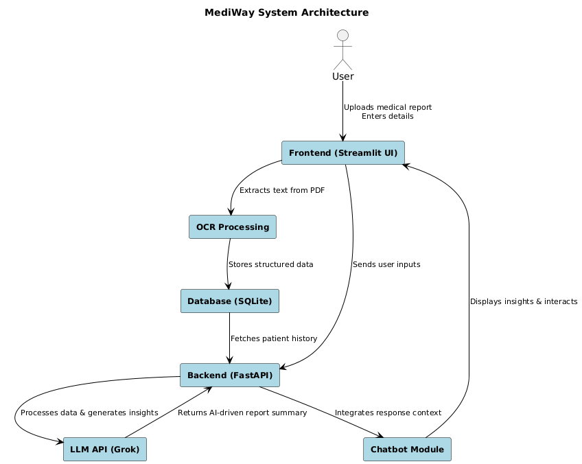

Fig : Data Flow Diagram ( Level 1 )

Fig : Data Flow Diagram ( Level 2 )

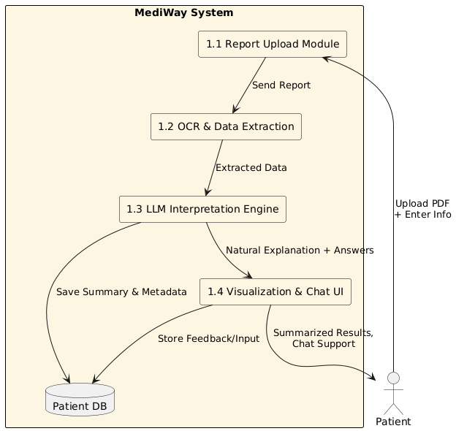

Fig Data Flow Diagram ( Level 3 )

Fig : The Development Process Followed

