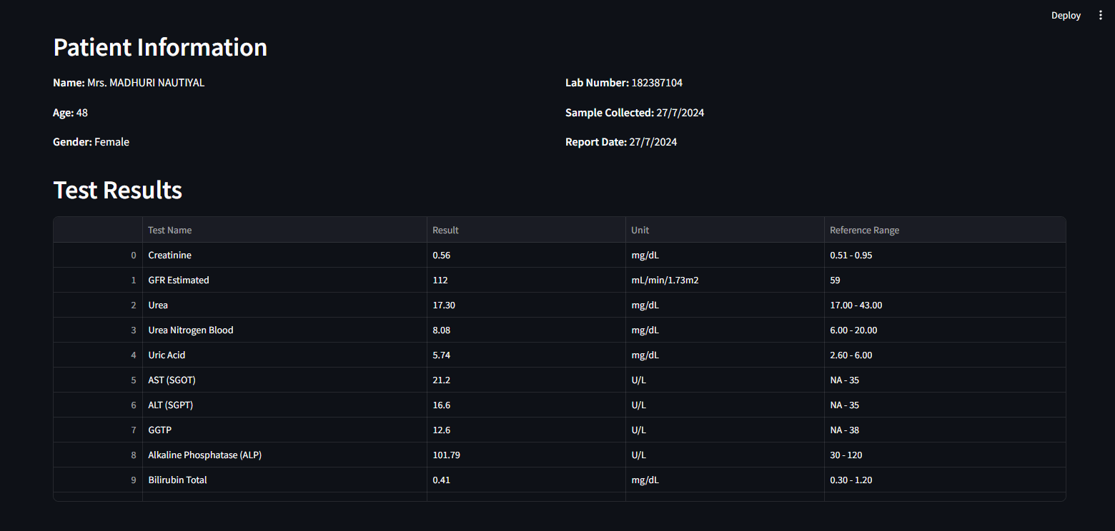

Figure 6: Extracted Blood Values –

The uploaded medical report is displayed with extracted parameters automatically parsed using OCR. The system intelligently identifies and highlights relevant test results for analysis.

Figure 7: AI-Generated Insights –

The platform generates patient-specific insights using LLM-powered analysis. Key parameters are explained in layman-friendly language, making it easier for users to understand their health condition.