**Instructions for the project setup – Windows**

**Step 1**: Install git if you don’t have installed, check the links for installation and setup (for Windows)

<https://phoenixnap.com/kb/how-to-install-git-windows>

<https://www.atlassian.com/git/tutorials/setting-up-a-repository>

**Step 2**: Check the git installed successfully, use the command.

* Git init

**Step 3**: Move to the directory where you want to import the project, and enter the command

* git clone <https://github.com/satz-git-py/Teachers.git>

**Step 4**: Check the project is moved successfully in the folder ‘Teachers’

**Step 5**: Move to the folder ‘Teachers’

* cd Teachers

**Step 6**: Check the folder has folders structures as in the given images

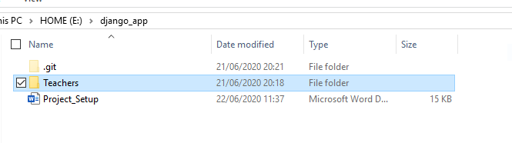

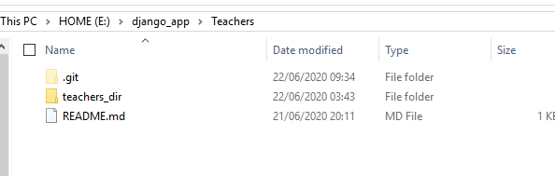

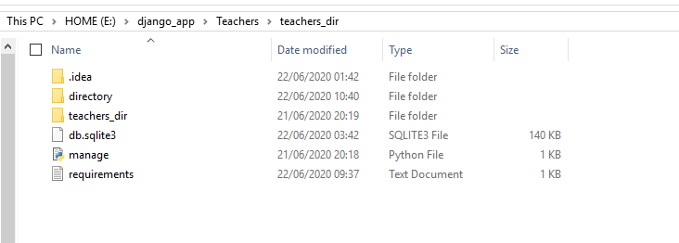

**Step 7**: If you have python installed, install python in the directory, Python-3.8.2 is used in this project

* <https://www.python.org/downloads/>

**Step 8**: Once done, install Django in the directory

* pip install django

**Step 9**: Move to ‘teachers_dir’ folder, and install the required dependencies from the file requirement.txt

* cd teachers_dir
* pip install - r requirements.txt

**Step 10**: type the command to run the server

* python manage.py runserver

**Step 11**: if successful, go to browser, and type <http://localhost:8000/> to load the page

**Step 12**: Admin page requires user name and password. Go to admin page using <http://localhost:8000/admin/> use can see the screen,

**USERNAME** : pinpoint, **PASSWORD:** pinpoint

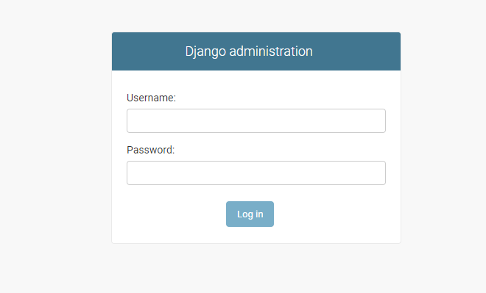

**Step 13**: Once logged in, you can see the screen given below

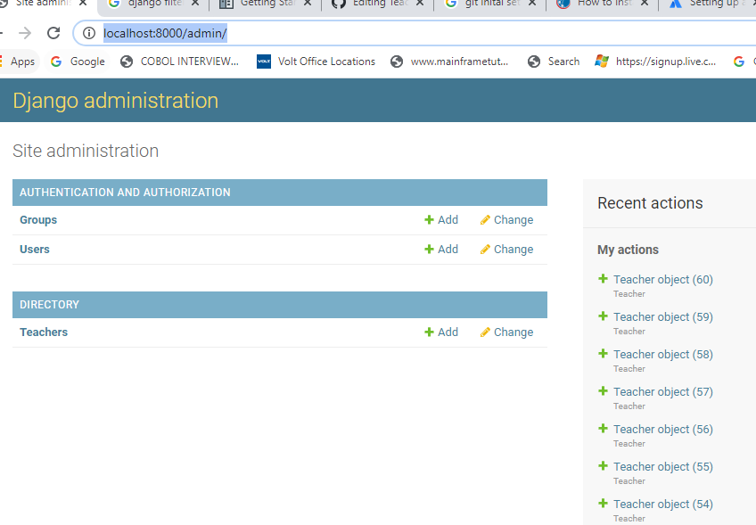

**Step 14**: move to the Directory Teachers by clicking it

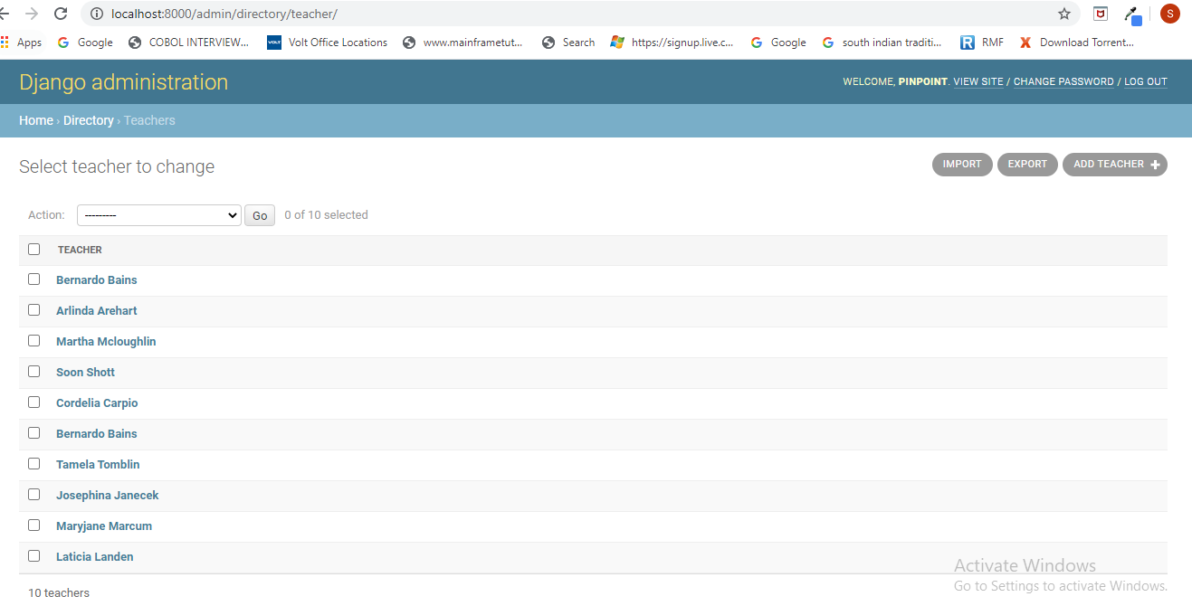

**Step 15**: Now you can see the options for upload data, you can use it. Some of the concerns present right now,

* column names as the same names as given the CSV file
* first letters should be Uppercase, space between words should be replaced with ‘_’
* the profile-pictures should be placed with the project folder structure
  + ..\Teachers\teachers_dir\directory\static\directory\img