**Project Setup Instructions**

**(Windows)**

**Step 1:** Confirm Python is installed in your machine by “python --version” in command prompt. 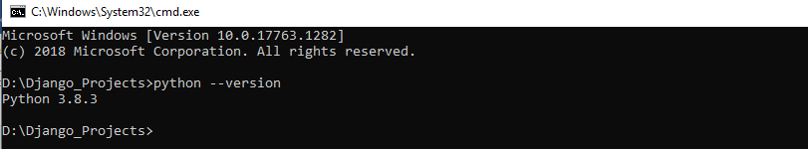

**Step 2**: If Python is not installed then install it from the link given below, (use Python 3.8.2 or above).

* <https://www.python.org/downloads/>
* check the “Add Python environment variable” option to reduce the work load
* You will also need to install **PIP** if you don’t have it installed

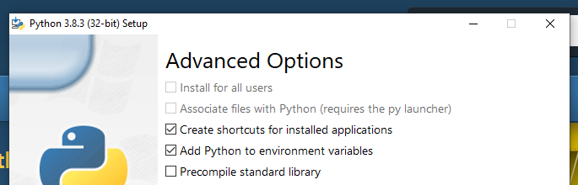

**Step 3**: Check the git installed successfully, use the command.

* Git --version
* If not installed it says likes unknown command

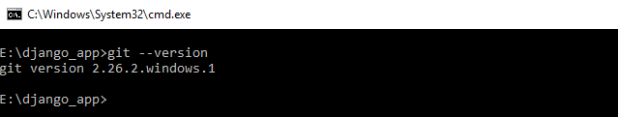

**Step 4**: Install git if you don’t have, check the links for installation and setup (for Windows)

* <https://git-scm.com/download/win> - for git download
* <https://phoenixnap.com/kb/how-to-install-git-windows>
* s<https://www.atlassian.com/git/tutorials/setting-up-a-repository>

**Step 5**: Move to the directory where you want to import the project, and enter the command

* git clone <https://github.com/satz-git-py/Teachers.git>

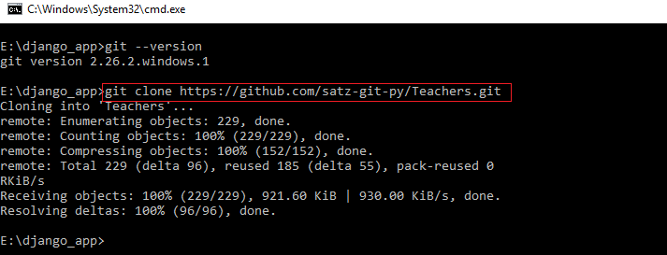

**Step 6**: Check the project folder ‘Teachers’ created successfully by using command below

* cd Teachers
* check for the folder structures as in the given images.

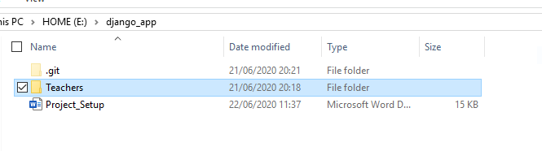

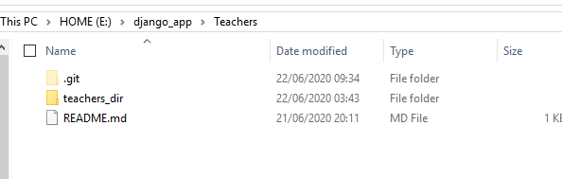

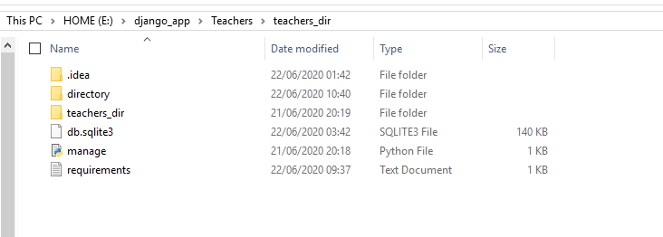

**Step 7**: Move to “**teachers_dir**” folder, and install the required dependencies from the file “requirement.txt”

* cd teachers_dir
* pip install -r requirements.txt

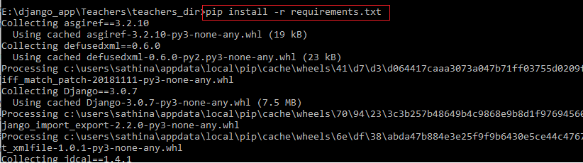

**Step 8**: once all required dependencies got installed type the command given below to run the server

* python manage.py runserver

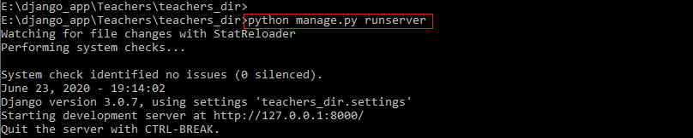

**Step 9**: As the server started click any of the links given below, or go to browser and type any of those to visit the directory home page.

* <http://localhost:8000/>
* <http://127.0.0.1:8000/>

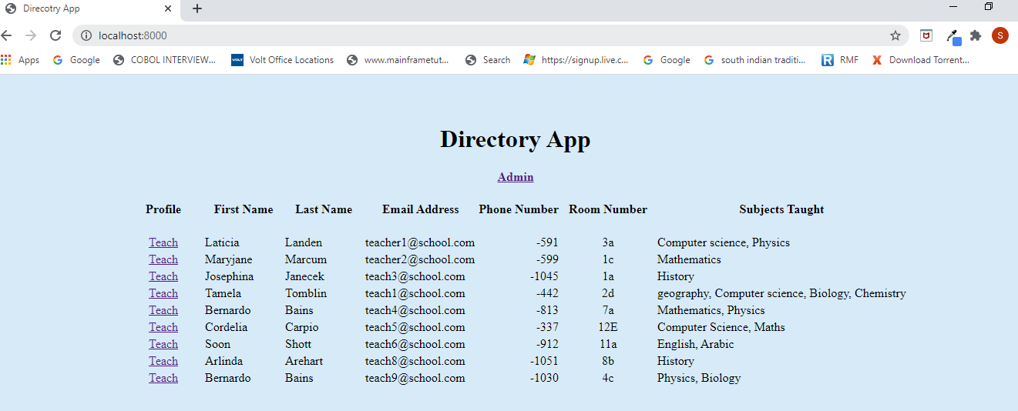

**Step 10:** Click on the “**Teach**” link in each row to see the profile of the respective teacher.

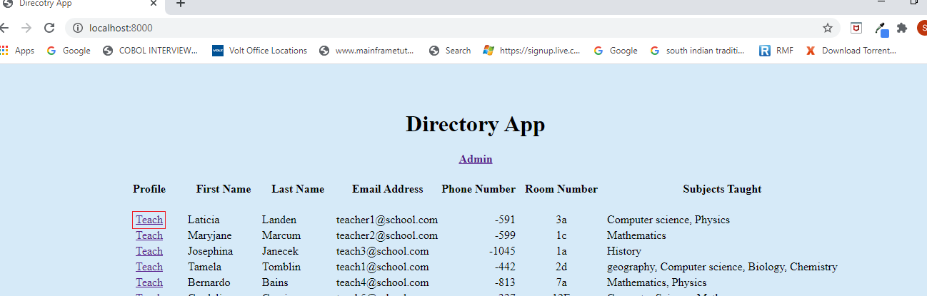

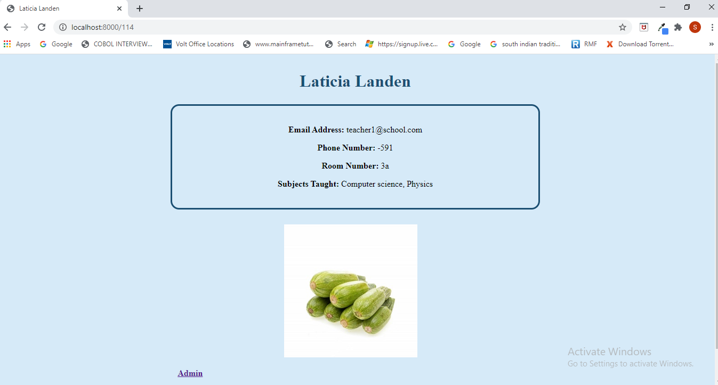

**Step 11:** Profile **not having profile picture**

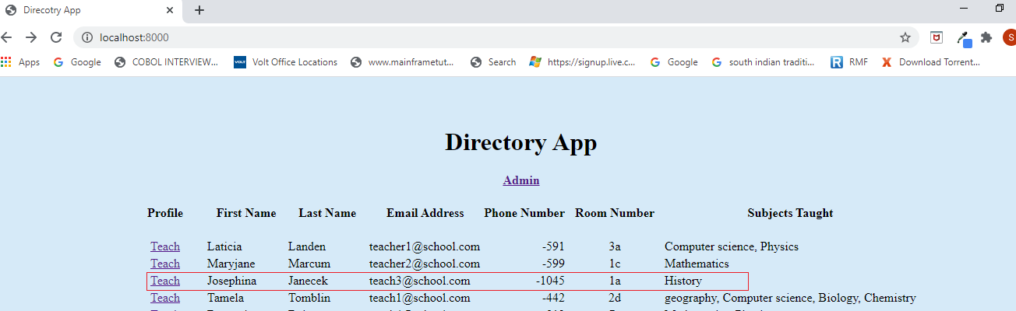

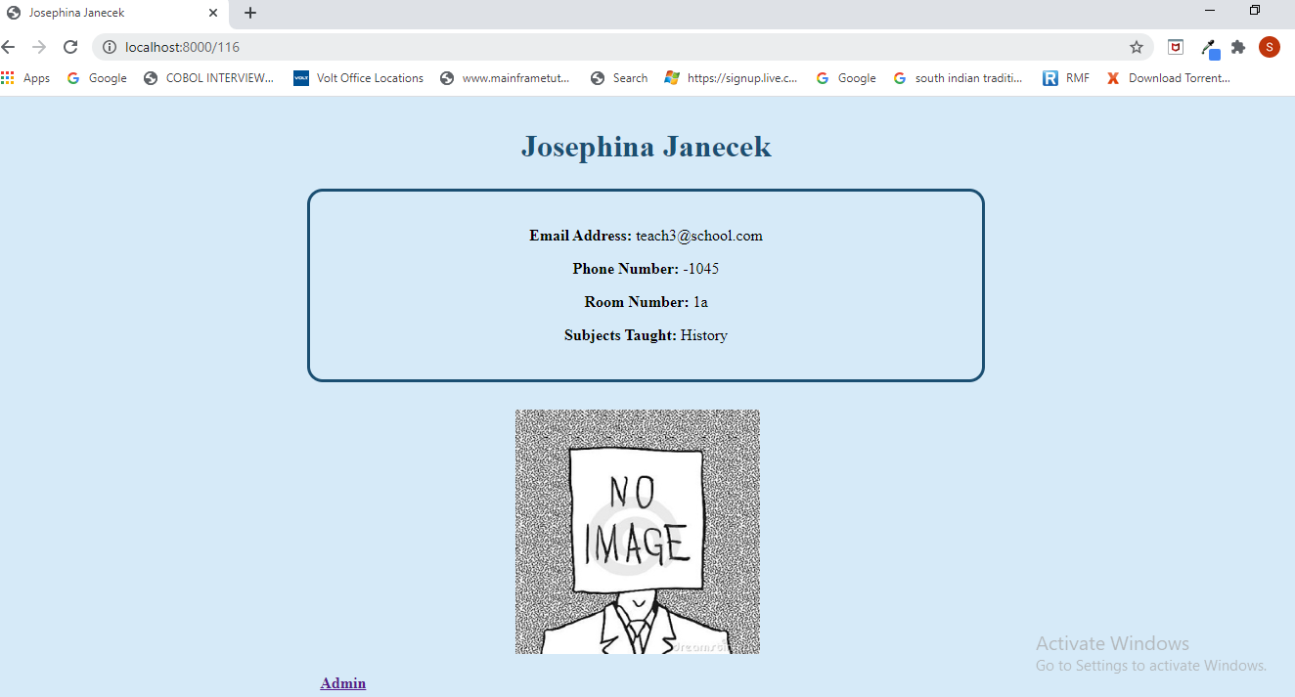

**Step 12**: To go to admin page click on the link given in the “Directory App” page or click the link given below

* <http://localhost:8000/admin/>
* <http://127.0.0.1:8000/admin/>

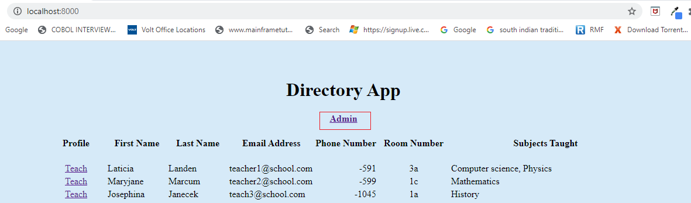

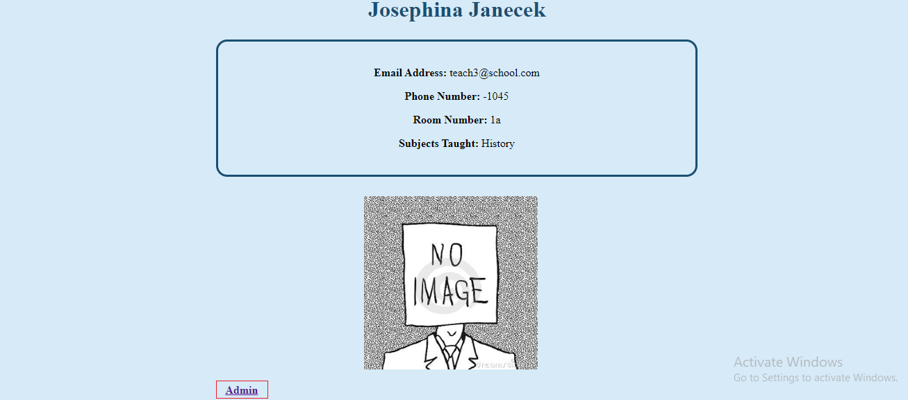

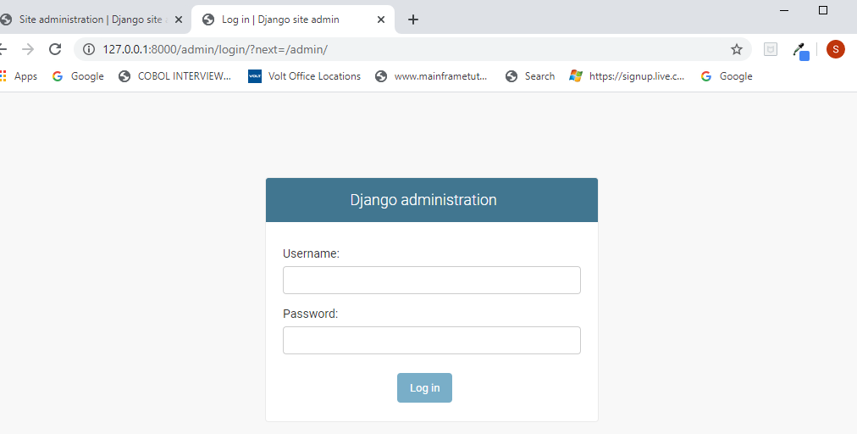

**Step 13:** You need username and password to login

* **USERNAME** : pinpoint
* **PASSWORD:** pinpoint

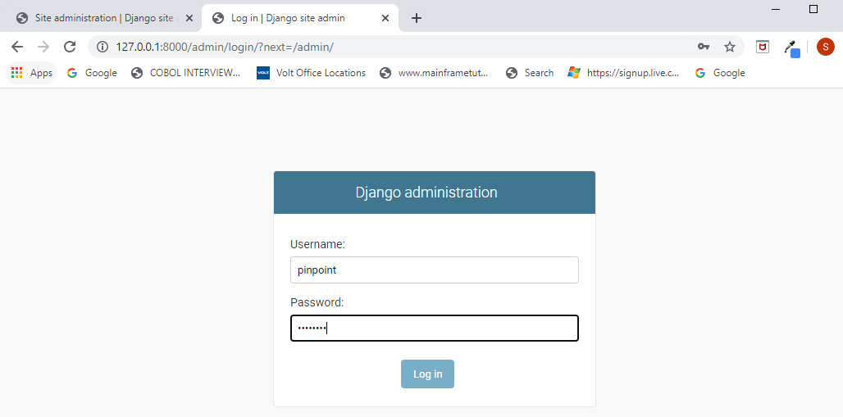

**Step 14**: Once logged in, click on the directory “**Teachers**” in the resultant page

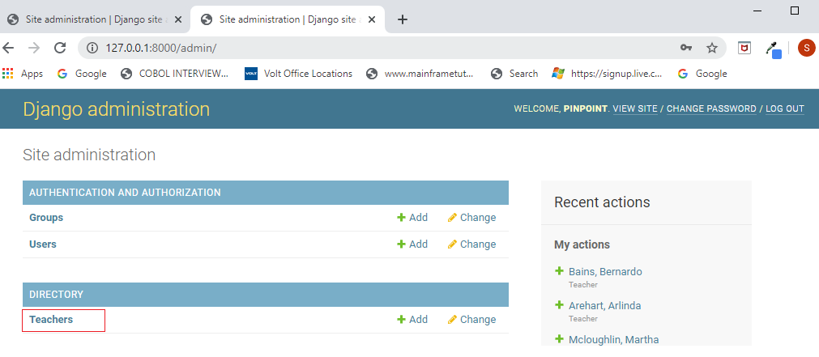

**Step 15**: Filter option is in the right-hand side of the page

* Filter by first letter of “**Last Name**”

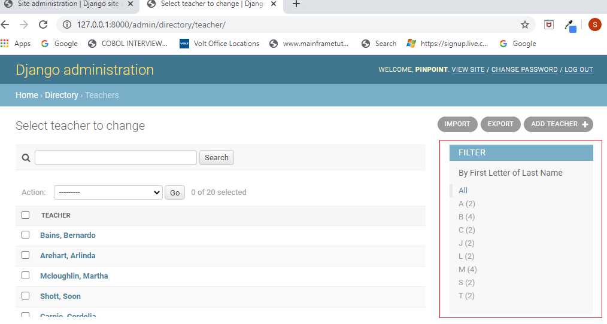

* Filter by “**D**” (first letter of last name)
  + Display name is configured as => Last Name, First Name

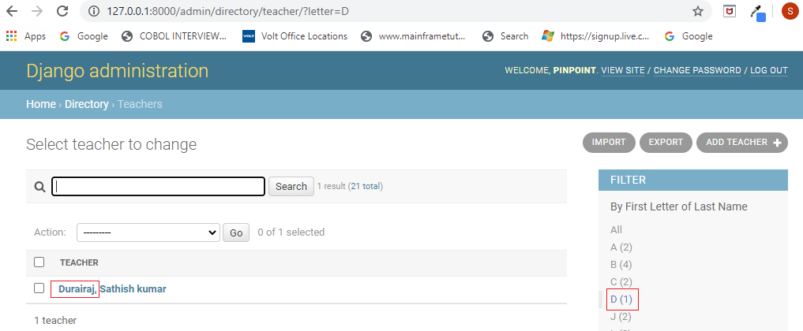

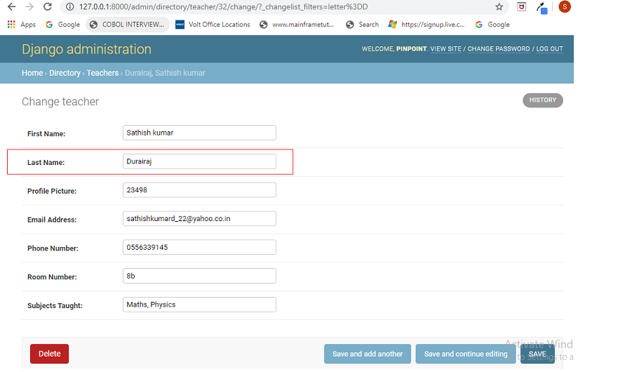

**Step 16**: **Import** option is present above the Filter, clicking on it takes to import page

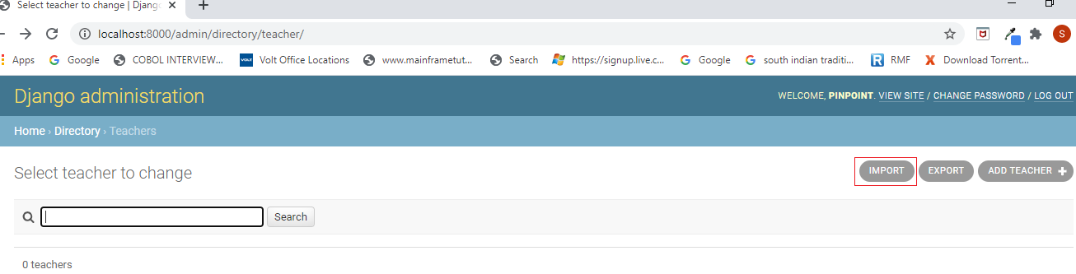

* Import page with file selected, Filename - “**Teachers.csv**” Format - **csv**

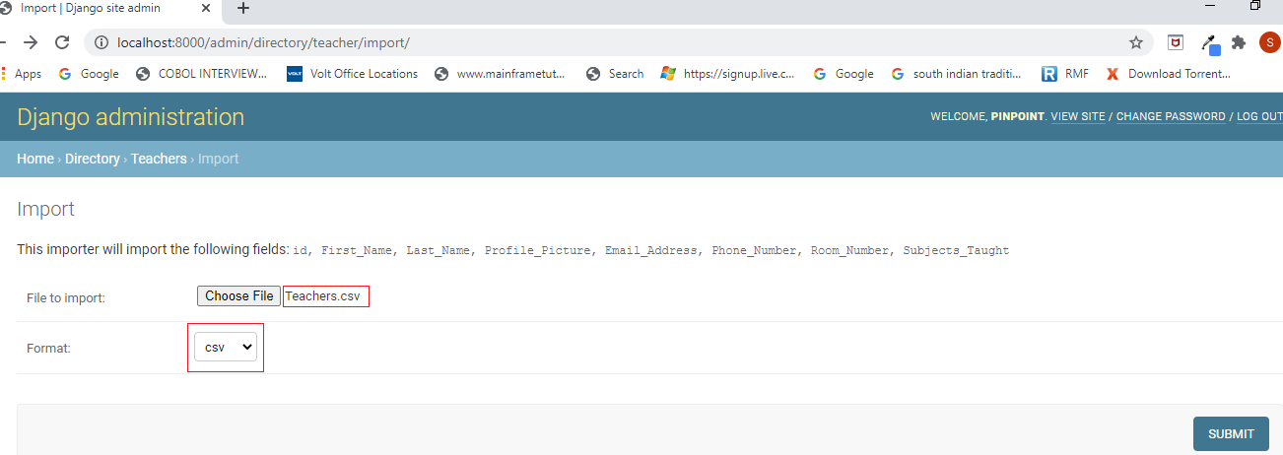

* The CSV file should have unique email ids
* First column should be added with column name ‘**id**’
* column names should be as follows
  + **First letter** of column names should be **Capital**
  + **Space between column name** to be replaced with ‘**_**’
    - First_Name
    - Last_Name
    - Profile_Picture
    - Email_Address
    - Phone_Number
    - Room_Number
    - Subjects_Taught

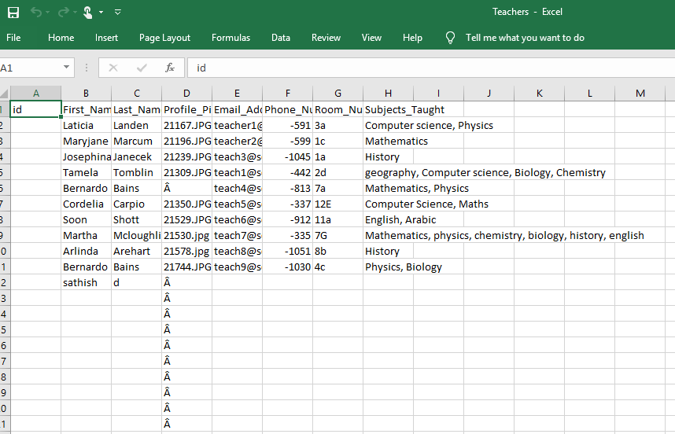

**Step 17**: Submitting for import will ask for confirmation

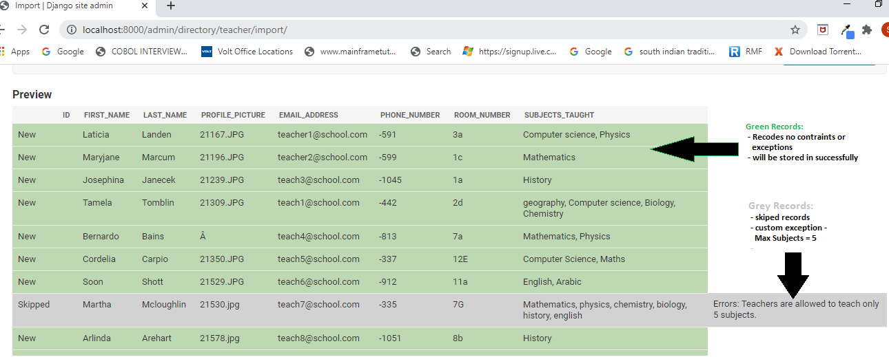

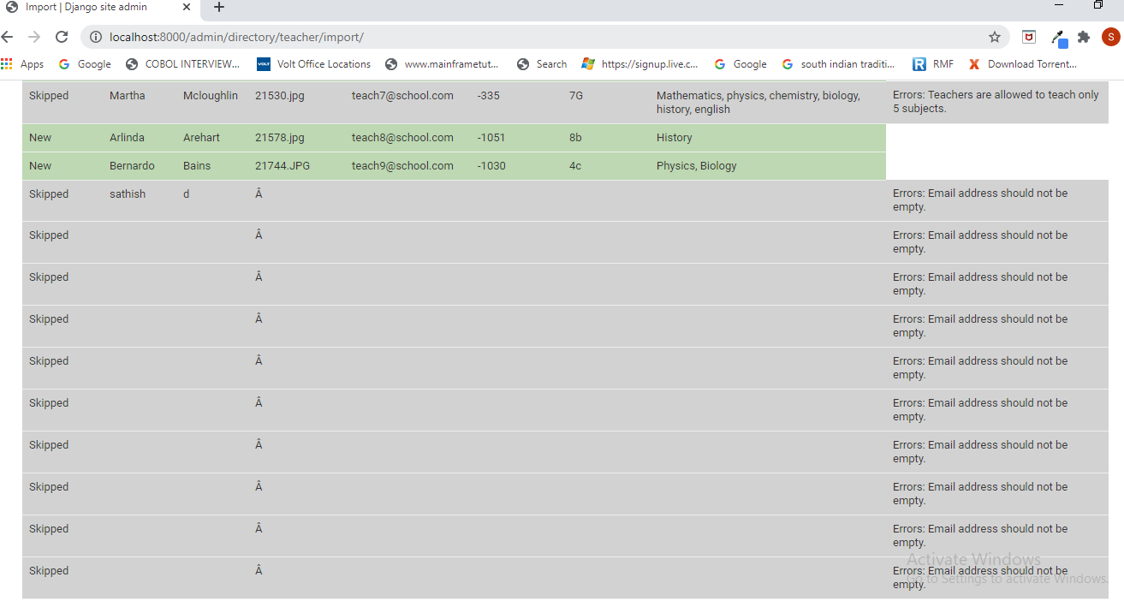

**Step 18**: Once confirmed it will upload the data

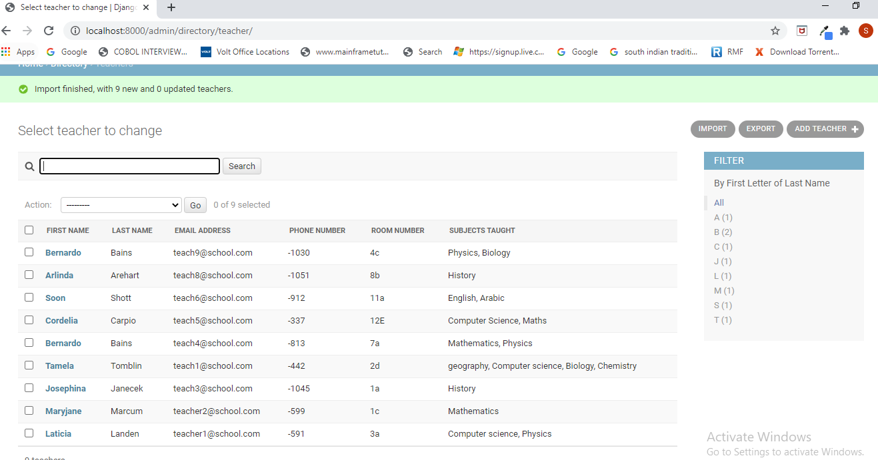

* Directory home, teachers’ records are loaded in home page

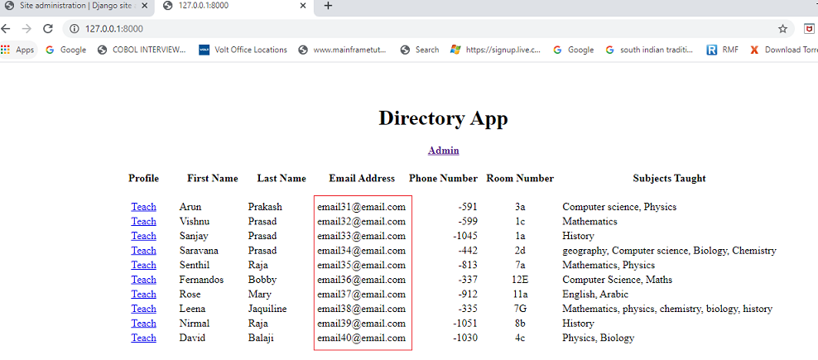

**Step 19:** The profile-pictures need to be copied in the project folder structure

* ..\Teachers\teachers_dir\directory\static\directory\img\ (**profile pictures**)

**Step 20:** When try to upload data with duplicate email



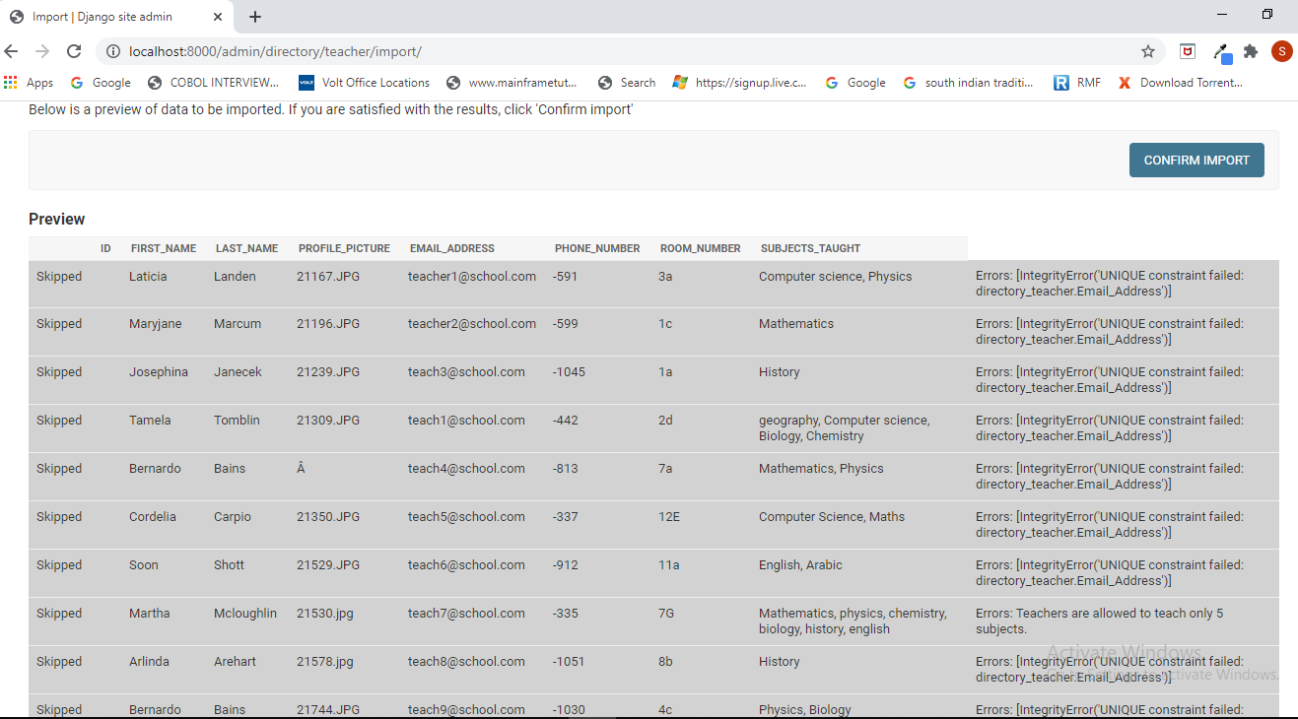

**Step 21:** Different custom exceptions for same record, the hierarchy of exceptions handled

* Email address shouldn’t be empty
* Subjects taught shouldn’t be more than 5
* First name shouldn’t be empty
* Last name shouldn’t be empty

