1. Create Key pair for ELB

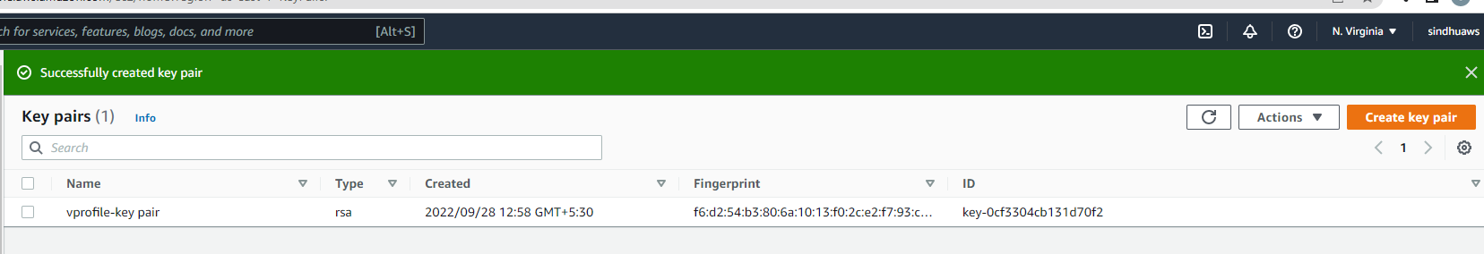

1. Create a security group for backend, which should allow its own security group access.

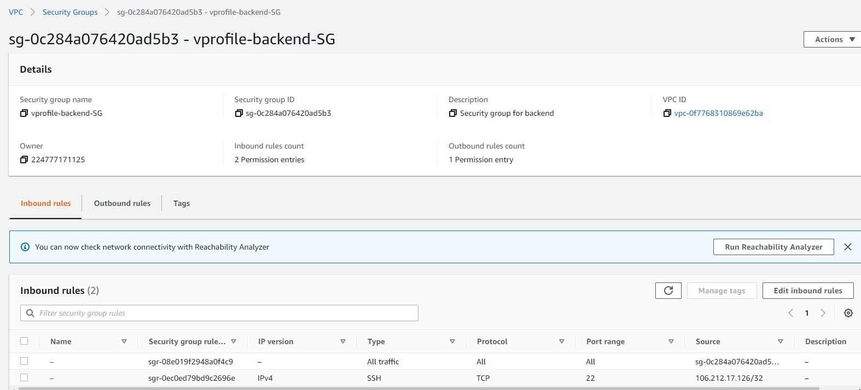

1. Create RDS Parameter groups,

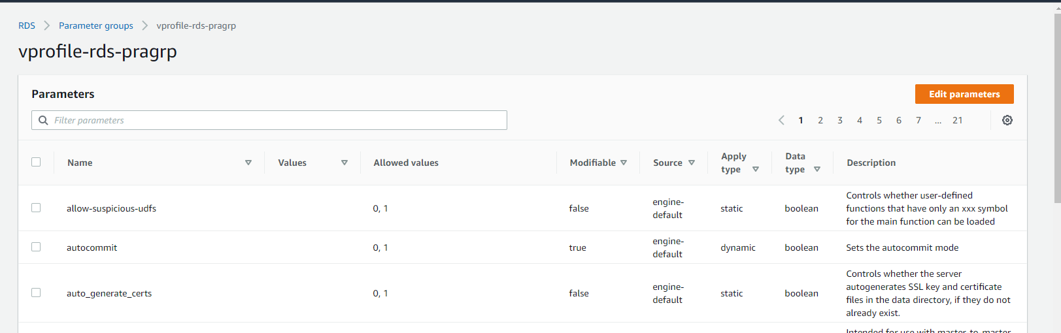

1. Create RDS subnet group,

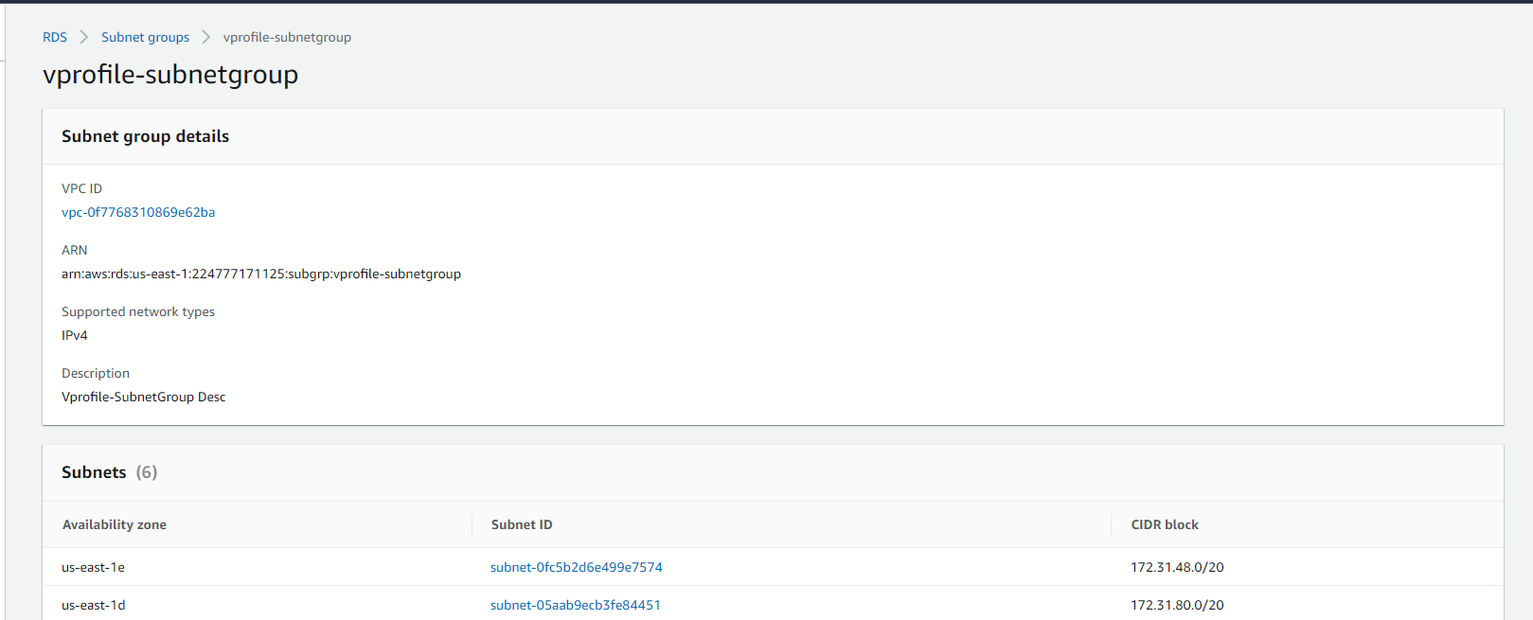

1. Create RDS Database under free tier, tag the parameter group that created above,

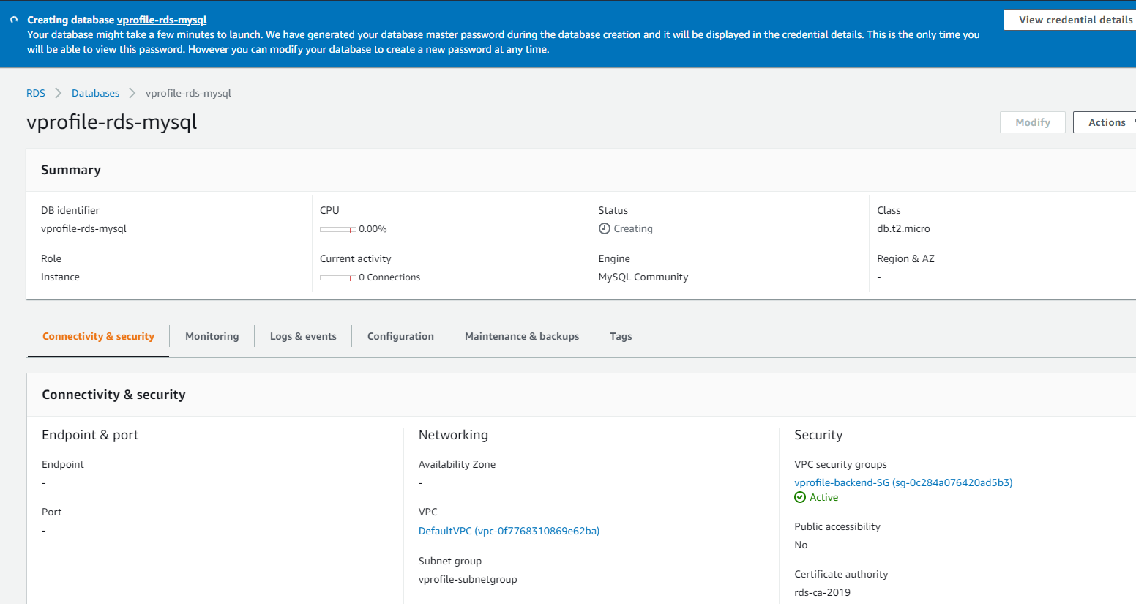

1. Create Elastic Cache, before that create parameter group and subnet groups.

Choose t2.micro

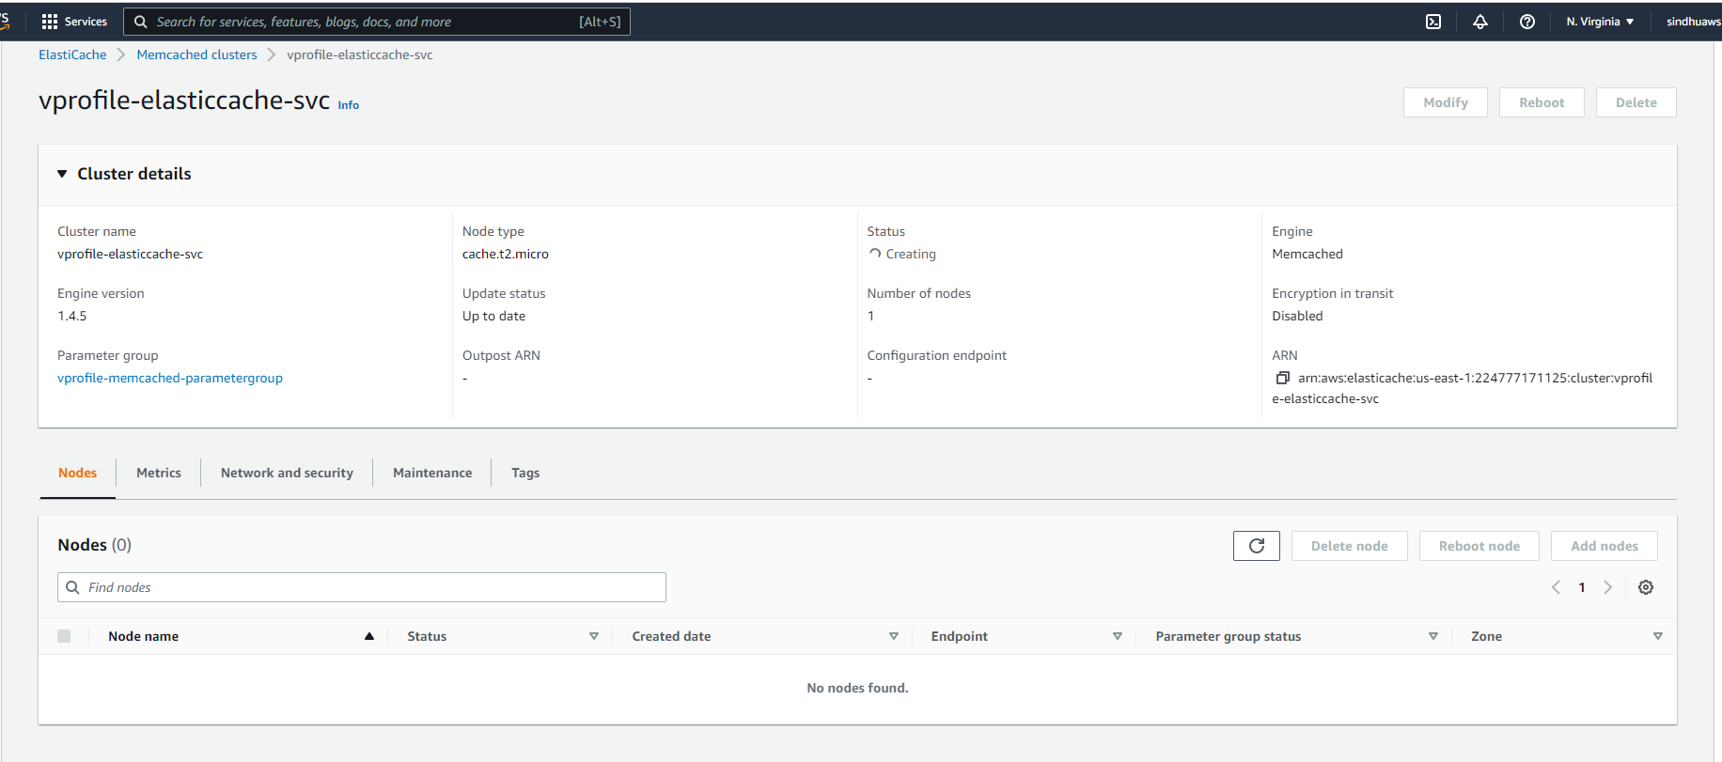

1. Create Amazon MQ – Rabbit MQ

Choose private access.

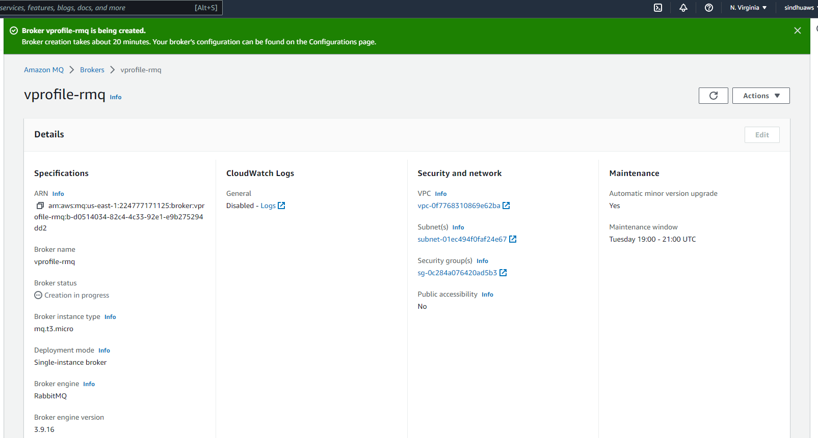

1. Create a EC2 instance (ubuntu), for RDS DB client., add the below user data,

#!/bin/bash

sudo apt update

sudo apt install mysql-client –y

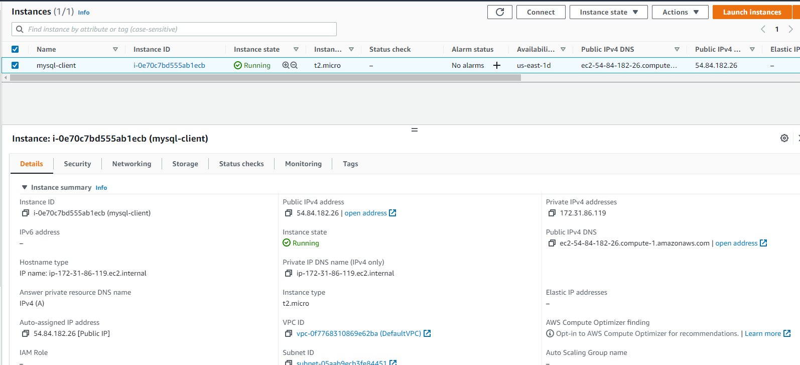

Once VM is launched, ssh into it.

satzw@LAPTOP-C4RG1671 MINGW64 ~/Downloads

$ ssh -i "vprofile-key pair.pem" ubuntu@54.84.182.26

sudo apt update

sudo apt install mysql-client –y

Update backend security groups to allow conn from mysql security group on port 3306.

Connect to rds via client:

mysql -h vprofile-rds-mysql.cs20txafmaaq.us-east-1.rds.amazonaws.com -u *admin* –p*54ZlSs8HRGinQCLsaPBQ*

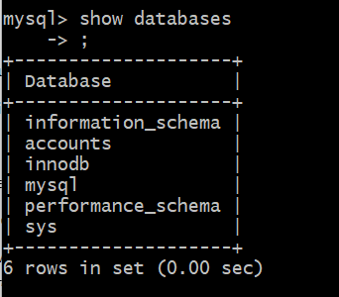

Exit

1. Now upload the table entries into RDS:

git clone <https://github.com/devopshydclub/vprofile-project.git>

git checkout aws-Refactor

Cd into /src/main/resources

mysql -h vprofile-rds-mysql.cs20txafmaaq.us-east-1.rds.amazonaws.com -u admin -p54ZlSs8HRGinQCLsaPBQ accounts < db_backup.sql

mysql -h vprofile-rds-mysql.cs20txafmaaq.us-east-1.rds.amazonaws.com -u admin -p54ZlSs8HRGinQCLsaPBQ accounts

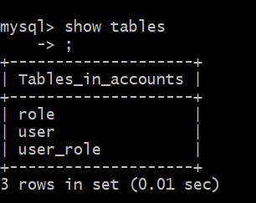

1. Gather all the endpoints and port.

RDS, Rabbit MQ and Elastic Cache

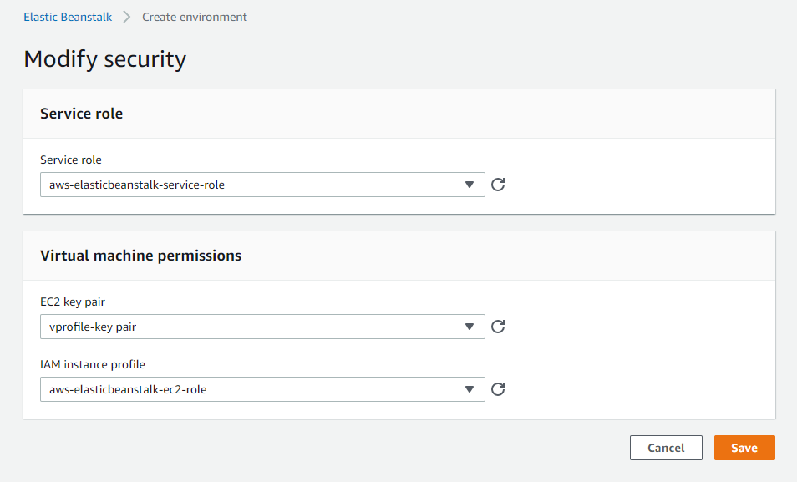

1. Create a certificate
2. In ELB, edit the load balancer, update http and https.
3. Upload the war file into ELB, then in the App version, select deploy.

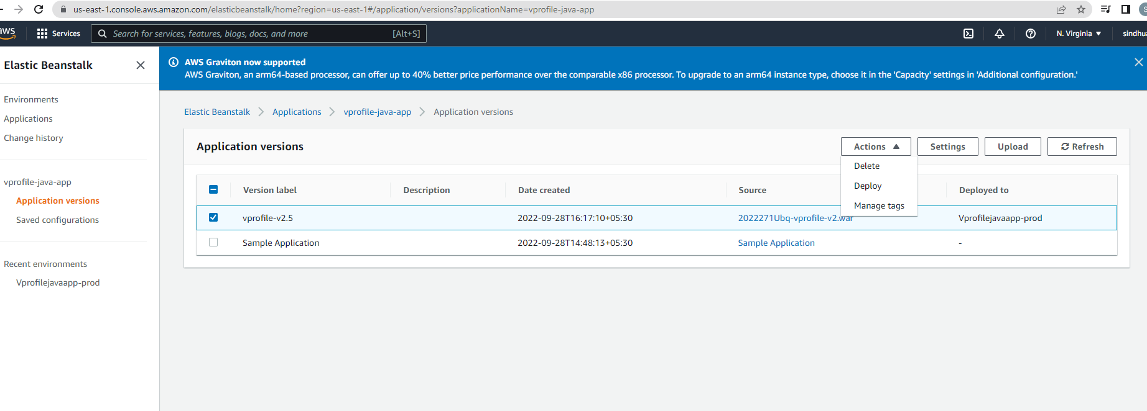

1. App will be hosted on the ELB endpoint url,

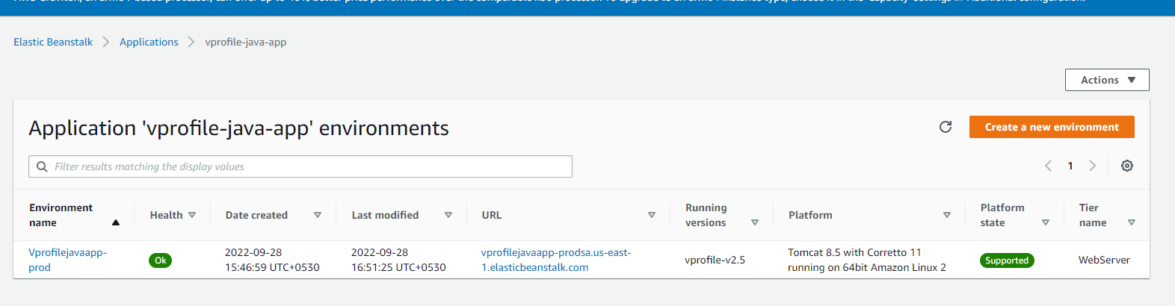

1. The application will be running,

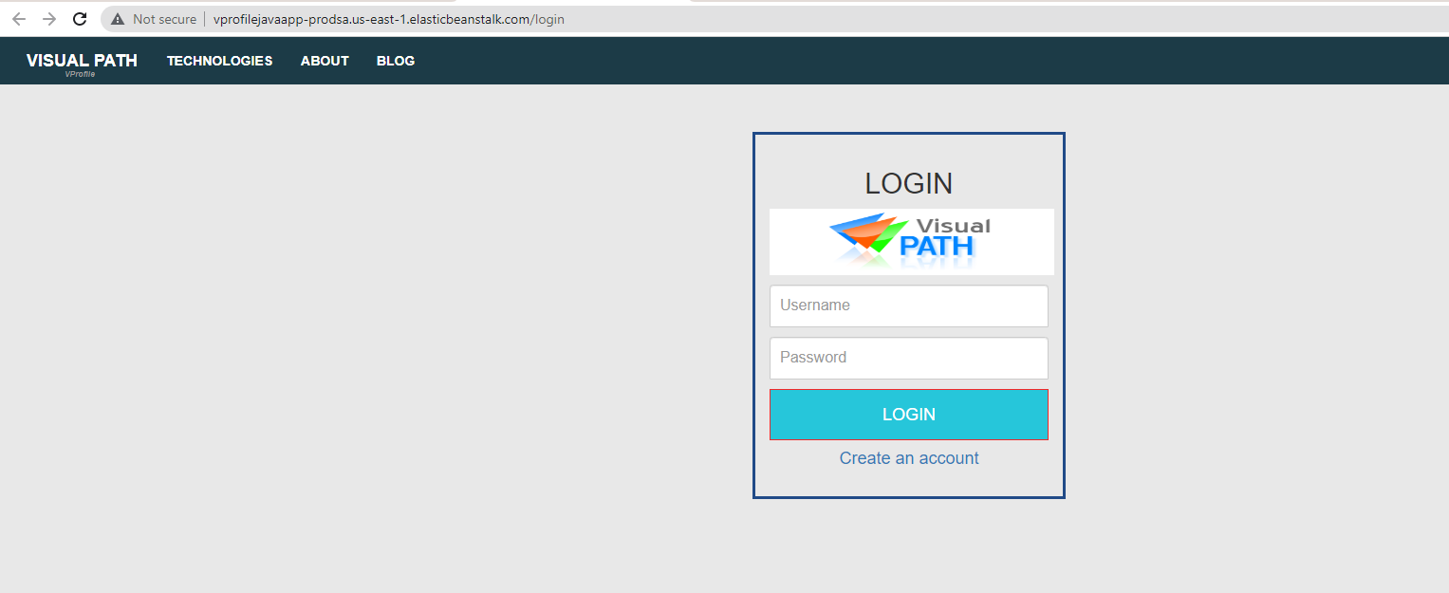

1. Update Cname in Godaddy,



1. Create a cloudfront distribution.

