# **Container Microservice Architecture**

This project explains the setup of container Microservice architecture, there are 4 services used in this project api gateway which is in nginx service, it listens for request and route based on the url.If the request is on root, then the Angular client home page will be loading, for backend we have two api’s Nodejs and Java, and two databses one for Mongo Db and one for MYsQL DB. Active Containers living in the project are nginx, Angular client, Nide JS, Java Api, Mongo Db and My SQL DB.

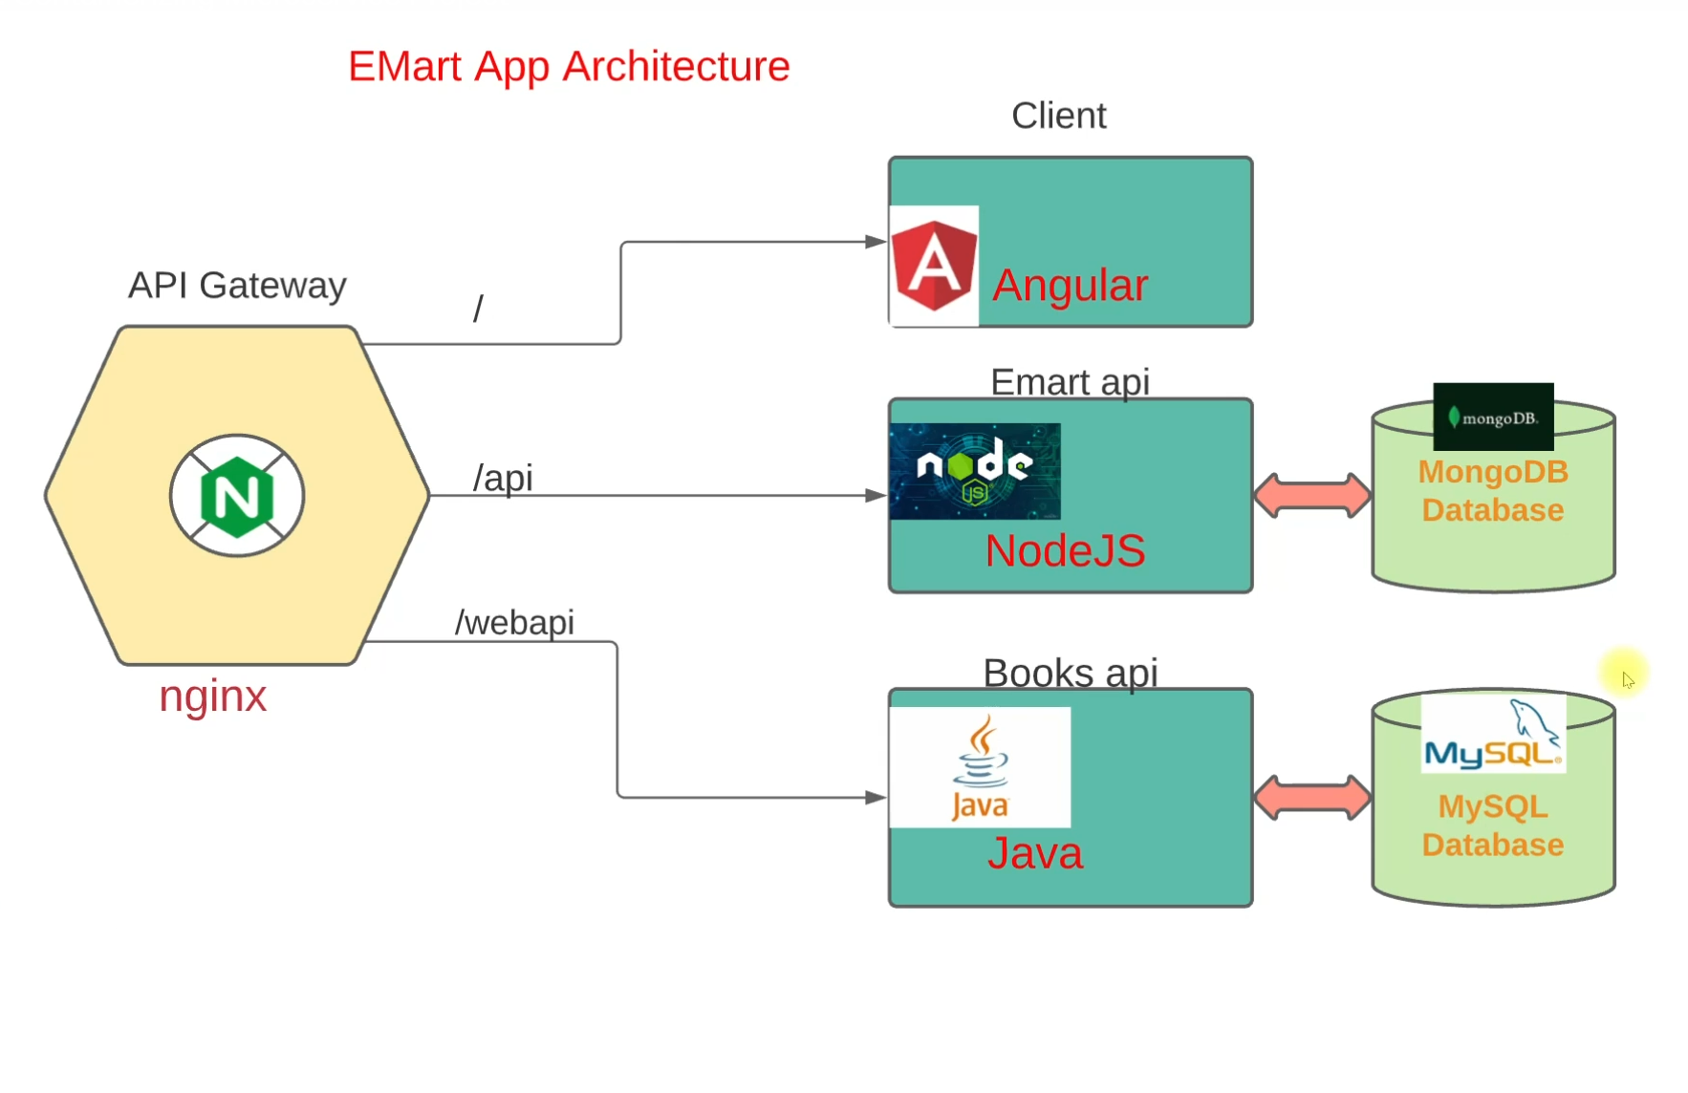

1. Launch a EC2 instance with user data for Docker, Docker compose and add user to the docke rgroup.

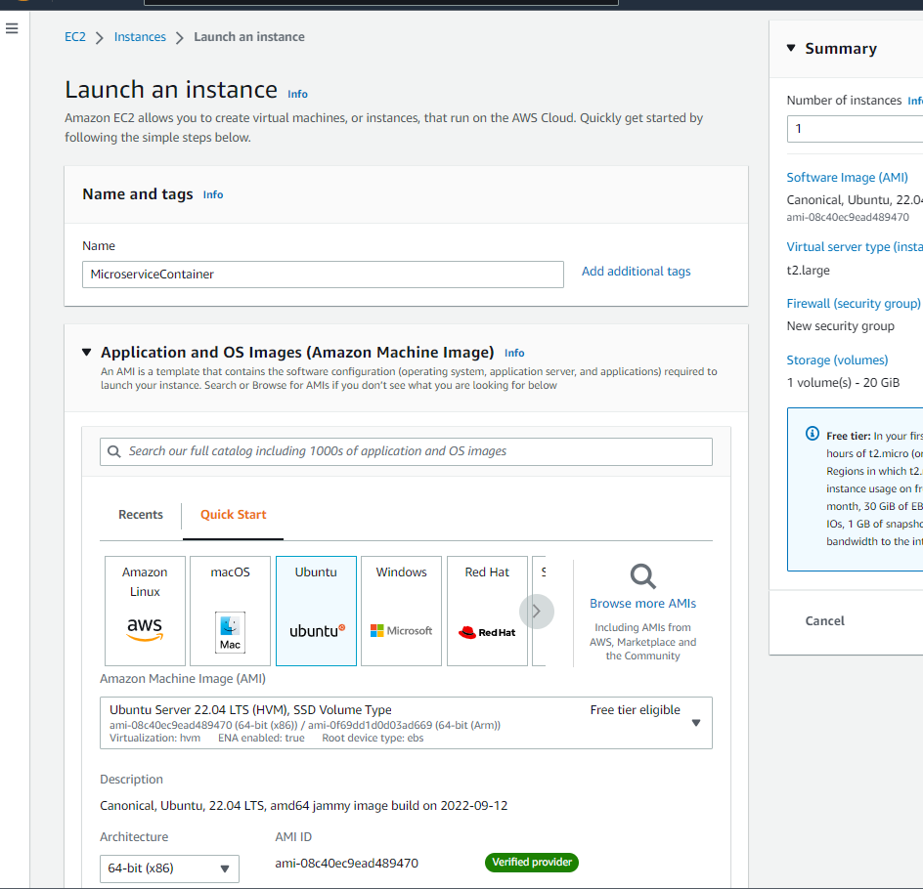

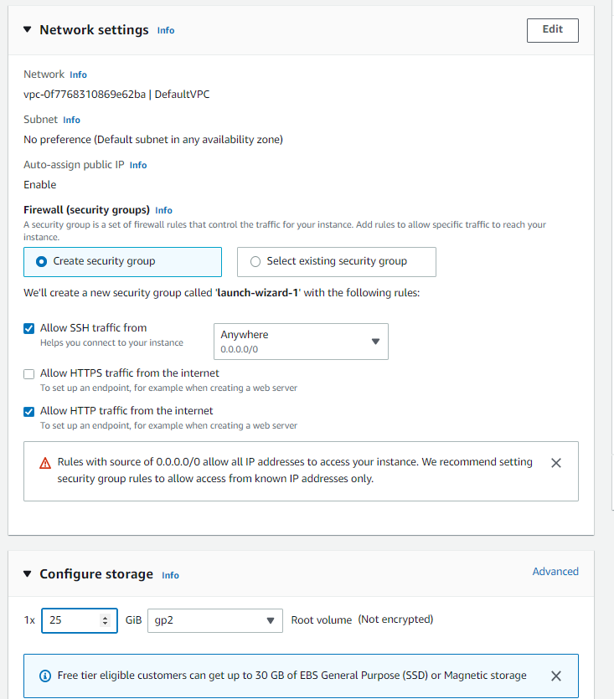

Add the below user data,

#!/bin/bash

# Install docker on Ubuntu

sudo apt-get update

sudo apt-get install \

ca-certificates \

curl \

gnupg \

lsb-release -y

curl -fsSL https://download.docker.com/linux/ubuntu/gpg | sudo gpg --dearmor -o /usr/share/keyrings/docker-archive-keyring.gpg

echo \

"deb [arch=$(dpkg --print-architecture) signed-by=/usr/share/keyrings/docker-archive-keyring.gpg] https://download.docker.com/linux/ubuntu \

$(lsb_release -cs) stable" | sudo tee /etc/apt/sources.list.d/docker.list > /dev/null

# Install docker-compose

sudo apt-get update

sudo apt-get install docker-ce docker-ce-cli containerd.io -y

sudo curl -L "https://github.com/docker/compose/releases/download/1.29.2/docker-compose-$(uname -s)-$(uname -m)" -o /usr/local/bin/docker-compose

sudo chmod +x /usr/local/bin/docker-compose

# Add ubuntu user into docker group

sudo usermod -a -G docker ubuntu

1. Login to the ubuntu machine

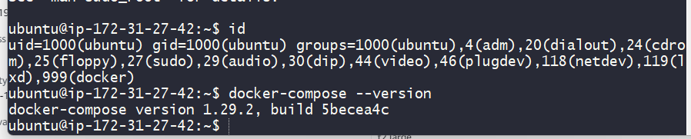

1. Clone the source code from Git repo, and execute docker-compose build

<https://github.com/devopshydclub/emartapp.git>

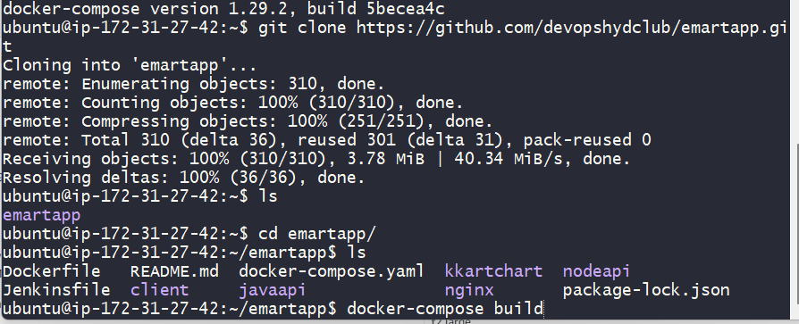

1. Show the docke images created in the machine,

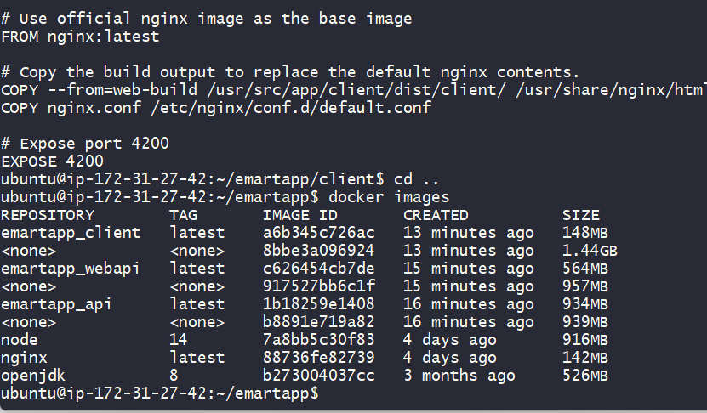

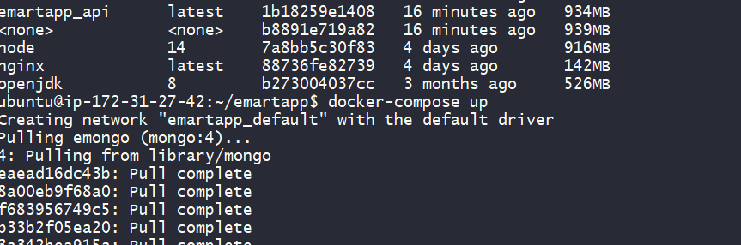

1. All the required docker instances are up and running, and the web application is loading from the EC2 machine.

