# **Setup K8s clusters with KOPS**

This project explains the setup of Kubernetes clusters with KOPS. Created a Linux VM with KOPS, Kubectls, ssh Keys and awscli to execute commands. A domain was created in Godaddy for Kubernetes DNS records and subdomain was created in Route53 for hosted zone. S3 bucket is created to store the state of Kops, so we can perform KOPS command from anywhere. An IAM user was created to perform AWScli commands,

1. Create an EC2 instance for KOPS, and make sure it allow ssh from Myip

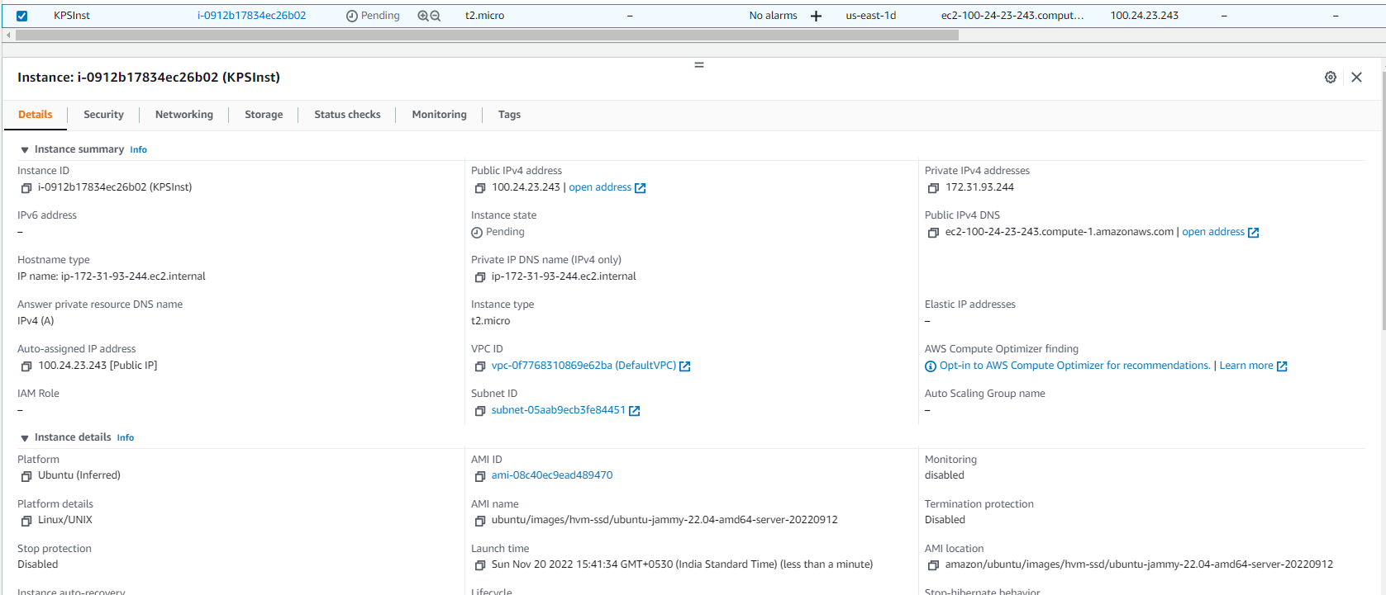

1. Create an S3 bucket.

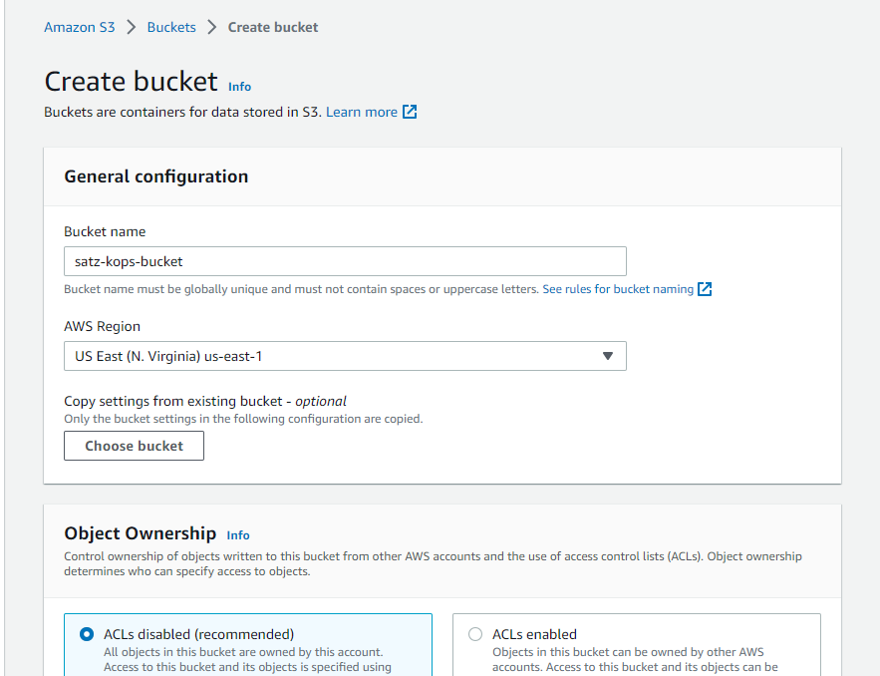

1. Created the IAM user with Full Admin access,

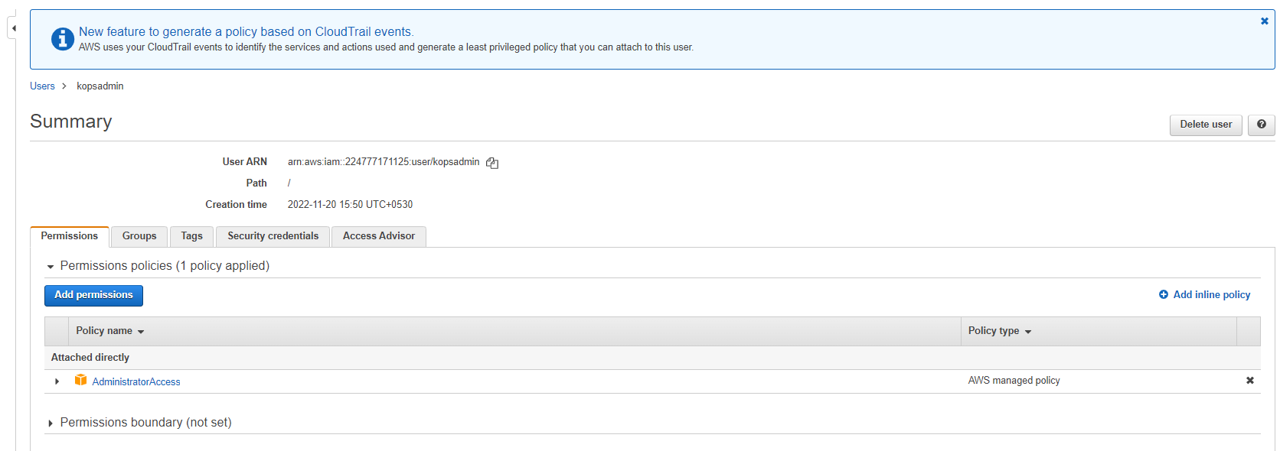

1. Create a hosted zone,

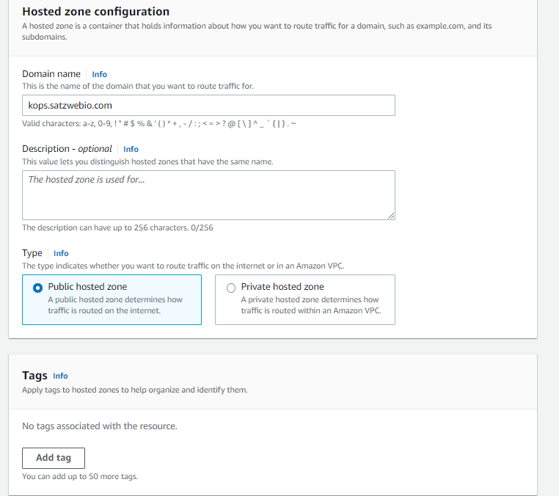

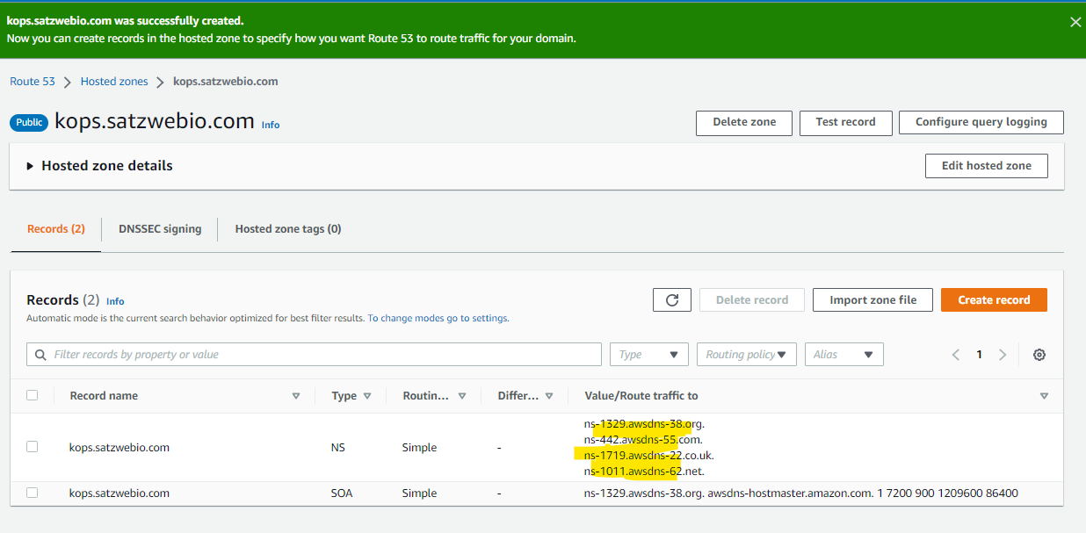

1. Update NS record with domain register

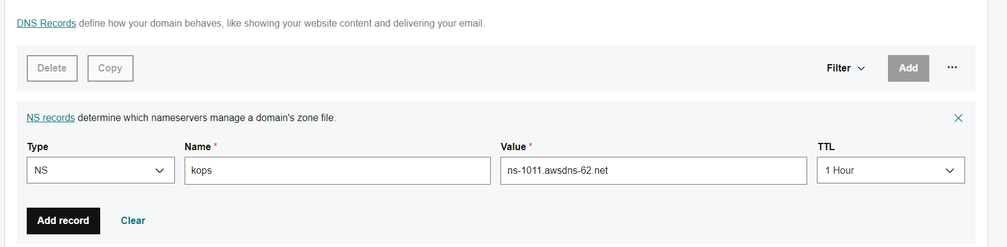

1. Login to the EC2 instance, and generate ssh key

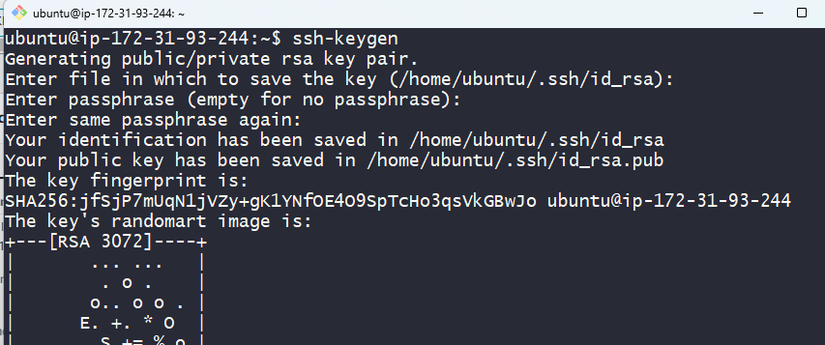

1. sudo apt update && sudo apt install awscli -y

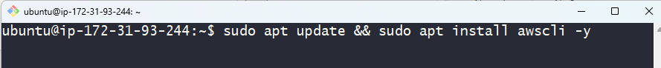

1. Do AWS configure with access key and secret key,

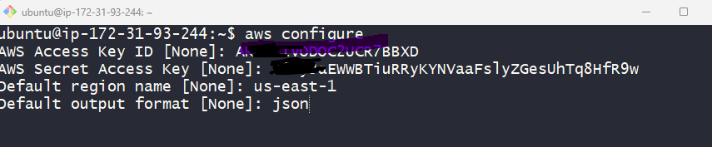

1. Install and setup kubectl, and provide exec permission

Refer: <https://kubernetes.io/docs/tasks/tools/install-kubectl-linux/>

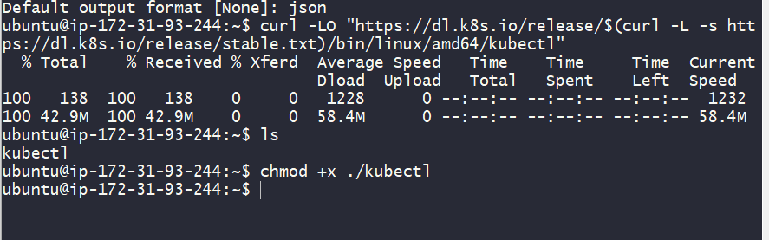

Move to usr/loca/bin to access the tool globally,

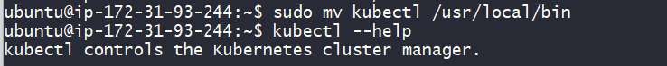

# Installing Kubernetes with kOps

Refer <https://kubernetes.io/docs/setup/production-environment/tools/kops/>

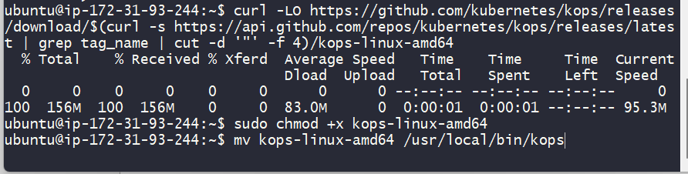

1. Nslookup validation,

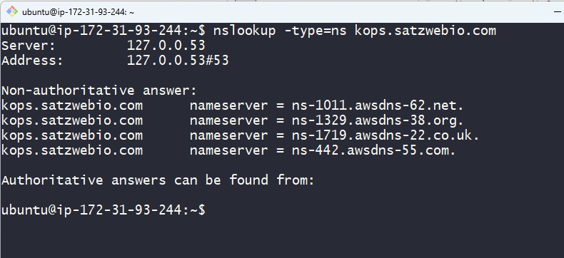

1. Execute Kops create cluster command,

kops create cluster --name=kops.satzwebio.com --state=s3://satz-kops-bucket --zones=us-east-2a,us-east-2b --node-count=2 --node-size=t3.small --master-size=t3.medium --dns-zone=kops.satzwebio.com --node-volume-size=8 --master-volume-size=8

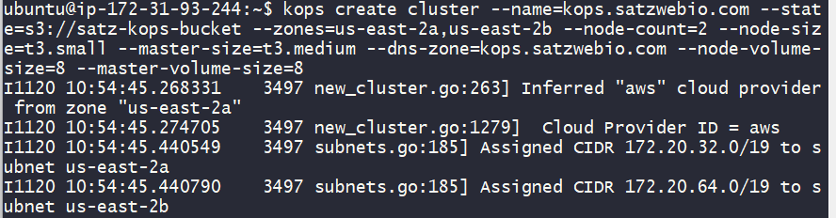

1. Following above, perfrom update cluster

kops update cluster --name kops.satzwebio.com --state=s3://satz-kops-bucket --yes –admin

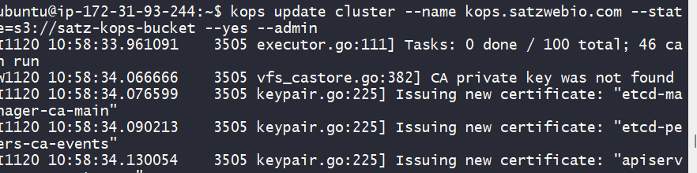

1. After 15 mins, validate your cluster with below commands,

kops validate cluster --state=s3://satz-kops-bucket

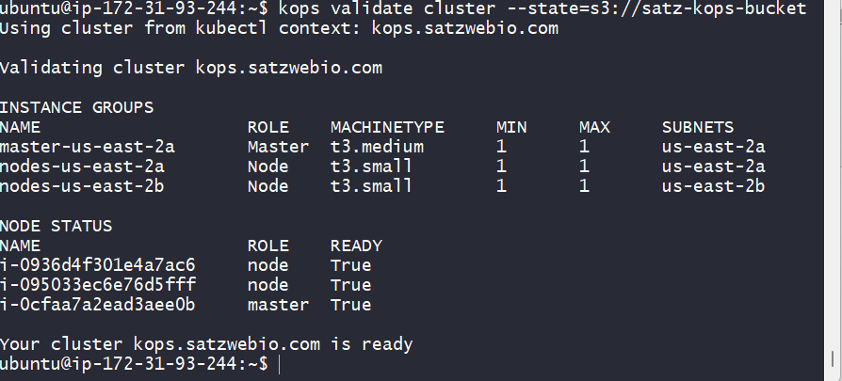

1. Show below the resources created in AWS.

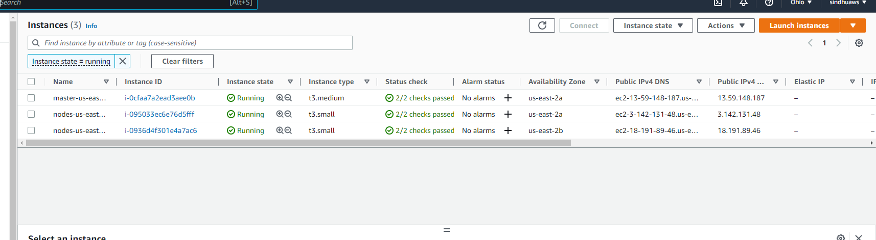

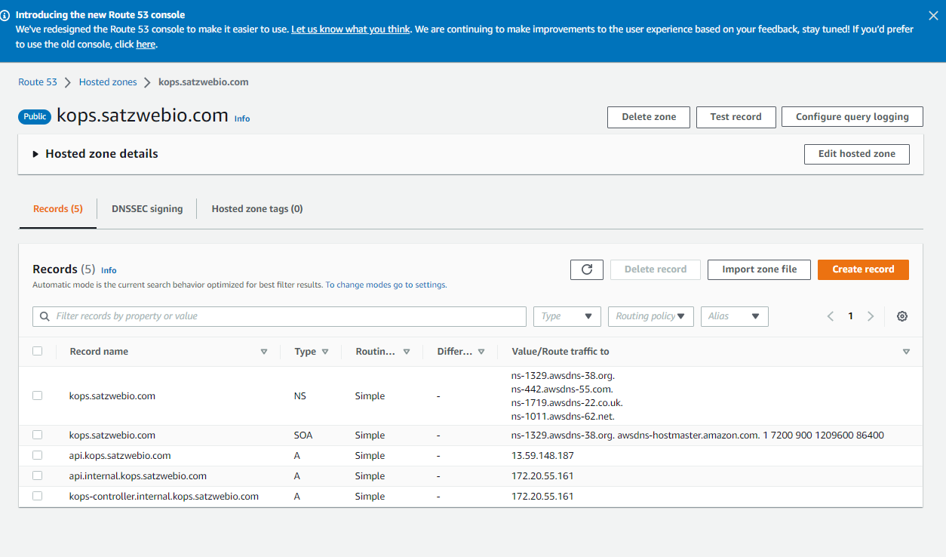

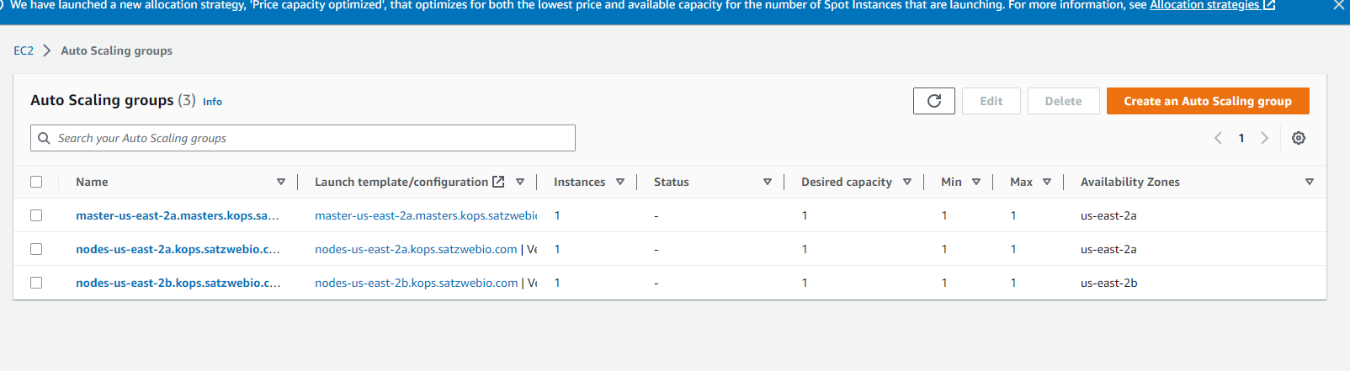

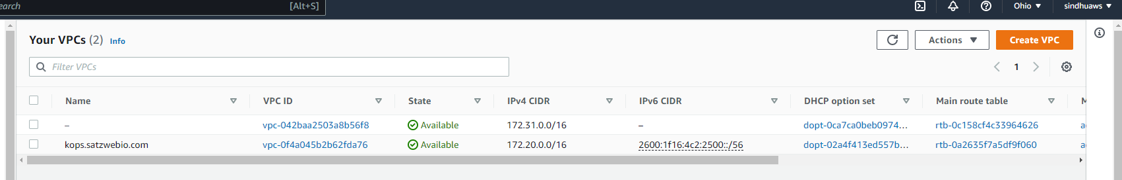

1. To delete the cluster

kops delete cluster --name kops.satzwebio.com --state=s3://satz-kops-bucket --yes

