**LOGISTIC REGRESSION (IRIS dataset)**

***(results have been compared with SVM)***

import pandas as pd

import matplotlib.pyplot as plt

import numpy as np

df = pd.read_csv('C:/Users/tanis/Downloads/ML_intern_resources/3.logistic_regression/Iris.csv')

df.head()

df['Species'].unique()

df['Species'] = df['Species'].replace({'Iris-setosa':1, 'Iris-versicolor':2, 'Iris-virginica':3})

df.head()

x = df.iloc[:, :-1].values

y = df.iloc[:, -1].values

from sklearn.model_selection import train_test_split

x_train, x_test, y_train, y_test = train_test_split(x, y, test_size = 0.1, random_state=0)

from sklearn.linear_model import LogisticRegression

regressor = LogisticRegression(max_iter = 500)

regressor.fit(x_train, y_train)

y_pred = regressor.predict(x_test)

print(np.concatenate((y_test.reshape(len(y_test),1),y_pred.reshape(len(y_pred),1)),1))

from sklearn.metrics import confusion_matrix, accuracy_score

cm = confusion_matrix(y_test, y_pred)

cm

array([[3, 0, 0],

[0, 8, 0],

[0, 0, 4]], dtype=int64)

accuracy_score(y_test, y_pred)

1.0

import seaborn as sn

plt.figure(figsize=(5,4))

sn.heatmap(cm, annot=True)

plt.xlabel('Predicted value')

plt.ylabel('Truth or Actual Value')

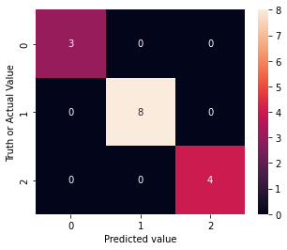

**USING SVM**

from sklearn.svm import SVC

classifier = SVC(kernel='rbf', random_state=0)

classifier.fit(x_train, y_train)

y_pred_2 = classifier.predict(x_test)

print(np.concatenate((y_test.reshape(len(y_test),1),y_pred_2.reshape(len(y_pred_2),1)),1))

from sklearn.metrics import confusion_matrix, accuracy_score

cm_2 = confusion_matrix(y_test, y_pred_2)

cm_2

array([[3, 0, 0],

[0, 8, 0],

[0, 1, 3]], dtype=int64)

accuracy_score(y_test, y_pred_2)

0.9333333333333333

import seaborn as sn

plt.figure(figsize=(5,4))

sn.heatmap(cm_2, annot=True)

plt.xlabel('Predicted value')

plt.ylabel('Truth or Actual Value')

