**DIGITAL MARKETING CAMPAIGN**

Name of Student

Institution Affiliation

Course Code

Date

**Table of Contents**

Executive Summary 3

Relevant Industry level data 3

Industry growth Trends 4

Consumer Preference and Demand Growth 5

Environmental Regulations 6

Social Media Influence 6

Industry Analysis Summary 7

References 8

# **Executive Summary**

Radical Root Seed Bombs is a Canadian company based in Cornwall, Ontario, which specializes in manufacturing wildflower seed bombs by using native eco-friendly seeds DIY Kits stations and workshops. The company has thrived by producing innovative seed bomb resources that are tailored to promote a green environment and biodiversity. Due to the increasing demand for environmentally responsible options in landscaping, gardening, and natural flower offices, the company can expand significantly through better digital marketing and effective online engagement. This project aims to develop effective digital marketing strategies to increase online traffic for the company's stores by generating quality leads and boosting its customer reach through data-driven strategies. The company will achieve a strong brand presence and increase customer engagement through digital activities like SEO, the right content, social media, and e-commerce for merchandising.

In order to achieve this campaign, the main components will include an in-depth industry analysis using tools like PESTEL and SWOT analysis. The campaign will also include consumer insights and actions that can be implemented to enhance the digital strategy. The industry analysis shows that global gardening and the sustainable market are speedy and are influenced by environmental awareness and urban trends. In that way, this project will create digital marketing strategies using available tools. The project thus will provide actional information and recommendations for Seed Bousedan to sue for its digital market activities.

## **Relevant Industry level data**

Based on the PESTEL Analysis, SWOT analysis and industry data, much has been revealed about the Radical Root Seed Bomb Company, which is based in the retail industry and focuses on manufacturing seeds from wildflowers. There is much that can be picked from its business environment. Seed Bombs have unique aspects of distributing beneficial wildflowers and achieving sustainable environmental needs (IBISWorld, 2025). Homes, corporate offices, and other areas are increasingly adopting eco-friendly gardening. The drive for Do it Yourself (DIY) sustainable gardening is making demand for seed bombs and handmade wildflowers to increase the need for more retailing of the seeds.

### **Industry growth Trends**

Sustainable gardening and horticulture practices are on the rise, with the market showing positive growth for the market. That indicates that companies manufacturing handmade wildflowers will have an opportunity to achieve a better increase in growth. Sustainable gardening with wildflowers and seed bombs will be widely impacted by greenhouse and horticulture. The market growth for greenhouse horticulture has been steady in the last six years. In 2023, the industry was valued at $29.68 billion, having grown with a compounded rate of 7.59% from 2018. The market is expected to reach about $49.59 billion by 2028, growing at 10.81% annually (Research and Markets, 2025). Such growth means that retailers for the seed bombs will have better opportunities to make significant sales for the greenhouse and horticulture companies. There is also evident growth of urban gardening activities involving permaculture and rewilding activities, which are gaining popularity in the market. The city dwellers will change how the eco-systems are being carried, thus creating more need to buy wildflowers.

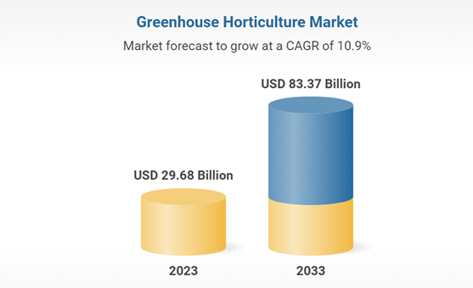

### **Consumer Preference and Demand Growth**

There are increasing preferences for the customer's demands. For example, most customers want to live in an eco-systems environment with good gardens and flowers. The approach for sustainability is not just a buzzword but a core business approach for multiple brands. In a report done by Deloitte in 2021, 63% of consumers made a choice for shopping based on sustainability or eco-system ecosystem-related concerns (SocialTargeter, 2021). The shift indicates a strong desire for customers and consumers to be associated with environmentally responsible brands. The increasing number of eco-conscious consumers will reflect a society project where individuals wish to feel good about the brand they are associated with. Thus, these companies must focus on displaying their compounds and landscaping to make consumers believe they are sustainable (NIQ, 2024). These consumers, for example, in real estate, will need to have compounds that have been well garnished with flowers to reflect the aspect of balancing biodiversity in the environment.

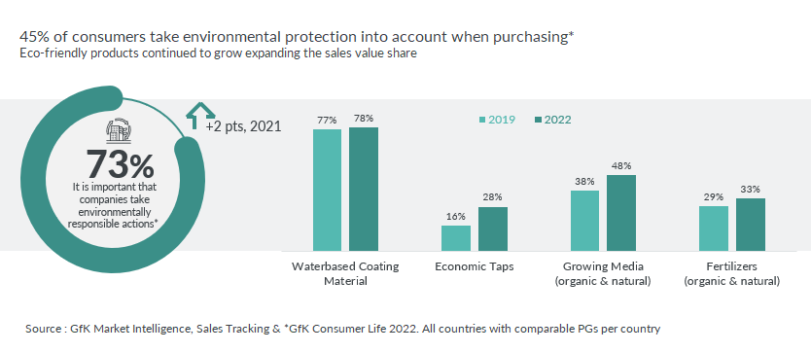

The increase in online shopping in the gardening industry has made most companies buy environmentally friendly products. Flowers and landscaping equipment have achieved high demand among these products (SocialTargeter, 2021). Customers are willing to pay much for the products if they feel that they will help them achieve eco-friendly needs. Such changes in consumer behaviours, especially among young people like millennials and Generation Z, are widely advocating for sustainable products, especially gardening.

### **Environmental Regulations**

The government and local authorities are promoting programs by offering grants and incentives to companies that are doing urban reforestation and biodiversity projects. Increasing advancement in seed technology is a key player in the production process, which is driving the world seed bomb market. There is also increasing government collaboration and making huge investments in seed production, with some practices like handmade wildflowers being some of the practices that are making the growth significant. For example, in 2023, a state-of-the-art seed production centre was established at the Indian Institute of Horticulture Research (IIHR) (Fortune Business Insight, 2025). The main aim of the unit was to accelerate sales and enhance advisory on services for the diagnosis of different diseases. That trend will drive the high production of the flower seed market.

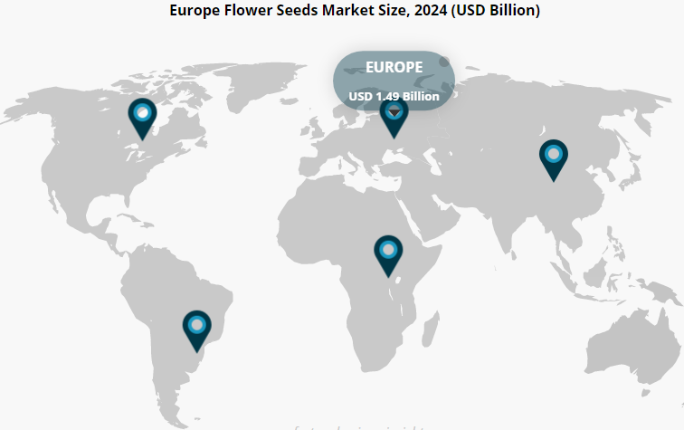

### **Social Media Influence**

Social media and digital trends are impacting gardening and eco-system activities due to engaging platforms like Instagram, TikTok, and Pinterest, which have increasingly showcased the aspect of DIY gardening and content on sustainability. In previous years, the gardening consumers were old adults and middle-aged, especially homeowners with high income levels. The demographic has changed and has mostly been influenced by social media. Recent studies have indicated that about 70% of the aged 18-35 years are interested in gardening, and about 83% of young people describe gardening as a cool thing to do (Birmingham 2024). The shift shows how young people view gardening as a hobby and a trendy endeavour. Thus, the shift presents an opportunity for retailers to sell sustainable gardening products and tools for the environment. Influencer marketing in spaces that depict eco-consciousness will increase engagement by more than 50%. Thus, such shops will score high for retailing eco-friendly products.

## **Industry Analysis Summary**

The overall observation for the retail industry for selling handmade wildflowers and seed bombs where Radical Root Seed Bomb Company operates is that eco-friendly gardening is an important opportunity. The industry is highly influenced by the demand for environmentally friendly spaces and brands that engage in environmentally friendly practices like landscaping, changing demographics, and social media activities. The competitive analysis shows that differentiation through brand positioning, teaching customers and engaging the community will make the company successful. The company will also benefit from partnering with other brands that sell environmentally conscious gardening products and tools.

# **References**

IBISWorld. (2025). *Plant & Flower Growing in Canada - Market Research Report (2015-2030)*. Ibisworld.com. <https://www.ibisworld.com/canada/industry/plant-flower-growing/32/>

Fortune Business Insight (2025). Flower Seeds Market Size, Share, Trends | Growth Report [2032]. (n.d.). Www.fortunebusinessinsights.com. <https://www.fortunebusinessinsights.com/flower-seed-market-103207>

Birmingham G. (2024) Gardening Among Younger Generations: How Retailers Can Adapt. (2024).. <https://www.gleebirmingham.com/news-and-views/gardening-younger-generations-retailers-adapt>

NIQ, (2024). Home improvement & gardening - the trends driving growth in 2023. (2023, May 31). NIQ. <https://nielseniq.com/global/en/insights/commentary/2023/home-improvement-gardening-the-trends-driving-growth-in-2023/>

Research and Markets. (2025, February 21). $83.37 Bn Greenhouse Horticulture Market Opportunities and Strategies to 2033: Arvesta Leads the Highly Fragmented Industry, Followed by Orbia Advance and Gibraltar Industries. GlobeNewswire News Room; Research and Markets. <https://www.globenewswire.com/news-release/2025/02/21/3030564/0/en/83-37-Bn-Greenhouse-Horticulture-Market-Opportunities-and-Strategies-to-2033-Arvesta-Leads-the-Highly-Fragmented-Industry-Followed-by-Orbia-Advance-and-Gibraltar-Industries.html>

SocialTargeter. (2021). *The Impact of Sustainability on Brand Engagement: How Eco-Conscious Consumers Influence Brand Loyalty*. Socialtargeter.com; SocialTargeter. <https://www.socialtargeter.com/blogs/the-impact-of-sustainability-on-brand-engagement-how-eco-conscious-consumers-influence-brand-loyalty>