FACULTY OF SCIENCE, ENGINEERING AND COMPUTING

School of Computer Science & Mathematics
BSc DEGREE
IN
Cyber Security and Digital Forensics

PROJECT PROPOSAL

Saubhagya Gunasekara
E172686

Doggy Care – Secure & Forensic-Ready Smart Digital Solution for Pet Care Management
Date:
Supervisor: Mr. Kavindu Yakupitiya

Did you discuss and agree on the viability of your project idea with your supervisor? Yes
Did you submit a draft of your proposal to your supervisor? yes
Did you receive feedback from your supervisor on any submitted draft? Yes

Abstract
The Doggy Care Project addresses the rising problem of pet owners using fragmented and insecure methods to manage important care tasks like medical records, vaccination schedules, feeding regimens, and grooming appointments. Current solutions usually rely on human reminders, paper records, or limited mobile apps, resulting in missed treatments, lost data, and decreased care consistency. More importantly, these systems rarely provide effective security or forensic assistance, exposing sensitive information to unauthorized access and providing no structured proof in the event of a dispute or cyber catastrophe. To address these concerns, the proposed project creates a secure and forensically sound digital platform that consolidates all aspects of pet care management into a single integrated system accessible via both online and mobile applications. The strategy entails creating a user-friendly interface in which owners can create and update pet profiles, provide medical and grooming information, and receive automated vaccination and appointment reminders. The system architecture incorporates strong security and monitoring measures, such as role-based access control, encrypted data storage, and structured audit logs, which ensure the veracity of digital evidence. The implementation phase is concerned with applying secure coding principles, integrating security monitoring tools, and ensuring that all user inputs are processed safely and reliably in the database. The analytical and design stages prioritize both usability and defense, resulting in workflows that strike a compromise between convenience and trust. Functional testing, vulnerability scanning, and forensic readiness verification are all part of the evaluation process to ensure that the system not only works as planned but also remains resilient to misuse. The Doggy Care Project offers a reliable and unique solution that enhances pet healthcare quality while ensuring accountability, resilience, and long-term dependability by integrating efficient care management with rigorous security and evidence preservation features.

Contents

1. Introduction & Background 6
1.1 Introduction 6
1.2 Background & Motivation 6
1.3 Problem in Brief 8
2. Aim & Objectives 9
2.1 Aim 9
2.2 Project Objectives 9
3. Technologies & Resources 10
3.1 Technologies 10
3.2 Resources 10
4. Methodology & Work Plan 11
5. Proposed Solution 12
5.1 Suggested Starting Point 12
6. Discussion 13
7. References 14
Appendices 15

Table of Tables

Table 1 11

Table of figures
Figure 1 12

Glossary of Terms
Term | Definition
AES-256 | Secure data encryption is achieved using the Advanced Encryption Standard, which has a key length of 256 bits.
Audit Log | A chronological record of system actions is intended to track and preserve evidence for accountability and investigations.
Chain-of-Custody | A defined process for proving the integrity of digital evidence from collection to presentation.
DDoS (distributed denial of service) | A cyberattack in which several systems overwhelm a target with traffic, rendering it inaccessible to legitimate users.
Forensic Readiness | The proactive ability of a system to preserve digital evidence in a way that will help future investigations.
GDPR | The General Data Protection Regulation is an EU law that oversees the acquisition and use of personal data.
MFA (multi-factor authentication) | A security mechanism that requires many forms of verification prior to allowing access.
RBAC (Role-Based Access Control) | An access control paradigm in which permissions are granted depending on user roles in a system.
SIEM (Security Information and Events Management) | A program that collects and analyzes security records in real time to detect threats.
Web Application Firewall (WAF) | A security solution that filters, monitors, and stops harmful web traffic directed at apps.

Introduction & Background

1.1 Introduction
Pet care management is frequently fragmented, with owners tracking immunizations, feeding, and grooming via paper records, reminders, or limited smartphone apps. This leads to missed treatments, missing data, and uneven care. Existing digital technologies prioritize convenience over security and forensic readiness, leaving sensitive information vulnerable and making investigations unfeasible in the event of misuse. The Doggy Care Project fills this void by developing a safe, centralized, and forensic-ready platform that provides dependable pet care while preserving data and promoting accountability.

1.2 Background & Motivation
Pet care is becoming more essential in both developed and developing countries, with higher expectations for animal health management, welfare, and preventive care. Historically, pet owners tracked feeding regimens, grooming routines, and medical histories using manual methods such as paper-based records, vaccination cards, or fragmented digital technologies. These procedures are frequently ineffective, resulting in missed immunizations, delayed treatments, and misplaced records. According to Nilsen (2015), mobile health (mHealth) reminders have already shown considerable benefits in compliance and health outcomes in human healthcare, and similar approaches can be used in the veterinary arena to increase adherence and reduce errors. Despite these advantages, existing digital pet care platforms are restricted in their ability to provide centralized management and rarely address the growing demand for cybersecurity and forensic preparedness.
This work is informed by several breakthroughs in the broader field of healthcare. Centralized Electronic Health Records (EHR) solutions enhance accessibility, accuracy, and efficiency (Srėbaliūtė, 2025). Wearable devices can now monitor health issues in real time, thanks to IoT-based solutions (Kumara, 2020). These innovations demonstrate the potential of smart systems to improve pet healthcare. Despite these gains, significant challenges remain. Many present programs lack adequate data protection methods or fail to apply proper forensic logging, leaving critical veterinary and owner information vulnerable to breaches, unauthorized access, and insider misuse. Furthermore, compliance with data privacy requirements such as GDPR (European Union, 2016) and HIPAA-like principles is frequently disregarded, posing legal concerns and damaging consumer trust.
The growing frequency of cyberattacks on healthcare systems around the world highlights the significance of this issue. Without encryption, role-based authentication, or tamper-proof audit trails, veterinary and pet-care systems are subject to the same dangers that affect human healthcare information technology. MoldStud (2024) emphasizes developers' ethical responsibility to prioritize privacy and transparency, whereas Exabeam (2025) emphasizes the need to include forensic preparedness into system architecture to improve incident response. The absence of such criteria in pet care applications suggests a substantial research and development gap.
In response to these issues, the Doggy Care Project has chosen secure and forensic-ready digital pet care management as its study topic. While previous studies have shown the value of reminders, centralization, and IoT connection, relatively few systems include cybersecurity and digital forensics principles in their architecture. This project bridges that gap by implementing technologies like AES-256 encryption, TLS-secured communication, Role-Based Access Control (RBAC) with Multi-Factor Authentication (MFA), Web Application Firewalls (WAF), and SIEM-based anomaly detection. These solutions provide data confidentiality, integrity, and availability while also allowing for forensic investigations using tamper-proof audit logs. By combining proven digital healthcare methodologies with strong security and forensic safeguards, the project adds both practical and academic value, harmonizing with global research and tackling a unique and underexplored topic in pet care management.
(nilsen, 2019) (Srebaliute, n.d.)
(union e. , 2016)
(MoldStud, 2024)

1.3 Problem in Brief

The growing reliance on digital platforms to manage personal and healthcare information has highlighted both the benefits and drawbacks of technology adoption. While human healthcare has shifted to centralized electronic record systems, pet care management remains highly fragmented. Owners frequently use paper immunization cards, manual reminders, or standalone software to keep track of feeding schedules, medical data, and grooming routines. This lack of connection frequently results in lost or inaccurate data, missing veterinary appointments, and overall inefficiency in pet care. More critically, existing systems that aim to provide centralized solutions frequently fail to address the key issue of cybersecurity and forensic preparedness, leaving sensitive veterinarian records and owners' personal information open to abuse. Without sufficient encryption, secure authentication, or structured access restrictions, such platforms leave users vulnerable to data breaches, unauthorized access, and insider threats.
The lack of forensic readiness compounds the problem. Many existing systems do not generate tamper-proof, time-stamped audit logs; therefore, in the case of a cyber incident or dispute, there is no credible evidence trail to support investigations or legal procedures. Given the growing global emphasis on data protection legislation like GDPR and HIPAA principles, this gap is not only a technological but also a legal and ethical issue. Cyberattacks on healthcare data have shown the terrible effects of inadequate protection and monitoring, and similar risks are also evident in pet care platforms. As a result, the Doggy Care Project characterizes the research challenge as a need for a safe and forensically ready centralized pet care management system. By solving this gap, the project provides not only greater efficiency and accuracy in pet healthcare management but also compliance, resilience, and the ability to support digital forensic investigations in the event of a cyber incident.

Aim & Objectives

Aim

To create a secure, scalable, and forensically ready pet care management platform that centralizes pet health and activity records while maintaining data confidentiality, integrity, availability, and forensic evidence preservation.

Project Objectives

- To conduct a rigorous examination of the pet care management domain, emphasizing security and forensic issues.

- To evaluate technology capable of addressing the stated issues, with an emphasis on data security and forensic readiness.

- To design and build a centralized system for secure storage, usability, and forensic evidence preservation.

- To test the proposed system's functionality, security, and forensic preparedness.

3. Technologies & Resources

3.1 Technologies
- Backend: Java Spring Boot or Node.js.
- Frontend: React.js or Angular.
- Database: MySQL for structured data and MongoDB for semi-structured data.
- Security: AES-256 encryption, TLS/SSL communication, RBAC with MFA, WAF, and SIEM.
- Testing Tools: OWASP ZAP, SonarQube, Selenium, and Postman.
- Forensics: ELK Stack (Elasticsearch, Logstash, Kibana) and Syslog audit trails
Data source:
- Sample veterinary data (mock datasets for testing)
- User-generated pet profiles (feeding, grooming, and health details).
- Simulated IoT data (further expansion for smart collars and sensors)

3.2 Resources
Category | Requirement
Hardware | Secure server or virtual machine for hosting, PCs/laptops for development, mobile devices for testing, and backup storage.
Software | Node.js/Java, React.js/Angular, MySQL/MongoDB, OWASP ZAP, SonarQube, Selenium, SIEM tools, GitHub/GitLab, Autopsy/Wireshark (forensic validation).
Table 1
(union e. , 2020)

4. Methodology & Work Plan
The project will follow the System Development Life Cycle and DevSecOps principles:
- Requirement Collection and Analysis - Gather functional and non-functional requirements, as well as identify security and forensic needs.
- System design includes architecture, data flow diagrams, RBAC models, and forensic log structure.
- Develop modules using secure coding principles, encrypted storage, and secure APIs.
- Testing includes unit testing, penetration testing (OWASP ZAP), and forensic readiness validation (audit log review).
- Deployment - Install the system on a secure server with HTTPS, WAF, and DDoS protection.
- Evaluation involves assessing performance, usability, security resilience, and forensic audit compliance.
(june, 2024)

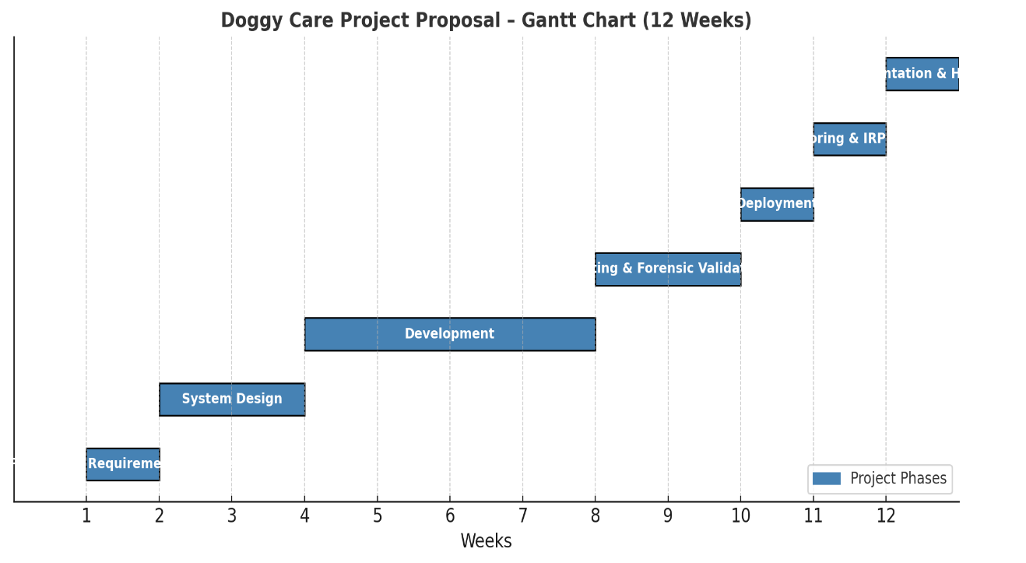
Figure 1

5. Proposed Solution
The proposed solution is to create a centralized, secure, and forensic-ready digital platform that allows pet owners to manage all aspects of dog care in one place, including health records, vaccination schedules, feeding routines, and grooming activities, using web and mobile interfaces. The technology directly solves the shortcomings of existing fragmented and insecure applications by incorporating cybersecurity and forensic ideas into its design. Sensitive data will be encrypted during both storage and transmission, and access will be controlled using role-based access control and multi-factor authentication to ensure that only authorized people may see or alter information. Aside from technical precautions, the system is led by ethical responsibilities: users will be provided insight into how their data is collected and used, and informed permission will be the foundation of information processing. In accordance with data protection legislation such as GDPR principles, users will be able to access, correct, and delete their information, ensuring legal accountability. Tamper-proof audit logging further supports safety and resilience by recording every system activity in a way that preserves chain-of-custody, making evidence admissible in forensic investigations. This forensic readiness not only allows for effective incident response but also builds trust by assuring accountability in the event of disputes or breaches. The Doggy Care Project goes beyond a management tool by incorporating ethical responsibility, data protection, and technical safety measures to create a trusted ecosystem that provides both successful pet care and digital resilience.

5.1 Suggested Starting Point
The first phase in this project will be to construct a secure development environment, which will include setting up version control systems and a server or virtual machine for testing. The next step will be to create a database schema with encryption capabilities and role-based access rules to describe how data is stored and secured. A secure login module will be created early in the process, combining authentication and audit logging to ensure that forensic readiness is built from the ground up. Parallel to this, mock veterinary datasets will be created to model real-world use scenarios that will influence the development of pet profile management and appointment reminder modules. Starting with these core components guarantees that the system has a solid security and forensic structure before moving on to additional features like dashboards, monitoring tools, and eventual IoT connection.
(kumara, 2020)
(k, 2021)

6. Discussion
The Doggy Care Project involves various legal, ethical, sociological, and security concerns that must be addressed for it to succeed and maintain long-term dependability. Legally, the platform must adhere to international data protection rules such as the GDPR, which emphasizes user permission, data minimization, and the right to erasure. Veterinary records, while not typically subject to the same safeguards as human health data, contain sensitive information on both dogs and owners, necessitating legal compliance in order to avoid liability and preserve users' rights. Ethically, the system must utilize a privacy-by-design approach, which ensures that data is only gathered and processed for its intended purpose, and that users are informed about how their information is handled. Transparency and accountability are essential for building trust, while inclusivity and accessibility ensure that the platform is usable by people of all technical skill levels. From a societal standpoint, the system encourages responsible pet ownership by reducing missed visits and improving healthcare outcomes; nevertheless, it must also prevent unwanted surveillance or intrusive use of IoT devices, which may cause discomfort or misuse. Finally, security concerns are important to the project, as platforms lacking encryption, effective authentication, or monitoring are extremely vulnerable to cyberattacks, insider threats, and abuse. To reduce these risks, the system includes AES-256 encryption, RBAC with MFA, WAF protections, forensic audit logging, and incident response protocols. These concerns ensure that the platform is not just effective, but also secure, ethical, and socially responsible.
(moldstud, 2024)

7. References
june. (2024). gdpr. Retrieved from gdpr.
k, y. (2021). Research Gate. Retrieved from the reached gate.
kumara. (2020). smart technology. Retrieved from the smart technology.
moldstud. (2024). ethical considerations in web development. Retrieved from moldstud.
MoldStud. (2024). Ethical Considerations in Web Development. Retrieved from. Retrieved from moldstud.
nilsen. (2019). MHEOC. Retrieved from MHR.
Srebaliute. (n.d.). Cybersecurity Review Journal. Retrieved from risks.
union, e. (2016). General Data Protection Regulation (GDPR). Retrieved from General Data Protection Regulation (GDPR).
union, e. (2020). exabeam. Retrieved from exabem.

Appendices
Appendix A: Technology Adoption: Details on the backend, frontend, database, and security stack.
Appendix B - Analysis and Design: use case diagrams, ER diagrams, and forensic logging workflow.
Appendix C - Prototype screenshots and a secure login module.
Appendix D: Evaluation, including test findings, penetration testing, and audit log forensic validation.

