KONNEKT

UI Designer
Project Brief
Screen-by-screen behavior specification
A source-grounded guide to the Android remote, desktop companion, shared states, and current web target.
Repository snapshot: 31 October 2026

Purpose
Use this brief to design the product UI while preserving the workflows and states already implemented in the code. The screenshots are current implementation references with sample data; they are not final visual requirements.
Design priority: Android phone/tablet remote first; desktop companion second. The web target is currently a starter demo, not a KonneKt remote-control interface.

Contents & reading guide
- 1. Product map and core user journey
- 2. Shared Android shell and visual system
- 3. Android screen specifications: Devices, Home, Media, Apps, Share, Keyboard, Standby, power countdown
- 4. Cross-screen behavior and states
- 5. Desktop companion UI
- 6. Web target status
- 7. Design handoff checklist
- 8. Source map

1. Product map and core user journey
KonneKt turns an Android phone into a remote for a desktop PC on the same local network. It covers PC power actions, media and audio output, app/window management, clipboard and file sharing, and two-way typing. A companion desktop app hosts the connection and provides setup, sharing, and shortcut-management screens.
Target | Role | Design scope
Android app | Primary remote-control experience: connect/pair, Home, Media, Apps, Share, Keyboard, Standby. | Primary deliverable; phone, landscape, tablet/foldable and wide-window behavior.
Desktop app | Background server plus setup/sharing/shortcut UI and PC keyboard overlay. | Secondary; preserve native OS handoffs for files, permissions and startup.
Shared module | Protocol, desktop control services, shared Material 3 Expressive theme. | No separate screen set; defines shared behavior/capability.
Web app | Starter Compose sample (button, sample image and greeting), no KonneKt workflow. | Not a product interface in this repository snapshot.

Core journey
Open Android app → Devices searches the local network → tap a paired PC to reconnect, or pair a new PC with the six-digit PIN displayed on desktop → connected shell opens on Home → use Home, Media, Apps, Share or Keyboard. Standby is a separate full-screen surface opened manually or by dock behavior.
- Saved PCs are attempted automatically when auto-connect is active; a saved-PC card also supports one-tap reconnect.
- A transient reconnect keeps the shell open and shows attempt state. A fully disconnected session returns to Devices.
- The desktop process can stay in the system tray/menu bar while its window is hidden; closing the window does not stop the server.

Navigation map
App state | Surface | Next actions
Not connected | Devices | Pair/reconnect, connect by address, forget a saved PC.
Connected/reconnecting | Connected shell: Home, Media, Apps, Share, Keyboard | Standby, Disconnect, feature actions.
Standby visible | Full-screen dark dock UI, with or without a PC | Select/swipe modes, choose clock face, control PC if connected, exit.
Desktop companion | Status / Share / Shortcuts panes | Pairing, permissions, file transfer, inbox, shortcut management.

User-facing product name is “KonneKt”. Some source packages/directories still use DeskBuddy/Konnekt; visible copy and design files should use KonneKt.

2. Shared Android shell and visual system

Connected shell chrome
- Top bar: PC/computer avatar, PC name, status line and colored dot (“Connected” or “Reconnecting… (attempt N)”), Standby moon icon, Disconnect/link-off icon. Disconnect is not PC shutdown.
- Primary destinations, in order: Home, Media, Apps, Share, Keyboard. Compact windows use bottom navigation; medium/expanded windows use a navigation rail. Wide but short landscape uses a collapsed rail to preserve vertical room.
- When the Android software keyboard is open, hide the navigation suite so the special-key bar can sit directly above the IME.
- Destination and per-destination saveable state survive tab changes and a standby round-trip.

Responsive rules
Window class | Behavior in current app
Compact phone | Single-column scroll surfaces; bottom navigation; 16 dp standard screen gutter.
At least 600 dp wide | Side-by-side layouts where useful; navigation rail; content generally centered and capped at 840 dp.
Landscape / short wide window | Media side by side; compact standby variants; rail rather than bottom nav when width is wide.
Tablet/foldable/desktop-sized Android window | Same feature hierarchy, adaptive grids/panels, avoid stretching text cards indefinitely.

Visual language
- Material 3 Expressive is the implemented base: system light/dark theme, expressive motion, default Material shape scale, and emphasized typography variants.
- Brand roles: teal primary (light #006A65, dark #80D5CE); primary container (light #9DF2EA, dark #00504C); slate/teal secondary; warm amber tertiary for attention. Error red marks destructive close/power outcomes.
- Cards use tonal surface-container roles rather than heavy shadows. Main screens use large rounded cards, subtle surface steps, semantic section headings, and centered max-width content.
- Computer/app avatars use a rounded nine-sided “cookie” shape. App shortcuts show desktop icon where available and a letter fallback otherwise.
- Keep icon-only controls labeled for accessibility, show selected/disabled states clearly, preserve contrast in both themes, and maintain at least 48 dp touch targets. Standby is always dark.
These tokens describe the actual shared theme, not a requirement to preserve every current pixel. A redesign can refine appearance while retaining the information hierarchy and behaviors below.

3. Android screen specifications
For each screen, the hierarchy, actions, feedback and state variations below are part of the current product behavior. Exact copy is in androidApp/src/main/res/values/strings.xml.

3.1 Devices — discovery, pairing, reconnect
Purpose: identify the desktop and establish a trusted connection. This is the root surface whenever the phone is disconnected. Discovery starts with the route, combines local-network discovery with a subnet fallback, and runs while this screen is visible.

Content hierarchy
- Large flexible top app bar: “KonneKt” and “Your PC, in your pocket”; it collapses as the list scrolls.
- If no PC has been saved: three-step setup card (install/open desktop app; put phone and PC on same Wi-Fi; tap PC and enter its PIN).
- “Your PCs” lists paired desktops, most recently used first. Card: computer avatar, PC name, host, Connect button, overflow → Forget.
- “Nearby” lists discovered unpaired desktops. Header has spinner while searching. Empty/search card explains that KonneKt must be running on the same network. A nearby card shows name, host:port, Pair and chevron.
- “Enter IP address” at bottom opens manual-connect sheet.

Interactions and states
- Tap a saved PC or Connect to reconnect without PIN. Tap a nearby PC to start connection and pairing.
- Connecting banner appears above sections, names target and offers Cancel.
- Manual sheet: “Connect by address”, desktop-window hint, single-line address field, Connect disabled while blank; Go submits trimmed address.
- PIN dialog: six large numeric cells and numeric password keyboard; Pair enabled only at six digits; Cancel dismisses. Wrong attempts show remaining count in error color.
- Forget confirmation explains that automatic reconnection stops and PIN is required to pair again.
- Connection/pairing errors use shared snackbar; includes connection failure/loss, PIN rejected, desktop busy, unsupported OS and internal failure.
Responsive: center list at up to 840 dp. Avoid over-wide cards; truncate long names and host values safely.
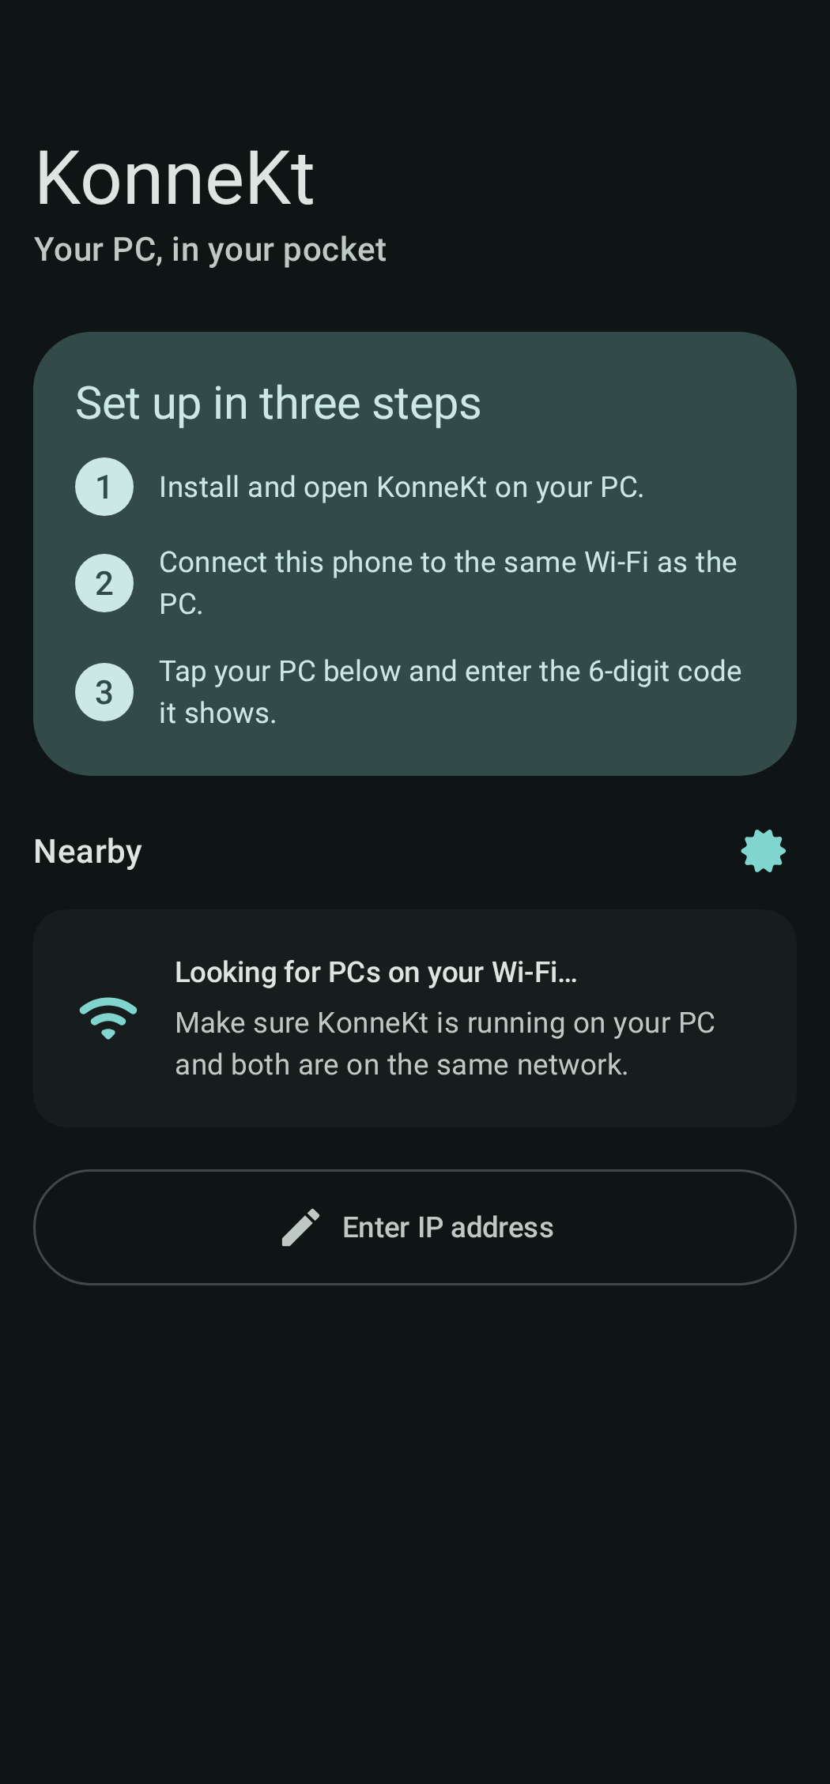
Current reference — Devices, first-run state (dark theme)
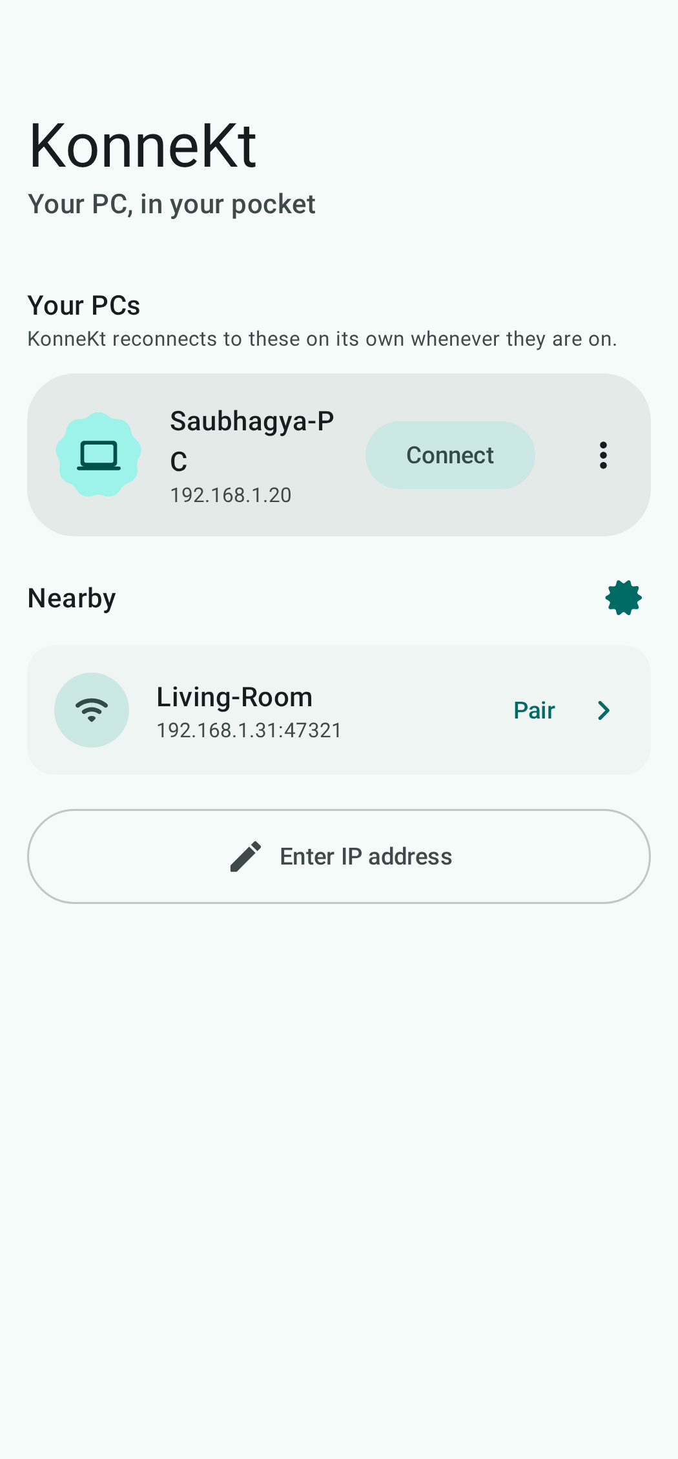
Current reference — Devices with saved and nearby PCs

3.2 Home — connected dashboard
Purpose: show connection status and the most common remote actions immediately after connecting. Home is the default connected destination.

Hierarchy
- PC status hero: computer badge, “Connected to”, PC name, automatic reconnect reassurance (or attempt status), and Lock / Restart / Shut down tiles.
- “App Features & Settings” card: Auto Standby on Dock / Charge and Auto-connect on Wi-Fi switches, each with supporting copy. Both default on for a fresh preference store.
- Conditional dock-setup card appears only when Auto Standby is on and a required Android permission is missing: display over apps and battery-optimization exemption. Show relevant buttons; each opens its Android settings page.
- Conditional transfer progress card while a file is moving; outgoing transfer can be cancelled.
- Mini-player with art/placeholder, title, artist, play/pause. Tapping card opens Media; play/pause acts in place.
- Quick actions: Send clipboard, Get PC clipboard, Send file, Type on PC.
- Shortcuts horizontal strip, All apps link to Apps; empty card explains how to star shortcuts.

Behavior and layout
- Lock sends immediately. Restart/Shut down open the global 10-second cancellable countdown and warn the user to save work.
- Send file opens Android’s content picker. Transfer status shows direction, name and percent.
- If no track: music-note artwork placeholder and empty-player text. Dock setup disappears when permissions are granted or Auto Standby is off.
- One scroll column, 16 dp gutters, max width 840 dp. Keep the four quick actions tappable and allow labels to wrap on narrow displays.
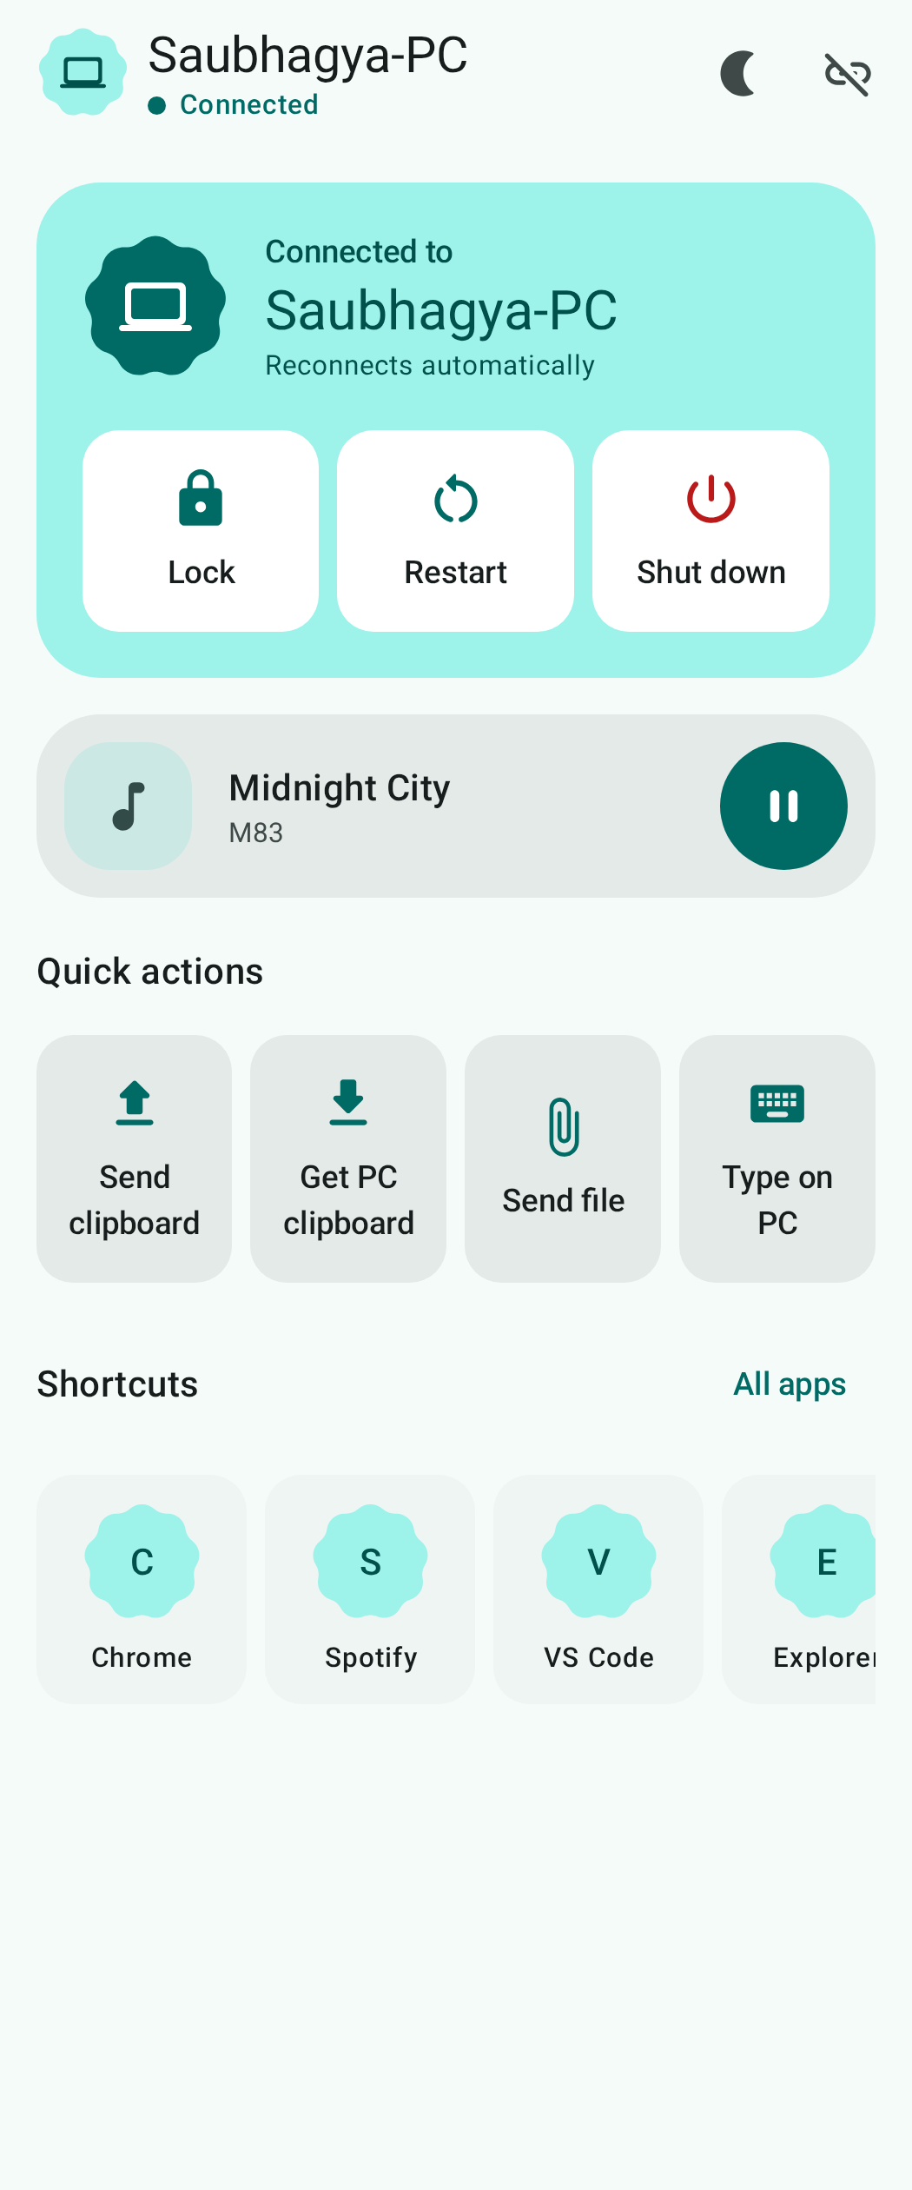
Current reference — Home, light theme and sample media
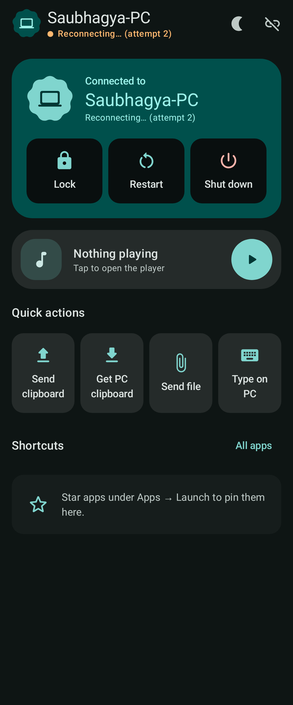
Current reference — Home, dark theme and reconnect state

3.3 Media — PC playback and sound
Purpose: control the PC’s current media session and audio output. The phone mirrors state reported by desktop; this is not a local phone music player.

Hierarchy and controls
- Now-playing card: artwork square (160 dp currently; music-note placeholder when absent), title, artist/album when available, source-app chip when available, and animated progress treatment while playing.
- Timeline slider with elapsed/total time. Position interpolates locally during playback; seeking commits on drag release.
- Transport group: previous, prominent play/pause, next.
- Volume panel: mute toggle, 0–100 slider with percentage, split button showing current output device plus chevron.
- Output-device dialog is a scrollable radio list. Current/default output is highlighted; selecting another device closes the dialog.

States and responsive layout
- No track: placeholder art, “Nothing playing”, start-playback hint. Seek disabled; transport remains available.
- Before desktop reports audio state, volume/mute are disabled and output picker is not shown.
- Portrait: scrollable stack, now-playing first. Wide: now-playing card left, controls column right.
- Support long titles; source app display name removes executable suffix where possible.
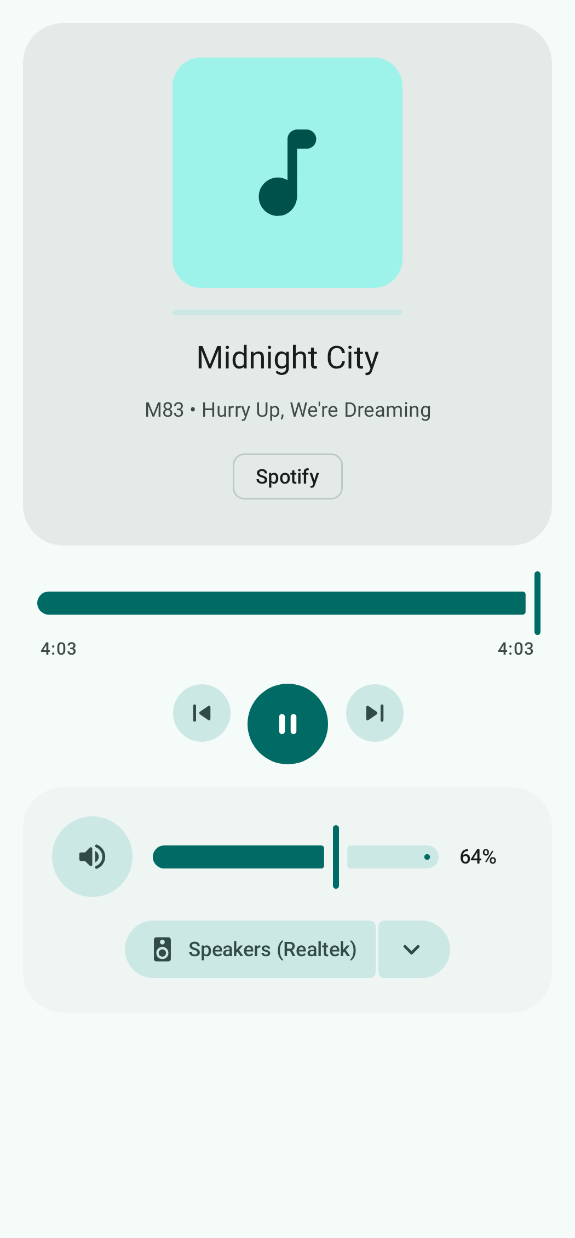
Current reference — Media player in portrait
Media capability varies by desktop OS and installed session integration. Follow reported state; unsupported actions use the existing error snackbar.

3.4 Apps — Open now and Launch
Purpose: inspect/close things open on PC, or find and start an installed program. A segmented switch has “Open now” and “Launch”; Open now is initial.

Open now pane
- Header: “Open on your PC”, explanatory line about closing windows/apps/tabs, Refresh action and last-updated time.
- Apps are grouped into cards: app name/avatar, window or tab count, destructive Close app action.
- Each window row shows title and close-window action. Browser windows also have expand/collapse; expanded list shows individual tab titles and close actions.
- Close app/window/tab each asks for confirmation identifying target. App close warns that unsaved work may cause a prompt on PC; close is graceful.
- States: loading, idle before first refresh, loaded-empty, loaded list, refresh in progress. Refresh when pane appears and on demand.

Launch pane
- Pinned shortcut tiles first, using desktop icon when available or avatar fallback; tap launches on PC. Refresh button refreshes installed catalog.
- Empty pinned state explains starring apps.
- All apps on PC section includes case-insensitive search. Unpinned catalog rows use letter avatars, app name and star toggle; row tap launches, star adds/removes shortcut.
- Show loading and no-search-match states. Pinned grid minimum tile width is 104 dp; full app rows span roughly three columns on wide windows.
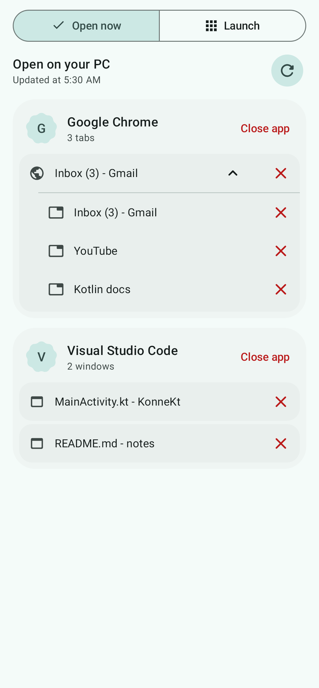
Current reference — Apps / Open now with browser tabs and windows
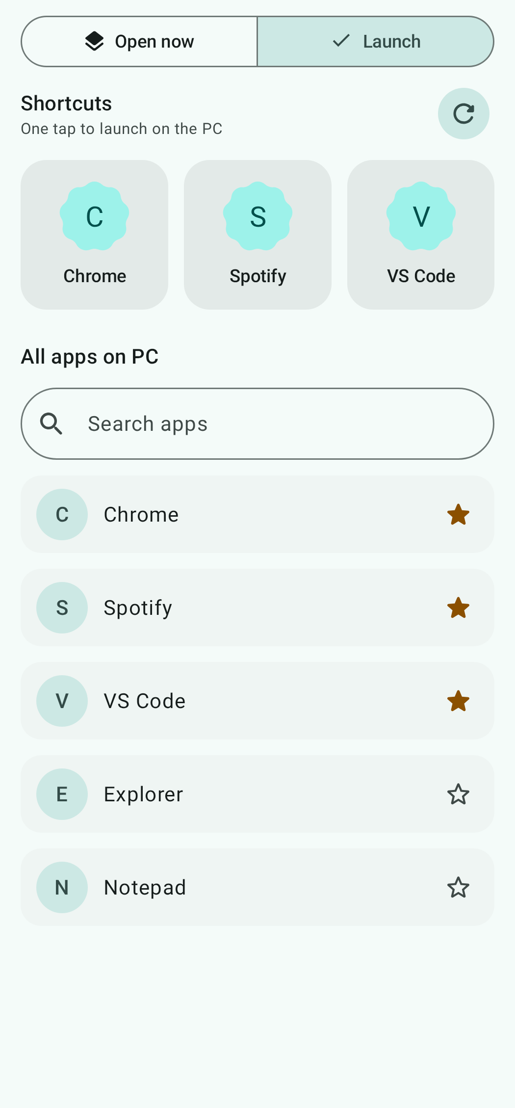
Current reference — Apps / Launch with shortcuts and app catalog

3.5 Share — clipboard, text, files, inbox
Purpose: move content either way between phone and PC. Android Share is a scrollable column ordered by frequent use.

Hierarchy and behavior
- Clipboard hero: Send (phone clipboard → PC), Get (PC clipboard → phone), and Sync automatically switch. Auto-sync defaults on; copy events mirror while KonneKt is open/connected.
- Send text card: multiline field accepts typing/paste; send disabled for blank text; sending clears the draft. Sent text reaches PC and its clipboard/inbox.
- Send a file opens Android content picker. Progress shows sending/receiving name and percent; outgoing transfer can be cancelled.
- “Received from PC” inbox is newest first. Text item shows bounded preview and Copy. File item shows filename and saved location. Empty state explains incoming items.
- Clear appears only with inbox items. Confirmation says the list is cleared but downloaded files remain saved.
- Incoming files use Downloads/KonneKt on current Android; older Android uses app external Downloads. Display location reported by app rather than hard-coding.
- Text/single-file shares from other Android apps can arrive through system share sheet. Send immediately when connected or queue until connection; unreadable files show an error.
Responsive: max width 840 dp; clipboard first, then text/file, then inbox. Keep progress visible in context without losing inbox scroll.
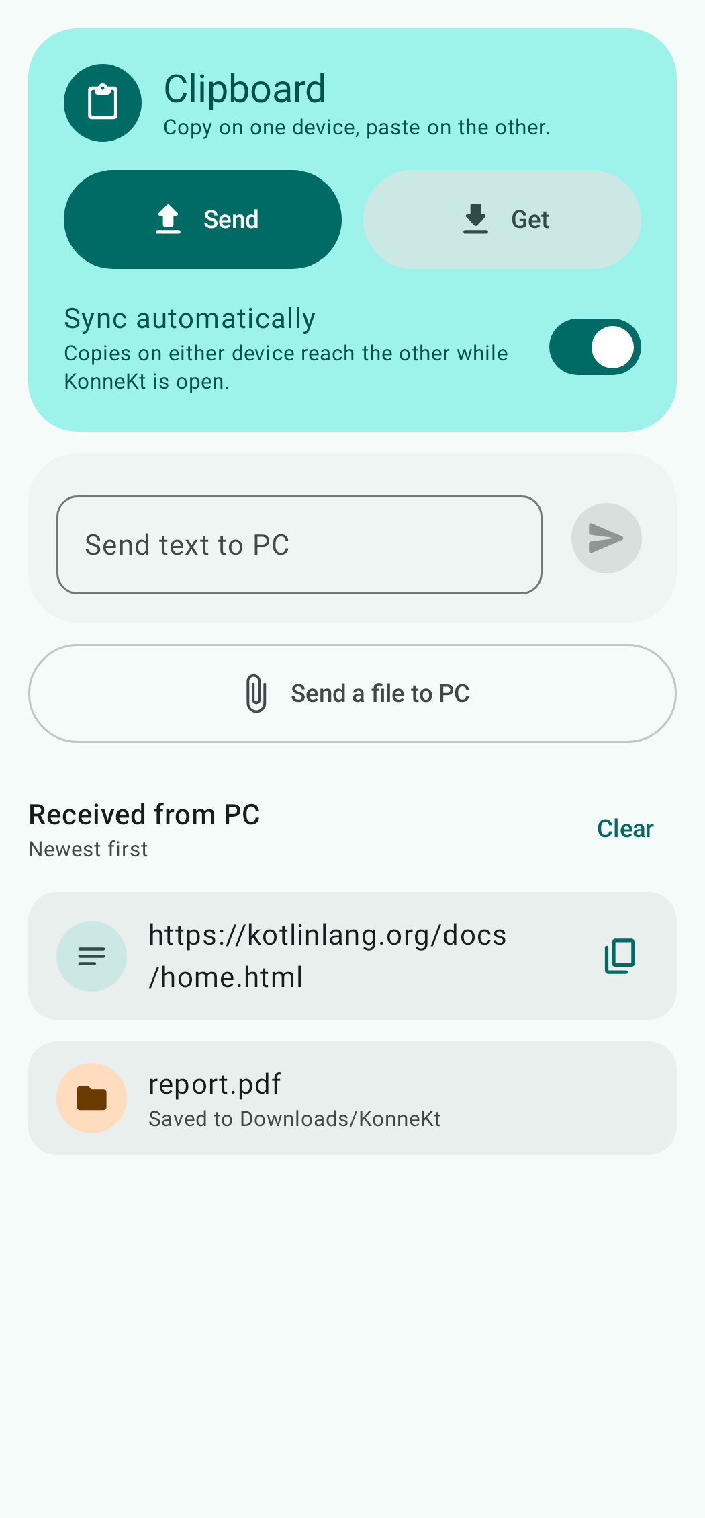
Current reference — Share with received text and file items

3.6 Keyboard — both typing directions
Purpose: type from phone into the active PC app, or use PC keyboard in any focused phone app. Segmented switch labels direction.

Type on PC (phone → PC)
- Status names PC and active window. Single-line “Type here” field sends edits live; autocorrect and auto-capitalization are off to avoid disruptive rewrite bursts.
- Android IME Send submits Enter. Explicit Enter key is also available and clears the field; Backspace works when empty.
- Special-key bar sits under text input and above Android IME: sticky Ctrl/Alt/Shift/Win chips, Backspace, Enter, horizontally scrolling navigation keys, and common shortcuts (Copy, Paste, Undo, Select all, Alt+Tab, Win+D).
- Modifier tap arms next key; double tap locks it, with lock state shown. Disable key actions if link cannot type; reconnecting remains type-capable to avoid focus loss.
- When phone IME opens, hide bottom navigation. Landscape provides wider typing workspace.

Type on phone (PC → phone)
- Status card names current PC and says whether PC is typing; active state uses tertiary/amber emphasis.
- Checklist: (1) enable KonneKt Keyboard in Android settings; (2) press Ctrl+Alt+K on PC; (3) switch Android input method to KonneKt Keyboard. Buttons open Android settings and keyboard picker; completed steps show checkmark.
- Show Android’s standard keyboard privacy warning and the product statement that this IME only types what PC sends and stores nothing.
- System IME has no key layout: a slim 56 dp status strip with PC typing state and Switch keyboard action. It returns to prior keyboard when PC typing ends.
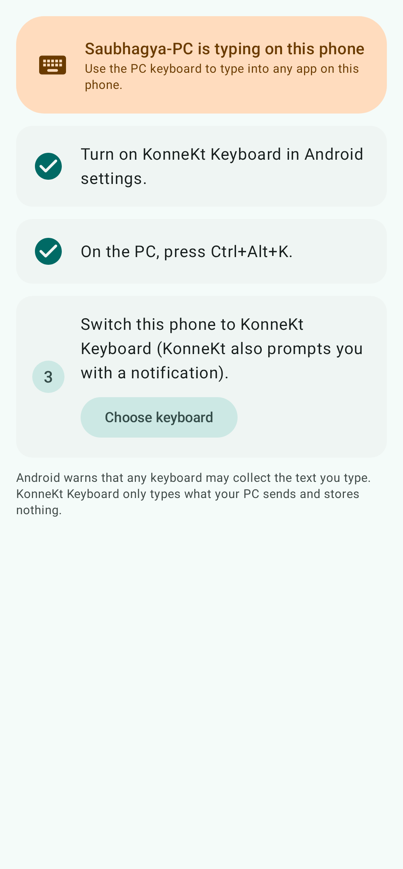
Current reference — Keyboard / Type on phone setup with active typing

3.7 Standby — always-dark dock surface
Purpose: an always-on dock display and PC controller. Standby is outside the connected shell and works without a PC. It hides system bars and keeps the display on.

Entry, exit and chrome
- Manual entry from connected top-bar Standby. Automatic entry when Auto Standby is enabled and phone is charging in landscape; PC optional. Background launch requires display-over-apps and battery optimization permissions.
- Automatic entry is suppressed while PC keyboard-to-phone typing is active, so it does not steal input focus.
- Connected entry defaults to Media + Apps; disconnected entry defaults to Clock. If PC connects while user has not chosen a mode, Clock may switch to Media + Apps. Disconnect from PC mode returns to Clock.
- Always-dark full-screen background. Floating controls show on entry, then hide after 4 seconds untouched. Blank-area tap toggles chrome; keyboard/D-pad wakes it. Taps on controls do not count as blank taps.
- Modes in order: Clock, Media + Apps, Multimedia, Development. Swipe vertically or select on rail. Rail is vertical in landscape/wide and horizontal at top in portrait.
- Top actions: Shut down, Restart, Exit. Power actions disabled without PC. Bottom bar on every PC mode except Clock: Lock, volume down, play/pause, volume up; dim/disabled when disconnected. Back exits.
- PC pages keep fixed clearance around floating chrome, so showing/hiding controls does not reflow content.

Clock and six swipeable faces
Clock is full-bleed and works without PC. Swipe horizontally through faces; bottom dots indicate selection. Face selection persists; time format follows Android’s 12/24-hour preference.
Face | Visual treatment / supporting data
Flip | Split-flap HH/MM; AM/PM label in 12-hour format.
Bubble | Heavy rounded digits over slowly drifting warm gradient.
Neon Orbit | Analog hands with cyan/pink glow and seconds comet.
LED / Dot Matrix | 5×7 LED dots, date and phone battery percentage.
Solar | Large lightweight digital numerals over warm radial gradient.
Classic Analog | Analog dial, weekday/date/month and battery indicator.

Reduced-motion preference damps animation. Clock face shifts subtly by up to about 8 dp over time for burn-in protection.

Media + Apps (connected default)
- Wide/landscape: roughly equal media and pinned-app areas. Portrait stacks compact media above app grid.
- Media: art, title/artist, seek, previous/play-pause/next. Current output-device chip expands to available output chips.
- App keys use desktop icons or initials; tap activates/launches. Small running dot marks pinned app with open window. Catalog is shared with Apps/Launch.
- Running apps refresh on entry and every 10 seconds while a key grid is visible.

Multimedia
- Landscape: now-playing and sound panels side by side; portrait stacks them. Empty track state keeps transport available.
- Sound panel: mute, volume step buttons/current percent, wrapping output-device chips with current device selected.
- Volume steps 2%; hold repeats (first after 400 ms, then ~150 ms, accelerating to 60 ms after 1.5 s); haptics per step and at endpoints.

Development
- Adaptive grid of pinned app keys; wider keys than mixed Media + Apps (at least 128 dp wide on wide windows, 104 dp on compact phone).
- Tap activates an existing app window when supported or launches it. Running dot refreshes every 10 seconds while visible/resumed.

Disconnected PC modes
When PC is away, replace PC controls/content with a centered reconnect/no-PC card. Clock remains usable. Reconnection restores PC content based on mode rules.
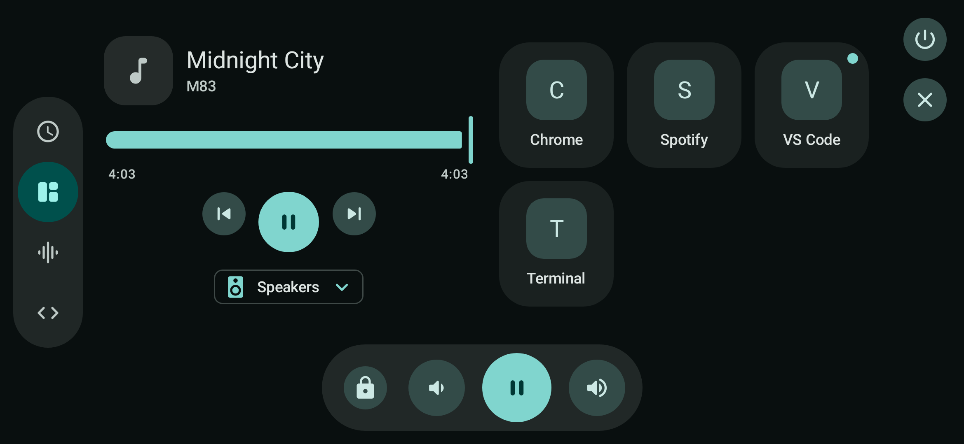
Current reference — Standby / Media + Apps, landscape with visible chrome
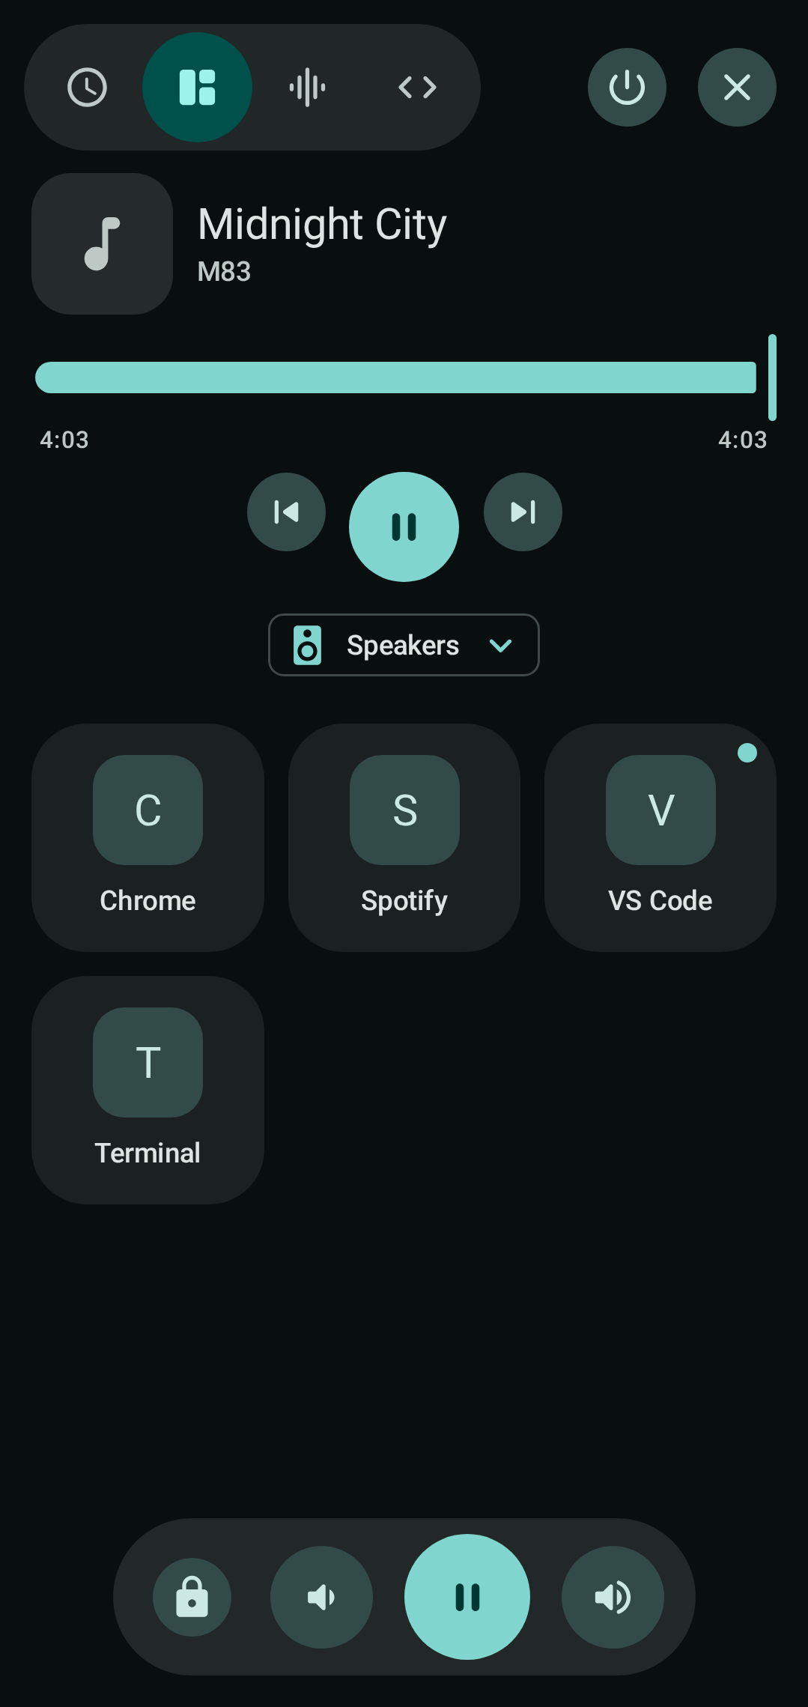
Current reference — Standby / Media + Apps, phone portrait
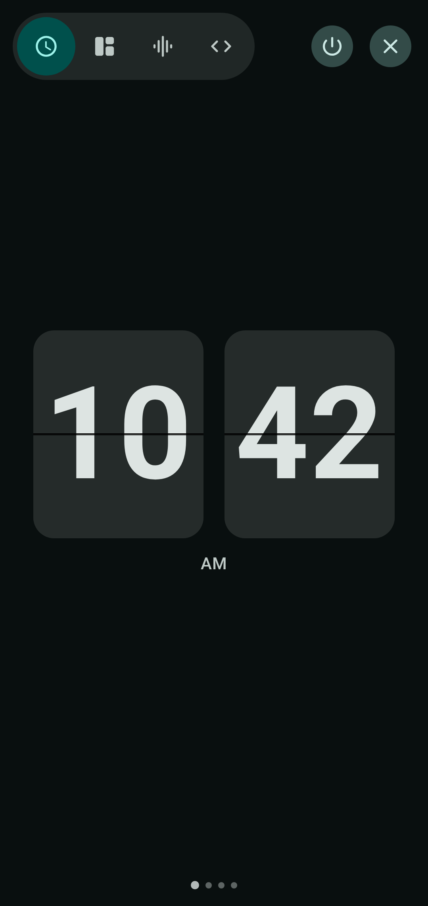
Current reference — Standby / Clock, portrait
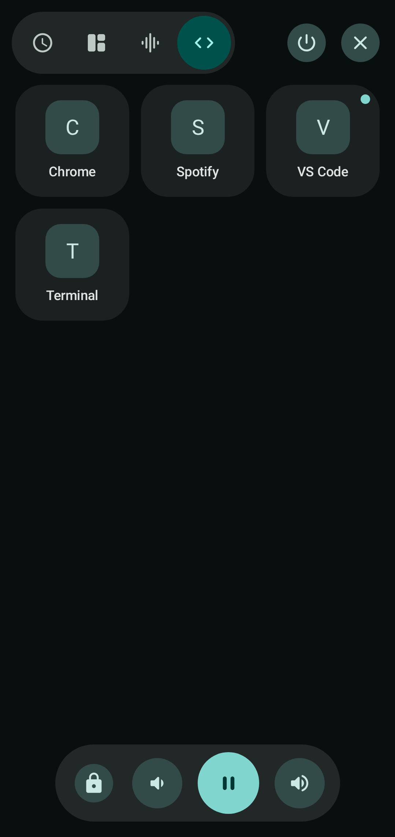
Current reference — Standby / Development, portrait
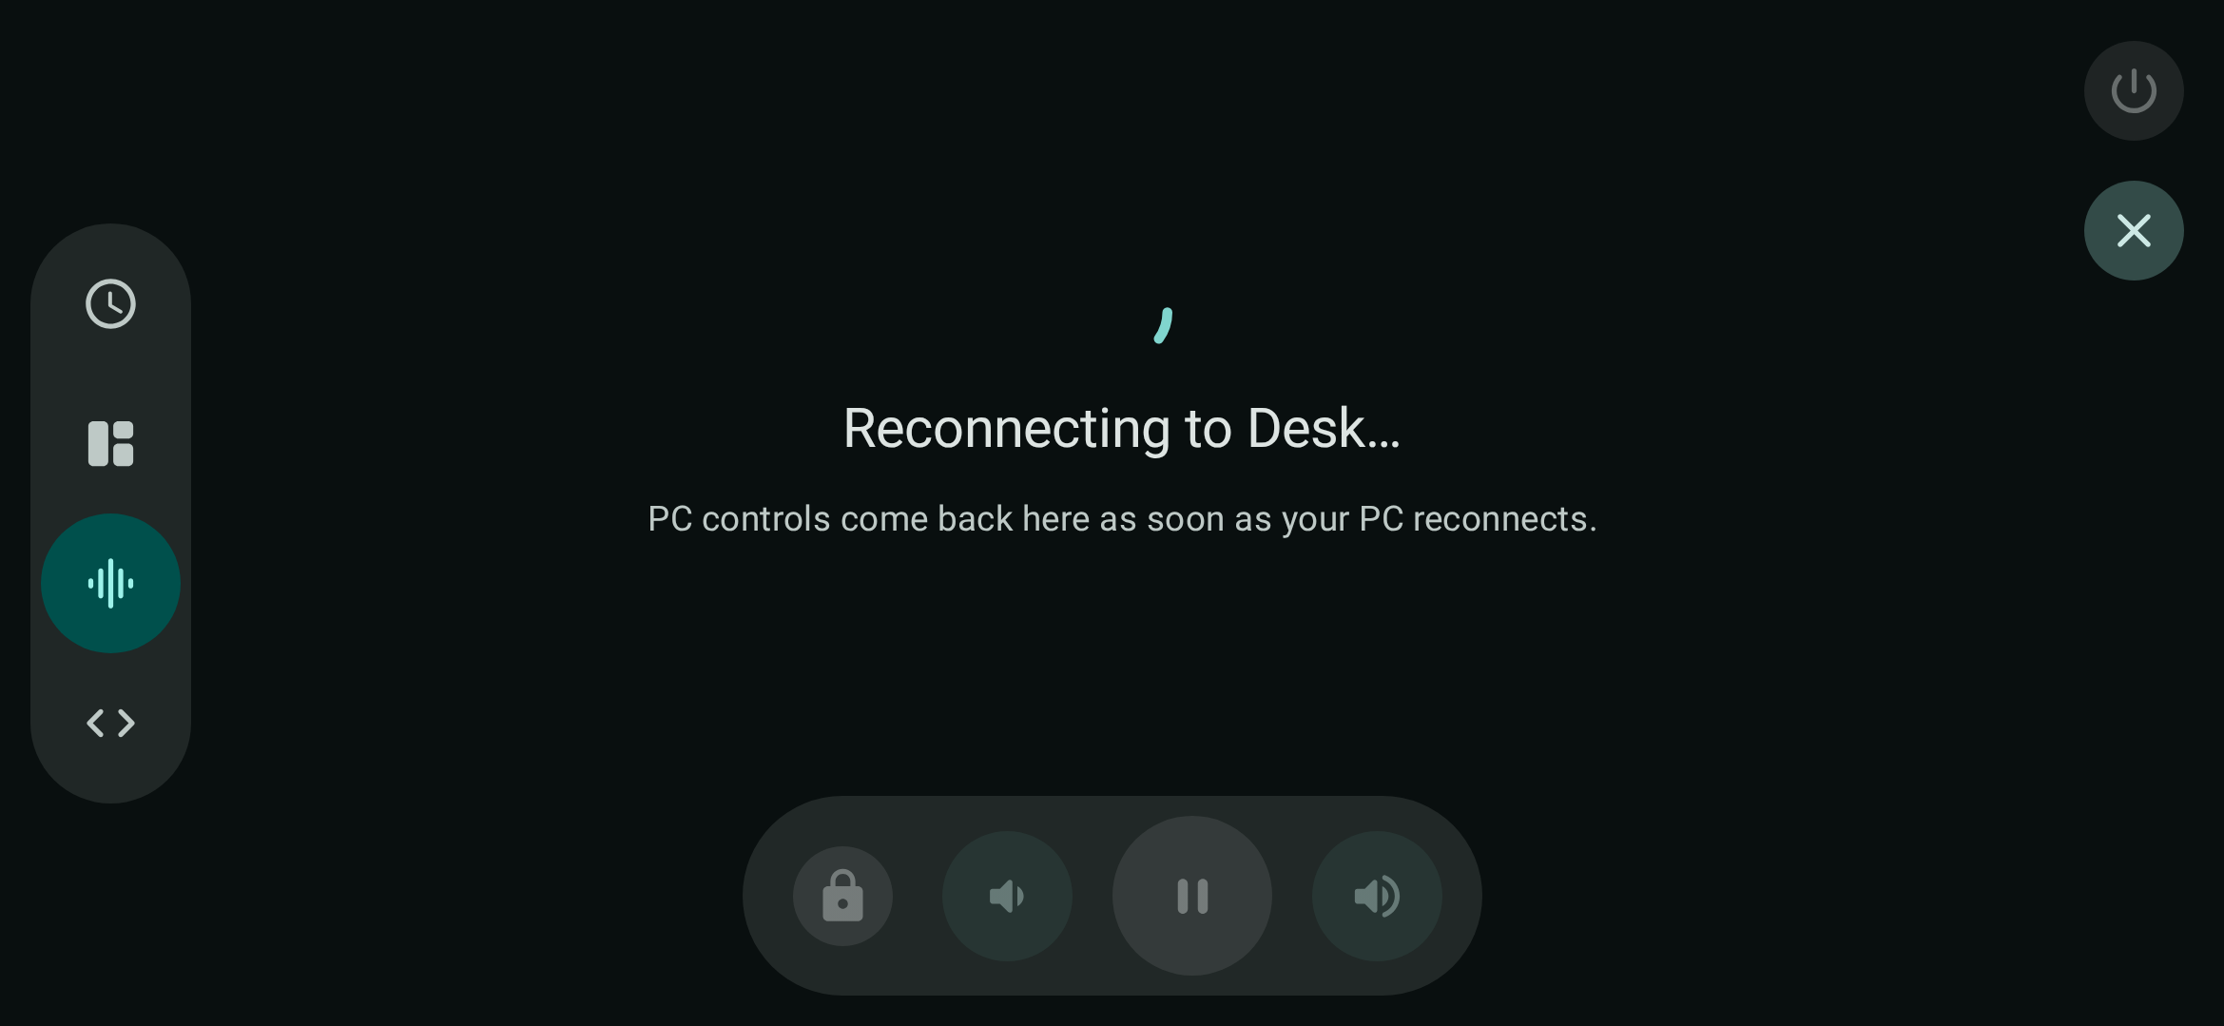
Current reference — Standby PC mode while disconnected

3.8 Restart/shut down countdown
Root-level dialog can overlay Home or Standby. Used for Restart/Shut down only; Lock is immediate.
- Counting: target-specific title, large 10-second circular countdown, save-work warning and Cancel. Back cancels; tapping outside does nothing.
- Sending: progress indicator and “Sending to [PC]…” after countdown. Command is in flight and no longer cancellable.
- Result: sent, cancelled or PC-not-connected outcome, visible briefly (~2 seconds). If connection drops during countdown, show not-connected and send nothing.
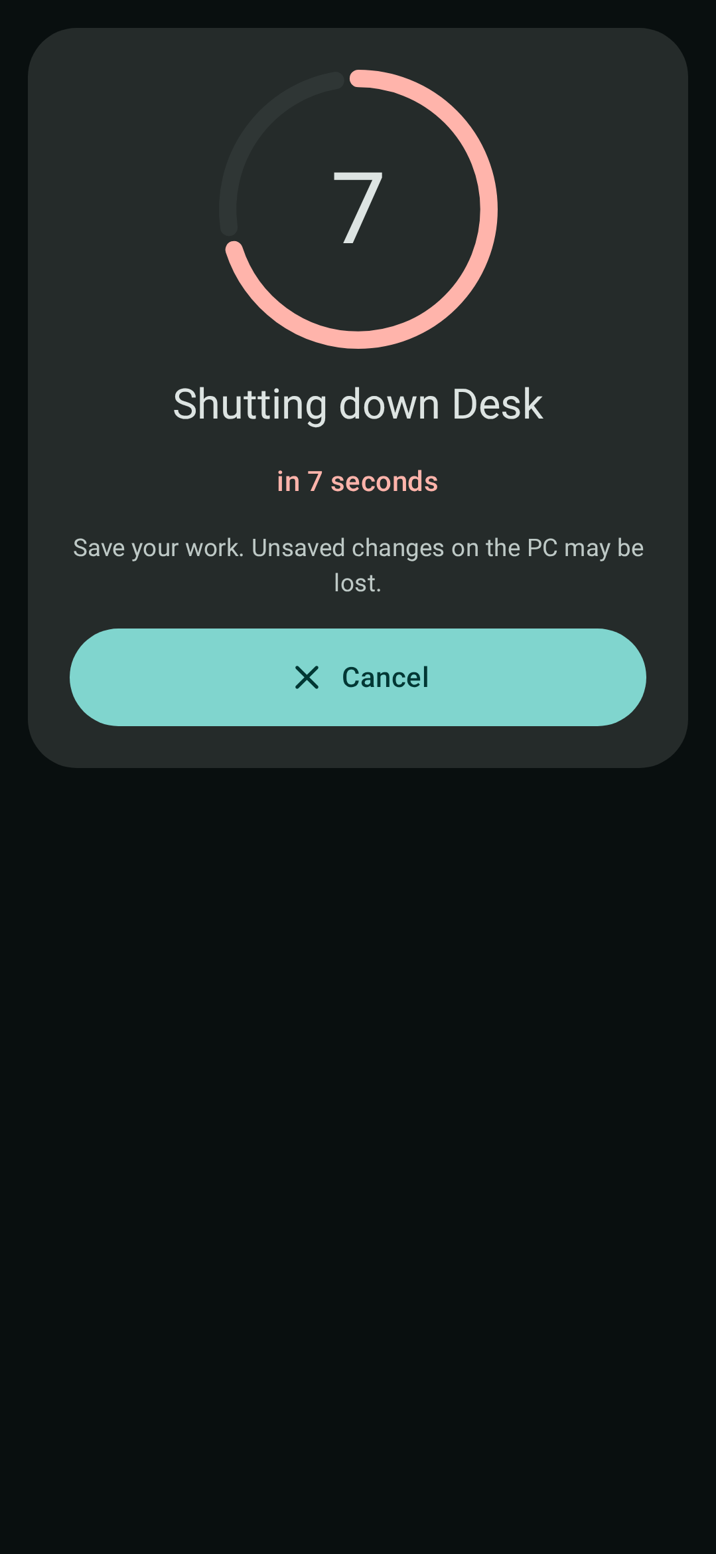
Current reference — Power countdown, active cancellation window
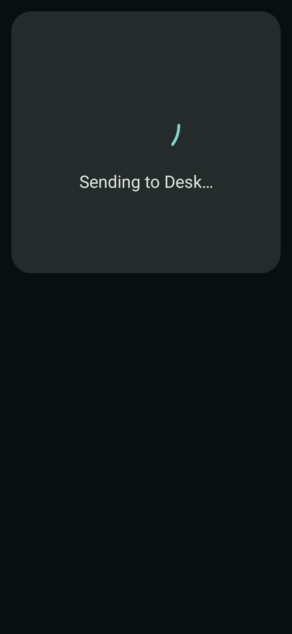
Current reference — Power countdown, sending state
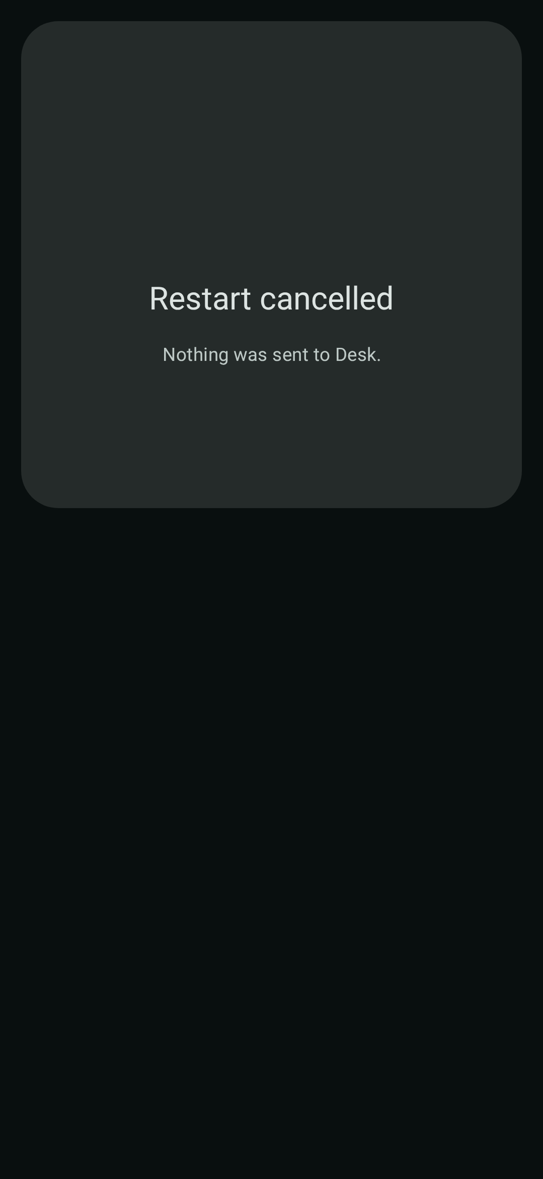
Current reference — Power countdown, cancelled result

4. Cross-screen behavior and states

Connection and recovery
- Connected shell stays visible during reconnect; top bar names PC and shows attempt number. Home mirrors reconnect status. Fully disconnected/idle returns to Devices.
- Connection errors use shared snackbar rather than feature-specific full-screen error pages; preserve current screen where possible.
- Foreground connection service maintains paired-PC reconnect path in background. Notification permission affects notification visibility, not service operation.

Automatic connection and standby
- Home preferences: Auto-connect on Wi-Fi and Auto Standby on Dock / Charge; both default enabled on fresh install.
- Dock setup card refreshes Android permission state when user returns from settings.
- Charging + landscape can open Standby with no PC. User exit suppresses immediate re-entry until the dock state is reset or auto mode is re-enabled.

System handoffs
- Android: native file/content picker, keyboard settings/picker, clipboard APIs and OS settings for dock permissions.
- Desktop: native file chooser, OS firewall/accessibility/automation settings and platform startup registration.
- Only show/enable controls supported by current desktop capability; do not suggest unavailable output devices or media actions.

Feedback and accessibility
- Section titles are semantic headings; icon-only controls have accessibility descriptions. Pair color with text for connection, selection, app running and IME setup state.
- Loading, empty, disabled, confirmation, sending and completed states are designed states, not missing data.
- Transfers can be incoming/outgoing; only outgoing has Cancel. Clearing inbox does not delete received files.

5. Desktop companion UI
Desktop app hosts the connection and setup/configuration UI; it is not the remote-control destination. Default window is 960×640 dp. Closing hides it to the system tray/menu bar; only Quit stops the server.

Shared desktop shell
- Left wide navigation rail with computer avatar and Status (“Your phone”), Share, Shortcuts. Page title/subtitle updates with current pane/server state.
- Status is initial pane. A snackbar host reports transient notices. Same shared KonneKt Material 3 Expressive theme.

5.1 Status pane
- Waiting hero: spinner, “Waiting for your phone”, same-Wi-Fi setup guidance.
- Pairing hero: six-digit PIN, enter-on-phone instruction, countdown progress and expiry time.
- Connected hero: phone names/count, feature summary and Unpair all devices action.
- Chips show PC host name, IP:port, now-playing helper availability, keyboard hotkey/instructions.
- Permissions card adapts by OS: macOS Accessibility and Automation/System Events/Music status/actions; Windows firewall settings and administrator/UIPI note. Re-check control.
- Start-at-login switch appears where supported, worded for Windows tray or macOS menu bar.

5.2 Share pane
- Two columns. Left: Send text card with multiline draft and Send; file card with native chooser, progress and Cancel; clipboard auto-sync switch.
- Right: Received from phone with Open folder action, inbox cards, text Copy, file path/filename and copy-path action; empty state when no items.

5.3 Shortcuts pane
- Actions: Add installed app (searchable installed-app dialog) and Browse for program (native file dialog).
- Adaptive grid (minimum tile width 220 dp) shows avatar, app name, app ID/path and remove action; explanatory empty state.
- Installed app dialog: search, scrollable names/IDs, Add, Rescan and Close; loading/no-match states.

Tray and PC keyboard overlay
- Tray/menu-bar menu: Open KonneKt, Type on phone (hotkey if available), Quit. Tray icon reopens hidden window.
- Type on phone opens an always-on-top, undecorated 640×76 dp pill near top center. PC key events go to the focused phone app via KonneKt Keyboard.
- Overlay states: active (phone name and hotkey/Esc hint), click-to-focus, no phone, phone disconnected. Active state can show short typed-text echo; inactive notice fades after ~1.5 seconds.
Desktop UI is implemented and useful as a reference. Prior redesign spec kept desktop redesign out of scope; prioritize Android unless a full desktop redesign is separately intended.

6. Web target status
The web module currently launches the starter Compose sample: primary-container background, “Click me!” button, animated sample greeting and image. There is no network connection or KonneKt feature screen in the current web target. Treat it as scaffolding, not a missing web edition.
Source: shared/src/commonMain/kotlin/com/saubh/deskbuddy/App.kt
A product web UI needs a separate product-scope decision; do not infer its screens from the sample.

7. Design handoff checklist
Use this checklist to make the proposed designs reviewable against implemented behavior.
Area | Required design states
Android foundations | Light/dark; color/type/shape tokens; compact phone, 600 dp+ wide, portrait/landscape shell.
Devices | First run, searching, nearby, saved PCs, connecting/cancel, manual sheet, PIN/wrong attempts, forget, errors.
Home | Connected/reconnecting, dark theme, no track/shortcuts, transfer, dock permissions, restart/shutdown countdown.
Media | Playing, paused, empty, missing audio, output chooser, seek/volume drag, disabled controls.
Apps | Open-now loading/idle/empty/list; browser tabs expanded/collapsed; close confirmations; Launch loading/empty/search/no-match; pin/unpin.
Share | Clipboard sync on/off; text empty/ready; file handoff/progress/cancel; inbox empty/populated; clear confirmation; system-share arrival.
Keyboard | Phone→PC connected/reconnecting; IME open/nav hidden; sticky/locked modifiers; Type-on-phone checklist, active/idle status and native IME strip.
Standby | Clock plus six faces; four modes; chrome visible/hidden; connected/disconnected; portrait/landscape/short landscape; running dot; volume hold; exit/power.
Desktop companion | Status waiting/pairing/connected, OS permissions; Share empty/populated/progress; Shortcuts empty/populated; app picker; tray overlay.

Constraints to retain
- Identify target before action: PC in countdown, output device in picker, window/tab in close confirmation.
- Style Close/Forget/Shutdown as destructive, while keeping Disconnect visually distinct from power-off.
- Keep frequent actions easy to find: Home quick actions, clipboard hero, pinned launches, keyboard entry.
- Plan long/localized labels, arbitrary PC/app/window names, zero/one/many counts, and IME overlap.
- Screenshot names/content are sample data only; do not bake “Saubhagya-PC”, “Midnight City” or “M83” into final design.

8. Source map
Use these current screen/controller files when a design question needs code-level verification.
Area | Primary source files
Root and shell | androidApp/src/main/kotlin/com/saubh/deskbuddy/ui/KonnektApp.kt; ui/shell/ConnectedShell.kt; ShellTopBar.kt; Destination.kt
Devices | ui/connect/DevicesScreen.kt; DeviceCards.kt; ManualConnectSheet.kt; PinDialog.kt; DevicesViewModel.kt; ui/ConnectionUiState.kt
Home/docking | ui/home/HomeScreen.kt; HomeCards.kt; DockSetupCard.kt; HomeViewModel.kt; service/AutoStandbyManager.kt; service/DockPermissions.kt
Media | ui/media/MediaScreen.kt; NowPlayingCard.kt; PlaybackControls.kt; VolumePanel.kt; OutputDeviceDialog.kt; media/MediaController.kt
Apps | ui/apps/AppsScreen.kt; OpenWindowsPane.kt; RunningAppCard.kt; LaunchPane.kt; AppsViewModel.kt
Share | ui/share/ShareScreen.kt; ShareCards.kt; TransferCard.kt; ShareViewModel.kt; MainActivity.kt
Keyboard | ui/keyboard/KeyboardScreen.kt; TypeOnPhonePane.kt; KeyBar.kt; ime/DeskBuddyInputMethodService.kt
Standby | ui/standby/StandbyRoute.kt; StandbyPages.kt; MultimediaMode.kt; MediaAppsMode.kt; DevelopmentMode.kt; ModeRail.kt; StandbyControlBar.kt; ui/standby/clock/*
Power dialog | ui/components/PowerCountdownDialog.kt; power/PowerController.kt
Desktop | desktopApp/src/main/kotlin/com/saubh/deskbuddy/ui/ServerScreen.kt; StatusPanel.kt; SharePanel.kt; ShortcutsPanel.kt; AppPickerDialog.kt; KeyboardOverlay.kt
Theme/copy | shared/src/commonMain/kotlin/com/saubh/deskbuddy/ui/theme/*; androidApp/src/main/res/values/strings.xml

Current Android preview references are under androidApp/src/screenshotTestDebug/reference/com/saubh/deskbuddy. Images here are current preview renderings, not final design approvals.

