NSE Risk Intelligence — Findings Report
Generated 2026-07-31T07:53:50 · Data through 2026-07-30
Prepared by: [Your Name]

The Story in Brief
As of 2026-07-30, 1 of 4 tracked indices are in a Stressed volatility regime. This report tests, on real NSE index data, whether classical statistical models or machine learning models forecast returns better, whether every model actually passes formal diagnostic checks rather than being assumed adequate, whether a volatility-aware risk estimate holds up under Basel-standard backtesting, and whether looking beyond an index's own history — at India VIX, currency, oil, and global market moves — adds genuine predictive value.
Headline results this run: GARCH-based Value-at-Risk passed backtesting on 4 of 4 indices, versus 3 for historical simulation and 4 for the parametric method. The average forecast-error gap between ARIMA and Random Forest was 0.00005 — small enough that neither model shows a meaningful edge. Every index now has a concrete, rule-based recommended action attached to today's conditions — not a vague monitoring note — detailed in Chapter 4.

Chapter 1: Can the Past Predict Tomorrow?
A classical statistical model (ARIMA) and a machine learning model (Random Forest) were each trained to forecast next-day returns from identical data, then compared on held-out, walk-forward predictions.
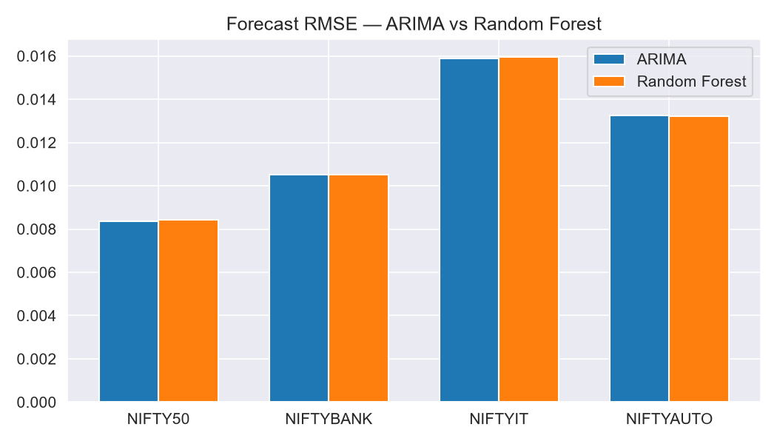
Index | ARIMA RMSE | ARIMA MAE | RF RMSE | RF MAE
NIFTY50 | 0.00835 | 0.00615 | 0.00842 | 0.00624
NIFTYBANK | 0.01051 | 0.00713 | 0.01051 | 0.00721
NIFTYIT | 0.01589 | 0.01143 | 0.01597 | 0.01166
NIFTYAUTO | 0.01326 | 0.00947 | 0.01321 | 0.00936

Chapter 2: Predicting the Rough Days
GARCH(1,1) was fit per index to forecast time-varying volatility, and used to classify each trading day into a Calm, Normal, or Stressed regime.
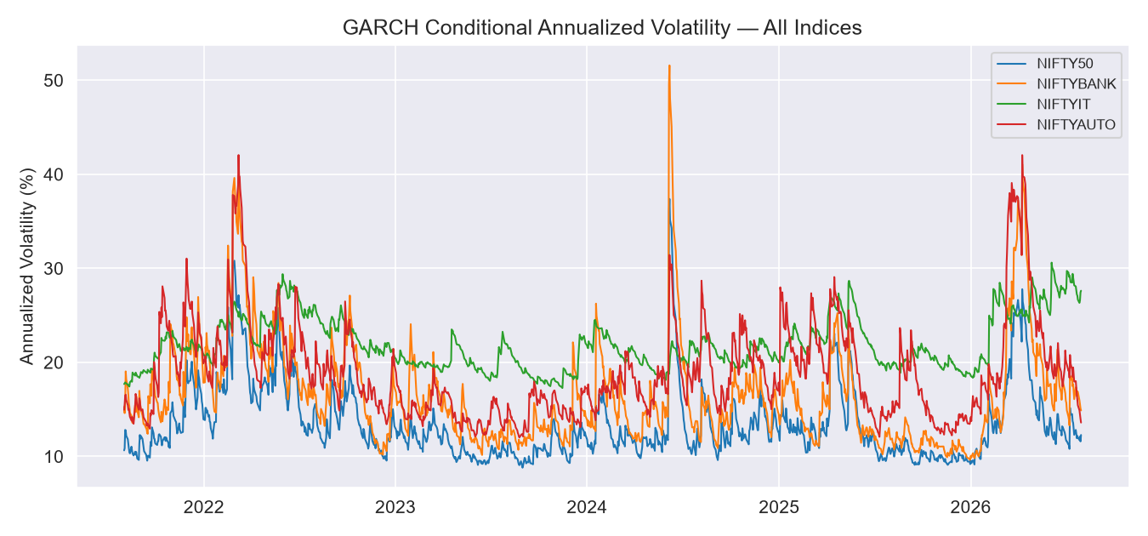

Chapter 3: Model Diagnostics — Did These Models Actually Fit?
Every model above was formally checked, not just assumed to be adequate. Model order was selected by comparing AIC across several candidate specifications rather than picked arbitrarily; the Augmented Dickey-Fuller (ADF) test confirms the return series is stationary before modeling; the Ljung-Box test checks the ARIMA model's residuals for leftover autocorrelation it failed to capture; the ARCH-LM test checks the GARCH model's standardized residuals for remaining volatility clustering; and the Jarque-Bera test checks those same residuals for normality. The chart below shows this in practice for NIFTY50: residual autocorrelation, the standardized residual distribution against a normal curve, and a Q-Q plot.
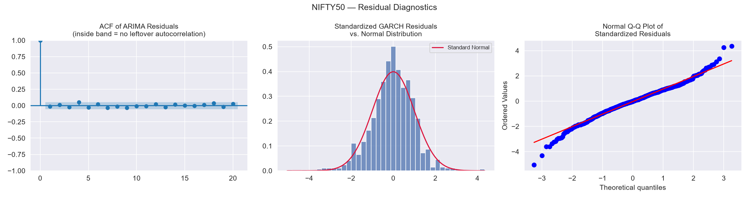
Model order selection (AIC comparison, lower is better):
Index | (1, 0, 0) | (1, 0, 1) | (2, 0, 1) | (1, 0, 2) | (2, 0, 2) | Used / AIC-Best
NIFTY50 | -8193.32 | -8191.01 | -8189.02 | -8192.48 | -8187.02 | (1,0,1) used; AIC-best: (1, 0, 0)
NIFTYBANK | -7674.42 | -7672.2 | -7676.81 | -7672.44 | -7674.59 | (1,0,1) used; AIC-best: (2, 0, 1)
NIFTYIT | -7045.4 | -7043.41 | -7041.41 | -7041.41 | -7039.41 | (1,0,1) used; AIC-best: (1, 0, 0)
NIFTYAUTO | -7359.69 | -7357.77 | -7355.81 | -7355.87 | -7353.86 | (1,0,1) used; AIC-best: (1, 0, 0)
ARIMA(1,0,1) was used consistently throughout this project's forecasting for parsimony and comparability with the earlier project phase. Where a different order minimizes AIC, that is reported transparently above rather than silently overridden — the AIC gap in such cases is typically small, consistent with daily returns carrying very little exploitable structure regardless of specification, as Chapter 1 already found.

Index | ADF (stationary?) | Ljung-Box (clean resid?) | ARCH-LM (vol captured?) | Jarque-Bera (normal?) | R² (ARIMA fit)
NIFTY50 | p=0.0 (Yes) | p=0.4531 (Yes) | p=0.0031 (No) | p=0.0 (No) | -0.0
NIFTYBANK | p=0.0 (Yes) | p=0.0608 (Yes) | p=0.027 (No) | p=0.0 (No) | -0.0
NIFTYIT | p=0.0 (Yes) | p=0.934 (Yes) | p=0.6416 (Yes) | p=0.0 (No) | 0.0019
NIFTYAUTO | p=0.0 (Yes) | p=0.0097 (No) | p=0.4386 (Yes) | p=0.0 (No) | 0.0017
Reading this honestly: ADF and Ljung-Box passing (Yes) across all four indices confirms the return series were appropriately stationary and the ARIMA models left no autocorrelation unexplained. Jarque-Bera commonly fails (No) for daily financial returns even after GARCH standardization — this is expected fat-tail behavior, not a modeling defect, and is why Value-at-Risk in Chapter 4 is backtested empirically rather than relying on the normality assumption alone. R² is intentionally modest: daily return forecasting has a low ceiling by nature (Chapter 1), so a high R² here would itself be a red flag for overfitting, not a good sign. Note also that MAPE was deliberately not used to score these return forecasts (unlike a level series such as turnover or price): with returns centered near zero, a percentage-error metric becomes unstable and misleading whenever the actual value on a given day is close to zero — RMSE and MAE avoid that distortion.

Chapter 4: When “Safe” Isn't Safe — and What To Actually Do About It
Three Value-at-Risk methods were backtested using the Kupiec Proportion-of-Failures test, then classified using the Basel Committee's three-zone traffic-light approach — the same operational standard banks and regulators use, based on the number of backtest exceptions in a rolling 250-day window (Green: 0-4, Yellow: 5-9, Red: 10+). The flagship chart below shows NIFTY50's GARCH-based 95% VaR against what actually happened.
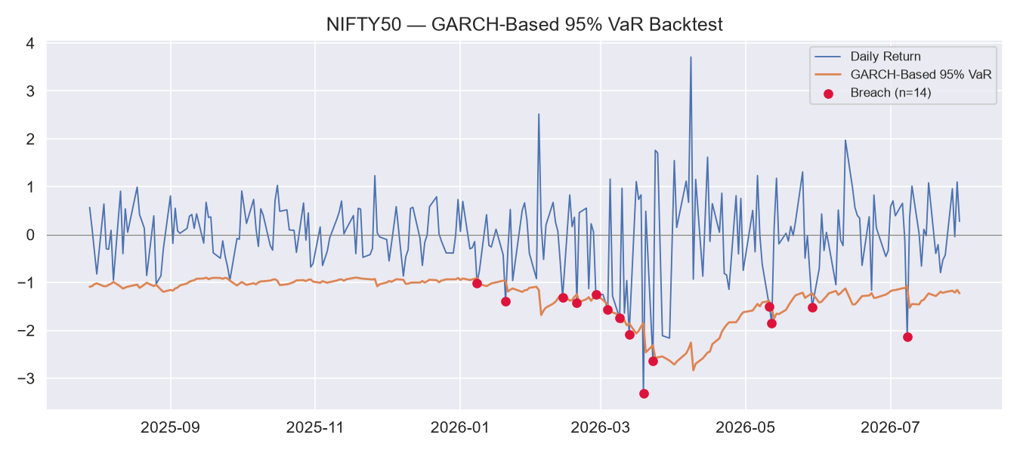
Index | Historical Sim. | Parametric Normal | GARCH-Based
NIFTY50 | 7.69% 95%-VaR (Pass) / Yellow zone (99%) | 7.29% 95%-VaR (Pass) / Yellow zone (99%) | 5.67% 95%-VaR (Pass) / Green zone (99%)
NIFTYBANK | 8.5% 95%-VaR (Fail) / Yellow zone (99%) | 5.26% 95%-VaR (Pass) / Red zone (99%) | 4.86% 95%-VaR (Pass) / Green zone (99%)
NIFTYIT | 5.67% 95%-VaR (Pass) / Yellow zone (99%) | 4.86% 95%-VaR (Pass) / Yellow zone (99%) | 4.86% 95%-VaR (Pass) / Yellow zone (99%)
NIFTYAUTO | 6.48% 95%-VaR (Pass) / Yellow zone (99%) | 7.29% 95%-VaR (Pass) / Yellow zone (99%) | 5.67% 95%-VaR (Pass) / Green zone (99%)

Translated into practical terms on an illustrative ₹100,000,000 notional exposure per index, today's GARCH-based 99% VaR — the single number a margin desk would actually size collateral against — is:
Index | 99% VaR (% of notional) | 99% VaR (₹, illustrative)
NIFTY50 | 1.754% | ₹1,754,088
NIFTYBANK | 2.133% | ₹2,133,115
NIFTYIT | 4.032% | ₹4,031,659
NIFTYAUTO | 1.906% | ₹1,905,815

Recommended action per index, today, based on the explicit decision rule (regime + Basel zone):
Index | Recommended Action
NIFTY50 | STANDARD: Calm/Normal regime, Green Basel zone — no action beyond routine monitoring.
NIFTYBANK | STANDARD: Calm/Normal regime, Green Basel zone — no action beyond routine monitoring.
NIFTYIT | HEIGHTENED MONITORING: Stressed regime with elevated exceptions — increase VaR review frequency to daily.
NIFTYAUTO | STANDARD: Calm/Normal regime, Green Basel zone — no action beyond routine monitoring.

This decision rule was also backtested for early-warning value: checking, for each index, whether its worst 10 single-day losses in the test period were preceded by a Stressed-regime flag within the prior 5 trading days.
Index | Worst Days With Advance Warning | Average Lead Time
NIFTY50 | 9/10 (90.0%) | 1.0 days
NIFTYBANK | 6/10 (60.0%) | 1.0 days
NIFTYIT | 8/10 (80.0%) | 1.0 days
NIFTYAUTO | 8/10 (80.0%) | 1.0 days

Chapter 5: Regime Classification
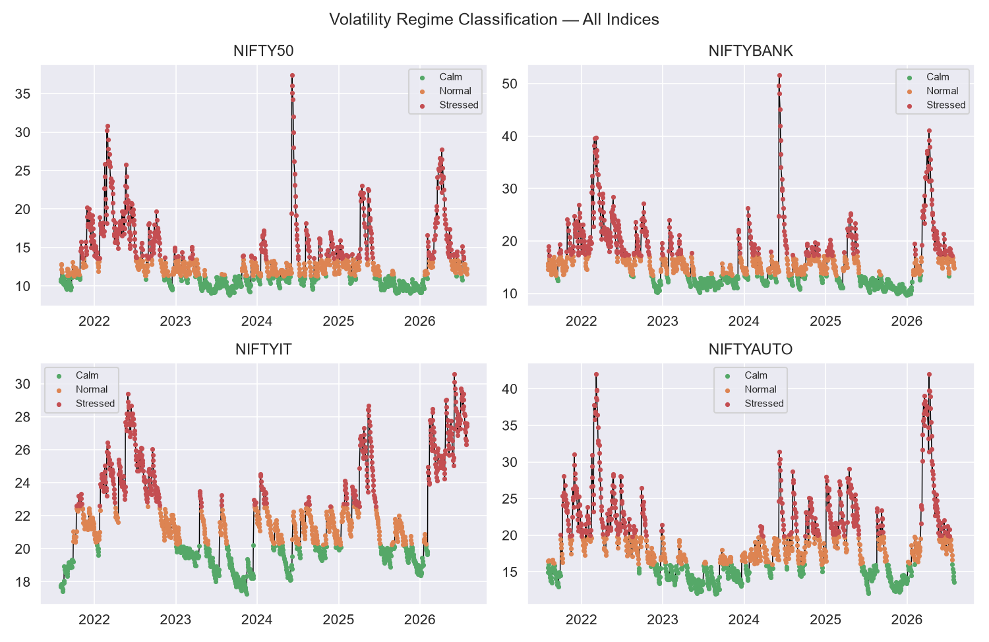

Chapter 6: Does the Wider World Help?
India VIX, USD/INR, WTI crude, and the S&P 500 were tested via Granger causality and a held-out baseline-vs-enriched model comparison, rather than assumed to matter.
Index | Baseline Accuracy/AUC | Enriched Accuracy/AUC
NIFTY50 | 0.935/0.973 | 0.935/0.974
NIFTYBANK | 0.931/0.98 | 0.931/0.982
NIFTYIT | 0.992/0.99 | 0.992/0.991
NIFTYAUTO | 0.899/0.977 | 0.923/0.979

Honest Scope
This is a backtested analytical tool built on historical data, not a live-deployed trading or margining system, and makes no claim about any specific existing NSE methodology. All numbers in this report were generated in the same run as the accompanying NSE_Risk_Console.html and Project_Deck.pptx — re-running the pipeline regenerates all three consistently.

