Ben Besthof

Terminating Terror

Hamas declared war on Israel on October 7th, 2023, with a deadly invasion capturing over 200 civilian hostages and killing 40 more within the next days. The main question that arises as a result is: how did Israel thwart the invasion with all of its security? In reality Israel has more enemies than the (Western) world thinks. Not only are the Israel Defense Forces (IDF) fighting Hamas, but they are also keeping out Hezbollah, and Islamic Jihad away from Israel’s civilians. The IDF carries out operations to neutralize casualties often due to the constant threat on the Jewish State. The question that researchers should be asking is: Can the Israeli Defense Forces draw useful insight from executed targets data to improve national security?

The Abu Ali Express Forum on telegram posted three different PDF files with a list of executed terrorists. Each PDF was uploaded on different months. Only users with access to the forum can access it, therefore I uploaded the PDFs to the repository.

Originally the data was contained in tables within the PDFs. All of the information was transferred to Excel and saved in CSV format. The information was limited, therefore, project time was devoted to cleaning and engineering the following features manually on Microsoft Excel:

**Name**

The name of the casualty, which uniquely identifies an instance within this dataset.

**Date**

The date attribute is the calendar day in which the casualty was neutralized. The value of this attribute is realized when visualizing statistics over a period of time. An example can be tracking terrorist casualties on a monthly basis. Possible time series trends may appear, but that is not likely due to the circumstances by which the casualty is killed.

**Age**

Age of the casualty at the time of their death. This attribute gives some insight to who the terrorist organizations are wanting to recruit. For example, it can be assumed that younger recruits have been in demand if the average age of the casualties is lower for a specific organization.

**Where**

Where attribute is the precise location where the casualty was neutralized. The precise location might be too specific; therefore, an additional location feature needs to be derived.

**Region**

Region is the general location in which the casualty was neutralized and is derived from the ‘where’ attribute. Neighborhoods and towns are converted to cities and regions respectively. The purpose of using this attribute is to have a location attribute with lower cardinality.

**Affiliation**

The affiliation attribute notes the terrorist organization to which the casualty was part of. This gives insight to who is threatening Israel’s national security. The represented terrorist organizations in the dataset are Hamas, Fatah, PFLP (popular front for liberation of Palestine), PIJ (Palestinian Islamic Jihad), Unaffiliated, Unknown, Al Mujahadeen, and al-Aqsa's Martyrs Brigades, Multiple. Note that values unknown and unaffiliated are not the same. An affiliation value of unknown means that the casualty was affiliated, but to which organization the casualty was affiliated to was not clear at the time of death. He unaffiliated value means that not a single terrorist organization or report can confirm the casualty’s association.

**Role**

Role is the casualty’s position in their organization. This gives insight into what the casualties’ responsibilities were and how significant their contributions to the organization are. The values for this attribute can also display who the IDF is able to neutralize more successfully, additionally it can exhibit who the IDF is focused on targeting.

**Incrimination**

The values in this attribute describe the means by which the IDF was able to confirm the casualty’s association with organized terror. The most common incrimination are official announcements, martyrdom posters, and pictures of the casualty with a rifle from when they were alive.

**Circumstances**

This field is a description of how or why the terrorist became a casualty.

**Method**

The manner by which the IDF was able to neutralize the terrorist. This attribute is derived from the circumstance attribute. The values for this feature are either: Fire, Injury, Airstrike, and Failed PL Attack. A value of fire means that the casualty was killed in an exchange of fire with IDF forces. A value of airstrike means that the casualty was killed by an aerial missile. A value of injury means the terrorist died from sustained injuries. The value ‘failed PL attack’ means that the casualty was neutralized via detonation of terrorist organization explosive.

**Offenses**

Is a derived field from circumstances and incrimination. The value returned is the number of punishable actions the terrorist has committed. It is assumed that any casualty with an offenses value of 3 has committed 3 or more acts of terrorism.

**Terrorist**

The terrorist attribute is the target variable created for this dataset. 1 = confirmed terrorist organization affiliation, 0 = civilian casualty.

a check for null values was the first method in exploratory data analysis of the *terrorismp1.csv* dataset is a null count check across all attributes including the target. There should not be null values in numeric fields like age because it is crucial for the analysis of this dataset. Age, for example, provides insight to who the terrorist organizations are recruiting. There are only six null values out of eighty-three instances. However, these null values are kept because a civilian casualty unaffiliated with any terror organization does not have an applicable role.

Pandas has the *.isnul()l* function, which checks if an attribute has null values and then it can be tallied up per attribute with the *.sum()* function.

Additionally, a high level, statistical analysis of the numerical variables is conducted. The description of the numerical variables shows that, on average, casualties have committed more than one offense.

Next the target variable is analyzed by value distribution to see how many casualties are confirmed terrorists. Analyzing the target variable would give insight into how precise IDF strikes on targets. Both Matplotlib and Seaborn visualization packages can be used to plot the distribution of values in each variable. Fortunately both histograms can be plotted next to each other by using Matplotlib’s *subplots()* function

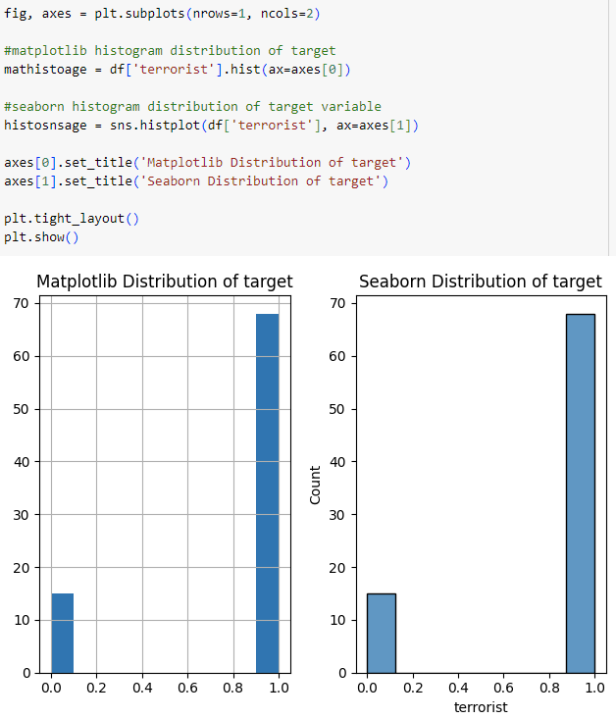

There is an imbalance among the target variable distribution, indicating that the IDF has limited civilian casualties when eliminating terrorists.

Exploration of casualty age gives a first glance at who the IDF is eliminating and who the terrorist organizations are recruiting.

The majority of executed targets are between 18-27 years old. The right skewed histogram shows that the militants possibly lack field experience because of their younger age. Through viewing the distribution of *offenses* values we can see how many acts of terrorism the majority of casualties commit, in other words, how experienced they were.

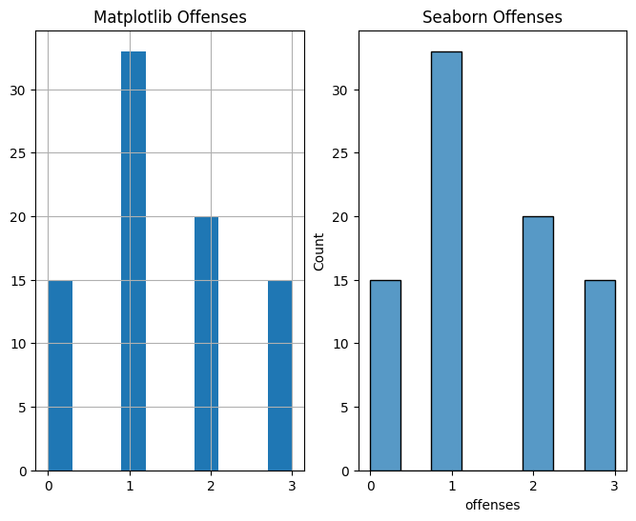

The *offenses* distribution shows that most casualties have committed one or more acts of terrorism. It is also interesting to note that this distribution is right skewed like the *age* distribution.

Viewing the distribution of values of the *method* variable shows how the IDF neutralized their targets.

It seems that the IDF has neutralized the most casualties through exchange of fire. It important to note that there are several casualties as a result of terrorists misfiring a rocket. However, the second most popular method used to eliminate terrorists is through airstrikes. After seeing the distribution of methods we can investigate who is being effected most by the airstrikes by aggregating the casualty count by affiliation.

The two most effected groups from Israeli airstrikes are PIJ and unaffiliated. Evidently, most of the unaffiliated casualties have been killed through airstrikes. Although, if one refers to the *role* column, they can see most of these unaffiliated casualties were with the terrorist at the time of the strike. Seven of the eleven unaffiliated casualties have a role of terrorist family, therefore, we can assume that the terrorist was at home at the time of the airstrike.

Lastly, we want to address where the casualties are being neutralized. The distribution of values in the *region* attribute will give insight to where the terrorists are concentrated.

Most terrorist casualties fall in Judea Samaria (West Bank) and the Gaza Strip. This demonstrates the fronts on which Israel is fighting terrorism.

The most insightful inferences came from grouping and aggregating data because it views different perspectives of the data. We can view the average age and average number of offenses committed by role to better understand who the IDF is able to successfully neutralize.

Most of the targets have committed more than one offense on average. Only 8% targets executed were considered high ranking, 63% of the casualties in this dataset are relatively young militants. We also find out through the data who the organizations are recruiting and how many acts of terrorism they commit.

PIJ has committed 47% of punished offenses between and its casualties tend to be relatively older compared with average ages of the other terror organizations.

The bar chart only magnifies PIJ’s contribution to terror. The Seaborn visualization package does a more effective job at emphasizing the difference between PIJ and the rest of the organizations with default color coding.

Although the IDF has been at war with Hamas in the Gaza Strip, there is still a growing presence of Islamic Jihad militants planning and committing attacks from Judea and Samaria. Majority of the casualties the IDF neutralized in the months leading up to October 7th come from Palestinian Islamic Jihad who consist 47% of the offenses identified in the dataset. Additionally, 63% of the terrorists killed in action by the Israeli forces are militants. The distribution of ages show that majority of the casualties were killed aged 18-27 years old with at least one act of terrorism committed in their lifetime. According to the data the PIJ has been the main target of IDF operations leading up to October. Thus, the largest national security threat to Israel is Palestinian Islamic Jihad. Unfortunately, the dataset was not as informative by itself as hoped. The IDF can focus on the methods they used to take-out high-ranking officials to improve their counterterrorism operations. However, more information is needed until this dataset can be of real help.

References:

1. Abu Ali Express, 2023, *Palestinian Casualties in Operation “House and Garden.”*
2. Abu Ali Express, 2023, *Palestinian Casualties in Operation “Shield and Arrow.”*
3. Abu Ali Express, 2023, *January Martyrs .*