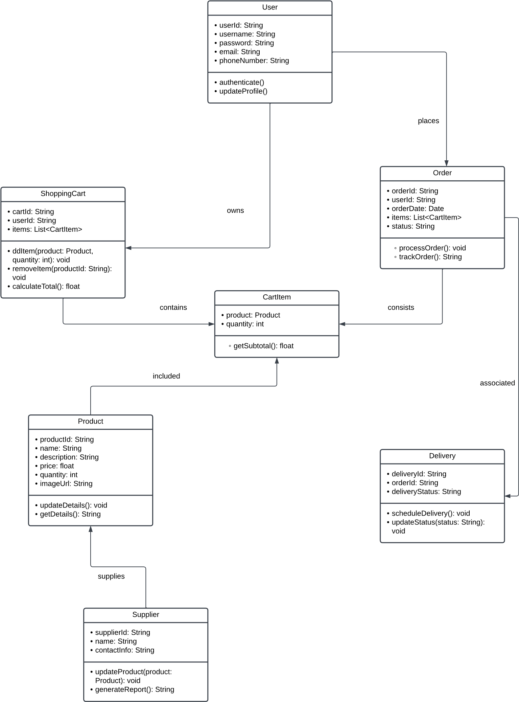**Class Diagram** (qahtan)  
  
Class Diagram is a diagram that shows the structure of a system through showing the system’s classes, attributes, operations and the relationship among objects, it is used to provide basic notation for other structure diagrams prescribed by UML, are helpful for developers and can be used to model systems. Class diagrams contains a set of classes and a set of relationships between them.