**2.4 Data Flow Diagrams (DFD)**

Muntadher Hani (20198780)

A Data Flow Diagram (DFD) is a graphical representation of data flow with any system. It represents how the data is working through the different stages of the system and is stored in data stores or transformed into outputs. DFDs are commonly used to visualize the system’s components such as processes, data stores, and other entities such as users and systems, and how the data flows between them. DFD helps to understand how information moves through a system, making it easier to analyze and design systems. They are often used to break down complex processes into simpler components which offer a clear overview of the system’s operations.

**Context level DFD:**

A context-level data flow diagram provides a general view of a system. It highlights the external entities and their interactions with the system. This level contains only the entities and their basic data flows, which show the connections between the processes and the entities.

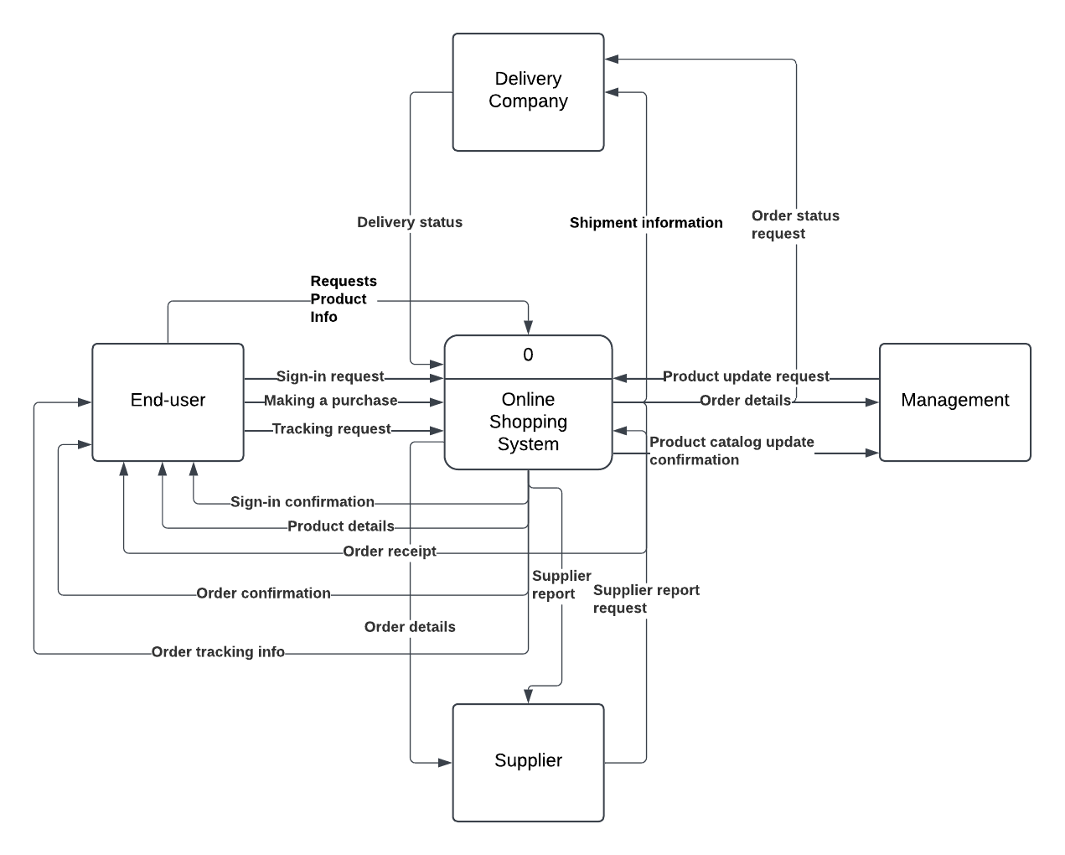

The context level of this system shows the interactions between the system and four entities, End-user, Supplier, Delivery company, and the management.

When a user attempts to log in, the system will respond either by granting access to the user (Signing-in confirmation) or rejecting the request.

After making a purchase, the order details will be sent to all the other entities, the supplier to provide the delivery company with the products, the delivery company to handle the shipping, and the management to send back the receipt.

The supplier can request to update a product’s information by inserting the new details into the system.

The supplier can also request a report from the management, who responds with the supplier report.

**Level 0 DFD:**

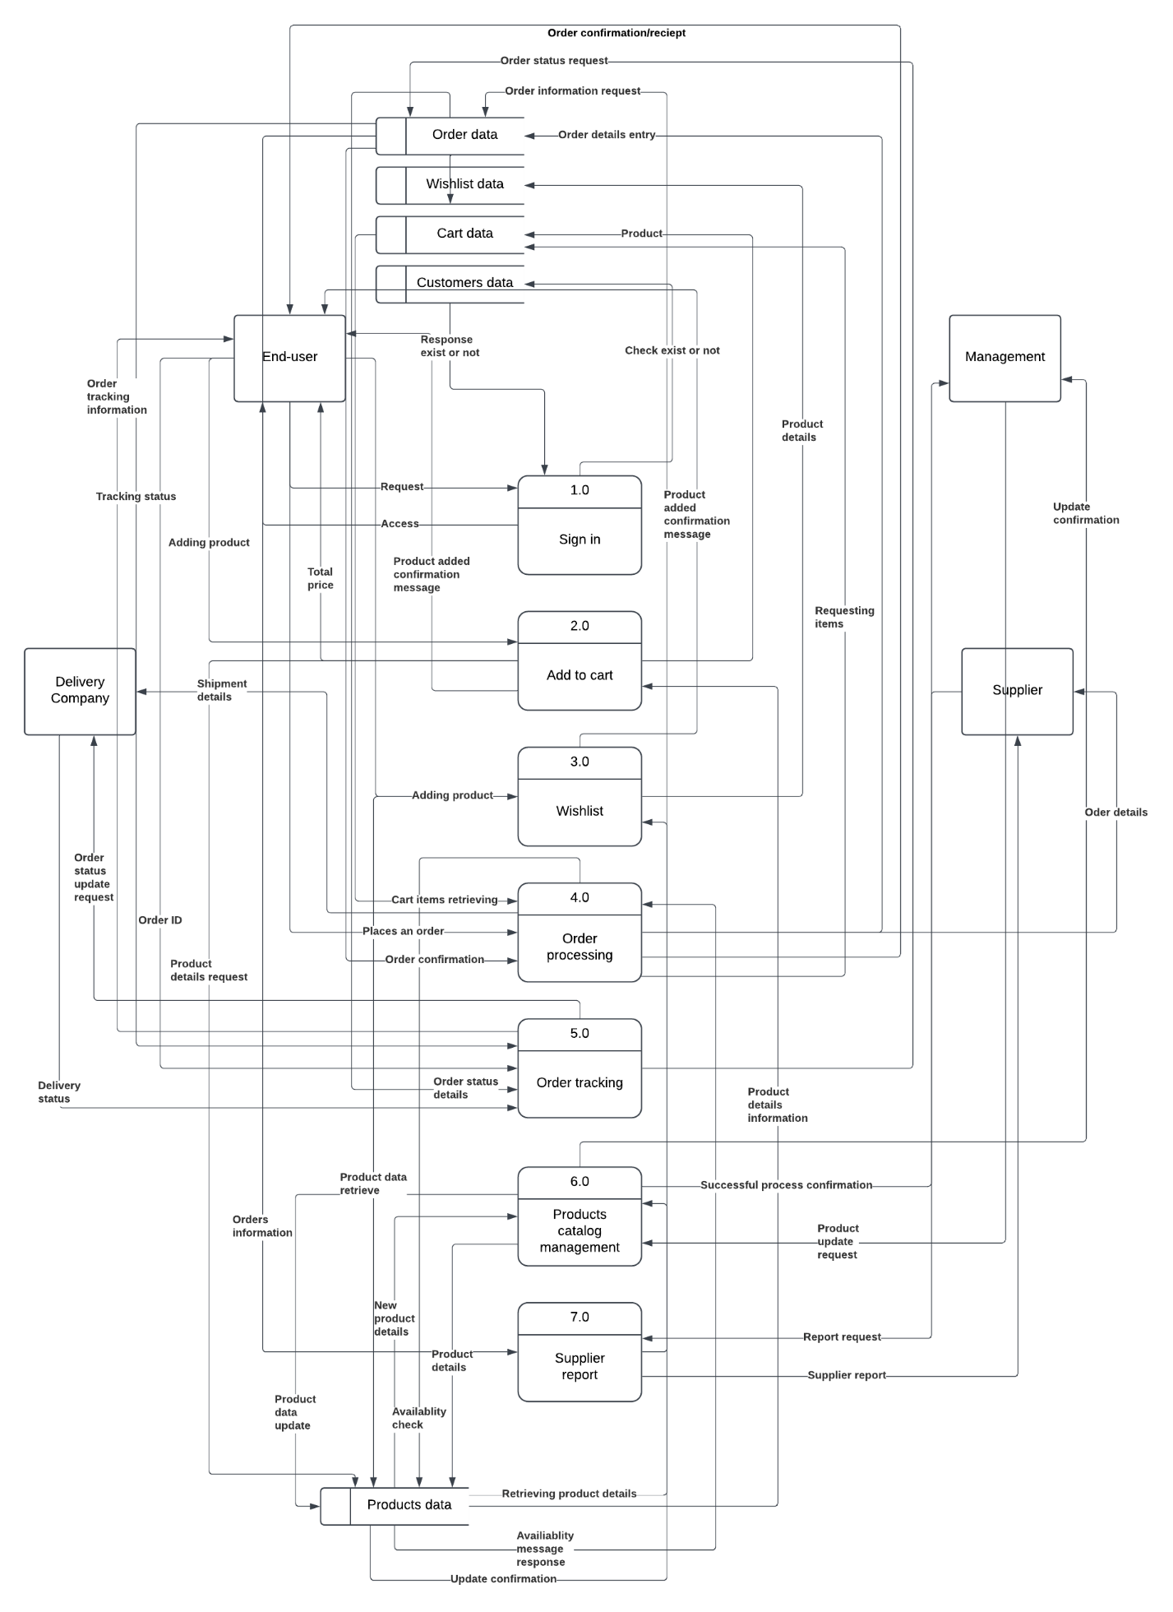

The level 0 diagram includes all key system processes and their connections with entities, as well as data stores, clarifying data flow paths between processes. The system contains seven main processes:

1. **Sign-in**: The user requests system access. The process retrieves user data from the Customers data store. If the user exists, access is granted with a confirmation message; otherwise, access is denied.
2. **Add to Cart**: The user selects products to add to their shopping cart. Product details are sent to the process which updates the Cart data store. If the product is already in the cart, the quantity is updated; if not, it’s added as a new item.
3. **Wishlist**: The user selects products to add to their Wishlist. The process updates the Wishlist data store, ensuring no duplicate entries. If the product is new, it’s added to the Wishlist.
4. **Order Processing**: When the user places an order, the process receives data from the Cart data store, generates an order, and updates the Order data store. Product availability is verified, and order details are sent to the Supplier for stock confirmation and to the Delivery Company for shipping.
5. **Order Tracking**: This allows the user to track order status. When requested, the process retrieves the order’s current status from the Order data store and provides it to the user.
6. **Products Catalog Management**: The Supplier requests to update the product catalog. The Product Catalog Management process updates the Products Data Store and sends a confirmation message to both the management and the Supplier.
7. **Supplier Report**: the management can request a report on sales data and stock levels. This process retrieves information from the Order and Products data stores, calculates important details, sends the report to management, and provides feedback to the Supplier.

**Level 1 DFD:**

The first level of the data flow diagram breaks down the processes into sub-processes, offering a deeper look into the internal structure of the system and how the different parts interact with each other, providing a clear view of the system processes. This level is helpful for understanding the detailed functions of each process, as well as their inputs, outputs, and connections with other parts of the system.

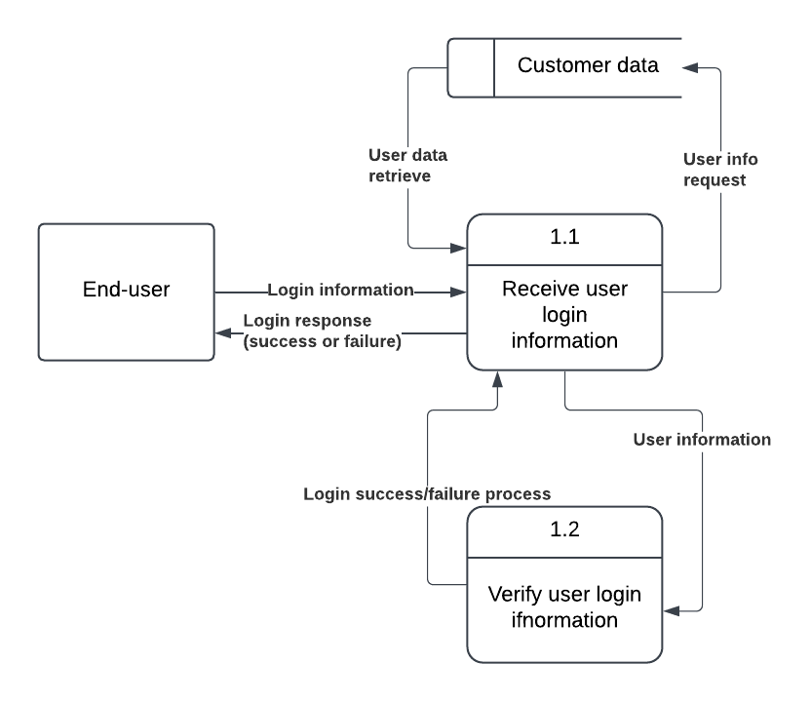

**1.1:** the user enters the login information, and then the process checks the customer data store to verify if the user exists or not. If the user is found, the system will respond with either a successful login or a failed access message.

**1.2:** The system verifies the user's information with the stored data. If the details match, the system grants access to the user; otherwise, it returns a failed login message.

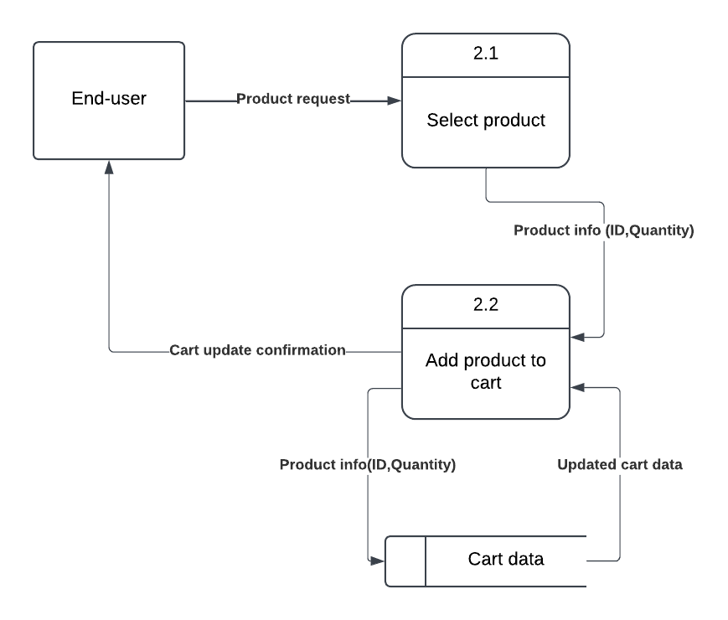

**2.1:** The user selects a product from the product catalog to add to their cart. The process retrieves the product details from the product data store.

**2.2:** After the user confirms their selection, the product details are sent to the Add Product to Cart process. The process updates the Cart Data store by adding the selected product. If the product is already in the cart, the quantity is updated; otherwise, it is added as a new item.

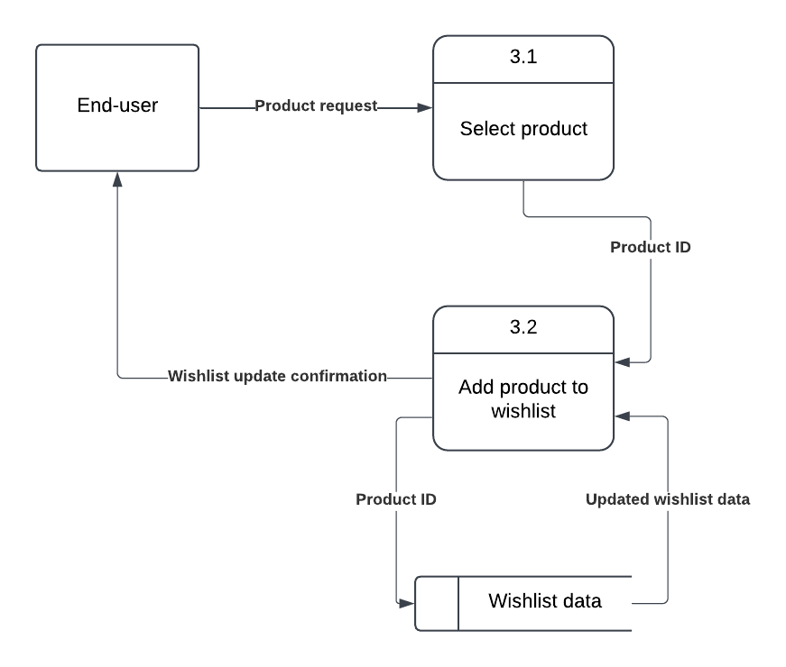

**3.1:** The user selects a product they wish to add to their Wishlist. The Wishlist Process retrieves the product details from the Products Data store to display to the user.

**3.2:** Once the user confirms their selection, the Add Product to Wishlist sub-process updates the Wishlist Data store by adding the chosen item. If the product is already on the Wishlist, the process prevents duplication.

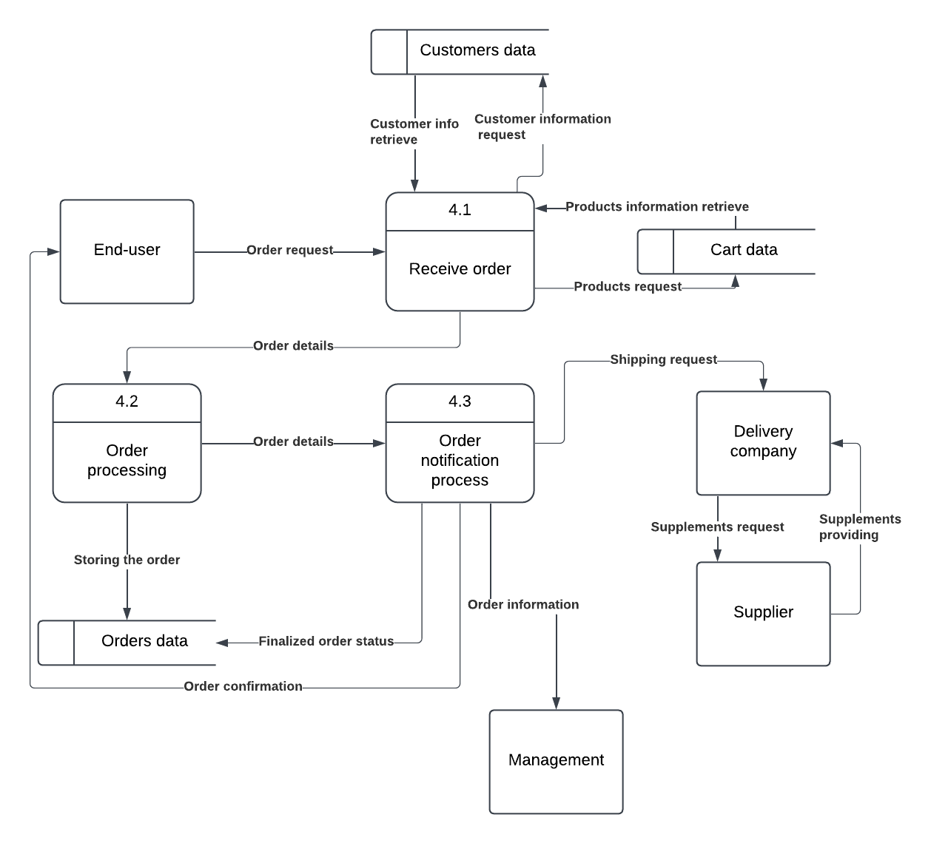

**4.1:** The user submits their order, sending the cart information to the Receive Order process. This process retrieves the item details from the Cart Data store, creates a new order, and stores it in the Orders Data store.

**4.2:** The Order Processing process takes the order details from the Orders Data store, stores them, and then sends the information to the Order Notification Process.

**4.3:** The Order Notification Process notifies the three other entities: management, the supplier, and the delivery company that a new order has been placed.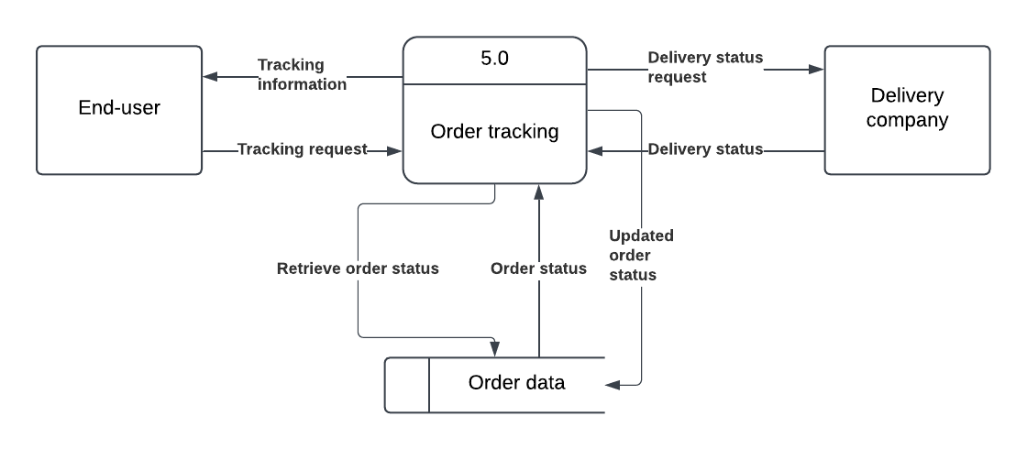

**5.0:**  The user requests the tracking status, and the process retrieves the current status from the Order Data store. If the status has changed, the process will ask the Delivery Company to update it. The updated status is then returned to the user.

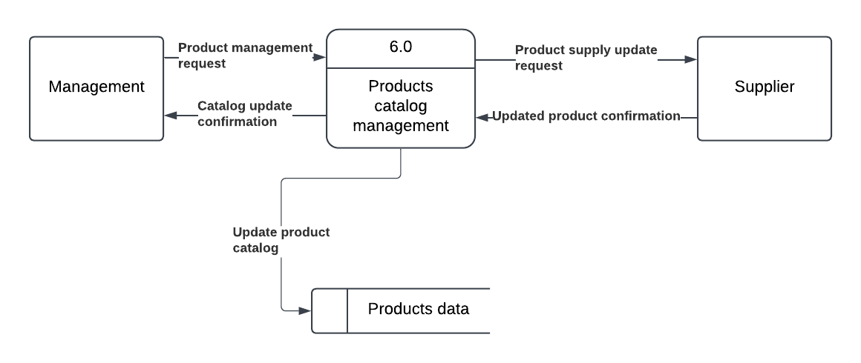

**6.0:**  The Supplier requests to update product catalog information. After receiving the request, the Product Catalog Management process updates the Products Data Store with the latest product details, such as price, description, and stock availability. Once the catalog is updated, the process sends a confirmation message to both the management and the Supplier to inform them that the catalog has been successfully updated.

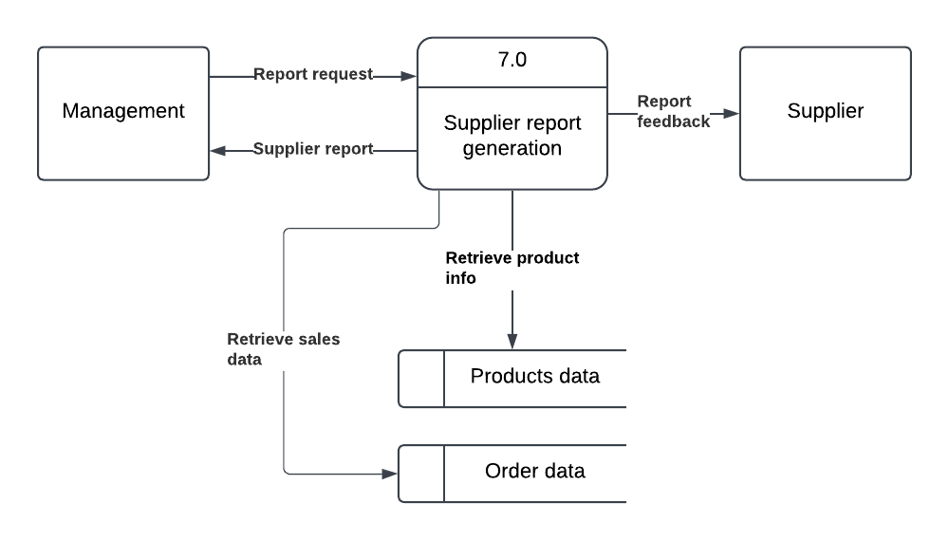

**7.0:** The management requests a supplier report. The Supplier Report Generation process retrieves the necessary data from the Products Data store and the Order Data store. After processing the data, it generates a report, which is then sent to the management as the Supplier Report. In addition, the process also provides feedback to the Supplier in the form of a Report containing sales and stock details.