
Smart Events Booking and Venue Management System
Software Requirements Specification (SRS)

Submitted by:
Saud Ahmad
Registration No: F22BINFT1E02123
Submitted to:
Ms. Sara Fareed
Department:
Department of Information Technology
Faculty:
Faculty of Computing
Session:
2025
THE ISLAMIA UNIVERSITY OF BAHAWALPUR

1. Introduction
1.1 Objective
This Software Requirements Specification (SRS) outlines the complete functional and non-functional requirements of the Smart Events Booking and Venue Management System.
It is intended for:
- Project supervisor
- Development team (frontend, backend, database)
- Testers
- Venue owners & end users
- Future researchers
The goal of this SRS is to provide a clear, structured, and professional description of the system ensuring smooth development and implementation.
1.2 Document Conventions
Convention | Meaning
Bold | System modules, important elements
Italics | Definitions
UPPERCASE | Actor names
UML Notation | Used in diagrams

1.3 Scope
The system is a web-based platform that enables users to browse and book event venues online with real-time availability, secure payments, and automated confirmations.
Modules Included
- User Module
- Venue Owner Module
- Admin Module
- Authentication Module
- Payment Integration Module
- Notification Module
Main System Capabilities
- Venue browsing/searching
- Filtering (location, capacity, price, amenities)
- Booking & reservation management
- Real-time availability
- Online payments (Easypaisa, JazzCash, cards)
- Reviews & ratings
- Owner dashboards
2. Complete Description
2.1 Product Perspective
The system is a stand-alone web application following a client–server architecture:
- Frontend: React.js
- Backend: Node.js (Express.js)
- Database: MongoDB
- Authentication: OAuth (Google, Facebook)
- Payment Gateway: Easypaisa It replaces the manual communication-based booking process with a fully digital one.
2.2 User Classes & Characteristics
User Type | Description | Technical Skill
Customer / User | Books venues, makes payments | Average
Venue Owner | Manages venue listings, bookings, transactions | Medium
Admin (future) | Manages platform, disputes, reported issues | High

2.3 Operating Environment
Component | Environment
Frontend | Browser (Chrome, Edge, Firefox), Mobile
Backend | Node.js Runtime
Database | MongoDB Atlas Cloud
Hosting | GitHub Pages + Cloud Server

2.4 Constraints
- Payment integration limited to available APIs in Pakistan
- System requires stable internet connection
- OAuth requires keys from Google/Facebook
- Real-time availability depends on accurate data from venue owners
2.5 Assumptions
- Users have internet access
- Venue owners can manage dashboards
- Payments processed by trusted third-party APIs
3. System Features
3.1 User Module Features
3.1.1 User Registration / Login
Description:
Users create accounts using email-password or OAuth.
Functional Requirements:
- FR-U1: The system must allow account creation.
- FR-U2: The system must support OAuth (Google, Facebook).
- FR-U3: The system must validate email formats.
- FR-U4: Passwords must be encrypted.
3.1.2 Venue Browsing & Search
Functional Requirements:
- FR-U5: Users must search venues by name, city, or category.
- FR-U6: Users must filter venues by:
  - Price range
  - Seating capacity
  - Event type
  - Amenities (AC, parking, catering, etc.)
- FR-U7: Users must view venue details.
3.1.3 Booking System
Functional Requirements:
- FR-U8: Users must select available dates & time slots.
- FR-U9: System must check real-time availability.
- FR-U10: Users must receive an online booking confirmation.
3.1.4 Payment Processing
Functional Requirements:
- FR-U11: Users must complete payments using:
  - Easypaisa
  - JazzCash
  - Credit/Debit cards
- FR-U12: The system must generate an automated receipt.
3.1.5 Reviews
Functional Requirements:
- FR-U13: Users can submit reviews after a booking.
- FR-U14: Reviews must display publicly on venue page.
3.2 Venue Owner Module
3.2.1 Venue Registration
- FR-V1: Owners can add venue details (name, location, images).
- FR-V2: Owners can set pricing, rules, amenities.
3.2.2 Dashboard Management
- FR-V3: Owners must view upcoming and past bookings.
- FR-V4: Owners must modify venue availability.
- FR-V5: Owners must view transaction history.
3.3 Admin Module (Future)
- FR-A1: Admin can manage users.
- FR-A2: Admin can deactivate fraudulent venues.
- FR-A3: Admin can monitor payments.
4. External Interface Requirements
4.1 User Interface
The system UI will include:
- Modern React.js components
- Responsive layout
- Separate dashboards for users & venue owners
Sample UI Layout (Reference Image)
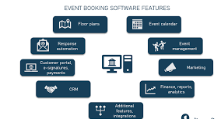
4.2 Hardware Interfaces
- Standard computer or mobile device
- Internet connectivity
4.3 Software Interfaces
Interface | Purpose
OAuth API | Authentication
Easypaisa API | Payments
MongoDB Atlas | Cloud database
Node.js Express APIs | Data transfer

5. System Models
5.1 Use Case Diagram
(UML)
(https://www.planttext.com?text=XPBBJiCm44NtbVeFeomGNLJy0MfvhQX03Ith8HcbeoHZPBkf8iI_O-S1IPqAhooTcUkvTxmo5hKzbiLyDfzXOfM6dI7TtwCzoP7WvIIa8q3JtdgwJaiMtwWfiIXPGH35fTE3nuh46hXJAcV9u0fQdGqAPbGw1d5jB9KHVFb-SCS_2ylbBLnlAMC7DTp0iyfO5kS5CQ5E3gsc2UWJ5xxv0jqpdRff7iWY5s79_O6I7DQLW_Z11TiwAF76MfK0RJ0dUCNQkmpWksPBiANAJR7edJUPdbaVQWzu6-3a_8EgtMUAxfa91uEY9eXkGHCQ3NxJACRjcfMOtt6RhO_6yVvwYP2E5Z74IjZ_eYwhlmU6wVwpaN7Q4xlvzg8hahJvuZy0)
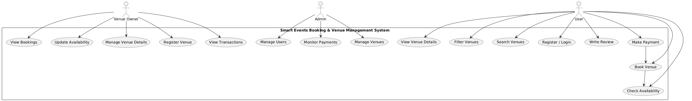5.2 Detailed Use Cases
UC-01: Search for Venue
Attribute | Description
Actor | User
Trigger | User enters search query
Precondition | User must be logged in
Postcondition | List of venues displayed
Main Flow | System fetches results from database

UC-02: Book Venue
Step | Description
 | - User selects venue
 | - User selects date/time
 | - System checks availability
 | - User completes payment
 | - System confirms booking
 | - Email/SMS notification sent

6. Non-Functional Requirements
6.1 Performance Requirements
- System must load pages within 3 seconds.
- System must handle 1000 concurrent users.
6.2 Security Requirements
- Password encryption using bcrypt.
- OAuth tokens secured via SSL.
- Role-based access control (RBAC).
- Secure payment gateways compliance.
6.3 Reliability
- 99% uptime.
- Auto-recovery on server crash.
6.4 Usability
- Clean, simple UI.
- Mobile-responsive.
- Tooltips and guidance for new users.
6.5 Maintainability
- Modular code architecture.
- Clear API documentation.
7. Database Requirements
7.1 Major Collections (MongoDB)
Collection | Description
users | stores user accounts
venues | venue details
bookings | booking records
payments | transaction details
reviews | user feedback

8. System Architecture Diagram
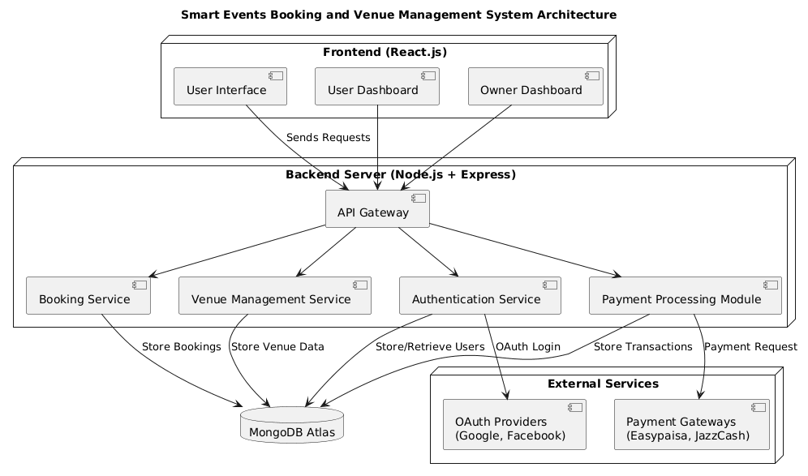 9. Future Enhancements
- AI-based venue recommendation
- Admin dispute resolution center
- Event service provider marketplace
10. Conclusion
The Smart Event Booking & Venue Management System digitizes the entire venue booking process. It ensures improved customer satisfaction, efficient management for venue owners, and reduced manual effort — making it an excellent real-world applicable final year project.
11. Glossary
Term | Meaning
OAuth | Open Authorization Login
Booking | Reservation of a venue
API | Application Programming Interface
Dashboard | Control panel for users/owners
12. References
- IEEE SRS Standard Documentation
- React Developer Docs(https://react.dev/)
- Easypaisa Payment API Docs(https://easypay.easypaisa.com.pk/easypay-merchant/faces/pg/site/IntegrationGuides.jsf)
- MongoDB Atlas Guides(https://www.mongodb.com/resources/products/platform/mongodb-atlas-tutorial)
- PlantUML Documentation(https://plantuml.com/)

