**OBJECT ORIENTED SOFTWARE ENGINEERING**

**Saud Khan**

Fa21-bse-033

**OOSE MID LAB**

Submitted to

**Sir Mukhtiar Zamin**

Table of Contents

**TASK:** 3

**Use case:** Process Consumption 3

**Actor** 3

**Main Success Scenario:** 3

**SYSTEM SEQUENCE DIAGRAM:** 4

**Gui Prototypes:** 5

# **TASK:**

## **Use case:** Process Consumption

**Actor**:Electricity Meter

### **Main Success Scenario:**

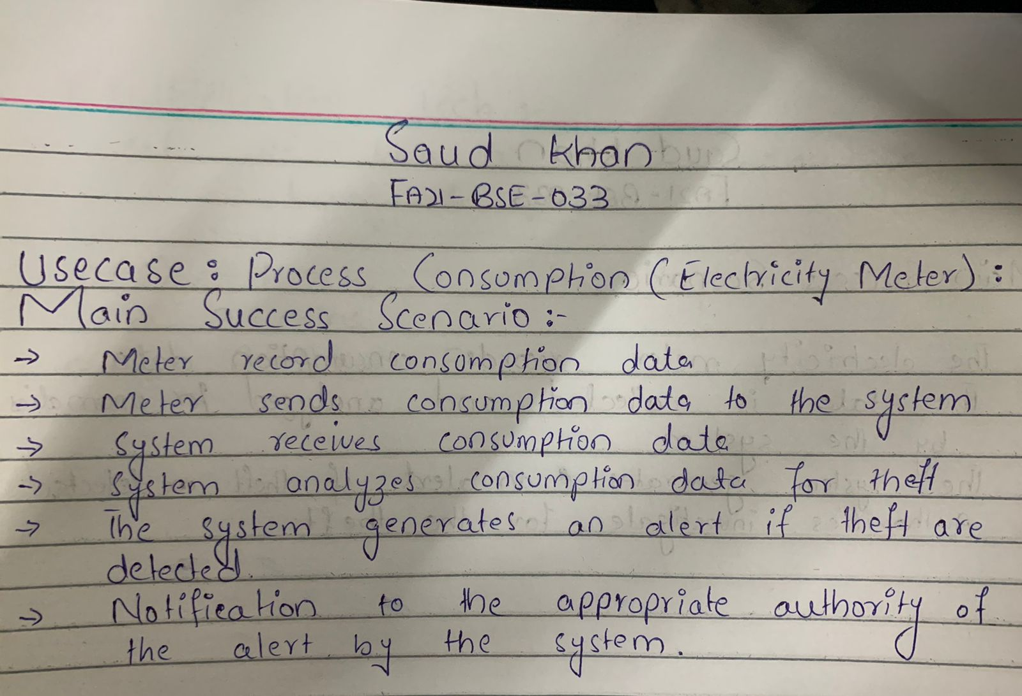

### **SYSTEM SEQUENCE DIAGRAM:**

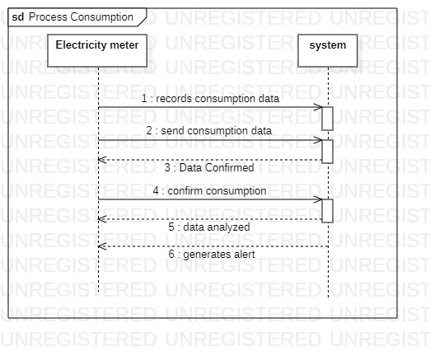

### **Gui Prototypes:**

