**Scenario:**

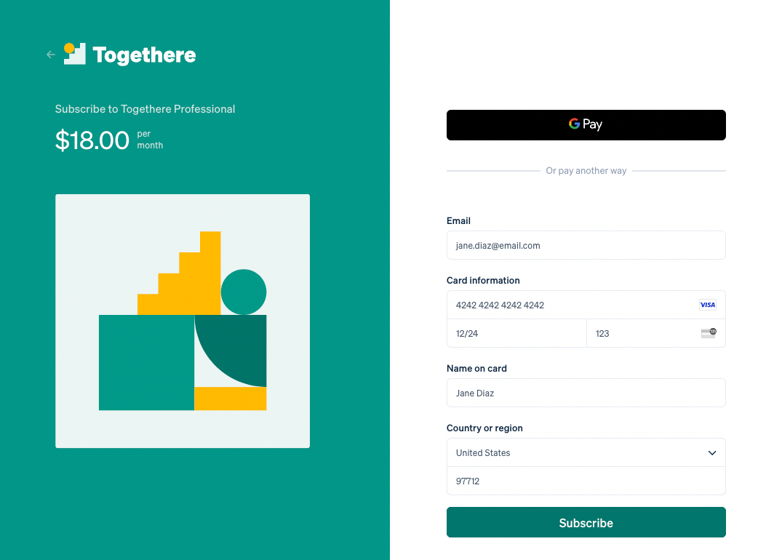

|  |  |  |  |  |  |
| --- | --- | --- | --- | --- | --- |
| **Test Case ID** | **Test Case Description** | **Input Data** | **Expected Outcome** | **Actual Outcome** | **Status** |
| TC-01 | Verify a successful subscription | Inputs Entered correctly | Successful subscription confirmation | Subscription successful | Pass |
| TC-02 | Incomplete card information | Inputs entered(incomplete card no) | Error message for incomplete card details | Please enter correct card no | Pass |
| TC-03 | Expired Card | Form Filled with expired card | Error Message for expired card | Card Expired | Pass |
| TC-04 | Verify a card is VISA or Master card | Details Entered of non-VISA card | Card must be VISA or Master Card | Please provide a VISA or Master card | Pass |
| TC-05 | Do subscription for valid email | Non register user email | You are not register with application | Subscription successful | Fail |
| TC-06 | Verify fields are empty | No inputs | Error: Please enter all fields | Same as expected | Pass |
| TC-07 | No subscription without email | Form filled without email | Error: Enter the email to complete subscription | Subscription successful | Fail |
| TC-08 | Verify the Card country | Card of Pakistan  Country: UAE | Card must be belonging country | Enter Card Country | Pass |
| TC-09 | Check the card holder name | Form Filled with invalid holder name | Error: invalid card holder name | Enter correct card holder name | Pass |
| TC-10 | Subscription not exist in given country | Form filled with non-existing country | Error: enter the current country | Subscription successful | Fail |
| TC-11 | Check the Name | Form Filled with incorrect Name | Error: Enter the correct card holder name | Subscription successful | Fail |
| TC-12 | Verify a successful subscription | Form filled with incorrect card no | Error: incorrect card no | Enter correct Card no | Pass |