**Software Testing**

LAB 2

**Create a program in java to implement Logic to find third angle of a triangle. After that check the triangle type with respect to the angle.**

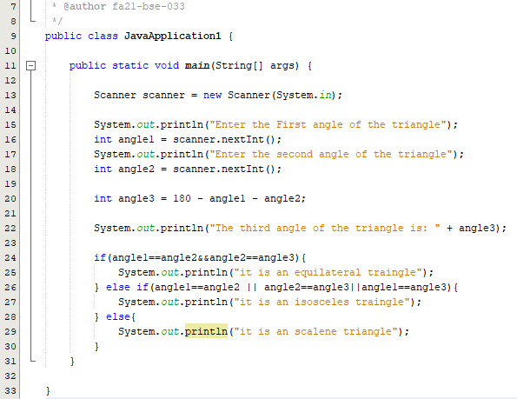

**USECASES:**

|  |  |  |  |  |  |
| --- | --- | --- | --- | --- | --- |
| **Test Case ID** | **Test Case Description** | **Input Data** | **Expected Outcome** | **Actual Outcome** | **Status** |
| TC-01 | Inputting three angles of an triangle | 30,60 | The third angle of the triangle is: 90  It is a right triangle. | The third angle of the triangle is: 90  It is a right triangle. | Pass |
| TC-02 | Inputting three angles of an triangle | 110,40 | The third angle of the triangle is: 30  It is an obtuse triangle. | The third angle of the triangle is: 30  It is an obtuse triangle. | Pass |
| TC-03 | Inputting three angles of an triangle | 60,60 | The third angle of the triangle is: 60  It is an acute triangle. | The third angle of the triangle is: 60  It is an acute triangle. | Pass |
| TC-04 | Inputting Negative angle values | -30,-60 | **Error**: Angle values cannot be negative | The third angle of the triangle is: 270  It is an obtuse triangle. | Fail |
| TC-05 | Inputting zero angle values | 0,0 | **Error**: Angle values cannot be zero | The third angle of the triangle is: 180  It is an obtuse triangle. | Fail |
| TC-06 | Input angle values whose sum is greater than 180 | 100,90 | **Error:** invalid inputs, since angles sum cannot exceed 180 | The third angle of the triangle is: -10  It is a right triangle. | Fail |