Smart Obstacle Detection Glasses Milestone 2
Product functionality and state model
This document describes the design and behavior of the Raspberry Pi obstacle-alert prototype. It combines an ultrasonic distance alert with a button-triggered camera description. The distance monitor runs continuously while the main program waits for a button press or completes a scan. The state diagram and transition table define normal operation, feedback, error paths, and shutdown.

Product purpose
The product gives a user two forms of information about the space ahead. A range sensor provides immediate tactile feedback when an object is within the configured five-foot zone. When the user presses and releases the button, a camera takes a picture, an AI vision model produces a brief description of the main obstacle, and text-to-speech plays the result through a connected speaker.

Hardware and software inputs and outputs
Element | Connection or service | Role
Push button | BCM GPIO 4; pull-down input | A press followed by release requests one image scan.
Ultrasonic sensor | TRIG BCM 27; ECHO BCM 22; VCC/GND | Measures distance repeatedly in the background.
Vibration motor | BCM GPIO 26 output | Produces pulsed tactile alerts for close obstacles.
USB camera | fswebcam; 640 × 480 | Captures a still image on a button scan.
AI and network | OpenAI API; gpt-4o-mini | Returns a short description of the primary obstacle.
Audio output | gTTS and mpg123; connected speaker | Converts and plays the description aloud.
Boot/service | systemd unit | Starts the script at boot and can restart it after failure.

Operating assumptions
The pin numbers in this document use BCM numbering. The project configuration uses a 152.4 cm alert threshold, a 30 ms echo-edge timeout, and a short median filter to reduce single-reading noise. The service example assumes the account pi and the folder /home/pi/obstacle-glasses; these values must match the Raspberry Pi installation.

1. Product functionality

1.1 Startup and initialization
When the Raspberry Pi boots, systemd starts the program after the network-online target. The service loads OPENAI_API_KEY from /etc/obstacle-glasses.env, configures GPIO using BCM numbering, initializes the motor and trigger pins LOW, and starts the distance-monitor thread. The main thread then waits for the button. If the service exits unexpectedly, systemd is configured to retry after a short delay.

1.2 Continuous distance sensing and tactile feedback
The monitor sends a 10-microsecond trigger pulse and measures the ECHO pulse width. It converts the round-trip travel time to centimeters using the speed of sound. Echo waits have bounded timeouts so a missing return does not hold the program indefinitely. Readings outside the sensor’s usable range are discarded; recent valid readings are median-filtered before the alert decision.
If the filtered distance is missing or greater than 152.4 cm (5 ft), the motor output is LOW. At or inside the threshold, the program calculates a pulse interval from distance: approximately 1.00 second at the edge of the alert zone, decreasing toward a 0.12-second floor as distance approaches zero. Each motor pulse is HIGH for 0.06 seconds, then LOW for the remaining interval. Thus a nearer obstacle produces more frequent vibration. Actual timing may be slightly slower because each sensor cycle also takes time.

1.3 Button-triggered camera scan
The button input is configured with a pull-down resistor. The main loop waits for the input to become HIGH, then waits for release back to LOW; the scan starts on release. The camera command captures a 640 × 480 still image and skips two frames. The operation has a 30-second timeout. If camera capture fails, the program logs the error and returns to button-waiting without interrupting the background distance monitor.

1.4 AI obstacle description
After a successful capture, the image is encoded and sent to the configured OpenAI vision model. The instruction asks for one short sentence of at most 15 words describing the main object or obstacle directly ahead and not reading text. If the API key is missing, the scan is skipped with a warning. If the request fails or returns no usable text, the error is logged and the main loop returns to waiting for another button press.

1.5 Spoken feedback and repeat operation
A non-empty description is passed to gTTS in English, saved temporarily as an MP3, and played with mpg123 through the configured speaker. Text-to-speech, network, or playback errors are logged. After playback or an error, the main loop waits for the next button press. Distance sensing and vibration continue during camera, AI, and audio work.

2. State diagram
The upper lane is a continuously running sensor task. The lower lane is the main interaction task. Both begin after GPIO initialization and run concurrently until shutdown.
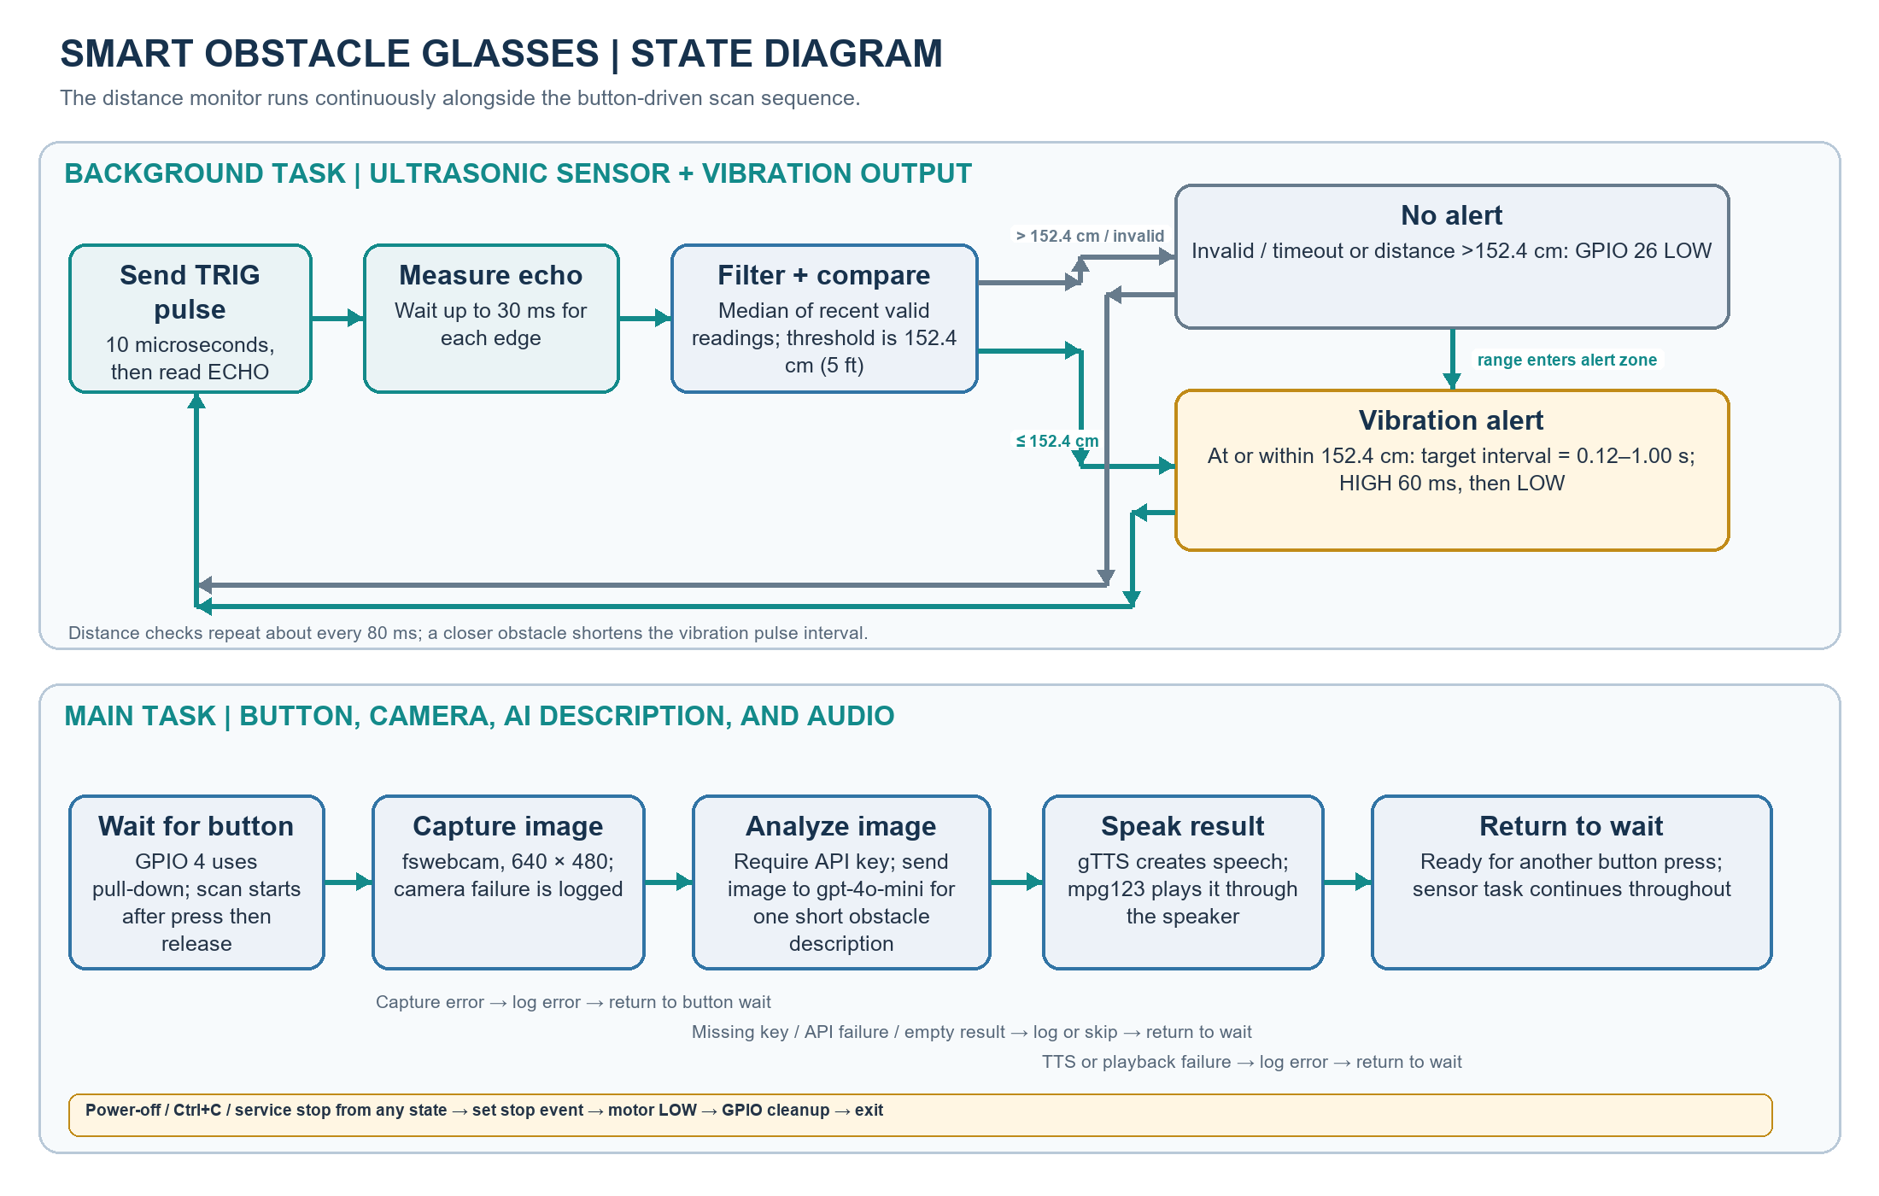
Figure 1. Concurrent sensor-alert and button-scan state flows.

3. State transitions and feedback
Current state | Event or condition | Action and next state
Boot / initialize | Power on or systemd start | Load key, configure GPIO, start monitor; enter concurrent RUN state.
Distance sample | Echo pulse is valid | Convert to centimeters, update recent samples, median-filter, then compare with threshold.
Distance sample | Echo timeout / invalid reading | Treat sample as unavailable; set motor LOW and continue monitoring.
No-alert | Filtered distance > 152.4 cm | Keep motor LOW; schedule next sensor sample.
Alert pulse | Filtered distance ≤ 152.4 cm | Set pulse period from distance; drive GPIO 26 HIGH for 60 ms, then LOW; repeat.
Wait for button | GPIO 4 becomes HIGH then LOW | Start camera capture after button release.
Capture | Camera returns an image | Send image to AI analysis.
Capture | Camera command fails or times out | Log error; return to wait for button.
AI analysis | Key missing, request fails, or response empty | Warn/log; skip speech; return to wait for button.
AI analysis | Description returned | Generate speech audio and play it.
Speak | Playback completes or fails | Log any failure; return to wait for button.
Any active state | Ctrl+C or systemd stop | Signal stop, set motor LOW, join monitor, clean up GPIO, exit.

4. Feedback and fault handling
Condition | User/system feedback | Recovery
Obstacle detected in range | Vibration pulses; rate increases as distance decreases. | Continue sampling and update pulse timing.
No echo or object outside range | No vibration; diagnostic distance is unavailable or outside alert zone. | Take another sample. A failed sensor can therefore produce no tactile warning.
Button scan requested | Console status; camera capture then spoken description if successful. | Return to the button wait state after the scan.
Camera, API, network, or audio error | Error or warning written to service logs. | Continue running; distance monitor remains active.
Program stop | Motor output is set LOW and GPIO is cleaned up. | systemd may restart after failure; a normal stop remains stopped.

5. Implementation status and design constraints
The project prototype has been run on the owner’s configured Raspberry Pi. Its core behavior includes button-triggered image capture and description, speaker playback, and continuous ultrasonic threshold monitoring. The current design revision adds distance-scaled vibration pulses and filtering; this revised pulse pattern should be checked on the physical device after deployment because it changes the original on/off alert behavior.
The motor is currently connected directly between GPIO 26 and ground, matching the project’s tested setup. This is recorded as the present prototype wiring; a transistor or MOSFET motor driver with an appropriate motor supply is the recommended design before extended use. The exact ultrasonic module must also be identified. Some HC-SR04 variants expect 5 V, and a 5 V ECHO signal must not be connected directly to Pi GPIO; use a voltage divider or level shifter if required by that module. Raspberry Pi GPIO operates at 3.3 V logic. [1]
This is an assistive prototype, not a certified mobility aid. Ultrasonic sensors can miss surfaces, soft materials, objects outside the beam, and obstacles outside their sensing range. Camera descriptions also depend on lighting, network access, and AI response quality. The vibration and speech outputs should supplement other safe navigation methods.

References
[1] Raspberry Pi Ltd., “Raspberry Pi computer hardware,” GPIO electrical information, https://www.raspberrypi.com/documentation/computers/raspberry-pi.html (accessed 21 October 2026).

